DSWD DROMIC Preparedness for Response Report #2
on the Low Pressure Areas [June 2018]
as of 5 June 2018, 8AM

Weather Bulletin

As of 3:00 am today, June 5, 2018, the Low Pressure Area (LPA) embedded in the Intertropical Convergence Zone(ITCZ) was estimated, based on all available data, at 795 km East of Surigao City, Surigao del Norte (10.0 ºN, 132.7 ºE).

Source: DOST-PAGASA Daily Weather Forecast

Predictive Analytics for Humanitarian Response
Based on the GSM and WRF data of PAGASA initialized on 05 June 2018, 2AM, the DSWD Predictive Analytics for Humanitarian Response results show 188,334 persons (see Figure 1) are exposed to high susceptibility of flooding and rain-induced landslide in the next 72 hours; of which, 11,532 families are poor (see Figure 2).

Figure 1. Exposed Population (PSA), Required FFPs, and Cost
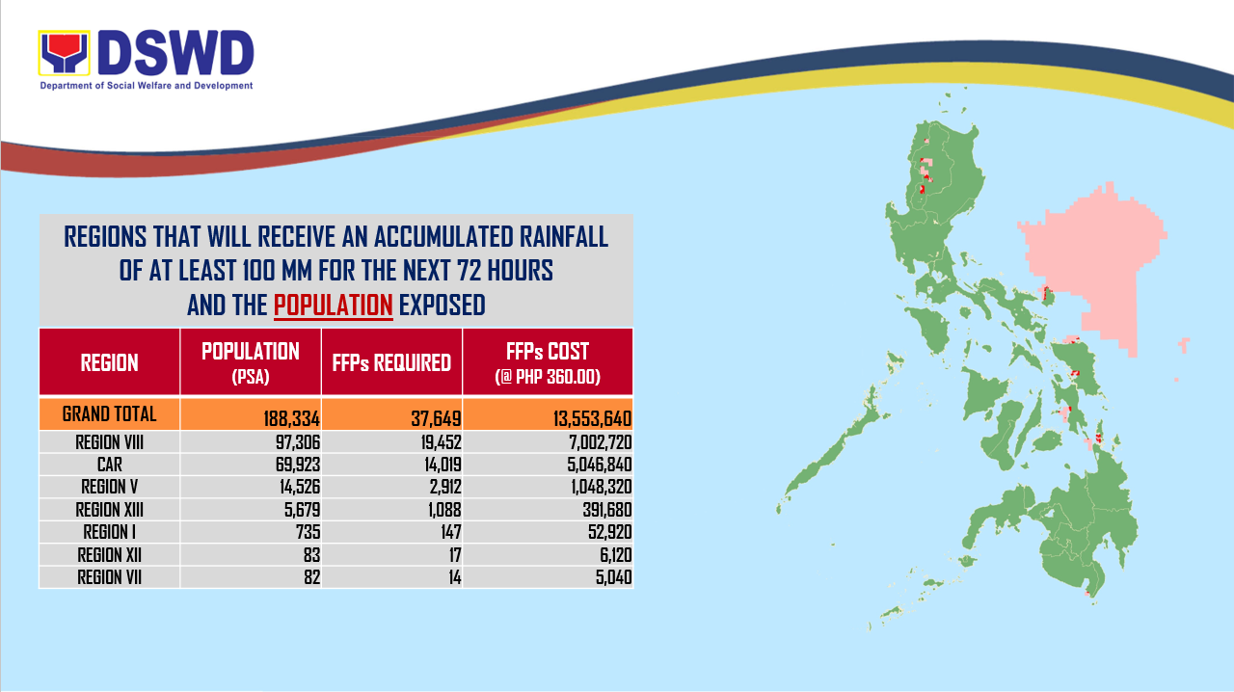

Figure 2. Exposed Poor Families (DSWD), Required FFPs, and Cost
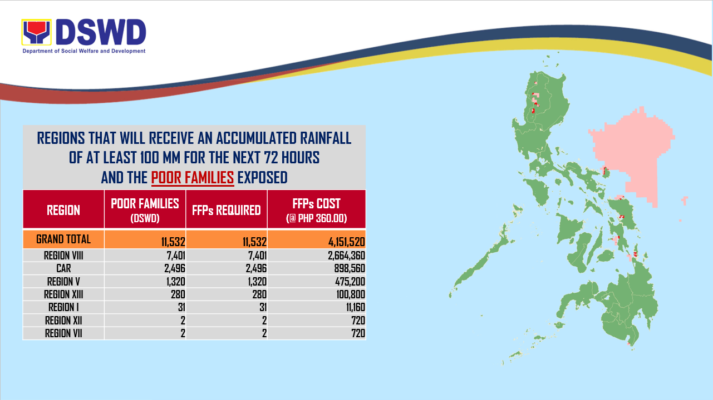

Status of Prepositioned Resources: Stockpile and Standby Funds

The DSWD Central Office (CO), Field Offices (FOs), and National Resource Operations Center (NROC) have stockpiles and standby funds amounting to ₱1,155,738,750.94 with breakdown as follows:

- Standby Funds
A total of ₱207,223,921.85 standby funds in the CO and FOs. Of the said amount,
₱165,181,069.00 is the available Quick Response Fund in the CO.

- Stockpiles
A total of 447,900 Family Food Packs (FFPs) amounting to ₱155,990,976.28 and available Food and Non-food Items (FNIs) amounting to ₱792,523,852.81.

FIELD OFFICE | STANDBY FUNDS | STOCKPILE |  |  |  |  | TOTAL STANDBY FUNDS AND STOCKPILE
 |  | Family Food Packs |  | Food | Non-Food | Sub-Total  (Food and NFIs)
 |  | Quantity | Total Cost
TOTAL | 207,223,921.85 | 447,900 | 155,990,976.28 | 120,208,894.40 | 672,314,958.41 | 792,523,852.81 | 1,155,738,750.94
Central Office* | 165,181,069.00 | - | - | - | - | - | 165,181,069.00
NROC | - | 77,075 | 27,747,000.00 | 36,925,252.22 | 254,687,765.00 | 291,613,017.22 | 319,360,017.22
NCR | 2,937,750.00 | 19,558 | 5,902,028.64 | 817,794.60 | 2,430,599.75 | 3,248,394.35 | 12,088,172.99
CAR | 1,922,353.00 | 8,193 | 3,188,802.92 | 188,215.00 | 15,432,353.48 | 15,620,568.48 | 20,731,724.40
I | 3,031,900.00 | 10,400 | 3,744,000.00 | 3,877,584.03 | 21,956,891.22 | 25,834,475.25 | 32,610,375.25
II | 2,762,375.00 | 36,495 | 12,773,250.00 | 3,052,800.00 | 3,533,649.96 | 6,586,449.96 | 22,122,074.96
III | 3,133,400.00 | 11,374 | 4,088,522.20 | 373,586.30 | 17,072,747.10 | 17,446,333.40 | 24,668,255.60
CALABARZON | 2,316,000.00 | 11,572 | 3,841,105.50 | 2,413,554.88 | 6,443,933.41 | 8,857,488.29 | 15,014,593.79
MIMAROPA | 503,660.00 | 27,788 | 10,083,987.30 | 8,056,951.06 | 1,395,732.36 | 9,452,683.42 | 20,040,330.72
V | 2,992,000.00 | 30,286 | 9,379,056.00 | 903,399.60 | 52,232,988.00 | 53,136,387.60 | 65,507,443.60
VI | 3,000,000.00 | 12,750 | 4,577,250.00 | 13,303,645.57 | 8,490,644.19 | 21,794,289.76 | 29,371,539.76
VII | 3,000,000.00 | 89,758 | 32,404,574.00 | 19,980,445.04 | 46,942,129.96 | 66,922,575.00 | 102,327,149.00
VIII | 2,049,600.00 | 20,210 | 7,077,048.44 | 12,206,151.62 | 48,746,786.55 | 60,952,938.17 | 70,079,586.61
IX | 2,873,664.85 | 22,361 | 8,049,960.00 | 1,141,829.35 | 3,315,422.67 | 4,457,252.02 | 15,380,876.87
X | 3,140,700.00 | 15,919 | 5,236,080.00 | 2,145,840.00 | 170,250,270.06 | 172,396,110.06 | 180,772,890.06
XI | 3,000,000.00 | 27,521 | 9,021,383.80 | 6,039,769.28 | 2,497,486.17 | 8,537,255.45 | 20,558,639.25
XII | 3,000,000.00 | 13,741 | 4,946,760.00 | 3,931,315.63 | 4,511,351.67 | 8,442,667.30 | 16,389,427.30
CARAGA | 2,379,450.00 | 12,899 | 3,930,167.48 | 4,850,760.22 | 12,374,206.86 | 17,224,967.08 | 23,534,584.56

DSWD-FOs have prepositioned FFPs in strategic locations. Breakdown per location is as follows:

REGION | LOCATION | NUMBER OF FFPS
GRAND TOTAL |  | 447,900
NROC |  | 77,075
 | Chapel Road, Pasay City | 77,075
NCR |  | 19,558
 | DSWD-FO NCR, 389 San Rafael St., Legarda, Sampaloc, Manila | 362
 | 4 Misamis Ext.,Bago Bantay,Q.C. (RSCC) | 1,212
 | NCWP, Chapel Road, Pasay City | 1,998
 | NROC Chapel Road (Reserve Stock) | 15,986
CAR |  | 8,193
 | DSWD Regional Warehouse, SN Oriental Cmpd., Palmaville, Puguis, La Trinidad | 8,193
 | Prepositioned Relief Goods | 0
 | Luna, Apayao
 | Province of Abra
I |  | 10,400
 | Regional Warehouse, Brgy. Urayong, Bauang, La Union | 7,000
 | Prepositioned Relief Goods | 3,400
 | Solsona Warehouse, Ilocos Norte | 0
 | Burgos Warehouse, Municipal Bldg., Perucho St., Brgy. Poblacion, Burgos, Ilocos Norte
 | Santa Warehouse, Santa, Ilocos Sur | 0
 | Caoyan Warehouse, Brgy. Don Lorenzo, Ilocus Sur | 0
 | Cervantes-Mankayan Rd., Brgy. Rosario, Cervantes, Ilocos Sur
 | Brgy. Concordia, Bolinao, Pangasinan | 0
 | Alaminos Warehouse, Brgy. Tangcarang, Alaminos City, Pangasinan | 0
 | Urbiztondo, Pangasinan | 0
 | Manaoag Warehouse, Pangasinan | 800
 | Brgy. Maningding, Sta. Barbara, Pangasinan | 800
 | Rosales Warehouse, Robert B. Estrella, Sr. Memorial Stadium, Umingan-Rosales Rd., Rosales, Pangasinan | 800
 | Vigan City Satellite Warehouse | 1,000
 | San Nicolas, Ilocos Norte
II |  | 36,495
 | DSWD Regional Warehouse, Regional Government Center, Carig, Tuguegarao City | 8,745
 | Prepositioned Relief Goods | 27,750
 | PSWDO CAGAYAN | 500
 | Aparri, Cagayan | 600
 | Alcala, Cagayan | 1,000
 | Buguey, Cagayan | 300
 | Gattaran, Cagayan | 400
 | Lasam, Cagayan | 1,200
 | Gonzaga, Cagayan | 300
 | Camalaniugan, Cagayan | 300
 | Sta Ana, Cagayan | 300
 | Abulug, Cagayan | 300
 | Allacapan, Cagayan | 600
 | Calayan, Cagayan | 600
 | Pamplona, Cagayan | 300
 | Piat, Cagayan | 300
 | Sto Niño, Cagayan | 400
 | Amulung, Cagayan | 300
 | Enrile, Cagayan | 500
 | Iguig, Cagayan | 300
 | Peñablanca, Cagayan | 600
 | Solana, Cagayan | 1,000
 | Tuao, Cagayan | 300
 | Tuguegarao City, Cagayan | 1,100
 | PSWDO ISABELA | 500
 | Cabagan, Isabela | 600
 | Cordon,Isabela | 300
 | Divilacan,Isabela | 600
 | Maconacon,Isabela | 600
 | Palanan,Isabela | 600
 | Santa Maria,Isabela | 400
 | Benito Soliven,Isabela | 300
 | Roxas,Isabela | 300
 | San Manuel,Isabela | 300
 | Gamu,Isabela | 300
 | Alicia, Isabela | 300
 | Cabatuan, Isabela | 300
 | Luna, Isabela | 300
 | Reina Mercedes, Isabela | 300
 | San Mateo,Isabela | 300
 | Cauayan City,Isabela | 300
 | Dinapigue,Isabela | 900
 | Santiago City,Isabela | 300
 | San Agustin, Isabela | 300
 | PSWDO QUIRINO | 500
 | Aglipay, Quirino | 250
 | Cabarroguis, Quirino | 400
 | Saguday, Quirino | 400
 | Diffun, Quirino | 400
 | Maddela,Quirino | 400
 | Nagtipunan, Quirino | 400
 | PSWDO NUEVA VIZCAYA | 500
 | Ambaguio, Nueva Vizcaya | 400
 | Aritao, Nueva Vizcaya | 400
 | Bagabag, Nueva Vizcaya | 400
 | Bambang, Nueva Vizcaya | 400
 | Bayombong, Nueva Vizcaya | 400
 | Diadi, Nueva Vizcaya | 400
 | Sta Fe, Nueva Vizcaya | 400
 | Villaverde, Nueva Vizcaya | 400
 | Kayapa, Nueva Vizcaya | 400
 | Alfonso Castaneda, Nueva Vizcaya | 400
 | Dupax del Norte, Nueva Vizcaya | 300
 | Dupax del Sur, Nueva Vizcaya | 300
 | Quezon, Nueva Vizcaya | 300
III |  | 11,374
 | DSWD Regional Warehouse, JASA, Dolores, City of San Fernando, Pampanga | 5,874
 | Prepositioned Relief Goods | 5,500
 | DPEO, Aurora( Sitio Hiwalayan, brgy. Bacong, San Luis, Aurora | 500
 | Evacuation Center, brgy. Suklayin, Baler, Aurora | 1,000
 | Municipality of Dilasag | 1,000
 | Municipality of Casiguran | 1,000
 | Pulilan, Bulacan | 1,000
 | San Jose, Plaridel, Bulacan | 1,000
 | Evacuation Center, Moncada, Tarlac
 | DPEO, PSWDO Cmpd., Palanginan, Iba, Zambales
 | DPEO, Olongapo City
CALABARZON |  | 11,572
 | DSWD Regional Warehouse, Brgy. Gregoria de Jesus,San Jose, G.M.A, Cavite | 10,052
 | Prepositioned Relief Goods | 1,520
 | PSWDO Lucena City, Quezon
 | Munipal Office, Quezon, Quezon
 | MSWDO Burdeous, Quezon
 | MSWDO Alabat, Quezon | 640
 | MSWDO Jomalig, Quezon | 880
 | PDRRMO, Brgy. G. De Leon, Sta. Cruz, Laguna
MIMAROPA |  | 27,788
 | DSWD Regional Warehouse, 1680 F. Benitez cor. Malvar Sts., Malate, Metro Manila | 3,000
 | Prepositioned Relief Goods | 24,788
 | M. Roxas Drive, Salong, Calapan City (SWADT Oriental Mindoro) | 3,333
 | JRB Building, San Jose, Occidental Mindoro (SWADT Occ. Mindoro) | 5,200
 | Brgy. Bangbangalon, Boac, Marinduque (SWADT Marinduque) | 1,586
 | 052 Gen. Luna St., Liwayway, Odiongan, Romblon (SWADT Romblon) | 5,511
 | Cor. Malvar and Sandoval Sts., Puerto Princesa City (SWADT Palawan) | 9,158
V |  | 30,286
 | DSWD Regional Warehouse, Brgy Bogtong, Legazpi City | 22,986
 | Prepositioned Relief Goods | 7,300
 | LGU Baao, Camarines Sur | 500
 | Lagonoy, Camarines Sur | 500
 | Canaman, Camarines Sur | 500
 | LGU San Vicente, Camarines Norte | 1,000
 | Pilar Sorsogon | 1,000
 | PLGU Catanduanes | 2,800
 | Virac, Catanduanes | 1,000
VI |  | 12,750
 | Juantong Warehouse, Bodega 8, Juantong Bldg., Rizal St., Iloilo City | 11,750
 | Prepositioned Relief Goods | 1,000
 | LGU Malay, Aklan | 1,000
 | SWAD Antique
 | SWAD Capiz
 | SWAD Negros Occidental
VII |  | 89,758
 | VDRC, P.C Suico St. Tingub, Mandaue City | 47,098
 | Labangon, Cebu CIty | 11,532
 | Bodega Polinitas, C.P.G. East Ave., Tagbilaran City, Bohol | 12,430
 | DC Warehouse, Tabuk Tubig, Dumaguete City, Negros Oriental | 11,541
 | SWAD Office, Siquijor | 141
 | Prepositioned Relief Goods | 7,016
 | Buenavista, Bohol
 | Carlos P. Garcia, Bohol
 | Candijay, Bohol
 | Duero, Bohol
 | Getafe, Bohol
 | SierraBullones, Bohol
 | Sevilla, Bohol
 | Dumanjug, Cebu | 1,997
 | Madridejos, Cebu | 1,500
 | Pilar, Cebu | 500
 | Poro, Cebu
 | Ronda, Cebu | 1,500
 | San Fracisco, Cebu | 500
 | Tabongon, Cebu
 | Toledo, Cebu | 564
 | Bayawan, Negros Oriental
 | Canlaon, Negros Oriental
 | Guihulngan, Negros Oriental
 | Mabinay, Negros Oriental
 | Tanjay City, Negros, Oriental | 455
 | Vallehermoso, Negros Oriental | 0
VIII |  | 20,210
 | DSWD Regional Warehouse, Brgy. 91, Abucay, Tacloban City | 11,510
 | Allen, Northern Samar | 0
 | PDRRMO (UEP Catarman) | 0
 | Prepositioned Relief Goods | 8,700
 | Dulag, Leyte | 500
 | Hilongos, Leyte | 500
 | San Isidro, Leyte | 500
 | Jipapad, Eastern Samar | 1,000
 | Almagro, Western Samar | 500
 | Calbiga, Western Samar | 800
 | Daram, Western Samar | 500
 | Hinabangan, Western Samar | 800
 | Matuguinao, Western Samar | 800
 | Motiong, Western Samar | 500
 | Sta. Margarita, Western Samar | 500
 | San Sebastian, Western Samar | 800
 | San Jose de Buan, Western Samar | 500
 | Catbalogan, Samar
 | Culaba, Biliran | 500
IX |  | 22,361
 | DSWD Regional Warehouse, Rojo Warehouse. No. 59, Santa Catalina, Zamboanga City | 20,152
 | Prepositioned Relief Goods | 2,209
 | SWADT, Ipil Heights, Ipil, Zamboanga Sibugay | 873
 | SWADT, Liloy, Zamboanga Del Norte | 838
 | SWADT-Dipolog, DSWDBldg. Dipolog City | 254
 | SWADT-Pagadian, DSWD Bldg., Pagadian City | 244
X |  | 15,919
 | DSWD Regional Warehouse, Corrales Ext., Puntod, Cagayan de Oro City
 | RCP Warehouse, Dalipuga, Iligan City | 15,919
XI |  | 27,521
 | Purok 7, BPI Compound, Brgy Oshiro, Tugbok District, Davao City | 20,010
 | Prepositioned Relief Goods | 7,511
 | Provincial Coliseum, Brgy. Mati Digos City Davao Del Sur | 2,000
 | Provincial Capitol, Brgy. Cabidianan, Nabunturan, Compostela Valley | 1,780
 | PDRRMO Compound Brgy Dahican, Mati City Davao Oriental | 2,000
 | PSWDO, Provincial Capitol Cmpd., Tagum City, Davao Del Norte | 1,731
XII |  | 13,741
 | DSWD Regional Warehouse, Arellano St., Brgy. Zone III, Koronadal City, South Cotabato | 13,741
CARAGA |  | 12,899
 | DSWD Regional Warehouse, DPWH Tiniwisan, Butuan City, Agusan del Norte | 7,253
 | Prepositioned Relief Goods | 5,646
 | Surigao City | 2,219
 | Patin-ay, Agusan Del Sur | 1,800
 | Sta. Monica, Surigao Del Norte
 | Pilar, Surigao Del Norte | 423
 | Burgos, Surigao Del Norte | 289
 | Socorro, Surigao Del Norte | 298
 | Placer (MSU Food Hub)
 | Tandag City, Surigao Del Sur
 | San Jose, Dinagat Island | 300
 | Libjo, Dinagat Island | 162
 | Loreto, Dinagat Island | 155

Situational Reports

DSWD-DRMB
DATE | SITUATIONS / ACTIONS UNDERTAKEN
June 3, 2018 | - The Disaster Response Operations Monitoring and Information Center (DROMIC) of the DSWD-DRMB is on 24/7 duty to continuously coordinate with the concerned DSWD-Field Offices for significant disaster preparedness for response updates.

FO I
DATE | SITUATION / PREPAREDNESS ACTIONS
June 3, 2018 | - The Ilocos Region is generally experiencing isolated rainshowers.  - The DRMD staff members of the FO are closely monitoring the possible effect of the LPA.  - The Quick Action Response Teams (QUARTS) of the FO and the Provincial Operations Offices are currently monitoring the weather and performing pre-disaster activities in coordination with the OCD – Region I and the different P/M/CDRRMCs.

FO MIMAROPA
DATE | SITUATION / PREPAREDNESS ACTIONS
June 3, 2018 | - The DSWD-FO MIMAROPA activated FO Operations Center to monitor daily local weather conditions.  - The DSWD-FO MIMAROPA alerted all P/C/M Quick Response Teams in the five (5) provinces of the region to regularly monitor the situations in their areas.  - All members of R/P/C/M QRTs are on an on-call status and are on standby to be on duty, ready for deployment if needed.  - The DSWD-FO MIMAROPA advised its P/MQRTs to coordinate with concerned LGUs to report any unusual eventualities in their respective areas and take appropriate actions.  - The FO’s Information and Communication Technology Management Unit (ICTMU) is activated to ensure robust communication system.  - The FO ensured that there is an available truck to deliver goods to areas that might be affected.
FO V
DATE | SITUATION / PREPAREDNESS ACTIONS
June 4, 2018 | - PAT and MAT members are on standby and were instructed to coordinate with the P/MDRRMOs for status reports and updates.

FO VII
DATE | SITUATION / PREPAREDNESS ACTIONS
June 3, 2018 | - Staff members from the field were alerted on the latest weather information and were requested to monitor areas of responsibility and provide updates for any incidents related to the weather.  - The DSWD-FO VII QRT is currently on standby for any assistance and augmentation that may be needed.

FO VIII
DATE | SITUATION / PREPAREDNESS ACTIONS
June 3, 2018 | - The SWAD Teams, were alerted and advised to closely coordinate with P/C/MSWDOs and P/C/MRRDMOs.  - At the FO, all QRT members were alerted in case the LPA elevates into a Tropical Depression or Storm for them to prepare for 24/7 duty.  - The FO’s DRIMS is closely monitoring weather bulletins to ensure readiness for any eventualities that may arise due to the present weather disturbance.  - The DRMD staffs were likewise alerted.  - Staff members manning the warehouse were also alerted to ensure the readiness of dispatching the food and non-food items whenever needed.

FO CARAGA
DATE | SITUATION / PREPAREDNESS ACTIONS
June 3, 2018 | - All QRT members are on standby for possible deployment.

***********

The Disaster Response Operations Monitoring and Information Center (DROMIC) of the DSWD-DRMB continues to closely coordinate with the concerned DSWD-Field Offices for any significant disaster preparedness for response updates.

EUGENE ALLAN H. LANUZA
Releasing Officer

