DSWD DROMIC Preparedness for Response Report #5
on the Tropical Depression “Domeng”
as of 7 June 2018, 8AM

Weather Bulletin

As of 3:00 am today, 07 June 2018, the center of Tropical Depression DOMENG was estimated, based on all available data, at 605 km East of Virac, Catanduanes (14.3 ºN, 129.8 ºE) with maximum sustained winds of 45 km/h near the center and gustiness of up to 60 km/h. It is forecast to move North Northwest at 15 km/h. Monsoon Trough affecting Luzon and Visayas.
Source: DOST-PAGASA Daily Weather Forecast

Predictive Analytics for Humanitarian Response
Based on the GSM and WRF data of PAGASA initialized on 07 June 2018, 2AM, the DSWD Predictive Analytics for Humanitarian Response results show 6,260,850 persons (see Figure 1) are exposed to high susceptibility of flooding and rain-induced landslide in the next 72 hours; of which, 83,340 families are poor (see Figure 2).

Figure 1. Exposed Population (PSA), Required FFPs, and Cost
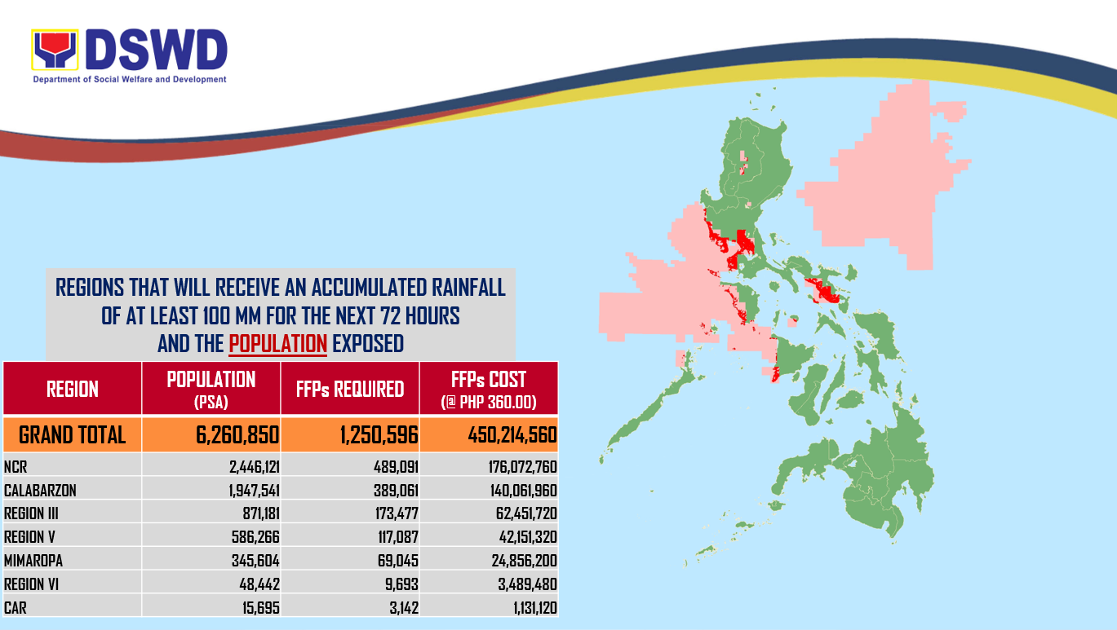

Figure 2. Exposed Poor Families (DSWD), Required FFPs, and Cost
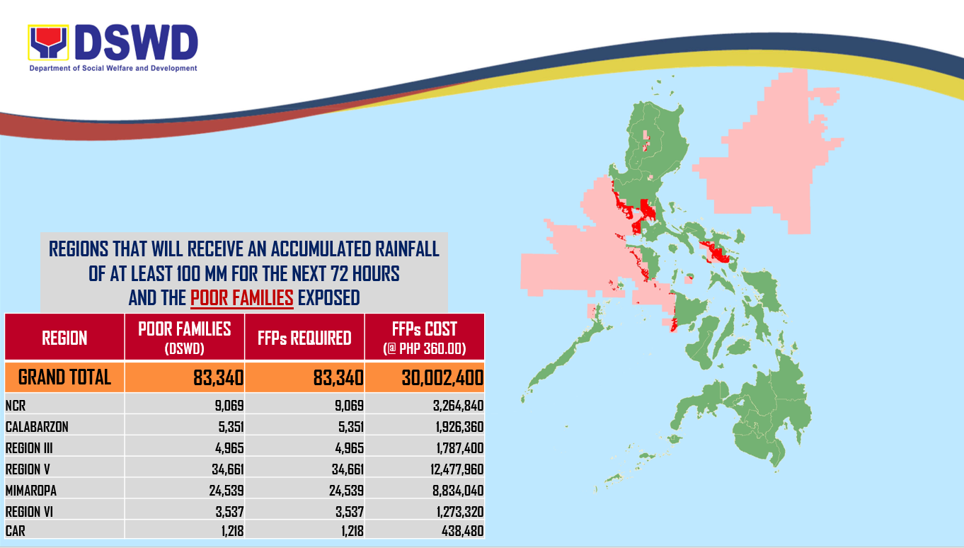

Status of Prepositioned Resources: Stockpile and Standby Funds

The DSWD Central Office (CO), Field Offices (FOs), and National Resource Operations Center (NROC) have stockpiles and standby funds amounting to ₱1,155,540,517.90 with breakdown as follows:

- Standby Funds
A total of ₱207,223,921.85 standby funds in the CO and FOs. Of the said amount,
₱165,181,069.00 is the available Quick Response Fund in the CO.

- Stockpiles
A total of 485,636 Family Food Packs (FFPs) amounting to ₱169,742,460.28 and available Food and Non-food Items (FNIs) amounting to ₱778,574,135.77.

FIELD OFFICE | STANDBY FUNDS | STOCKPILE |  |  |  |  | TOTAL STANDBY FUNDS AND STOCKPILE
 |  | Family Food Packs |  | Food | Non-Food | Sub-Total  (Food and NFIs)
 |  | Quantity | Total Cost
TOTAL | 207,223,921.85 | 485,636 | 169,742,460.28 | 129,041,248.40 | 649,532,887.37 | 778,574,135.77 | 1,155,540,517.90
Central Office* | 165,181,069.00 | - | - | - | - | - | 165,181,069.00
NROC | - | 77,075 | 27,747,000.00 | 36,925,252.22 | 254,687,765.00 | 291,613,017.22 | 319,360,017.22
NCR | 2,937,750.00 | 19,558 | 5,902,028.64 | 817,794.60 | 2,430,599.75 | 3,248,394.35 | 12,088,172.99
CAR | 1,922,353.00 | 8,193 | 3,188,802.92 | 188,215.00 | 15,432,353.48 | 15,620,568.48 | 20,731,724.40
I | 3,031,900.00 | 10,400 | 3,744,000.00 | 3,877,584.03 | 21,956,891.22 | 25,834,475.25 | 32,610,375.25
II | 2,762,375.00 | 36,495 | 12,773,250.00 | 3,052,800.00 | 3,533,649.96 | 6,586,449.96 | 22,122,074.96
III | 3,133,400.00 | 11,374 | 4,088,522.20 | 373,586.30 | 17,072,747.10 | 17,446,333.40 | 24,668,255.60
CALABARZON | 2,316,000.00 | 11,572 | 3,841,105.50 | 2,413,554.88 | 6,443,933.41 | 8,857,488.29 | 15,014,593.79
MIMAROPA | 503,660.00 | 27,788 | 10,083,987.30 | 8,056,951.06 | 1,395,732.36 | 9,452,683.42 | 20,040,330.72
V | 2,992,000.00 | 30,786 | 11,082,960.00 | 903,399.60 | 52,232,988.00 | 53,136,387.60 | 67,211,347.60
VI | 3,000,000.00 | 12,750 | 4,577,250.00 | 13,303,645.57 | 8,490,644.19 | 21,794,289.76 | 29,371,539.76
VII | 3,000,000.00 | 89,758 | 32,404,574.00 | 19,980,445.04 | 46,942,129.96 | 66,922,575.00 | 102,327,149.00
VIII | 2,049,600.00 | 20,210 | 7,077,048.44 | 12,206,151.62 | 48,746,786.55 | 60,952,938.17 | 70,079,586.61
IX | 2,873,664.85 | 22,361 | 8,049,960.00 | 1,141,829.35 | 3,315,422.67 | 4,457,252.02 | 15,380,876.87
X | 3,140,700.00 | 53,155 | 17,283,660.00 | 10,978,194.00 | 147,468,199.02 | 158,446,393.02 | 178,870,753.02
XI | 3,000,000.00 | 27,521 | 9,021,383.80 | 6,039,769.28 | 2,497,486.17 | 8,537,255.45 | 20,558,639.25
XII | 3,000,000.00 | 13,741 | 4,946,760.00 | 3,931,315.63 | 4,511,351.67 | 8,442,667.30 | 16,389,427.30
CARAGA | 2,379,450.00 | 12,899 | 3,930,167.48 | 4,850,760.22 | 12,374,206.86 | 17,224,967.08 | 23,534,584.56
*Quick Response Fund (QRF) as of 1 June 2018

DSWD-FOs have prepositioned FFPs in strategic locations. Breakdown per location is as follows:

REGION | LOCATION | NUMBER OF FFPS
GRAND TOTAL |  | 485,636
NROC |  | 77,075
 | Chapel Road, Pasay City | 77,075
NCR |  | 19,558
 | DSWD-FO NCR, 389 San Rafael St., Legarda, Sampaloc, Manila | 362
 | 4 Misamis Ext.,Bago Bantay,Q.C. (RSCC) | 1,212
 | NCWP, Chapel Road, Pasay City | 1,998
 | NROC Chapel Road (Reserve Stock) | 15,986
CAR |  | 8,193
 | DSWD Regional Warehouse, SN Oriental Cmpd., Palmaville, Puguis, La Trinidad | 8,193
I |  | 10,400
 | Regional Warehouse, Brgy. Urayong, Bauang, La Union | 7,000
 | Prepositioned Relief Goods | 3,400
 | Manaoag Warehouse, Pangasinan | 800
 | Brgy. Maningding, Sta. Barbara, Pangasinan | 800
 | Rosales Warehouse, Robert B. Estrella, Sr. Memorial Stadium, Umingan-Rosales Rd., Rosales, Pangasinan | 800
 | Vigan City Satellite Warehouse | 1,000
II |  | 36,495
 | DSWD Regional Warehouse, Regional Government Center, Carig, Tuguegarao City | 8,745
 | Prepositioned Relief Goods | 27,750
 | PSWDO CAGAYAN | 500
 | Aparri, Cagayan | 600
 | Alcala, Cagayan | 1,000
 | Buguey, Cagayan | 300
 | Gattaran, Cagayan | 400
 | Lasam, Cagayan | 1,200
 | Gonzaga, Cagayan | 300
 | Camalaniugan, Cagayan | 300
 | Sta Ana, Cagayan | 300
 | Abulug, Cagayan | 300
 | Allacapan, Cagayan | 600
 | Calayan, Cagayan | 600
 | Pamplona, Cagayan | 300
 | Piat, Cagayan | 300
 | Sto Niño, Cagayan | 400
 | Amulung, Cagayan | 300
 | Enrile, Cagayan | 500
 | Iguig, Cagayan | 300
 | Peñablanca, Cagayan | 600
 | Solana, Cagayan | 1,000
 | Tuao, Cagayan | 300
 | Tuguegarao City, Cagayan | 1,100
 | PSWDO ISABELA | 500
 | Cabagan, Isabela | 600
 | Cordon,Isabela | 300
 | Divilacan,Isabela | 600
 | Maconacon,Isabela | 600
 | Palanan,Isabela | 600
 | Santa Maria,Isabela | 400
 | Benito Soliven,Isabela | 300
 | Roxas,Isabela | 300
 | San Manuel,Isabela | 300
 | Gamu,Isabela | 300
 | Alicia, Isabela | 300
 | Cabatuan, Isabela | 300
 | Luna, Isabela | 300
 | Reina Mercedes, Isabela | 300
 | San Mateo,Isabela | 300
 | Cauayan City,Isabela | 300
 | Dinapigue,Isabela | 900
 | Santiago City,Isabela | 300
 | San Agustin, Isabela | 300
 | PSWDO QUIRINO | 500
 | Aglipay, Quirino | 250
 | Cabarroguis, Quirino | 400
 | Saguday, Quirino | 400
 | Diffun, Quirino | 400
 | Maddela,Quirino | 400
 | Nagtipunan, Quirino | 400
 | PSWDO NUEVA VIZCAYA | 500
 | Ambaguio, Nueva Vizcaya | 400
 | Aritao, Nueva Vizcaya | 400
 | Bagabag, Nueva Vizcaya | 400
 | Bambang, Nueva Vizcaya | 400
 | Bayombong, Nueva Vizcaya | 400
 | Diadi, Nueva Vizcaya | 400
 | Sta Fe, Nueva Vizcaya | 400
 | Villaverde, Nueva Vizcaya | 400
 | Kayapa, Nueva Vizcaya | 400
 | Alfonso Castaneda, Nueva Vizcaya | 400
 | Dupax del Norte, Nueva Vizcaya | 300
 | Dupax del Sur, Nueva Vizcaya | 300
 | Quezon, Nueva Vizcaya | 300
III |  | 11,374
 | DSWD Regional Warehouse, JASA, Dolores, City of San Fernando, Pampanga | 5,874
 | Prepositioned Relief Goods | 5,500
 | DPEO, Aurora( Sitio Hiwalayan, brgy. Bacong, San Luis, Aurora | 500
 | Evacuation Center, brgy. Suklayin, Baler, Aurora | 1,000
 | Municipality of Dilasag | 1,000
 | Municipality of Casiguran | 1,000
 | Pulilan, Bulacan | 1,000
 | San Jose, Plaridel, Bulacan | 1,000
CALABARZON |  | 11,572
 | DSWD Regional Warehouse, Brgy. Gregoria de Jesus,San Jose, G.M.A, Cavite | 10,052
 | Prepositioned Relief Goods | 1,520
 | MSWDO Alabat, Quezon | 640
 | MSWDO Jomalig, Quezon | 880
MIMAROPA |  | 27,788
 | DSWD Regional Warehouse, 1680 F. Benitez cor. Malvar Sts., Malate, Metro Manila | 3,000
 | Prepositioned Relief Goods | 24,788
 | M. Roxas Drive, Salong, Calapan City (SWADT Oriental Mindoro) | 3,333
 | JRB Building, San Jose, Occidental Mindoro (SWADT Occ. Mindoro) | 5,200
 | Brgy. Bangbangalon, Boac, Marinduque (SWADT Marinduque) | 1,586
 | 052 Gen. Luna St., Liwayway, Odiongan, Romblon (SWADT Romblon) | 5,511
 | Cor. Malvar and Sandoval Sts., Puerto Princesa City (SWADT Palawan) | 9,158
V |  | 30,786
 | DSWD Regional Warehouse, Brgy Bogtong, Legazpi City | 21,986
 | Prepositioned Relief Goods | 8,800
 | LGU Baao, Camarines Sur | 500
 | Lagonoy, Camarines Sur | 1,000
 | Canaman, Camarines Sur | 500
 | San Jose, Camarines Sur | 1,000
 | LGU San Vicente, Camarines Norte | 1,000
 | Pilar Sorsogon | 1,000
 | PLGU Catanduanes | 2,800
 | Virac, Catanduanes | 1,000
VI |  | 12,750
 | Juantong Warehouse, Bodega 8, Juantong Bldg., Rizal St., Iloilo City | 11,750
 | Prepositioned Relief Goods | 1,000
 | LGU Malay, Aklan | 1,000
VII |  | 89,758
 | VDRC, P.C Suico St. Tingub, Mandaue City | 47,098
 | Labangon, Cebu CIty | 11,532
 | Bodega Polinitas, C.P.G. East Ave., Tagbilaran City, Bohol | 12,430
 | DC Warehouse, Tabuk Tubig, Dumaguete City, Negros Oriental | 11,541
 | SWAD Office, Siquijor | 141
 | Prepositioned Relief Goods | 7,016
 | Dumanjug, Cebu | 1,997
 | Madridejos, Cebu | 1,500
 | Pilar, Cebu | 500
 | Ronda, Cebu | 1,500
 | San Fracisco, Cebu | 500
 | Toledo, Cebu | 564
 | Tanjay City, Negros, Oriental | 455
VIII |  | 20,210
 | DSWD Regional Warehouse, Brgy. 91, Abucay, Tacloban City | 11,510
 | Prepositioned Relief Goods | 8,700
 | Dulag, Leyte | 500
 | Hilongos, Leyte | 500
 | San Isidro, Leyte | 500
 | Jipapad, Eastern Samar | 1,000
 | Almagro, Western Samar | 500
 | Calbiga, Western Samar | 800
 | Daram, Western Samar | 500
 | Hinabangan, Western Samar | 800
 | Matuguinao, Western Samar | 800
 | Motiong, Western Samar | 500
 | Sta. Margarita, Western Samar | 500
 | San Sebastian, Western Samar | 800
 | San Jose de Buan, Western Samar | 500
 | Culaba, Biliran | 500
IX |  | 22,361
 | DSWD Regional Warehouse, Rojo Warehouse. No. 59, Santa Catalina, Zamboanga City | 20,152
 | Prepositioned Relief Goods | 2,209
 | SWADT, Ipil Heights, Ipil, Zamboanga Sibugay | 873
 | SWADT, Liloy, Zamboanga Del Norte | 838
 | SWADT-Dipolog, DSWDBldg. Dipolog City | 254
 | SWADT-Pagadian, DSWD Bldg., Pagadian City | 244
X |  | 53,155
 | DSWD Regional Warehouse, Corrales Ext., Puntod, Cagayan de Oro City | 3,860
 | RCP Warehouse, Dalipuga, Iligan City | 40,274
 | Prepositioned Relief Goods | 9,021
 | Tubod, Lanao Del Norte | 3,000
 | Oroquieta, Misamis Occidental | 4,021
 | Mambajao, Camiguin Province | 2,000
XI |  | 27,521
 | Purok 7, BPI Compound, Brgy Oshiro, Tugbok District, Davao City | 20,010
 | Prepositioned Relief Goods | 7,511
 | Provincial Coliseum, Brgy. Mati Digos City Davao Del Sur | 2,000
 | Provincial Capitol, Brgy. Cabidianan, Nabunturan, Compostela Valley | 1,780
 | PDRRMO Compound Brgy Dahican, Mati City Davao Oriental | 2,000
 | PSWDO, Provincial Capitol Cmpd., Tagum City, Davao Del Norte | 1,731
XII |  | 13,741
 | DSWD Regional Warehouse, Arellano St., Brgy. Zone III, Koronadal City, South Cotabato | 13,741
CARAGA |  | 12,899
 | DSWD Regional Warehouse, DPWH Tiniwisan, Butuan City, Agusan del Norte | 7,253
 | Prepositioned Relief Goods | 5,646
 | Surigao City | 2,219
 | Patin-ay, Agusan Del Sur | 1,800
 | Pilar, Surigao Del Norte | 423
 | Burgos, Surigao Del Norte | 289
 | Socorro, Surigao Del Norte | 298
 | San Jose, Dinagat Island | 300
 | Libjo, Dinagat Island | 162
 | Loreto, Dinagat Island | 155

Situational Reports

DSWD-DRMB
DATE | SITUATIONS / ACTIONS UNDERTAKEN
June 3, 2018-Present | - The DSWD-DRMB is on 24/7 duty to continuously coordinate with the concerned DSWD-Field Offices for significant disaster preparedness for response updates.

FO I
DATE | SITUATION / PREPAREDNESS ACTIONS
June 3, 2018 | - The DRMD staff members of the FO were closely monitoring the possible effect of the LPA.  - The Quick Action Response Teams (QUARTS) of the FO and the Provincial Operations Offices were monitoring the weather and performing pre-disaster activities in coordination with the OCD-Region I and the different P/M/CDRRMCs.

FO II
DATE | SITUATION / PREPAREDNESS ACTIONS
June 5, 2018 | - The DMRT in the Field Office, SWAD and MAT teams in the provinces of Batanes, Cagayan, Isabela, Quirino and Nueva were on-call.

FO NCR
DATE | SITUATION / PREPAREDNESS ACTIONS
June 5, 2018 | - The QRT was on standby alert and would be activated and mobilize in response to any eventuality.

FO CALABARZON
DATE | SITUATION / PREPAREDNESS ACTIONS
June 6, 2018 | - The Regional and Provincial Quick Response Team (QRT) members are placed on heightened alert status for possible duty at the DSWD-FO CALABARZON Disaster Operations Center and ready for deployment in case need arises.  - The DSWD-FO CALABARZON in collaboration with the Office of Civil Defense (OCD) IV-A conducted coordination meeting with the member agencies of the Response Pillar to ensure that response assets are readily available should TD Domeng affects the Region.  - The DSWD-FO CALABARZON notified the Local Social Welfare and Development Officers (LSWDOs) in the Region to ensure the availability of food and non-food items should there be an activation of evacuation centers.  - The DSWD-FO CALABARZON advised the LSWDOs to closely coordinate with Local Disaster Risk Reduction Management Offices (LRRMOs) and ensure data sharing and monitoring of disaster events.  - The DSWD-FO CALABARZON coordinated with National Food Authority (NFA) for possible purchase of NFA rice in case TD Domeng affects the Region.  - The Disaster Response Management Division (DRMD) of DSWD-FO CALABARZON coordinated with Philippine Coast Guard (PCG) and Philippine Ports Authority (PPA) to ensure, whenever there should be suspension of sea travel, the tourist and other travelers will be taken care off by the PPA.
June 5, 2018 | - The Disaster Response Management Division Operation Center was at heightened alert to monitor possible effects of the TD.  - The Field Office was closely coordinating with RDRRMC IV-A secretariat, Provincial/City/Municipal Social Welfare and Development Offices and C/MSWDOs and C/MDRRMOs for updates.  - Advised LSWDOs to conduct pre-emptive evacuation in case the need arises.

FO MIMAROPA
DATE | SITUATION / PREPAREDNESS ACTIONS
June 3, 2018 | - The DSWD-FO MIMAROPA activated FO Operations Center to monitor daily local weather conditions.  - The DSWD-FO MIMAROPA alerted all P/C/M Quick Response Teams in the five (5) provinces of the region to regularly monitor the situations in their areas.  - All members of R/P/C/M QRTs are on an on-call status and are on standby to be on duty, ready for deployment if needed.  - The DSWD-FO MIMAROPA advised its P/MQRTs to coordinate with concerned LGUs to report any unusual eventualities in their respective areas and take appropriate actions.  - The FO’s Information and Communication Technology Management Unit (ICTMU) was activated to ensure robust communication system.  - The FO ensured that there is an available truck to deliver goods to areas that might be affected.

FO V
DATE | SITUATION / PREPAREDNESS ACTIONS
June 4, 2018 | - PAT and MAT members were on standby and were instructed to coordinate with the P/MDRRMOs for status reports and updates.

FO VI
DATE | SITUATION / PREPAREDNESS ACTIONS
June 5, 2018 | - All QRT members are on standby and ready for necessary augmentation.

FO VII
DATE | SITUATION / PREPAREDNESS ACTIONS
June 6, 2018 | - DSWD-FO VII Quick Response Team (QRT) remains on heightened alert and is on standby for any assistance and augmentation support needed from the field.  - DSWD-FO VII DROMIC focal person is closely monitoring weather updates and information and cascades the same to the Social Welfare and Development Team Leaders (SWADTLs) and City/Municipal Action Teams (C/MATs) who are working together to closely monitor their areas of responsibility (AOR) in coordination with the local disaster units for any incidents/occurrences in the field relating to TD Domeng.
June 3, 2018 | - Staff members from the field were alerted on the latest weather information and were requested to monitor areas of responsibility and provide updates for any incidents related to the weather.

FO VIII
DATE | SITUATION / PREPAREDNESS ACTIONS
June 3, 2018 | - The SWAD Teams, were alerted and advised to closely coordinate with P/C/MSWDOs and P/C/MRRDMOs.  - At the FO, all QRT members were alerted in case the LPA elevates into a Tropical Depression or Storm for them to prepare for 24/7 duty.  - The DSWD-FO VIII DRIMS was closely monitoring weather bulletins to ensure readiness for any eventualities that may arise due to the present weather disturbance.  - The DRMD staffs were likewise alerted.  - Staff members manning the warehouse were also alerted to ensure the readiness of dispatching the food and non-food items whenever needed.

FO X
DATE | SITUATION / PREPAREDNESS ACTIONS
June 6, 2018 | - The DSWD-FO X has activated its Quick Response Team (QRT) in anticipation and preparation for the possible effects of TD Domeng.  - The DSWD-FO X is closely monitoring and coordinating with the local disaster risk reduction and management offices (LDRRMOs) of the local government units (LGUs) of Northern Mindanao.  - The City/Municipal Action Team (C/MAT) Leaders in Northern Mindanao were ordered to coordinate with their respective local disaster risk reduction management (LDRRM) to assist the latter in its disaster response.
June 5, 2018 | - The SWADTLs were in close coordination with their respective P/C/LDRRMCs.

FO XI
DATE | SITUATION / PREPAREDNESS ACTIONS
June 5, 2018 | - All QRT members were on standby and ready for necessary augmentation.  - Disaster Response and Management Division personnel were on “on-call” status.  - The DSWD-FO XI was closely coordinating with the Office of Civil Defense XI and all SWADOs, PSWDOs and CSWDO/MSWDOs for updates.  - Disaster Wing Van and Vehicles were available for use.

FO CARAGA
DATE | SITUATION / PREPAREDNESS ACTIONS
June 5, 2018 | - The Field Office through the Disaster Response Management Division was in close coordination with the SWAD Team Leaders, the Provincial/City/Municipal Teams and the local Social Welfare Development Officers for updates.
June 3, 2018 | - All QRT members were on standby for possible deployment.

***********

The Disaster Response Operations Monitoring and Information Center (DROMIC) of the DSWD-DRMB continues to closely coordinate with the concerned DSWD-Field Offices for any significant disaster preparedness for response updates.

EUGENE ALLAN H. LANUZA
Releasing Officer

