DSWD DROMIC Terminal Report on the Fire Incident
in Brgy. Poblacion, Muntinlupa City
as of 19 October 2018, 6PM

This is the final report on a fire incident that transpired in Brgy. Poblacion, Muntinlupa City.

Source: DSWD-FO NCR

- Status of Affected Families / Persons
311 families or 1,149 persons were affected by the fire incident in Brgy. Poblacion, Muntinlupa City (see Table 1).

Table 1. Affected Families / Persons
REGION / PROVINCE / MUNICIPALITY | NUMBER OF AFFECTED
 | Barangays | Families | Persons
GRAND TOTAL | 1 | 311 | 1,149
NCR | 1 | 311 | 1,149
Muntinlupa City | 1 | 311 | 1,149
Source: DSWD-FO NCR

- Status of Displaced Families/ Persons

Table 2. Status of Displaced Families/ Persons Inside Evacuation Centers
REGION / PROVINCE / MUNICIPALITY | NUMBER OF EVACUATION CENTERS (ECs) |  | NUMBER OF SERVED
 |  |  | INSIDE ECs
 |  |  | Families |  | Persons
 | CUM | NOW | CUM | NOW | CUM | NOW
GRAND TOTAL | 2 | 0 | 150 | 0 | 600 | 0
NCR | 2 | 0 | 150 | 0 | 600 | 0
Muntinlupa City | 2 | 0 | 150 | 0 | 600 | 0
Tents near the Blazed Area | 1 | 0 | 100 | 0 | 400 | 0
Open Covered Court | 1 | 0 | 50 | 0 | 200 | 0

Source: DSWD-FO NCR

- Damaged Houses

Table 3. Status of Damaged Houses
REGION / PROVINCE / MUNICIPALITY | NO. OF DAMAGED HOUSES
 | Total | Totally | Partially
GRAND TOTAL | 260 | 260 | -
NCR | 260 | 260 | -
Muntinlupa City | 260 | 260 | -
Source: DSWD-FO NCR

- Cost of Assistance
₱341,000.00 worth of assistance was provided by the Department of Social Welfare and Development (see Table 2).

Table 4. Cost of Assistance
REGION / PROVINCE / MUNICIPALITY | TOTAL COST OF ASSISTANCE (PHP)
 | DSWD | LGU | NGOs | OTHERS | GRAND TOTAL
GRAND TOTAL | 341,000.00 | - | - | - | 341,000.00
NCR | 341,000.00 | - | - | - | 341,000.00
Muntinlupa City | 341,000.00 | - | - | - | 341,000.00
Source: DSWD-FO NCR

SITUATIONAL REPORT

DSWD-DRMB
DATE | SITUATIONS / ACTIONS UNDERTAKEN
19 October 2018 | - The Disaster Response Operations Monitoring and Information Center (DROMIC) of the DSWD-DRMB continues to closely coordinate with DSWD-FO NCR for any requests of Technical Assistance and Resource Augmentation (TARA).

DSWD-FO NCR
DATE | SITUATIONS / ACTIONS UNDERTAKEN
19 October 2018 | - FO-NCR Submitted Terminal Report  - Some of the affected families are currently staying with their relatives who live in nearby areas while others have already rebuild their gutted houses with the help of financial assistance from the Local Government Unit of Muntinlupa thru its City Social Welfare and Development Office.

*****
The Disaster Response Operations Monitoring and Information Center (DROMIC) of the DSWD continues to closely coordinate with DSWD-FO NCR for significant reports on the status of affected families, assistance, and relief efforts.

JAN ERWIN ANDREW ONTANILLAS
Releasing Officer

PHOTO DOCUMENTATION

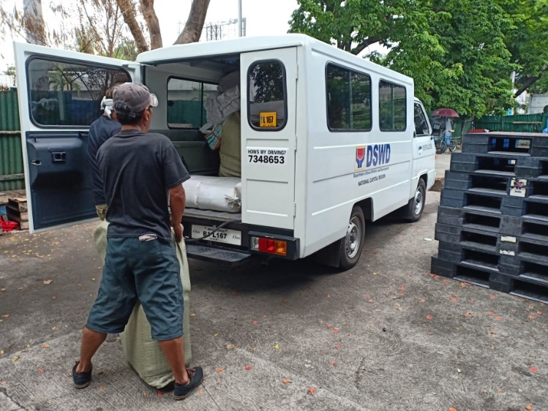

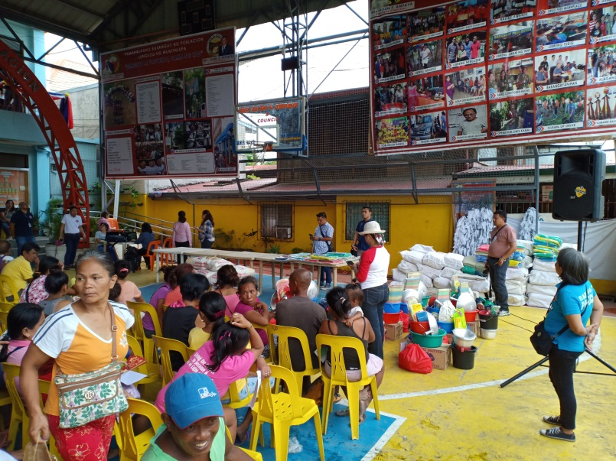
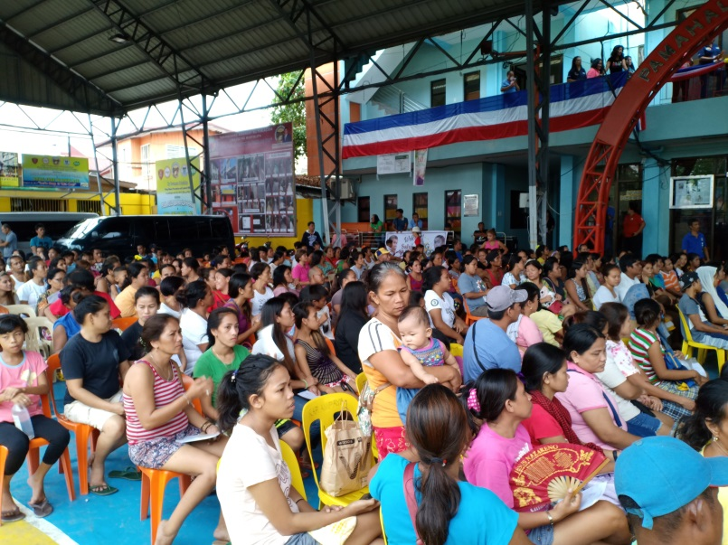
Pick-up of relief items from National Council for Women of the Philippines (NCWP) for delivery and distribution to the affected families at Brgy. Poblacion, Muntinlupa City.
The affected families during the relief distribution

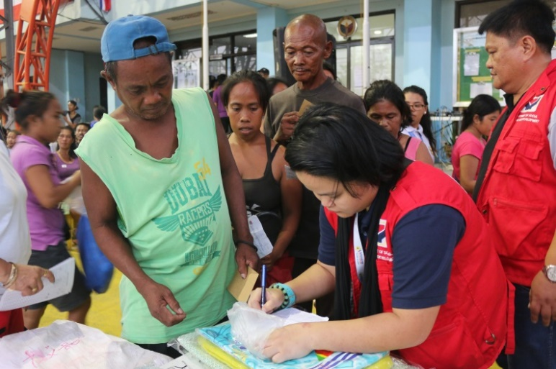
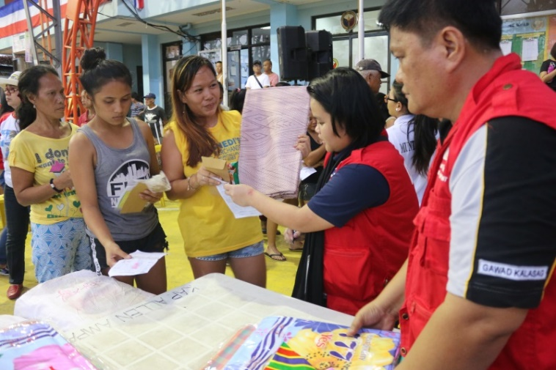
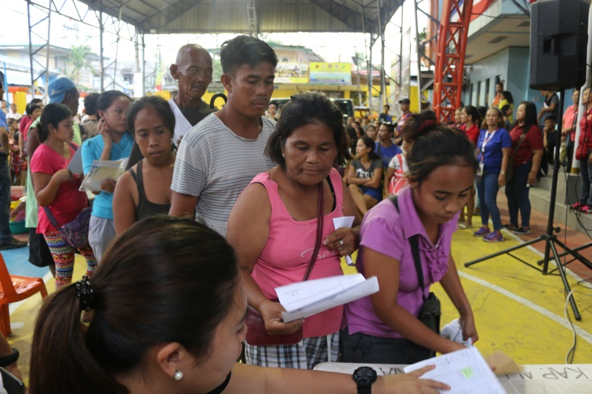
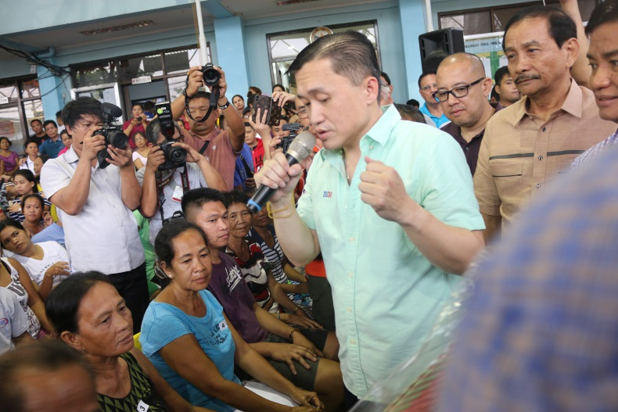
Actual Distribution of Relief Goods to the Affected families.

The Office of Special Assistance to the President led by Sec. Bong Go was also present to provide financial assistance to the affected families.
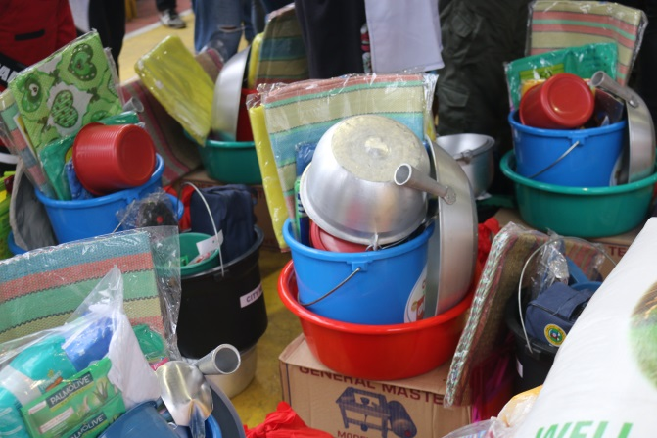
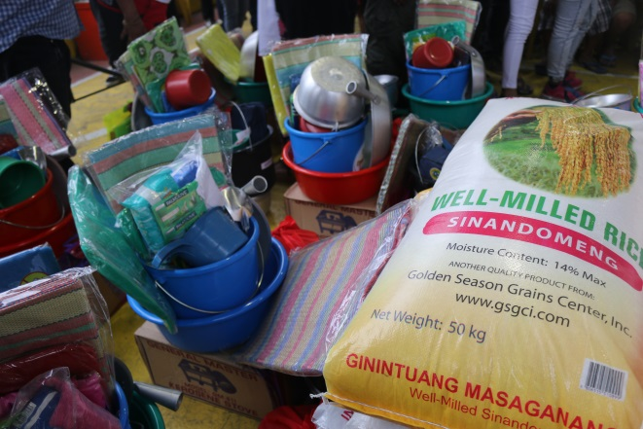

Relief Items from LGU Muntinlupa thru the City Social Welfare and Development Office.

