DSWD DROMIC Report #26 on the
Effects of Southwest Monsoon
As of 24 August 2018, 7PM

SITUATION OVERVIEW

At 3:00 PM today, TROPICAL DEPRESSION "LUIS" was estimated based on all available data at 505 km North Northwest of Basco, Batanes (24.7°N, 120.3°E) with maximum sustained winds of 45 km/h near the center and gustiness of up to 65 km/h. It is moving North at 10 km/h. Meanwhile, the Low Pressure Area was estimated at 1,055 km East of Basco, Batanes (22.0 °N, 132.0 °E). Southwest Monsoon affecting the western section of Northern and Central Luzon.

Source: DOST-PAGASA Daily Weather Forecast

SUMMARY
REGION / PROVINCE / CITY / MUNICIPALITY | NUMBER OF AFFECTED |  |  | NUMBER OF EVACUATION CENTERS (ECs) | NUMBER OF INSIDE ECs |  | NUMBER OF OUTSIDE ECs |  | TOTAL DISPLACED |  | NO. OF DAMAGED HOUSES
 | Barangays | Families | Persons |  | Families | Persons | Families | Persons | Total Families | Total Persons
 |  |  |  | NOW | NOW | NOW | NOW | NOW | NOW | NOW | Total | Totally | Partially
GRAND TOTAL | 1,272 | 422,398 | 1,708,746 | 107 | 3,451 | 13,068 | 7,961 | 38,995 | 11,412 | 52,063 | 2,104 | 361 | 1,743
NCR | 56 | 10,006 | 45,242 | 4 | 57 | 328 | - | - | 57 | 328 | - | - | -
REGION I | 555 | 100,668 | 415,938 | 4 | 432 | 1,629 | 67 | 207 | 499 | 1,836 | 916 | 53 | 863
REGION III | 469 | 287,674 | 1,136,472 | 97 | 2,937 | 10,994 | 7,879 | 38,729 | 10,816 | 49,723 | 26 | 8 | 18
CALABARZON | 96 | 20,506 | 95,832 | 1 | 24 | 115 | - | - | 24 | 115 | 1,016 | 287 | 729
CAR | 96 | 3,544 | 15,262 | 1 | 1 | 2 | 15 | 59 | 16 | 61 | 146 | 13 | 133
Note: Ongoing assessment and validation.
Sources: DSWD-FOs I, III, CAR, NCR, and CALABARZON

BREAKDOWN PER REGIONS

- NCR
REGION / PROVINCE / CITY / MUNICIPALITY | NUMBER OF AFFECTED |  |  | NUMBER OF EVACUATION CENTERS (ECs) | NUMBER OF INSIDE ECs |  | NUMBER OF OUTSIDE ECs |  | TOTAL DISPLACED |  | NO. OF DAMAGED HOUSES
 | Barangays | Families | Persons |  | Families | Persons | Families | Persons | Total Families | Total Persons
 |  |  |  | NOW | NOW | NOW | NOW | NOW | NOW | NOW | Total | Totally | Partially
NCR | 56 | 10,006 | 45,242 | 4 | 57 | 328 | - | - | 57 | 328 | - | - | -
Malabon City | 4 | 217 | 943 | 1 | 25 | 75 | - | - | 25 | 75 | - | - | -
Mandaluyong City | 1 | 200 | 1,000 | - | - | - | - | - | - | - | - | - | -
Manila City | 1 | 220 | 561 | - | - | - | - | - | - | - | - | - | -
Marikina City | 13 | 5,451 | 24,751 | 2 | 10 | 54 | - | - | 10 | 54 | - | - | -
Navotas | 1 | 22 | 199 | 1 | 22 | 199 | - | - | 22 | 199 | - | - | -
Pasig City | 8 | 1,157 | 5,323 | - | - | - | - | - | - | - | - | - | -
Quezon City | 17 | 2,217 | 10,739 | - | - | - | - | - | - | - | - | - | -
San Juan City | 1 | 214 | 714 | - | - | - | - | - | - | - | - | - | -
Valenzuela City | 10 | 308 | 1,012 | - | - | - | - | - | - | - | - | - | -
Note: Ongoing assessment and validation.

- REGION I
REGION / PROVINCE / CITY / MUNICIPALITY |  | NUMBER OF AFFECTED |  |  | NUMBER OF EVACUATION CENTERS (ECs) | NUMBER OF INSIDE ECs |  | NUMBER OF OUTSIDE ECs |  | TOTAL DISPLACED |  | NO. OF DAMAGED HOUSES
 |  | Barangays | Families | Persons |  | Families | Persons | Families | Persons | Total Families | Total Persons
 |  |  |  |  | NOW | NOW | NOW | NOW | NOW | NOW | NOW | Total | Totally | Partially
REGION I |  | 555 | 100,668 | 415,938 | 4 | 432 | 1,629 | 67 | 207 | 499 | 1,836 | 916 | 53 | 863
Ilocos Norte |  | 82 | 357 | 1,715 | - | - | - | 2 | 8 | 2 | 8 | 357 | - | 357
 | Adams | 1 | 4 | 20 | - | - | - | - | - | - | - | 4 | - | 4
 | Badoc | 4 | 9 | 43 | - | - | - | 2 | 8 | 2 | 8 | 9 | - | 9
 | Banna (Espiritu) | 12 | 65 | 305 | - | - | - | - | - | - | - | 65 | - | 65
 | Burgos | 4 | 28 | 140 | - | - | - | - | - | - | - | 28 | - | 28
 | Dingras | 7 | 12 | 60 | - | - | - | - | - | - | - | 12 | - | 12
 | LAOAG CITY (Capital) | 2 | 2 | 10 | - | - | - | - | - | - | - | 2 | - | 2
 | Pagudpud | 6 | 13 | 65 | - | - | - | - | - | - | - | 13 | - | 13
 | Paoay | 16 | 67 | 335 | - | - | - | - | - | - | - | 67 | - | 67
 | Pasuquin | 22 | 147 | 672 | - | - | - | - | - | - | - | 147 | - | 147
 | Sarrat | 4 | 5 | 25 | - | - | - | - | - | - | - | 5 | - | 5
 | Vintar | 4 | 5 | 40 | - | - | - | - | - | - | - | 5 | - | 5
Ilocos Sur |  | 104 | 10,935 | 52,570 | - | - | - | 64 | 197 | 64 | 197 | 47 | 46 | 1
 | Alilem | 1 | 1 | 5 | - | - | - | - | - | - | - | - | - | -
 | Banayoyo | 4 | 31 | 125 | - | - | - | - | - | - | - | 2 | 1 | 1
 | Bantay | 9 | 807 | 4,037 | - | - | - | 4 | 20 | 4 | 20 | - | - | -
 | Burgos | 1 | 72 | 360 | - | - | - | - | - | - | - | - | - | -
 | Cabugao | 9 | 2,636 | 13,354 | - | - | - | - | - | - | - | - | - | -
 | CITY OF CANDON | 1 | 58 | 166 | - | - | - | 58 | 166 | 58 | 166 | 44 | 44 | -
 | Caoayan | 4 | 1,705 | 8,525 | - | - | - | - | - | - | - | - | - | -
 | Galimuyod | 1 | 54 | 270 | - | - | - | - | - | - | - | - | - | -
 | Lidlidda | 2 | 4 | 22 | - | - | - | 2 | 11 | 2 | 11 | - | - | -
 | Magsingal | 7 | 1,355 | 6,008 | - | - | - | - | - | - | - | 1 | 1 | -
 | Nagbukel | 2 | 8 | 40 | - | - | - | - | - | - | - | - | - | -
 | Narvacan | 5 | 125 | 567 | - | - | - | - | - | - | - | - | - | -
 | San Esteban | 9 | 605 | 3,025 | - | - | - | - | - | - | - | - | - | -
 | San Ildefonso | 5 | 109 | 545 | - | - | - | - | - | - | - | - | - | -
 | San Juan (Lapog) | 10 | 197 | 928 | - | - | - | - | - | - | - | - | - | -
 | Santa Catalina | 4 | 170 | 510 | - | - | - | - | - | - | - | - | - | -
 | Santa Lucia | 11 | 963 | 3,972 | - | - | - | - | - | - | - | - | - | -
 | Santiago | 2 | 92 | 345 | - | - | - | - | - | - | - | - | - | -
 | Sinait | 4 | 388 | 1,939 | - | - | - | - | - | - | - | - | - | -
 | Suyo | 1 | 27 | 135 | - | - | - | - | - | - | - | - | - | -
 | Tagudin | 11 | 1,518 | 7,642 | - | - | - | - | - | - | - | - | - | -
 | CITY OF VIGAN (Capital) | 1 | 10 | 50 | - | - | - | - | - | - | - | - | - | -
La Union |  | 93 | 10,150 | 39,681 | - | - | - | 1 | 2 | 1 | 2 | 508 | 6 | 502
 | Bacnotan | 10 | 574 | 1,872 | - | - | - | - | - | - | - | 6 | - | 6
 | Bagulin | 3 | 7 | 33 | - | - | - | - | - | - | - | 7 | 1 | 6
 | Bangar | 5 | 744 | 3,720 | - | - | - | - | - | - | - | - | - | -
 | Bauang | 4 | 13 | 52 | - | - | - | - | - | - | - | 2 | - | 2
 | Burgos | 2 | 12 | 48 | - | - | - | - | - | - | - | 4 | - | 4
 | Caba | 17 | 2,357 | 8,308 | - | - | - | - | - | - | - | 483 | - | 483
 | Luna | 30 | 3,223 | 13,005 | - | - | - | - | - | - | - | - | - | -
 | Naguilian | 1 | 1 | 2 | - | - | - | 1 | 2 | 1 | 2 | 1 | 1 | -
 | Pugo | 1 | 4 | 15 | - | - | - | - | - | - | - | 4 | 3 | 1
 | San Gabriel | 7 | 1,500 | 5,765 | - | - | - | - | - | - | - | - | - | -
 | San Juan | 12 | 1,714 | 6,856 | - | - | - | - | - | - | - | - | - | -
 | Santol | 1 | 1 | 5 | - | - | - | - | - | - | - | 1 | 1 | -
Pangasinan |  | 276 | 79,226 | 321,972 | 4 | 432 | 1,629 | - | - | 432 | 1,629 | 4 | 1 | 3
 | Aguilar | 7 | 2,677 | 13,071 | - | - | - | - | - | - | - | - | - | -
 | Alcala | 15 | 1,403 | 5,612 | - | - | - | - | - | - | - | - | - | -
 | Balungao | 10 | 1,046 | 6,276 | - | - | - | - | - | - | - | - | - | -
 | Bautista | 3 | 1,610 | 6,471 | - | - | - | - | - | - | - | - | - | -
 | Bayambang | 12 | 1,362 | 5,844 | 4 | 432 | 1,629 | - | - | 432 | 1,629 | - | - | -
 | Binmaley | 1 | 300 | 1,500 | - | - | - | - | - | - | - | - | - | -
 | Bugallon | 7 | 1,545 | 7,360 | - | - | - | - | - | - | - | - | - | -
 | Calasiao | 25 | 12,059 | 34,322 | - | - | - | - | - | - | - | 3 | - | 3
 | Dagupan City | 31 | 31,627 | 120,370 | - | - | - | - | - | - | - | - | - | -
 | Infanta | 13 | 1,939 | 5,686 | - | - | - | - | - | - | - | - | - | -
 | LINGAYEN (Capital) | 13 | 462 | 1,771 | - | - | - | - | - | - | - | - | - | -
 | Malasiqui | 2 | 350 | 1,750 | - | - | - | - | - | - | - | - | - | -
 | Mangaldan | 18 | 1,100 | 5,500 | - | - | - | - | - | - | - | - | - | -
 | Mangatarem | 25 | 6,589 | 32,915 | - | - | - | - | - | - | - | - | - | -
 | San Carlos City | 20 | 3,127 | 13,590 | - | - | - | - | - | - | - | - | - | -
 | San Nicolas | 1 | 18 | 74 | - | - | - | - | - | - | - | - | - | -
 | Santa Barbara | 29 | 8,801 | 44,005 | - | - | - | - | - | - | - | - | - | -
 | Santo Tomas | 1 | 1 | 7 | - | - | - | - | - | - | - | - | - | -
 | Tayug | 21 | 1,697 | 8,408 | - | - | - | - | - | - | - | 1 | 1 | -
 | Urbiztondo | 21 | 1,388 | 6,940 | - | - | - | - | - | - | - | - | - | -
 | CITY OF URDANETA | 1 | 125 | 500 | - | - | - | - | - | - | - | - | - | -
Note: Ongoing assessment and validation.

- REGION III
REGION / PROVINCE / CITY / MUNICIPALITY |  | NUMBER OF AFFECTED |  |  | NUMBER OF EVACUATION CENTERS (ECs) | NUMBER OF INSIDE ECs |  | NUMBER OF OUTSIDE ECs |  | TOTAL DISPLACED |  | NO. OF DAMAGED HOUSES
 |  | Barangays | Families | Persons |  | Families | Persons | Families | Persons | Total Families | Total Persons
 |  |  |  |  | NOW | NOW | NOW | NOW | NOW | NOW | NOW | Total | Totally | Partially
REGION III |  | 469 | 287,674 | 1,136,472 | 97 | 2,937 | 10,994 | 7,879 | 38,729 | 10,816 | 49,723 | 26 | 8 | 18
Bataan |  | 14 | 5,143 | 21,560 | - | - | - | - | - | - | - | - | - | -
 | Dinalupihan | 5 | 95 | 375 | - | - | - | - | - | - | - | - | - | -
 | Hermosa | 9 | 5,048 | 21,185 | - | - | - | - | - | - | - | - | - | -
Bulacan |  | 205 | 151,321 | 627,103 | 17 | 1,214 | 4,475 | 4,098 | 24,116 | 5,312 | 28,591 | - | - | -
 | Balagtas (Bigaa) | 5 | 8,130 | 40,650 | - | - | - | - | - | - | - | - | - | -
 | Baliuag | 7 | 1,032 | 4,437 | - | - | - | - | - | - | - | - | - | -
 | Bocaue | 13 | 7,989 | 13,795 | - | - | - | - | - | - | - | - | - | -
 | Bulacan | 4 | 811 | 3,029 | - | - | - | 125 | 575 | 125 | 575 | - | - | -
 | Bustos | 1 | 4 | 20 | - | - | - | - | - | - | - | - | - | -
 | Calumpit | 29 | 27,599 | 115,797 | 13 | 1,178 | 4,336 | - | - | 1,178 | 4,336 | - | - | -
 | Guiguinto | 14 | 5,385 | 26,925 | - | - | - | - | - | - | - | - | - | -
 | Hagonoy | 26 | 41,282 | 198,153 | 4 | 36 | 139 | - | - | 36 | 139 | - | - | -
 | City of Malolos (capital) | 51 | 27,769 | 70,303 | - | - | - | - | - | - | - | - | - | -
 | Marilao | 16 | 9,795 | 46,036 | - | - | - | - | - | - | - | - | - | -
 | City of Meycauayan | 6 | 4,135 | 24,306 | - | - | - | 3,944 | 23,400 | 3,944 | 23,400 | - | - | -
 | Paombong | 14 | 14,121 | 71,105 | - | - | - | - | - | - | - | - | - | -
 | Plaridel | 2 | 76 | 366 | - | - | - | 29 | 141 | 29 | 141 | - | - | -
 | Pulilan | 15 | 2,954 | 11,464 | - | - | - | - | - | - | - | - | - | -
 | Santa Maria | 2 | 239 | 717 | - | - | - | - | - | - | - | - | - | -
Pampanga |  | 171 | 116,150 | 430,433 | 72 | 1,096 | 4,422 | 3,781 | 14,613 | 4,877 | 19,035 | 3 | - | 3
 | Apalit | 9 | 7,062 | 20,709 | 5 | 232 | 989 | - | - | 232 | 989 | - | - | -
 | Arayat | 5 | 1,404 | 6,652 | - | - | - | 8 | 36 | 8 | 36 | - | - | -
 | Bacolor | 4 | 753 | 3,225 | - | - | - | - | - | - | - | - | - | -
 | Candaba | 3 | 2,023 | 10,144 | 1 | 7 | 35 | - | - | 7 | 35 | - | - | -
 | Guagua | 19 | 13,157 | 62,659 | - | - | - | 15 | 71 | 15 | 71 | - | - | -
 | Lubao | 31 | 14,464 | 49,709 | - | - | - | 1,804 | 6,734 | 1,804 | 6,734 | - | - | -
 | Mabalacat | 1 | 50 | 211 | - | - | - | - | - | - | - | - | - | -
 | Macabebe | 25 | 30,749 | 79,381 | 19 | 106 | 462 | - | - | 106 | 462 | - | - | -
 | Masantol | 26 | 10,770 | 54,290 | 23 | 246 | 852 | - | - | 246 | 852 | 3 | - | 3
 | Mexico | 6 | 1,206 | 6,059 | - | - | - | - | - | - | - | - | - | -
 | Minalin | 15 | 7,433 | 36,258 | 10 | 61 | 263 | - | - | 61 | 263 | - | - | -
 | City of San Fernando (capital) | 2 | 63 | 272 | 3 | 63 | 272 | - | - | 63 | 272 | - | - | -
 | San Simon | 13 | 9,641 | 38,021 | 1 | 19 | 54 | - | - | 19 | 54 | - | - | -
 | Santa Rita | 1 | 10 | 42 | - | - | - | - | - | - | - | - | - | -
 | Santo Tomas | 7 | 9,066 | 36,204 | 9 | 325 | 1,385 | 1,954 | 7,772 | 2,279 | 9,157 | - | - | -
 | Sasmuan (Sexmoan) | 4 | 8,299 | 26,597 | 1 | 37 | 110 | - | - | 37 | 110 | - | - | -
Tarlac |  | 74 | 14,356 | 55,123 | 8 | 627 | 2,097 | - | - | 627 | 2,097 | - | - | -
 | Bamban | 1 | 17 | 70 | - | - | - | - | - | - | - | - | - | -
 | Camiling | 29 | 4,106 | 17,834 | - | - | - | - | - | - | - | - | - | -
 | Capas | 5 | 4,056 | 16,983 | - | - | - | - | - | - | - | - | - | -
 | La Paz | 10 | 2,216 | 7,615 | - | - | - | - | - | - | - | - | - | -
 | Moncada | 19 | 3,373 | 10,520 | 4 | 166 | 478 | - | - | 166 | 478 | - | - | -
 | Paniqui | 7 | 529 | 1,850 | 4 | 461 | 1,619 | - | - | 461 | 1,619 | - | - | -
 | Ramos | 3 | 59 | 251 | - | - | - | - | - | - | - | - | - | -
Zambales |  | 5 | 704 | 2,253 | - | - | - | - | - | - | - | 23 | 8 | 15
 | Botolan | 1 | 511 | 1,523 | - | - | - | - | - | - | - | 16 | 7 | 9
 | Palauig | 2 | 11 | 56 | - | - | - | - | - | - | - | 4 | - | 4
 | Santa Cruz | 2 | 182 | 674 | - | - | - | - | - | - | - | 3 | 1 | 2
Note: Ongoing assessment and validation.

- REGION CALABARZON
REGION / PROVINCE / CITY / MUNICIPALITY |  | NUMBER OF AFFECTED |  |  | NUMBER OF EVACUATION CENTERS (ECs) | NUMBER OF INSIDE ECs |  | NUMBER OF OUTSIDE ECs |  | TOTAL DISPLACED |  | NO. OF DAMAGED HOUSES
 |  | Barangays | Families | Persons |  | Families | Persons | Families | Persons | Total Families | Total Persons
 |  |  |  |  | NOW | NOW | NOW | NOW | NOW | NOW | NOW | Total | Totally | Partially
CALABARZON |  | 96 | 20,506 | 95,832 | 1 | 24 | 115 | - | - | 24 | 115 | 1,016 | 287 | 729
Batangas |  | 11 | 318 | 1,480 | - | - | - | - | - | - | - | 318 | 114 | 204
 | Calaca | 2 | 16 | 74 | - | - | - | - | - | - | - | 16 | 4 | 12
 | Lemery | 7 | 232 | 1,064 | - | - | - | - | - | - | - | 232 | 100 | 132
 | San Luis | 1 | 45 | 218 | - | - | - | - | - | - | - | 45 | 6 | 39
 | Taal | 1 | 25 | 124 | - | - | - | - | - | - | - | 25 | 4 | 21
Cavite |  | 49 | 6,074 | 27,037 | - | - | - | - | - | - | - | 307 | 41 | 266
 | Cavite City | 34 | 5,495 | 24,727 | - | - | - | - | - | - | - | 24 | 2 | 22
 | Noveleta | 3 | 89 | 412 | - | - | - | - | - | - | - | - | - | -
 | Rosario | 10 | 282 | 1,232 | - | - | - | - | - | - | - | 283 | 39 | 244
 | Tanza | 2 | 208 | 666 | - | - | - | - | - | - | - | - | - | -
Laguna |  | 3 | 16 | 71 | - | - | - | - | - | - | - | 1 | - | 1
 | Biñan | 1 | 7 | 36 | - | - | - | - | - | - | - | - | - | -
 | Los Baños | 1 | 5 | 17 | - | - | - | - | - | - | - | 1 | - | 1
 | Paete | 1 | 4 | 18 | - | - | - | - | - | - | - | - | - | -
Rizal |  | 33 | 14,098 | 67,244 | 1 | 24 | 115 | - | - | 24 | 115 | 390 | 132 | 258
 | City of Antipolo | 1 | 4 | 20 | - | - | - | - | - | - | - | - | - | -
 | Binangonan | 1 | 17 | 91 | - | - | - | - | - | - | - | - | - | -
 | Cainta | 3 | 1,194 | 3,805 | - | - | - | - | - | - | - | - | - | -
 | Rodriguez (Montalban) | 7 | 5,881 | 29,246 | - | - | - | - | - | - | - | 21 | 21 | -
 | San Mateo | 13 | 6,419 | 31,042 | 1 | 24 | 115 | - | - | 24 | 115 | 278 | 54 | 224
 | Tanay | 5 | 417 | 2,320 | - | - | - | - | - | - | - | 91 | 57 | 34
 | Taytay | 3 | 166 | 720 | - | - | - | - | - | - | - | - | - | -

- REGION CAR
REGION / PROVINCE / CITY / MUNICIPALITY |  | NUMBER OF AFFECTED |  |  | NUMBER OF EVACUATION CENTERS (ECs) | NUMBER OF INSIDE ECs |  | NUMBER OF OUTSIDE ECs |  | TOTAL DISPLACED |  | NO. OF DAMAGED HOUSES
 |  | Barangays | Families | Persons |  | Families | Persons | Families | Persons | Total Families | Total Persons
 |  |  |  |  | NOW | NOW | NOW | NOW | NOW | NOW | NOW | Total | Totally | Partially
CAR |  | 96 | 3,544 | 15,262 | 1 | 1 | 2 | 15 | 59 | 16 | 61 | 146 | 13 | 133
Abra |  | 47 | 3,293 | 14,209 | - | - | - | 6 | 20 | 6 | 20 | 39 | 7 | 32
 | Bangued (capital) | 25 | 1,332 | 5,362 | - | - | - | - | - | - | - | 37 | 7 | 30
 | Bucay | 1 | - | 15 | - | - | - | - | - | - | - | - | - | -
 | Dolores | 1 | 3 | 15 | - | - | - | - | - | - | - | - | - | -
 | Lagangilang | 7 | 1,116 | 5,194 | - | - | - | - | - | - | - | - | - | -
 | Lagayan | 1 | 225 | 950 | - | - | - | - | - | - | - | - | - | -
 | Luba | 1 | 2 | 11 | - | - | - | - | - | - | - | 2 | - | 2
 | Pidigan | 2 | 12 | 33 | - | - | - | 6 | 20 | 6 | 20 | - | - | -
 | Pilar | 1 | 1 | 7 | - | - | - | - | - | - | - | - | - | -
 | San Isidro | 1 | 15 | 63 | - | - | - | - | - | - | - | - | - | -
 | San Quintin | 3 | 205 | 895 | - | - | - | - | - | - | - | - | - | -
 | Villaviciosa | 4 | 382 | 1,664 | - | - | - | - | - | - | - | - | - | -
Benguet |  | 32 | 185 | 753 | 1 | 1 | 2 | 4 | 13 | 5 | 15 | 35 | 4 | 31
 | Atok | 1 | 15 | 60 | - | - | - | - | - | - | - | 7 | 1 | 6
 | Baguio City | 16 | 51 | 241 | - | - | - | - | - | - | - | 13 | 1 | 12
 | Bakun | 3 | 8 | 34 | - | - | - | - | - | - | - | 1 | - | 1
 | Buguias | 3 | 12 | 37 | - | - | - | - | - | - | - | 3 | 1 | 2
 | Itogon | 1 | 59 | 219 | - | - | - | - | - | - | - | - | - | -
 | Kabayan | 2 | 5 | 15 | 1 | 1 | 2 | 4 | 13 | 5 | 15 | - | - | -
 | Kapangan | 3 | 7 | 40 | - | - | - | - | - | - | - | 7 | - | 7
 | Kibungan | 1 | 2 | 10 | - | - | - | - | - | - | - | 3 | 1 | 2
 | Mankayan | 1 | 6 | 15 | - | - | - | - | - | - | - | 1 | - | 1
 | Tuba | 1 | 20 | 82 | - | - | - | - | - | - | - | - | - | -
Mountain Province |  | 17 | 66 | 300 | - | - | - | 5 | 26 | 5 | 26 | 72 | 2 | 70
 | Paracelis | 2 | 34 | 170 | - | - | - | - | - | - | - | 34 | - | 34
 | Bauko | 9 | 22 | 93 | - | - | - | - | - | - | - | 23 | - | 23
 | Tadian | 6 | 10 | 37 | - | - | - | 5 | 26 | 5 | 26 | 15 | 2 | 13
Note: Ongoing assessment and validation.

Sources: DSWD-FOs I, III, CAR, NCR, and CALABARZON

COST OF ASSISTANCE
REGION / PROVINCE / CITY / MUNICIPALITY |  | TOTAL COST OF ASSISTANCE (PHP)
 |  | DSWD | LGU | NGOs | OTHERS | GRAND TOTAL
NCR |  | 19,893,038.54 | - | - | - | 19,893,038.54
Malabon City |  | 74,474.00 | - | - | - | 74,474.00
Mandaluyong City |  | 302,740.00 | - | - | - | 302,740.00
Manila City |  | 1,817,629.34 | - | - | - | 1,817,629.34
Marikina City |  | 15,356,000.00 | - | - | - | 15,356,000.00
Navotas |  | 30,274.00 | - | - | - | 30,274.00
Pasig City |  | 363,288.00 | - | - | - | 363,288.00
Quezon City |  | 1,645,893.20 | - | - | - | 1,645,893.20
San Juan City |  | 302,740.00 | - | - | - | 302,740.00
REGION I |  | 16,474,040.00 | 1,358,270.11 | - | 435,000.00 | 18,267,310.11
Ilocos Sur |  | 1,800,000.00 | 217,493.00 | - | - | 2,017,493.00
 | Cabugao | 842,760.00 | - | - | - | 842,760.00
 | Caoayan | 558,000.00 | - | - | - | 558,000.00
 | Magsingal | 259,920.00 | 71,000.00 | - | - | 330,920.00
 | Sinait | 139,320.00 | - | - | - | 139,320.00
La Union |  | 1,664,640.00 | 801,630.00 | - | - | 2,466,270.00
 | Bacnotan | 54,000.00 | - | - | - | 54,000.00
 | Bagulin | 2,520.00 | - | - | - | 2,520.00
 | Bangar | 267,840.00 | - | - | - | 267,840.00
 | Burgos | 4,320.00 | - | - | - | 4,320.00
 | Caba | 108,000.00 | - | - | - | 108,000.00
 | Luna | 476,640.00 | 239,080.00 | - | - | 715,720.00
 | Naguilian | 2,160.00 | - | - | - | 2,160.00
 | San Gabriel | 236,160.00 | 364,640.00 | - | - | 600,800.00
 | San Juan | 513,000.00 | 188,340.00 | - | - | 701,340.00
Pangasinan |  | 13,009,400.00 | 288,577.11 | - | 435,000.00 | 13,732,977.11
 | Aguilar | 360,000.00 | 149,640.00 | - | - | 509,640.00
 | Balungao | 1,415,500.00 | - | - | - | 1,415,500.00
 | Bautista | 360,000.00 | - | - | - | 360,000.00
 | Bayambang | 324,000.00 | - | - | - | 324,000.00
 | Bugallon | 796,000.00 | - | - | - | 796,000.00
 | Calasiao | 2,231,060.00 | - | - | - | 2,231,060.00
 | Dagupan City | 720,000.00 | - | - | - | 720,000.00
 | LINGAYEN (Capital) | 1,163,500.00 | 7,003.68 | - | - | 1,170,503.68
 | Malasiqui | 126,000.00 | - | - | - | 126,000.00
 | Mangaldan | 2,327,000.00 | - | - | - | 2,327,000.00
 | Mangatarem | 582,840.00 | 90,420.43 | - | - | 673,260.43
 | San Carlos City | 360,000.00 | - | - | - | 360,000.00
 | Santa Barbara | 1,163,500.00 | 40,343.00 | - | 435,000.00 | 1,638,843.00
 | Tayug | 360,000.00 | - | - | - | 360,000.00
 | Urbiztondo | 720,000.00 | - | - | - | 720,000.00
REGION III |  | 9,906,760.00 | 17,191,676.00 | 2,893,250.00 | - | 29,991,686.00
Bulacan |  | 5,256,000.00 | 13,508,036.00 | - | - | 18,764,036.00
 | Bulacan | 360,000 | 90,000 | - | - | 450,000
 | Calumpit | 1,296,000 | 6,082,204 | - | - | 7,378,204
 | Hagonoy | 1,080,000 | 5,844,000 | - | - | 6,924,000
 | City of Malolos (capital) | 720,000 | 989,000 | - | - | 1,709,000
 | Paombong | 1,440,000 | - | - | - | 1,440,000
 | Pulilan | 360,000 | 207,500 | - | - | 567,500
Pampanga |  | 4,578,760.00 | 3,269,904.00 | 2,893,250.00 | - | 10,741,914.00
 | Apalit | 360,000 | 308,000 | 389,200 | - | 1,057,200
 | Guagua | 50,040 | 374,186 | 700,000 | - | 1,124,226
 | Lubao | 893,875 | 839,825 | 236,250 | - | 1,969,950
 | Macabebe | 2,194,485 | - | - | - | 2,194,485
 | Masantol | 90,360 | 500,000 | 328,500 | - | 918,860
 | Mexico | 90,000 | - | - | - | 90,000
 | Minalin | 360,000 | 11,750 | - | - | 371,750
 | Santo Tomas | 540,000 | 897,443 | 1,239,300 | - | 2,676,743
Zambales |  | 72,000.00 | - | - | - | 72,000.00
 | Olongapo City | 72,000 | - | - | - | 72,000
CALABARZON |  | 1,820,000.00 | 8,851,412.00 | 176,400.00 | 1,629,500.00 | 12,477,312.00
Rizal |  | 1,820,000.00 | 6,521,950.00 | 176,400.00 | 1,629,500.00 | 10,147,850.00
 | Rodriguez (Montalban) | 180,000.00 | 3,318,850.00 | - | 1,279,500.00 | 4,778,350.00
 | San Mateo | 1,640,000.00 | 3,185,100.00 | 176,400.00 | 350,000.00 | 5,351,500.00
CAR |  | 1,375,418.24 | 372,663.00 | - | - | 1,748,081.24
Abra |  | 1,148,752.35 | 348,178.00 | - | - | 1,496,930.35
 | Bangued (capital) | 207,689.10 | 14,000.00 | - | - | 221,689.10
 | Lagangilang | 337,614.75 | 115,500.00 | - | - | 453,114.75
 | Lagayan | 69,956.25 | 68,750.00 | - | - | 138,706.25
 | Pidigan | 9,594.00 | 4,800.00 | - | - | 14,394.00
 | San Isidro | 5,996.25 | - | - | - | 5,996.25
 | Villaviciosa | 517,902.00 | 126,060.00 | - | - | 643,962.00
Benguet |  | 182,000.59 | 24,485.00 | - | - | 206,485.59
 | Baguio City | 33,514.84 | 9,485.00 | - | - | 42,999.84
 | Buguias | 17,757.00 | - | - | - | 17,757.00
 | Itogon | 79,950.00 | - | - | - | 79,950.00
 | Kabayan | 7,398.75 | 15,000.00 | - | - | 22,398.75
 | Kapangan | 4,439.25 | - | - | - | 4,439.25
 | Kibungan | 1,479.75 | - | - | - | 1,479.75
 | Tuba | 37,461.00 | - | - | - | 37,461.00
Mountain Province |  | 44,665.30 | - | - | - | 44,665.30
 | Bauko | 29,964.50 | - | - | - | 29,964.50
 | Tadian | 14,700.80 | - | - | - | 14,700.80

Sources: DSWD-FOs I, III, CAR, NCR, and CALABARZON

Situational Reports

DSWD-DRMB
DATE | SITUATIONS / ACTIONS UNDERTAKEN
July 14, 2018 to present | - The Disaster Response Operations Monitoring and Information Center of DSWD-DRMB is on 24/7 duty and continuously monitoring and coordinating with the concerned DSWD-Field Offices for significant disaster response operations updates.

FO NCR
DATE | SITUATIONS / ACTIONS UNDERTAKEN
13 August 2018 to present | - DSWD FO-NCR is continuously coordinating with the 17 LGUs through its respective Local Social Welfare and Development Office (LSWDOs) regarding necessary augmentation assistance needed by the affected families.  - DSWD FO-NCR is also closely coordinating with MMDA Flood Control Center for updates.  - DSWD FO-NCR Disaster Response Management Division and the FO Quick Response Teams are on standby-alert for any eventualities that might happen due to the effects of Habagat.

FO I
DATE | SITUATIONS / ACTIONS UNDERTAKEN
19 August 2018 | - DSWD-FO I is continuously monitoring, coordinating and validation through the SWAD Team Leaders, P/C/MDRRMCs and P/C/MSWDO relative to the status of their respective area of responsibility along with the CCCM, IDP Protection and FNFI concerns.

FO III
DATE | SITUATIONS / ACTIONS UNDERTAKEN
13 August 2018 to present | - DSWD-FO III is continuously monitoring and coordinating with the DSWD Provincial Extension Office of the 7 provinces relative to the status of their respective areas.  - DSWD-FO III is continuously monitoring the existing evacuation centers in the provinces of Bulacan, Pampanga, Zambales, and Tarlac.  - DSWD-FO III facilitated 1,500 FFPs requested by Municipality of Bocaue, Bulacan.  - DSWD-FO III facilitated approval of recommended 5, 364 FFPs requested by Chairman Engr. Aldrin CardenasMRRD-NECC Camiling, Tarlac Chapter.  - DSWD-FO III facilitated approval of letter requesting two trucks from PNP RO3 to replenish stockpile from NROC.  - DSWD-FO III facilitated approval for the request of NCMF- North Luzon Regional Director, Dir Jo Anne Haber and Municipal Mayor of Calumpit Bulacan.

FO CAR
DATE | SITUATIONS / ACTIONS UNDERTAKEN
13 August 2018 to present | - Alert Blue is raised by the DSWD-CAR consistent with the Blue Alert status of the Cordillera RDRRM Council.  - DRMD QRT DROMIC Team on duty.  - QRT DROMIC Report duty of the different Provincial SWAD Teams are activated.  - Close coordination is being conducted with the Cordillera RDRRM Council in monitoring and verifying reports on affected and displaced persons and families and the assistance needed.

FO CALABARZON
DATE | SITUATIONS / ACTIONS UNDERTAKEN
17 August 2018 | - The weather has improved since August 13, 2018 and the flood has already receded. The displaced families / persons are gradually returning to their residence and most of the evacuation centers are already closing. As of this reporting, only 10 evacuation centers remain open.  - The previously reported damaged houses in Cavite City and Rosario, Cavite are being validated if the cause of damages was brought about by the Southwest Monsoon enhanced by TS Karding.  - The alert level of Disaster Response Operations Monitoring and Information Center (DROMIC) and the Regional QRTs is now in Blue Alert status. However, the DRMD Staff and QRT are advised to stay vigilant for possible deployment.  - QRT Members facilitated the distribution of FFPs and Sleeping Kits in San Mateo Rizal.  - The DRMD is conducting assessment and validation on the request for augmentation on FFPs; and continuously reviewing reports from the affected LGUs to identify areas for technical assistance.  - Regular coordination with LSWDOs in order to determine if there is a need for augmentation on Food and Non-Food Items.  - From August 15, 2018 to present, the DSWD FO IV-A is currently conducting distribution of Family Food Packs and Non Food Items at San Mateo Rizal. To date, 2,000 Family Food Packs (FFPs) and 2,000 sleeping kits were already distributed to the affected IDPs in San Mateo, Rizal and still ongoing as of this reporting time. These items were identified based on the RDANA conducted by the Field Office on August 13-14, 2018. The NFIs were hauled at GMA Warehouse last night and the Family Food Packs were hauled at the NRLMS this morning till 5:00 PM. Rizal PDRRMO lent 2 trucks thru the coordination with Office of Civil Defense IV-A.  - Some photo-documentations of ongoing response activities:  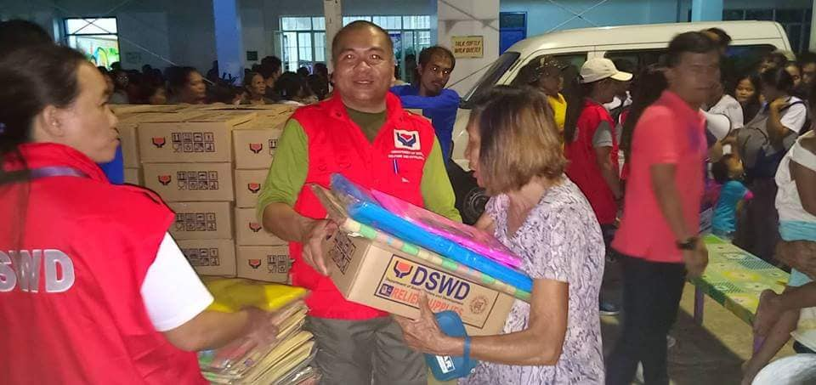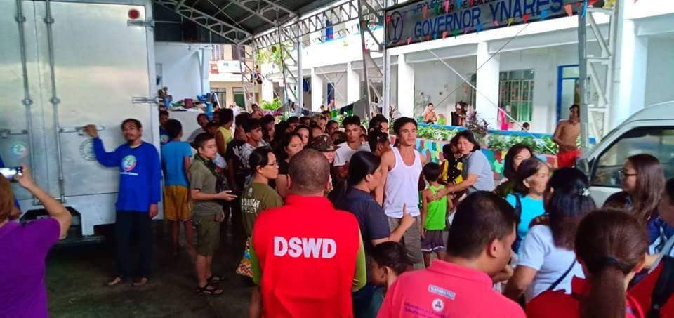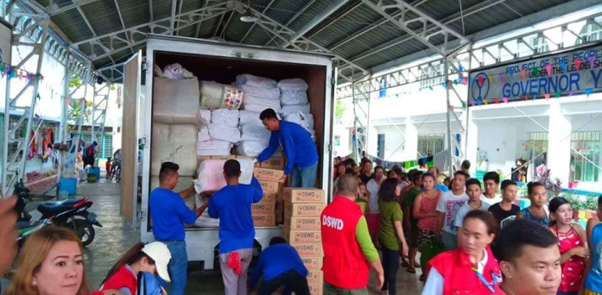  - On August 16, 2018 the Regional Quick Response Team facilitated the distribution of Family Food Packs and Sleeping Kits to the affected families in San Mateo, Rizal:  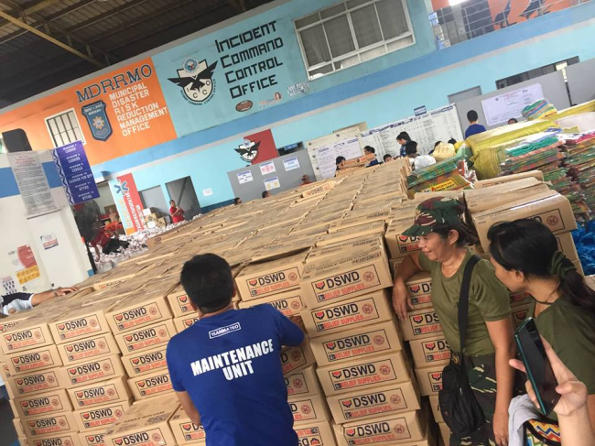
13 August 2018 to present | - Affected LGUs were conducting relief efforts and provision of hot meals for residents of areas affected by the Southwest Monsoon.  - The affected LGUs mobilized their staff in their operational areas to strengthen the government’s emergency response coordination.  - MSWDOs were conducting profiling of the families who sought temporary shelter in evacuation centers. The MSWDOs prioritized the provision of hot meals as immediate response.  - MSWDOs of the affected LGUs mobilized there trained personnel on camp coordination and camp management, psychosocial support program, and information management  - DSWD-FO CALABARZON maintained close coordination with the MSWDOs of the LGUs with reported evacuation centers.  - The Disaster Response Management Division (DRMD) of DSWD-FO CALABARZON closely monitored the relief operations conducted by the LGUs.  - DSWD-FO CALABARZON continued to send rainfall warnings and flood advisories through SMS and other media platforms to MSWDOs who are in flood and landslide-prone areas.  - DSWD-FO CALABARZON closely monitored the progress of the response activities of the affected LGUs.  - Based on the above information, the team would like to recommend that the monitoring and further evaluation of the existing evacuation centers be turned-over to the DRU. However, the succeeding teams shall be on-call should there be scheduled hauling and distribution to LGUs.

*****
The Disaster Response Operations Monitoring and Information Center (DROMIC) of the DSWD-DRMB continues to closely coordinate with concerned DSWD-Field Offices for significant disaster response updates.

MARC LEO L. BUTAC
Releasing Officer

