DSWD DROMIC Preparedness for Response Report #1
on Typhoon “PAENG” [I.N. TRAMI]
as of 23 September 2018, 10PM

Situation Overview
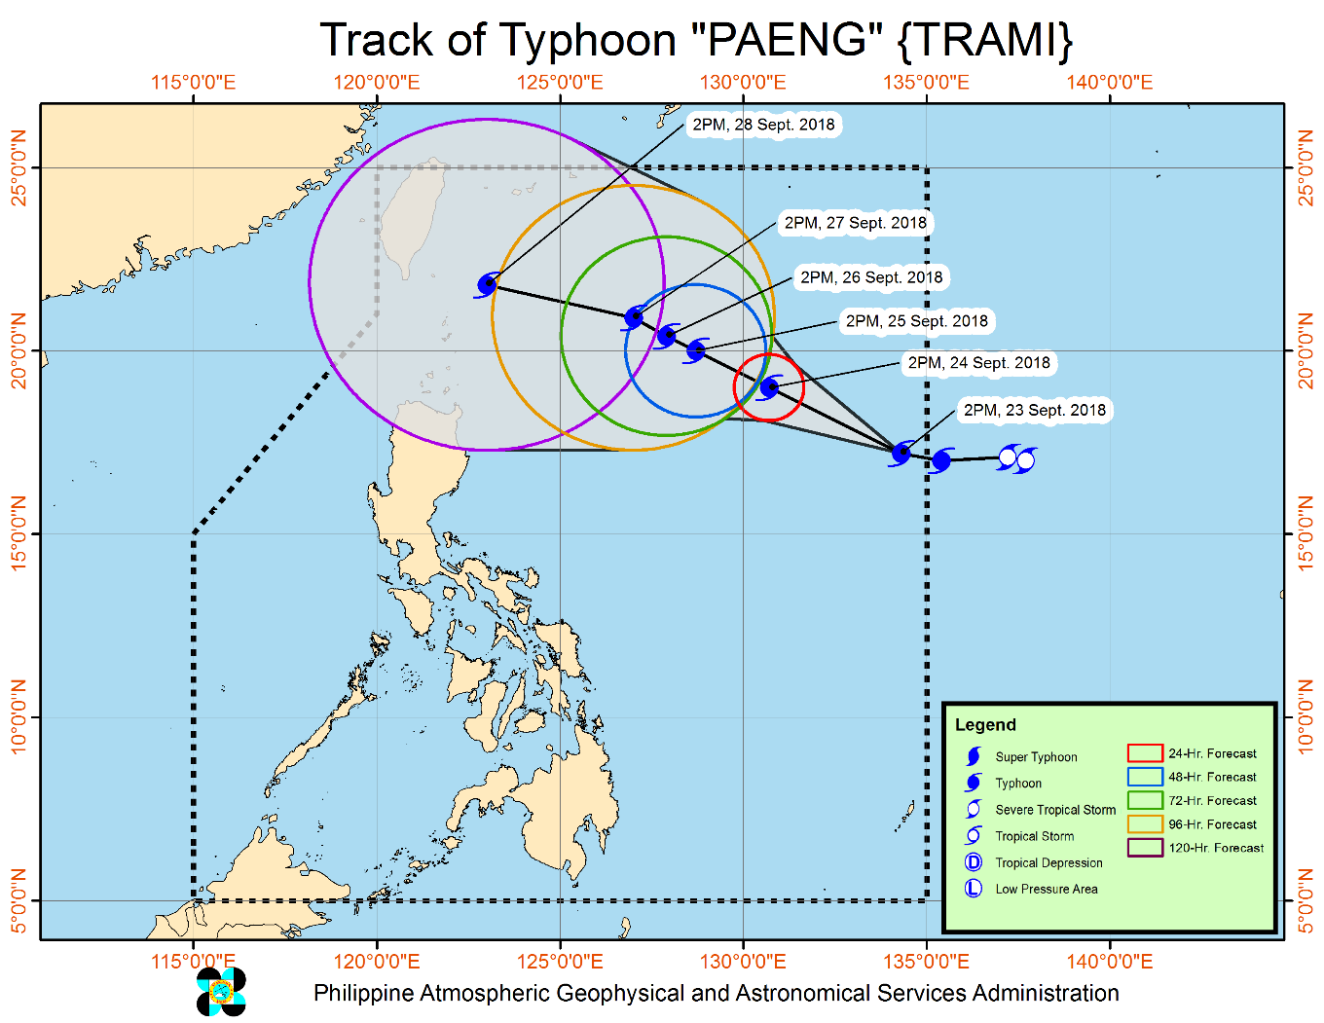
THE TYPHOON WITH INTERNATIONAL NAME "TRAMI" HAS ENTERED THE PHILIPPINE AREA OF RESPONSIBILITY (PAR) AND WAS NAMED "PAENG".

- Typhoon "PAENG" has no direct effect yet in any part of the country.
- Typhoon "PAENG" may affect the extreme Northern Luzon (Batanes - Babuyan Group of Islands) around Friday (Sept. 28).
- Possible hoisting Tropical Cyclone Warning Signals over extreme Northern Luzon by Thursday (27 Sept.) or Friday (28 Sept).
- Possible issuing Gale Warning over the seaboards of Northern Luzon as the Typhoon approaches.
- No significant enhancement of the Southwest Monsoon is expected during the outlook period.

Source: DOST-PAGASA Daily Weather Forecast

Status of Prepositioned Resources: Stockpile and Standby Funds

The DSWD Central Office (CO), Field Offices (FOs), and National Resource Operations Center (NROC) have stockpiles and standby funds amounting to ₱1,489,463,502.90 with breakdown as follows:

- Standby Funds
A total of ₱658,613,833.62 standby funds in the CO and FOs. Of the said amount,
₱589,309,966.00 is the available Quick Response Fund in the CO.

- Stockpiles
A total of 386,413 Family Food Packs (FFPs) amounting to ₱130,083,366.85 and available Food and Non-food Items (FNIs) amounting to ₱700,766,302.43.

FIELD OFFICE | STANDBY FUNDS | STOCKPILE |  |  |  |  | TOTAL STANDBY FUNDS AND STOCKPILE
 |  | Family Food Packs |  | Food | Non-Food | Sub-Total  (Food and NFIs)
 |  | Quantity | Total Cost
TOTAL | 658,613,833.62 | 386,413 | 130,083,366.85 | 116,672,969.88 | 584,093,332.55 | 700,766,302.43 | 1,489,463,502.90
Central Office* | 589,309,966.00 | - | - | - | - | - | 589,309,966.00
NROC | - | 39,682.00 | 14,289,120.00 | 34,827,921.00 | 250,345,852.00 | 285,173,773.00 | 299,462,893.00
NCR | 3,620,973.50 | 19,351.00 | 5,144,882.50 | 817,794.60 | 1,841,414.65 | 2,659,209.25 | 11,425,065.25
CAR | 6,853,185.95 | 13,468.00 | 4,882,665.00 | 1,737,985.36 | 15,483,106.84 | 17,221,092.20 | 28,956,943.15
I | 10,560,000.00 | 25,210.00 | 9,075,600.00 | 1,896,000.00 | 12,586,636.44 | 14,482,636.44 | 34,118,236.44
II | 14,500,000.00 | 33,900.00 | 12,204,000.00 | 54,126.45 | 161,844.20 | 215,970.65 | 26,919,970.65
III | 3,424,610.00 | 18,885.00 | 7,074,073.88 | 624,218.25 | 11,586,512.53 | 12,210,730.78 | 22,709,414.66
CALABARZON | 3,716,000.00 | 5,039.00 | 1,754,313.80 | 2,621,970.05 | 6,004,401.25 | 8,626,371.30 | 14,096,685.10
MIMAROPA | 4,000,000.00 | 21,785.00 | 8,114,195.00 | 7,011,657.61 | 1,344,028.86 | 8,355,686.47 | 20,469,881.47
V | 2,745,582.32 | 32,697.00 | 13,189,036.00 | 815,000.00 | 53,420,476.00 | 54,235,476.00 | 70,170,094.32
VI | 1,400,000.00 | 14,822.00 | 5,335,920.00 | 10,764,574.98 | 8,157,707.19 | 18,922,282.17 | 25,658,202.17
VII | 1,468,000.00 | 79,218.00 | 20,693,122.45 | 26,678,765.96 | 47,691,666.70 | 74,370,432.66 | 96,531,555.11
VIII | 2,697,960.00 | 18,488.00 | 6,655,680.00 | 12,012,119.62 | 46,597,416.15 | 58,609,535.77 | 67,963,175.77
IX | 2,176,505.85 | 13,220.00 | 4,759,200.00 | 3,955,890.00 | 6,964,083.29 | 10,919,973.29 | 17,855,679.14
X | 3,140,700.00 | 17,536.00 | 5,930,310.00 | 6,651,385.00 | 96,006,050.32 | 102,657,435.32 | 111,728,445.32
XI | 3,000,000.00 | 23,582.00 | 7,730,179.60 | - | 12,788,415.66 | 12,788,415.66 | 23,518,595.26
XII | 3,000,350.00 | 3,547.00 | 1,413,450.00 | 1,537,412.25 | 3,114,896.67 | 4,652,308.92 | 9,066,108.92
CARAGA | 3,000,000.00 | 5,983.00 | 1,837,618.62 | 4,666,148.75 | 9,998,823.80 | 14,664,972.55 | 19,502,591.17

DSWD-FOs have prepositioned FFPs in strategic locations. Breakdown per location is as follows:

REGION | LOCATION | NUMBER OF FFPS
GRAND TOTAL |  | 386,413
NROC |  | 39,682
 | Chapel Road, Pasay City | 39,682
NCR |  | 19,351
 | DSWD-FO NCR, 389 San Rafael St., Legarda, Sampaloc, Manila | 742
 | NCWP, Chapel Road, Pasay City | 2,400
 | NROC Chapel Road (Reserve Stock) | 16,209
CAR |  | 13,468
 | DSWD Regional Warehouse, SN Oriental Cmpd., Palmaville, Puguis, La Trinidad | 13,468
 | Prepositioned Relief Goods | 0
 | Province of Abra
 | Province of Apayao
 | Province of Benguet
 | Province of Ifugao
 | Province of Kalinga
 | Mt. Province
I |  | 25,210
 | Regional Warehouse, Brgy. Urayong, Bauang, La Union | 4,000
 | Prepositioned Relief Goods | 21,210
 | Alaminos Warehouse, Brgy. Tangcarang, Alaminos City, Pangasinan
 | Bolinao Warehouse, Brgy. Concordia, Bolinao, Pangasinan | 200
 | Manaog Warehouse, Tiong Street, Brgy. Poblacion, Manaoag, Pangasinan | 800
 | Santa Barbara Warehouse, Brgy. Maningding, Sta Barbara, Pangasinan | 17,000
 | Rosales Warehouse, Umingan-Rosales Rd., Rosales, Pangasinan
 | Vigan Warehouse, A Reyes St. Brgy. 8 Vigan City, Ilocos Sur | 1,000
 | San Nicholas, Cleveland Street, Barangay 2, San Nicolas, Ilocos Norte | 1,560
 | Burgos Warehouse, Municipal Bldg., Perucho St., Brgy. Poblacion, Burgos, Ilocos Norte | 650
II |  | 33,900
 | DSWD Regional Warehouse, Regional Government Center, Carig, Tuguegarao City | 12,000
 | Prepositioned Relief Goods | 21,900
 | PSWDO CAGAYAN
 | Aparri, Cagayan | 300
 | Alcala, Cagayan
 | Baggago, Cagayan | 600
 | Buguey, Cagayan | 300
 | Gattaran, Cagayan | 300
 | Camalaniugan, Cagayan
 | Gonzaga, Cagayan | 300
 | Lallo, Cagayan | 300
 | Sta Ana, Cagayan
 | Sta. Teresita, Cagayan | 600
 | Abulug, Cagayan | 300
 | Allacapan, Cagayan | 300
 | Ballesteros | 300
 | Calayan, Cagayan | 1,100
 | Claveria, Cagayan
 | Lasam, Cagayan | 300
 | Pamplona, Cagayan
 | Piat, Cagayan
 | Rizal, Cagayan | 300
 | Sto Niño, Cagayan | 300
 | Sanchez Mira | 300
 | Sta. Praxedes | 300
 | Amulung, Cagayan | 300
 | Enrile, Cagayan | 300
 | Iguig, Cagayan | 300
 | Peñablanca, Cagayan | 300
 | Solana, Cagayan | 300
 | Tuao, Cagayan
 | Tuguegarao City, Cagayan | 300
 | PSWDO ISABELA | 500
 | Cabagan, Isabela
 | Cordon,Isabela
 | Delfin Albano | 300
 | Divilacan,Isabela
 | Maconacon,Isabela | 300
 | Palanan,Isabela | 300
 | Santa Maria,Isabela | 300
 | San Pablo, Isabela | 300
 | Sto. Tomas, Isabela | 300
 | Tumauini, Isabela | 300
 | Aurora, Isabela | 300
 | Benito Soliven,Isabela | 300
 | Malig, Isabela | 300
 | Naguilian, Isabela | 300
 | Roxas,Isabela
 | San Mariano, Isabela | 300
 | Burgos, Isabela | 300
 | Gamu,Isabela | 300
 | Quezon, Isabela | 300
 | Quirino, Isabela | 300
 | Alicia, Isabela
 | Cabatuan, Isabela | 300
 | Luna, Isabela
 | Reina Mercedes, Isabela | 300
 | San Mateo,Isabela
 | Angadanan, Isabela | 300
 | Cauayan City,Isabela | 300
 | San Guillermo, Isabela | 300
 | Cordon,Isabela | 300
 | Dinapigue,Isabela | 600
 | Echague, Isabela | 300
 | Jones, Isabela
 | Ramon, Isabela | 300
 | San Isidro, Isabela | 300
 | Santiago City,Isabela | 300
 | San Agustin, Isabela
 | PSWDO QUIRINO
 | Aglipay, Quirino
 | Cabarroguis, Quirino | 400
 | Saguday, Quirino
 | Diffun, Quirino
 | Maddela,Quirino
 | Nagtipunan, Quirino
 | PSWDO NUEVA VIZCAYA | 500
 | Ambaguio, Nueva Vizcaya
 | Aritao, Nueva Vizcaya | 400
 | Bagabag, Nueva Vizcaya | 400
 | Bambang, Nueva Vizcaya | 400
 | Bayombong, Nueva Vizcaya | 400
 | Diadi, Nueva Vizcaya
 | Solano, Nueva Vizcaya | 400
 | Sta Fe, Nueva Vizcaya | 400
 | Villaverde, Nueva Vizcaya | 400
 | Kayapa, Nueva Vizcaya
 | Alfonso Castaneda, Nueva Vizcaya
 | Dupax del Norte, Nueva Vizcaya | 300
 | Dupax del Sur, Nueva Vizcaya | 300
 | Kasibu, Nueva Vizcaya | 300
 | Quezon, Nueva Vizcaya | 400
III |  | 18,885
 | DSWD Regional Warehouse, JASA, Dolores, City of San Fernando, Pampanga | 12,561
 | Prepositioned Relief Goods | 6,324
 | Dingalan, Aurora | 384
 | DPEO, Aurora Sitio Hiwalayan, brgy. Bacong, San Luis, Aurora | 500
 | PLGU Aurora (Old hospital, Brgy 5)
 | LGU Dinalungan, Aurora | 466
 | LGU Dipaculao, Aurora
 | LGU San Luis, Aurora | 88
 | Evacuation Center, brgy. Suklayin, Baler, Aurora | 988
 | Municipality of Dilasag
 | Municipality of Casiguran | 1,000
 | DPEO, Bataan
 | Pulilan, Bulacan
 | PSWDO Bulacan
 | San Jose, Plaridel, Bulacan
 | Concepcion, Tarlac | 1,000
 | PSWDO Iba, Zambales | 1,213
 | DPEO Nueva Ecija
 | DPEO Bataan | 500
 | DPEO, Olongapo City | 185
CALABARZON |  | 5,039
 | DSWD Regional Warehouse, Brgy. Gregoria de Jesus,San Jose, G.M.A, Cavite | 5,039
 | PSWDO Lucena City, Quezon
 | Munipal Office, Quezon, Quezon
 | MSWDO Burdeous, Quezon
 | MSWDO Alabat, Quezon
 | MSWDO Jomalig, Quezon
 | PDRRMO, Brgy. G. De Leon, Sta. Cruz, Laguna
MIMAROPA |  | 21,785
 | DSWD Regional Warehouse, 1680 F. Benitez cor. Malvar Sts., Malate, Metro Manila | 183
 | Prepositioned Relief Goods | 21,602
 | M. Roxas Drive, Salong, Calapan City (SWADT Oriental Mindoro) | 4,838
 | JRB Building, San Jose, Occidental Mindoro (SWADT Occ. Mindoro) | 5,151
 | Brgy. Bangbangalon, Boac, Marinduque (SWADT Marinduque) | 4,159
 | 052 Gen. Luna St., Liwayway, Odiongan, Romblon (SWADT Romblon) | 2,882
 | Cor. Malvar and Sandoval Sts., Puerto Princesa City (SWADT Palawan) | 4,572
V |  | 32,697
 | DSWD Regional Warehouse, Brgy Bogtong, Legazpi City | 5,360
 | Prepositioned Relief Goods | 27,337
 | Guinobatan, Albay | 1,537
 | Pioduran, Albay | 1,000
 | Sto. Domingo, Albay | 827
 | Tabaco, Albay | 2,173
 | LGU Baao, Camarines Sur | 1,000
 | Lagonoy, Camarines Sur | 1,000
 | Canaman, Camarines Sur | 500
 | San Jose, Camarines Sur | 1,000
 | Tinambac, Camarines Sur | 1,000
 | Camaligan, Camarines Sur | 500
 | Del Gallego, Camarines Sur | 1,000
 | Balatan, Camarines Sur | 1,000
 | Siruma, Camarines Sur | 1,500
 | Sagnay, Camarines Sur | 1,000
 | PLGU Camarines Norte | 2,000
 | San Vicente, Camarines Norte | 1,000
 | Pilar Sorsogon | 1,000
 | Matnog, Sorsogon | 1,000
 | Castilla, Sorsogon | 500
 | Donsol, Sorsogon | 1,000
 | PLGU Catanduanes | 2,800
 | Virac, Catanduanes | 1,000
 | San Miguel, Catanduanes | 1,000
 | Gigmoto, Catanduanes | 1,000
VI |  | 14,822
 | Juantong Warehouse, Bodega 8, Juantong Bldg., Rizal St., Iloilo City | 13,614
 | Prepositioned Relief Goods | 1,208
 | LGU Malay, Aklan | 208
 | SWAD Antique | 500
 | SWAD Capiz | 500
 | SWAD Negros Occidental
VII |  | 79,218
 | VDRC, P.C Suico St. Tingub, Mandaue City | 51,098
 | Labangon, Cebu CIty | 7,870
 | Bodega Polinitas, C.P.G. East Ave., Tagbilaran City, Bohol | 1,080
 | DC Warehouse, Tabuk Tubig, Dumaguete City, Negros Oriental | 9,150
 | SWAD Office, Siquijor | 89
 | Prepositioned Relief Goods | 9,931
 | Batuan, Bohol | 500
 | Buenavista, Bohol | 1,452
 | Carlos P. Garcia, Bohol
 | Candijay, Bohol | 988
 | Duero, Bohol | 1,000
 | Getafe, Bohol
 | Loboc, Bohol | 1,500
 | SierraBullones, Bohol | 1,500
 | Sevilla, Bohol | 1,500
 | Trinidad, Bohol | 1,200
 | Ubay, Bohol | 91
 | Dumanjug, Cebu
 | Madridejos, Cebu
 | Pilar, Cebu
 | Poro, Cebu
 | Ronda, Cebu
 | San Fracisco, Cebu
 | Tabongon, Cebu
 | Toledo, Cebu | 200
 | Bayawan, Negros Oriental
 | Canlaon, Negros Oriental
 | Guihulngan, Negros Oriental
 | Mabinay, Negros Oriental
 | Tanjay City, Negros, Oriental
VIII |  | 18,488
 | DSWD Regional Warehouse, Brgy. 91, Abucay, Tacloban City | 9,788
 | Prepositioned Relief Goods | 8,700
 | Dulag, Leyte | 500
 | Hilongos, Leyte | 500
 | San Isidro, Leyte | 500
 | Jipapad, Eastern Samar | 1,000
 | Almagro, Western Samar | 500
 | Calbiga, Western Samar | 800
 | Daram, Western Samar | 500
 | Hinabangan, Western Samar | 800
 | Matuguinao, Western Samar | 800
 | Motiong, Western Samar | 500
 | Sta. Margarita, Western Samar | 500
 | San Sebastian, Western Samar | 800
 | San Jose de Buan, Western Samar | 500
 | Catbalogan, Samar
 | Culaba, Biliran | 500
IX |  | 13,220
 | DSWD Regional Warehouse, Rojo Warehouse. No. 59, Santa Catalina, Zamboanga City | 10,576
 | Prepositioned Relief Goods | 2,644
 | SWADT, Ipil Heights, Ipil, Zamboanga Sibugay | 804
 | SWADT, Liloy, Zamboanga Del Norte | 838
 | SWADT-Dipolog, DSWDBldg. Dipolog City | 506
 | SWADT-Pagadian, DSWD Bldg., Pagadian City | 496
X |  | 17,536
 | DSWD Regional Warehouse, Corrales Ext., Puntod, Cagayan de Oro City | 4,490
 | RCP Warehouse, Dalipuga, Iligan City | 3,536
 | Prepositioned Relief Goods | 9,510
 | Tubod, Lanao Del Norte | 3,000
 | Oroquieta, Misamis Occidental | 3,760
 | Mambajao, Camiguin Province | 2,750
XI |  | 23,582
 | Purok 7, BPI Compound, Brgy Oshiro, Tugbok District, Davao City | 18,702
 | Prepositioned Relief Goods | 4,880
 | Provincial Coliseum, Brgy. Mati Digos City Davao Del Sur | 1,260
 | Provincial Capitol, Brgy. Cabidianan, Nabunturan, Compostela Valley | 1,620
 | PDRRMO Compound Brgy Dahican, Mati City Davao Oriental | 2,000
 | PSWDO, Provincial Capitol Compound, Tagum City, Davao Del Norte
XII |  | 3,547
 | DSWD Regional Warehouse, Arellano St., Brgy. Zone III, Koronadal City, South Cotabato | 3,547
CARAGA |  | 5,983
 | DSWD Regional Warehouse, DPWH Tiniwisan, Butuan City, Agusan del Norte | 5,983

Situational Reports

DSWD-DRMB
DATE | SITUATIONS / ACTIONS UNDERTAKEN
September 24, 2018 | - The Disaster Response Operations Monitoring and Information Center (DROMIC) of the DSWD-DRMB is on 24/7 duty to continuously coordinate with the concerned DSWD-Field Offices for significant disaster preparedness for response updates.

***********

The Disaster Response Operations Monitoring and Information Center (DROMIC) of the DSWD-DRMB continues to closely coordinate with the concerned DSWD-Field Offices for any significant disaster preparedness for response updates.

JAN ERWIN ANDREW I. ONTANILLAS
Releasing Officer

