DSWD DROMIC Preparedness for Response Report #1
on the Earthquake Incident in Manay, Davao Oriental
as of 08 September 2018, 5PM

Situation Overview

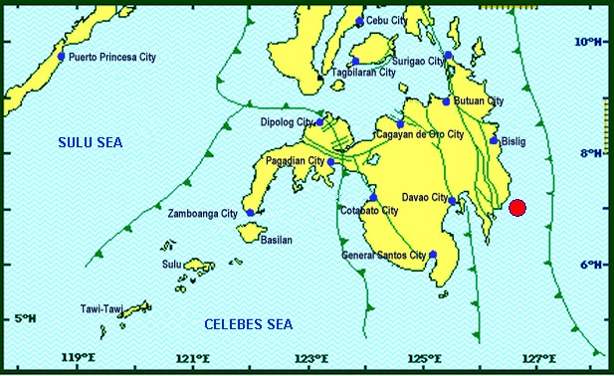

On September 8, 2018 at exactly 3:16 PM, a Magnitude 6.4 earthquake shook Manay, Davao Oriental. The epicenter of the earthquake was located 07.02°N, 126.68°E - 027 km S 35° E of Manay, Davao Oriental with a depth focus of 014 km and with a Tectonic origin.

Reported Intensities (03:54 PM): | Intensity V - Davao City; Mati City, Davao Oriental  Intensity IV - Koronadal City; Bislig City  Inetsntiy III - Tupi, South Cotabato; Alabel, and Malapatan, Sarangani  Intensity II - Cotabato City; Gen. Santos City
Instrumental Intensity (03:54 PM): | Instrumental Intensities:  Intensity III - Alabel, Sarangani  Intensity II - Bislig City;  Intensity I - Gen. Santos City
Expecting Damage: | YES
Expecting Aftershocks: | YES
Source: DOST-PHIVOLCS Earthquake Bulletin

Status of Prepositioned Resources: Stockpiles and Standby Funds

The DSWD Central Office (CO), Field Offices (FOs), and National Resource Operations Center (NROC) have stockpiles and standby funds amounting to ₱1,111,374,714.11 with breakdown as follows:

- Stockpiles
A total of 337,502 Family Food Packs (FFPs) (see Table 4) amounting to ₱117,917,481.30 and available Food and Non-food Items (FNIs) amounting to ₱629,754,634.45.

- Standby Funds
A total of ₱275,830,574.86 standby funds in the CO and FOs. Of the said amount, ₱227,950,586.00 is the available Quick Response Fund in the CO.

Standby Funds and Stockpile
FIELD OFFICE | STANDBY FUNDS | STOCKPILE |  |  |  |  | TOTAL STANDBY FUNDS AND STOCKPILE
 |  | Family Food Packs |  | Food | Non-Food | Sub-Total  (Food and NFIs)
 |  | Quantity | Total Cost
TOTAL | 275,830,574.86 | 337,502 | 117,917,481.30 | 87,872,023.50 | 629,754,634.45 | 717,626,657.95 | 1,111,374,714.11
Central Office* | 227,950,586.00 | - | - | - | - | - | 227,950,586.00
NROC | - | 24,429.00 | 8,794,440.00 | 9,067,500.00 | 298,386,172.00 | 307,453,672.00 | 316,248,112.00
NCR | 3,620,973.50 | 19,351 | 5,144,882.50 | 817,794.60 | 1,841,414.65 | 2,659,209.25 | 11,425,065.25
CAR | 3,000,000.40 | 12,671 | 4,929,724.50 | 957,375.60 | 18,447,885.30 | 19,405,260.90 | 27,334,985.80
I | 3,199,775.00 | 9,499 | 3,443,448.00 | 1,896,000.00 | 11,908,765.11 | 13,804,765.11 | 20,447,988.11
II | 1,503,422.04 | 33,945 | 11,880,750.00 | 1,388,883.87 | 161,844.20 | 1,550,728.07 | 14,934,900.11
III | 3,424,610.00 | 9,559 | 3,441,379.40 | 373,398.50 | 9,374,253.43 | 9,747,651.93 | 16,613,641.33
CALABARZON | 3,716,000.00 | 3,059 | 1,132,619.70 | 3,205,062.13 | 6,304,401.25 | 9,509,463.38 | 14,358,083.08
MIMAROPA | 3,470,389.75 | 22,397 | 8,334,441.00 | 7,437,151.54 | 1,345,932.36 | 8,783,083.90 | 20,587,914.65
V | 3,229,182.32 | 25,268 | 9,880,574.00 | 2,872,473.00 | 55,186,434.00 | 58,058,907.00 | 71,168,663.32
VI | 3,000,000.00 | 12,956 | 4,651,204.00 | 11,479,289.46 | 8,365,826.19 | 19,845,115.65 | 27,496,319.65
VII | 3,000,000.00 | 81,636 | 28,232,546.40 | 19,378,883.34 | 48,035,431.70 | 67,414,315.04 | 98,646,861.44
VIII | 2,398,080.00 | 20,098 | 7,042,066.00 | 12,112,619.62 | 46,600,107.05 | 58,712,726.67 | 68,152,872.67
IX | 2,176,505.85 | 12,032 | 4,331,520.00 | 2,301,890.00 | 6,964,083.29 | 9,265,973.29 | 15,773,999.14
X | 3,140,700.00 | 21,525 | 7,206,790.00 | 7,549,173.00 | 90,834,033.70 | 98,383,206.70 | 108,730,696.70
XI | 3,000,000.00 | 24,992 | 8,192,377.60 | - | 12,884,329.75 | 12,884,329.75 | 24,076,707.35
XII | 3,000,350.00 | 455 | 163,800.00 | 2,023,728.74 | 3,114,896.67 | 5,138,625.41 | 8,302,775.41
CARAGA | 3,000,000.00 | 3,630 | 1,114,918.20 | 5,010,800.10 | 9,998,823.80 | 15,009,623.90 | 19,124,542.10
* Quick Response Fund (QRF) as of 08 September 2018
Sources: DSWD-Central Office, DSWD-Field Offices, and NROC

Situational Reports

DREAMB
DATE | ACTION(S) TAKEN
08 September 2018 | - The Disaster Response Operations Monitoring and Information Center (DROMIC) of DSWD-DReAMB is on standby for monitoring reports related to the Earthquake Incident

FO XI
DATE | ACTION(S) TAKEN
08 September 2018 | - There are no reported casualties and damages or any affected families and individuals in line with the incident. Possibilities of aftershocks have been negated by Phivolcs.

***
The Disaster Response Operations Monitoring and Information Center (DROMIC) of DSWD continues to closely coordinate with concerned DSWD-Field Offices for significant updates on their preparedness levels and actions taken.

by:

JAN ERWIN ANDREW I. ONTANILLAS
Releasing Officer

