DSWD DROMIC Preparedness for Response Report #4
on Typhoon “OMPONG” [I.N. MANGKHUT]
as of 14 September 2018, 2PM

Situation Overview
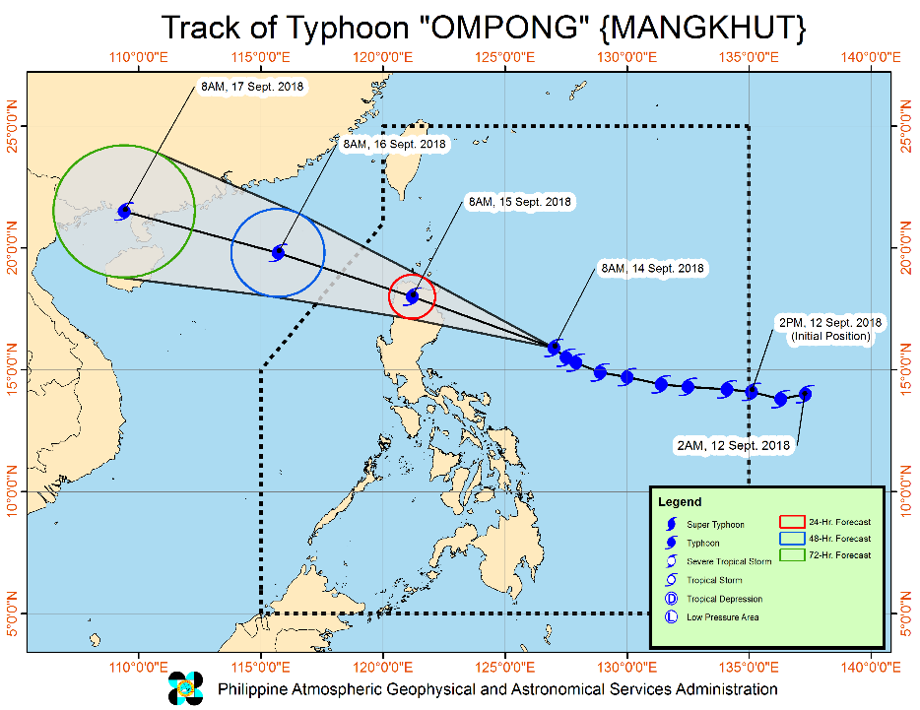
Issued At 11:00 AM today, Typhoon "OMPONG" maintains its strength as it continues to threaten the Isabela-Cagayan area.
- Occasional rains and gusty winds will be experienced over areas under TCWS #1.
- Stormy weather is expected over areas under TCWS#2 and TCWS#3.
- TY "OMPONG" is expected to make landfall in Cagayan-Isabela area tomorrow early morning (Saturday, 15 September).
- The Southwest Monsoon (Habagat) enhanced by the typhoon will bring moderate to occasionally heavy rains over Visayas, while scattered light to moderate to at times heavy rains over Palawan, Zamboanga Peninsula, Northern Mindanao and Caraga. Residents in these areas, especially those living near river channels, in low-lying areas and in mountainous areas, are advised to take appropriate actions against possible flooding and landslides, coordinate with local disaster risk reduction and management offices, and to continue monitoring for updates.
- The storm surge prone areas of Cagayan and Isabela may expect up to 6 meters of surge.
- Fisherfolks and those with small seacrafts are advised not to venture out over the seaboards of areas with TCWS and the eastern seaboards of Visayas and of Mindanao.

Location of Eye/center | At 10:00 AM today, the eye of Typhoon "OMPONG" was located based on all available data at 540 km East of Baler, Aurora (16.0°N, 126.6°E)
Movement | Moving Northwest at 20 kph
Strength | Maximum sustained winds of 205 kph near the center and gustiness of up to 255 kph
Forecast Position | - 24 Hour (Tomorrow morning): In the vicinity of Kabugao, Apayao (after landfall in Cagayan) (18°N, 121.2°E)  - 48 Hour (Sunday morning): 660 km West of Basco, Batanes (19.8°N, 115.7°E)  - 72 Hour (Monday morning): 1,310 km West of Basco, Batanes (21.5°N, 109.4°E)

TROPICAL CYCLONE WARNING SIGNAL
TCWS | Luzon | Visayas | Mindanao | Impacts of the wind
#3  (Winds of 121 -170 kph is expected in at least 18 hrs) | Cagayan incl. Babuyan group of Is., Apayao, Abra, Kalinga, Mountain Province, Ifugao, Nueva Vizcaya, Quirino, Northern Aurora, Isabela, | - | - | ->Light to Moderate damage to high risk structures;
 |  |  |  | ->Very light to light damage to medium-risk structures;
 |  |  |  | ->No damage to very light damage to low risk structures
 |  |  |  | ->Unshielded, old dilapidated schoolhouses, makeshift shanties, and other structures of light materials are partially damaged or unroofed.
 |  |  |  | ->A number of nipa and cogon houses may be partially or totally unroofed.
 |  |  |  | ->Some old galvanized iron (G.I.) roofs may be peeled or blown off.
 |  |  |  | ->Some wooden, old electric posts are tilted or downed.
 |  |  |  | ->Some damage to poorly constructed signs/billboards
 |  |  |  | ->In general, the winds may bring moderate to heavy damage to the exposed communities. Most banana plants, a few mango trees, ipil-ipil and similar types of trees are downed or broken
 |  |  |  | ->Some coconut trees may be tilted with few others broken
 |  |  |  | ->Rice and corn may be adversely affected
 |  |  |  | ->Considerable damage to shrubbery and trees with some heavy-foliaged trees blown down.
 | Wave Height: (Open Sea) > 14.0 meters Storm surge possible at coastal areas
#2  (61-120kph expected in 24 hrs) | Batanes, Ilocos Norte, Ilocos Sur, La Union, Benguet, Pangasinan, Tarlac, Nueva Ecija, Southern Aurora, Northern Zambales | - | - | ->Light to Moderate damage to high risk structures;
 |  |  |  | ->Very light to light damage to medium-risk structures;
 |  |  |  | ->No damage to very light damage to low risk structures
 |  |  |  | ->Unshielded, old dilapidated schoolhouses, makeshift shanties, and other structures of light materials are partially damaged or unroofed.
 |  |  |  | ->A number of nipa and cogon houses may be partially or totally unroofed.
 |  |  |  | ->Some old galvanized iron (G.I.) roofs may be peeled or blown off.
 |  |  |  | ->Some wooden, old electric posts are tilted or downed.
 |  |  |  | ->Some damage to poorly constructed signs/billboards
 |  |  |  | ->In general, the winds may bring light to moderate damage to the exposed communities. Most banana plants, a few mango trees, ipil-ipil and similar types of trees are downed or broken
 |  |  |  | ->Some coconut trees may be tilted with few others broken
 |  |  |  | ->Rice and corn may be adversely affected
 |  |  |  | ->Considerable damage to shrubbery and trees with some heavy-foliaged trees blown down.
 | Wave Height: (Open Sea) 4.1-14.0 meters Storm surge possible at coastal areas
#1  (30-60kph expected in 36 hrs) | Southern Zambales, Pampanga, Bulacan, Bataan, Rizal, Metro Manila, Cavite, Batangas, Laguna, Quezon incl. Polillo Is., Northern Occidental Mindoro incl. Lubang Is., Northern Oriental Mindoro, Masbate, Marinduque, Camarines Norte, Camarines Sur, Catanduanes, Albay, Sorsogon,Burias and Ticao Islands | Northern Samar | - | ->Very light or no damage to high risk structures,
 |  |  |  | ->Light damage to medium to low risk structures
 |  |  |  | ->Slight damage to some houses of very light materials or makeshift structures in exposed communities. Some banana plants are tilted, a few downed and leaves are generally damaged
 |  |  |  | ->Twigs of small trees may be broken.
 |  |  |  | ->Rice crops, however, may suffer significant damage when it is in its flowering stage.
 | Wave Height: (Open Sea) 1.25-4.0 meters

Source: DOST-PAGASA Severe Weather Bulletin

Predictive Analytics for Humanitarian Response

Based on the GSM and WRF data of PAGASA initialized on 14 September 2018, 8AM, the DSWD Predictive Analytics for Humanitarian Response results show 1,348,848 families (see Figure 1) exposed to high susceptibility of flooding and rain-induced landslide in the next 72 hours; of which, 224,990 families are poor (see Figure 2).

Figure 1. Exposed Population (PSA), Required FFPs, and Cost
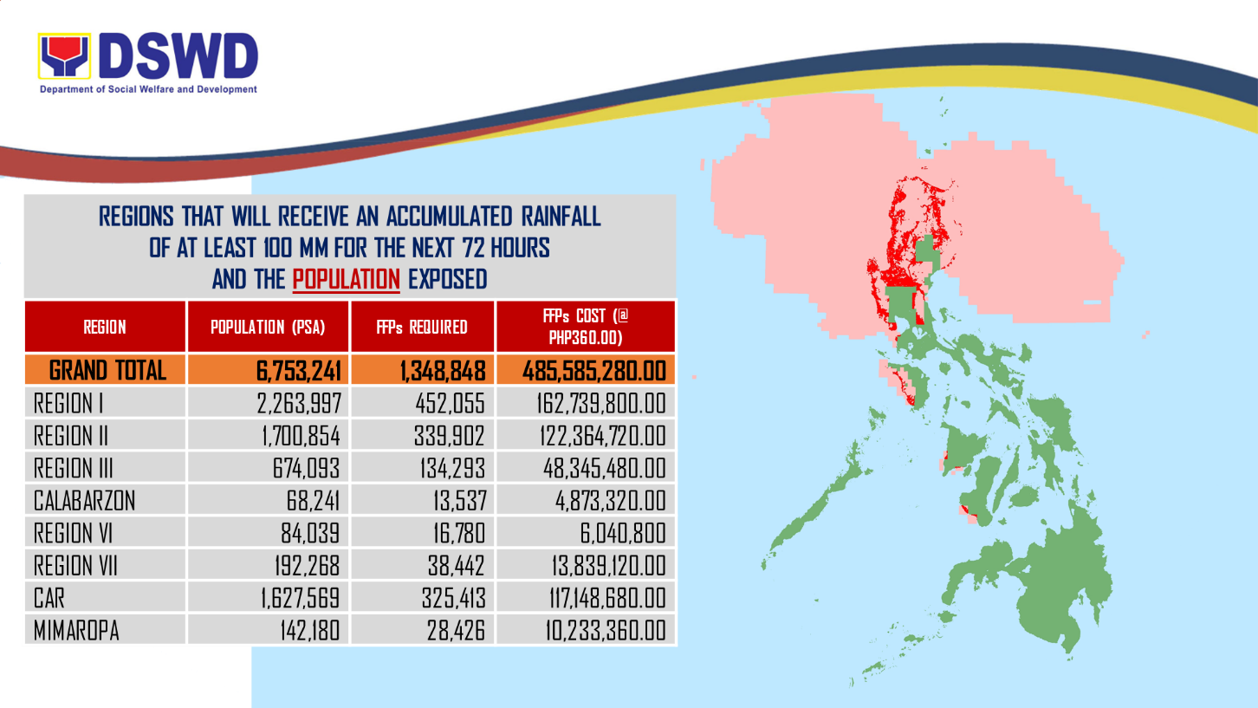

Figure 2. Exposed Poor Families (DSWD), Required FFPs, and Cost
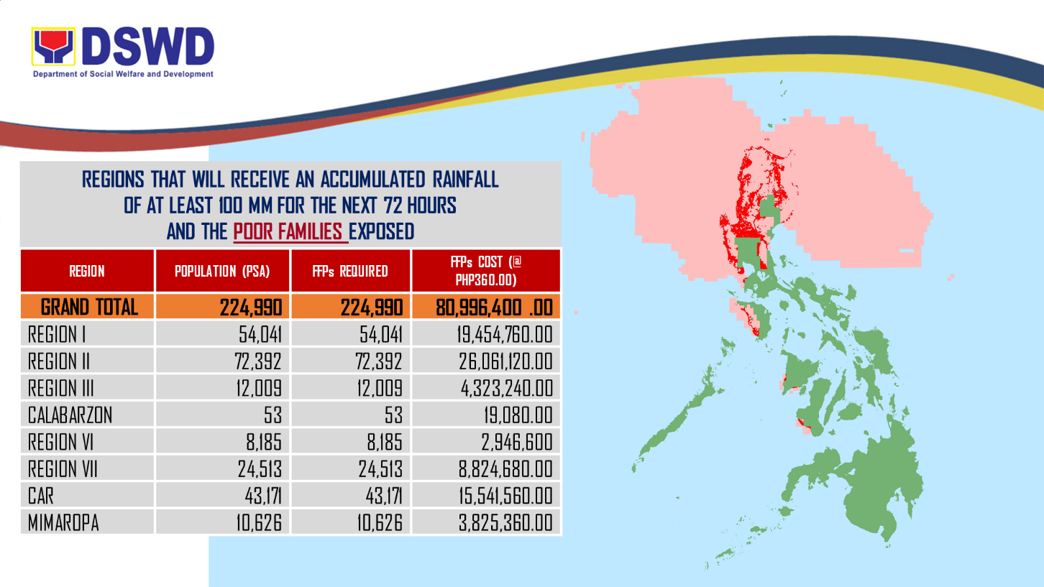

Status of Prepositioned Resources: Stockpile and Standby Funds

The DSWD Central Office (CO), Field Offices (FOs), and National Resource Operations Center (NROC) have stockpiles and standby funds amounting to ₱1,603,857,679.33 with breakdown as follows:

- Standby Funds
A total of ₱779,597,203.21 standby funds in the CO and FOs. Of the said amount,
₱734,266,693.00 is the available Quick Response Fund in the CO.

- Stockpiles
A total of 336,164 Family Food Packs (FFPs) amounting to ₱109,247,812.93 and available Food and Non-food Items (FNIs) amounting to ₱715,012,663.19.

FIELD OFFICE | STANDBY FUNDS | STOCKPILE |  |  |  |  | TOTAL STANDBY FUNDS AND STOCKPILE
 |  | Family Food Packs |  | Food | Non-Food | Sub-Total  (Food and NFIs)
 |  | Quantity | Total Cost
TOTAL | 779,597,203.21 | 336,164 | 109,247,812.93 | 87,397,708.37 | 627,614,954.82 | 715,012,663.19 | 1,603,857,679.33
Central Office* | 734,266,693.00 | - | - | - | - | - | 734,266,693.00
NROC | - | 11,317 | 4,074,120.00 | 4,342,538.00 | 293,966,644.00 | 298,309,182.00 | 302,383,302.00
NCR | 3,620,973.50 | 19,351 | 5,144,882.50 | 817,794.60 | 1,841,414.65 | 2,659,209.25 | 11,425,065.25
CAR | 3,230,215.35 | 11,416 | 4,428,038.25 | 957,375.60 | 18,337,700.02 | 19,295,075.62 | 26,953,329.22
I | 2,579,081.40 | 8,560 | 3,081,600.00 | 1,896,000.00 | 12,586,636.44 | 14,482,636.44 | 20,143,317.84
II | 1,503,422.04 | 36,800 | 13,248,000.00 | 54,126.45 | 161,844.20 | 215,970.65 | 14,967,392.69
III | 3,424,610.00 | 11,852 | 4,322,148.00 | 132,615.05 | 8,773,095.64 | 8,905,710.69 | 16,652,468.69
CALABARZON | 3,716,000.00 | 2,669 | 997,645.51 | 2,352,693.27 | 6,004,401.25 | 8,357,094.52 | 13,070,740.03
MIMAROPA | 2,843,389.75 | 21,785 | 8,114,195.00 | 7,011,657.61 | 1,344,028.86 | 8,355,686.47 | 19,313,271.22
V | 3,229,182.32 | 32,997 | 12,473,056.00 | 786,900.00 | 54,670,476.00 | 55,457,376.00 | 71,159,614.32
VI | 3,000,000.00 | 13,491 | 4,843,269.00 | 11,259,368.62 | 8,338,826.19 | 19,598,194.81 | 27,441,463.81
VII | 1,468,000.00 | 79,480 | 19,052,211.85 | 28,767,437.35 | 47,720,431.70 | 76,487,869.05 | 97,008,080.90
VIII | 2,398,080.00 | 20,098 | 7,042,066.00 | 12,112,619.62 | 46,599,507.05 | 58,712,126.67 | 68,152,272.67
IX | 2,176,505.85 | 12,032 | 4,331,520.00 | 3,907,890.00 | 6,964,083.29 | 10,871,973.29 | 17,379,999.14
X | 3,140,700.00 | 19,849 | 6,670,470.00 | 6,653,173.00 | 94,394,297.38 | 101,047,470.38 | 110,858,640.38
XI | 3,000,000.00 | 24,897 | 8,161,236.60 | - | 12,797,847.68 | 12,797,847.68 | 23,959,084.28
XII | 3,000,350.00 | 3,547 | 1,413,450.00 | 2,267,932.10 | 3,114,896.67 | 5,382,828.77 | 9,796,628.77
CARAGA | 3,000,000.00 | 6,023 | 1,849,904.22 | 4,077,587.10 | 9,998,823.80 | 14,076,410.90 | 18,926,315.12

DSWD-FOs have prepositioned FFPs in strategic locations. Breakdown per location is as follows:
REGION | LOCATION | NUMBER OF FFPS
GRAND TOTAL |  | 336,164
NROC |  | 11,317
 | Chapel Road, Pasay City | 11,317
NCR |  | 19,351
 | DSWD-FO NCR, 389 San Rafael St., Legarda, Sampaloc, Manila | 742
 | NCWP, Chapel Road, Pasay City | 2,400
 | NROC Chapel Road (Reserve Stock) | 16,209
CAR |  | 11,416
 | DSWD Regional Warehouse, SN Oriental Cmpd., Palmaville, Puguis, La Trinidad | 11,416
I |  | 8,560
 | Regional Warehouse, Brgy. Urayong, Bauang, La Union | 3,401
 | Prepositioned Relief Goods | 5,159
 | Bolinao Warehouse, Brgy. Concordia, Bolinao, Pangasinan | 200
 | Manaog Warehouse, Tiong Street, Brgy. Poblacion, Manaoag, Pangasinan | 800
 | Santa Barbara Warehouse, Brgy. Maningding, Sta Barbara, Pangasinan | 1,509
 | Vigan Warehouse, A Reyes St. Brgy. 8 Vigan City, Ilocos Sur | 1,000
 | San Nicholas, Cleveland Street, Barangay 2, San Nicolas, Ilocos Norte | 1,000
 | Burgos Warehouse, Municipal Bldg., Perucho St., Brgy. Poblacion, Burgos, Ilocos Norte | 650
II |  | 36,800
 | DSWD Regional Warehouse, Regional Government Center, Carig, Tuguegarao City | 12,000
 | Prepositioned Relief Goods | 24,800
 | PSWDO CAGAYAN | 500
 | Baggago, Cagayan | 300
 | Buguey, Cagayan | 300
 | Gattaran, Cagayan | 300
 | Gonzaga, Cagayan | 300
 | Lallo, Cagayan | 300
 | Sta. Teresita, Cagayan | 300
 | Abulug, Cagayan | 300
 | Allacapan, Cagayan | 300
 | Ballesteros | 300
 | Calayan, Cagayan | 600
 | Claveria, Cagayan | 300
 | Lasam, Cagayan | 300
 | Rizal, Cagayan | 300
 | Sanchez Mira | 300
 | Sta. Praxedes | 300
 | Amulung, Cagayan | 300
 | Enrile, Cagayan | 300
 | Iguig, Cagayan | 300
 | Peñablanca, Cagayan | 300
 | Tuao, Cagayan | 300
 | Tuguegarao City, Cagayan | 300
 | PSWDO ISABELA | 500
 | Cabagan, Isabela | 300
 | Delfin Albano | 300
 | Maconacon,Isabela | 600
 | Palanan,Isabela | 600
 | Santa Maria,Isabela | 300
 | San Pablo, Isabela | 300
 | Sto. Tomas, Isabela | 300
 | Tumauini, Isabela | 300
 | Aurora, Isabela | 300
 | Benito Soliven,Isabela | 300
 | Malig, Isabela | 300
 | Naguilian, Isabela | 300
 | San Mariano, Isabela | 300
 | Burgos, Isabela | 300
 | Gamu,Isabela | 300
 | Quezon, Isabela | 300
 | Quirino, Isabela | 300
 | Cabatuan, Isabela | 300
 | Reina Mercedes, Isabela | 300
 | San Mateo,Isabela | 300
 | Angadanan, Isabela | 300
 | Cauayan City,Isabela | 300
 | San Guillermo, Isabela | 300
 | Cordon,Isabela | 300
 | Dinapigue,Isabela | 600
 | Echague, Isabela | 300
 | Jones, Isabela | 300
 | Ramon, Isabela | 300
 | Santiago City,Isabela | 300
 | San Agustin, Isabela | 300
 | Aglipay, Quirino | 400
 | Saguday, Quirino | 400
 | Diffun, Quirino | 400
 | Maddela,Quirino | 400
 | Nagtipunan, Quirino | 400
 | PSWDO NUEVA VIZCAYA | 500
 | Aritao, Nueva Vizcaya | 400
 | Bagabag, Nueva Vizcaya | 400
 | Bambang, Nueva Vizcaya | 400
 | Bayombong, Nueva Vizcaya | 400
 | Diadi, Nueva Vizcaya | 400
 | Solano, Nueva Vizcaya | 400
 | Sta Fe, Nueva Vizcaya | 400
 | Villaverde, Nueva Vizcaya | 400
 | Alfonso Castaneda, Nueva Vizcaya | 400
 | Dupax del Norte, Nueva Vizcaya | 300
 | Dupax del Sur, Nueva Vizcaya | 300
 | Kasibu, Nueva Vizcaya | 300
 | Quezon, Nueva Vizcaya | 300
III |  | 11,852
 | DSWD Regional Warehouse, JASA, Dolores, City of San Fernando, Pampanga | 2,769
 | Prepositioned Relief Goods | 9,083
 | Dingalan, Aurora | 1,000
 | DPEO, Aurora Sitio Hiwalayan, brgy. Bacong, San Luis, Aurora | 2,000
 | PLGU Aurora (Old hospital, Brgy 5) | 1,000
 | LGU Dinalungan, Aurora | 1,000
 | Evacuation Center, brgy. Suklayin, Baler, Aurora | 1,000
 | Municipality of Dilasag | 1,000
 | Municipality of Casiguran | 1,000
 | PSWDO Bulacan | 426
 | San Jose, Plaridel, Bulacan | 244
 | DPEO, PSWDO Cmpd., Palanginan, Iba, Zambales | 213
 | DPEO, Olongapo City | 200
CALABARZON |  | 2,669
 | DSWD Regional Warehouse, Brgy. Gregoria de Jesus,San Jose, G.M.A, Cavite | 2,669
MIMAROPA |  | 21,785
 | DSWD Regional Warehouse, 1680 F. Benitez cor. Malvar Sts., Malate, Metro Manila | 183
 | Prepositioned Relief Goods | 21,602
 | M. Roxas Drive, Salong, Calapan City (SWADT Oriental Mindoro) | 4,838
 | JRB Building, San Jose, Occidental Mindoro (SWADT Occ. Mindoro) | 5,151
 | Brgy. Bangbangalon, Boac, Marinduque (SWADT Marinduque) | 4,159
 | 052 Gen. Luna St., Liwayway, Odiongan, Romblon (SWADT Romblon) | 2,882
 | Cor. Malvar and Sandoval Sts., Puerto Princesa City (SWADT Palawan) | 4,572
V |  | 32,997
 | DSWD Regional Warehouse, Brgy Bogtong, Legazpi City | 10,333
 | Prepositioned Relief Goods | 22,664
 | Guinobatan, Albay | 1,537
 | Pioduran, Albay | 1,000
 | Sto. Domingo, Albay | 827
 | LGU Baao, Camarines Sur | 1,000
 | Lagonoy, Camarines Sur | 1,000
 | Canaman, Camarines Sur | 500
 | San Jose, Camarines Sur | 1,000
 | Tinambac, Camarines Sur | 1,000
 | Camaligan, Camarines Sur | 500
 | Del Gallego, Camarines Sur | 1,000
 | Balatan, Camarines Sur | 1,000
 | Siruma, Camarines Sur | 1,500
 | Sagnay, Camarines Sur | 1,000
 | PLGU Camarines Norte | 2,000
 | San Vicente, Camarines Norte | 1,000
 | Pilar Sorsogon | 1,000
 | PLGU Catanduanes | 2,800
 | Virac, Catanduanes | 1,000
 | San Miguel, Catanduanes | 1,000
 | Gigmoto, Catanduanes | 1,000
VI |  | 13,491
 | Juantong Warehouse, Bodega 8, Juantong Bldg., Rizal St., Iloilo City | 13,283
 | Prepositioned Relief Goods | 208
 | LGU Malay, Aklan | 208
VII |  | 79,480
 | VDRC, P.C Suico St. Tingub, Mandaue City | 51,098
 | Labangon, Cebu CIty | 8,489
 | Bodega Polinitas, C.P.G. East Ave., Tagbilaran City, Bohol | 1,080
 | DC Warehouse, Tabuk Tubig, Dumaguete City, Negros Oriental | 8,981
 | SWAD Office, Siquijor | 89
 | Prepositioned Relief Goods | 9,743
 | Batuan, Bohol | 500
 | Buenavista, Bohol | 1,452
 | Candijay, Bohol | 1,000
 | Duero, Bohol | 1,000
 | Loboc, Bohol | 1,500
 | SierraBullones, Bohol | 1,500
 | Sevilla, Bohol | 1,500
 | Trinidad, Bohol | 1,200
 | Ubay, Bohol | 91
VIII |  | 20,098
 | DSWD Regional Warehouse, Brgy. 91, Abucay, Tacloban City | 11,398
 | Prepositioned Relief Goods | 8,700
 | Dulag, Leyte | 500
 | Hilongos, Leyte | 500
 | San Isidro, Leyte | 500
 | Jipapad, Eastern Samar | 1,000
 | Almagro, Western Samar | 500
 | Calbiga, Western Samar | 800
 | Daram, Western Samar | 500
 | Hinabangan, Western Samar | 800
 | Matuguinao, Western Samar | 800
 | Motiong, Western Samar | 500
 | Sta. Margarita, Western Samar | 500
 | San Sebastian, Western Samar | 800
 | San Jose de Buan, Western Samar | 500
 | Culaba, Biliran | 500
IX |  | 12,032
 | DSWD Regional Warehouse, Rojo Warehouse. No. 59, Santa Catalina, Zamboanga City | 9,388
 | Prepositioned Relief Goods | 2,644
 | SWADT, Ipil Heights, Ipil, Zamboanga Sibugay | 804
 | SWADT, Liloy, Zamboanga Del Norte | 838
 | SWADT-Dipolog, DSWDBldg. Dipolog City | 506
 | SWADT-Pagadian, DSWD Bldg., Pagadian City | 496
X |  | 19,849
 | DSWD Regional Warehouse, Corrales Ext., Puntod, Cagayan de Oro City | 4,490
 | RCP Warehouse, Dalipuga, Iligan City | 6,599
 | Prepositioned Relief Goods | 8,760
 | Tubod, Lanao Del Norte | 3,000
 | Oroquieta, Misamis Occidental | 3,760
 | Mambajao, Camiguin Province | 2,000
XI |  | 24,897
 | Purok 7, BPI Compound, Brgy Oshiro, Tugbok District, Davao City | 21,202
 | Prepositioned Relief Goods | 3,695
 | Provincial Coliseum, Brgy. Mati Digos City Davao Del Sur | 2,000
 | Provincial Capitol, Brgy. Cabidianan, Nabunturan, Compostela Valley | 1,695
XII |  | 3,547
 | DSWD Regional Warehouse, Arellano St., Brgy. Zone III, Koronadal City, South Cotabato | 3,547
CARAGA |  | 6,023
 | DSWD Regional Warehouse, DPWH Tiniwisan, Butuan City, Agusan del Norte | 6,023

DSWD Preparedness Measures and Activities

Food and Non-Food Cluster
- Requested C-130 Airplane through Logistic Cluster to airlift 1,600 Family Food Packs to Basco, Batanes
- Ongoing repacking of relief goods at the National Resource Operation Center (NROC) and Visayas Disaster Response Center (VDRC)
- Transported FNFIs to DSWD-FO II
  - 5,000 family food packs, 1,000 family kits, 1,000 hygiene kits, and 1,000 sleeping kits
- Transported FNFIs to DSWD-FO I
  - 1,100 family food packs, 2,600 sleeping kits, and 2,166 hygiene kits
- Transported FNFIs to DSWD-FO III
  - 1,000 hygiene kits, 1,300 sleeping kits, and 760 family kits
- The following FNIs were received by concerned DSWD Field Offices on 14 September 2018:
REGION | QUANTITY | PARTICULARS
DSWD-FO CAR | 1,600 | Family Food Packs
DSWD-FO I | 7,400 | Sleeping Kits
 | 7,834 | Hygiene Kits
 | 8,900 | Family Kits

Camp Coordination and Camp Management Cluster
- Quick Response Team trained on the Management of Evacuation Center are on standby and ready for deployment to augment the Local Government Units, when necessary.

Internally Displaced Persons (IDP) Protection Cluster
- Quick Response Team trained on Psycho-social support processing (PSSP) and Facilitators for Child/Women Friendly Spaces are on standby for deployment.

DSWD Rapid Emergency Telecommunications Team (RETT)
- CO RETT was deployed to DSWD-FO CAR on 12 September 2018 to provide the following: 1) RETT Orientation, 2) Orientation on DROMIC Reporting, and 3) GX Terminal troubleshooting. From CAR, the team travelled to DSWD-FO II and has arrived today to setup emergency telecommunications.
- FO-CAR RETT are deployed with emergency telecommunications in Tabuk, Kalinga and Luna, Apayao.
- CO and FO-II RETT members are deployed in the province of Batanes with emergency telecommunications equipment.
- CO and FO-V RETT members are on standby for possible deployment.
- DSWD RETT conducted communications connectivity testing today between CO (Quezon City), CO RETT (Tuguegarao City, Cagayan), FO-CAR RETT 1 (Luna, Apayao), FO-CAR RETT 2 (Tabuk, Kalinga), and FO-II RETT (Basco, Batanes). Successful connectivity of all equipment.
(See Annex A for the names and contact details of the DSWD CO and FO RETT members.)

Situational Reports

DSWD-DRMB
DATE | SITUATIONS / ACTIONS UNDERTAKEN
September 12, 2018 to present | - The Disaster Response Operations Monitoring and Information Center (DROMIC) of the DSWD-DRMB is on 24/7 duty to continuously coordinate with the concerned DSWD-Field Offices for significant disaster preparedness for response updates.
September 14, 2018 | - DSWD-DRMB processed the downloading of funds to the following DSWD Field Offices:  - FO-CAR – ₱15,082,500.00 intended for purchase of family food packs, standby funds and operational expenses  - FO-II – ₱4,500,000.00 for standby funds  - FO-I – ₱10,560,000.00 intended for the purchase of family food packs

FO CAR
DATE | SITUATION / PREPAREDNESS ACTIONS
September 13, 2018 | Alert Field Office QUART Team 21 rendered duty from 7:30 PM of 13 September 2018 to 7:30 AM of 14 September 2018. In anticipation of the land fall of Typhoon “OM PONG”, Field Office personnel particularly Division Chiefs were proactively deployed to augment in all provinces with the following assignment, to wit:  Province Division Chief – In – Charge  Abra Ms. Mary Ann G. Buclao  Apayao Mr. Rogerson Dennis R. Fernandez  Baguio City Ms. Amely P. Cabrera  Benguet Mr. Ronilo R. Flores  Ifugao Mr. Arnold Lartec  Kalinga Ms. Marygrail B. Dong-as  Mountain Province Concepcion E. Navales  Moreover, Rapid Emergency Telecommunication Team (RETT) was activated and deployed in selected provinces. Mr. Michael Angelo Gapoy headed the Apayao team. His team carried with them various equipment such as GX, BGAN (auto pointing), and satellite phone. On the other hand, Mr. Gian Carlo De Guzman led the Kalinga team. At their disposal are satellite phone and BGAN. The previously mentioned equipment are intended for communication for reporting purposes in the affected areas.  The following were updates from different provinces, to wit:  Province of Abra  - The weather is fine, clear and calm. It is not raining in the area.  Province of Apayao  - The weather is fine, clear and calm. It is not raining in the area.  - The main discussion of the PDRRMC Meeting was on the inventory of available resources to be contributed by the different agencies during disaster response.  - Local Government Units in the area are prepositioning food packs to possible barangays that will be affected by the typhoon.  Province of Benguet  - To furnish the Field Office their DROMIC report this 11:00 PM.  - The Field Office is in receipt of information from OCD CAR to validate Five (5) affected families, Thirteen (13) individuals in Puguis, La Trinidad, Benguet. The concern was endorsed to SWAD Benguet for validation.  - The Municipality of Kabayan is on blue alert. There were no evacuees yet, no power interruption, and the weather is fair. They had also done operational briefing and temporary suspended the small-scale mining and tourism activities.  - The weather in the Municipality of Kibungan is fair.The road going to the area is passable, no power interruption, temporary suspension of tourism activities. They have done preparedness activities like prepositioning of relief goods, inventory and purchase of supplies and fuels for Sagpat, Poblacion, Madaymen, and Tacadang. Also, the Municipality has issued a memorandum stating the cancellation of all trips using municipal vehicles.  - No evacuees in the Municipality of Itogon.  Province of Ifugao  - The weather is fine, clear and calm. It is not raining in the area.  - For validation regarding the pre-emptive evacuation in Lamut and Alfonso Lista.  - Two Family Food Packs issued and medical services to Alfonso Lista with monetized amount of 2,587.25.  Province of Kalinga  - Intermittent rain.  - The Mayor of Tabuk City declared Force Evacuation to selected barangays.  Mountain Province  - No significant update in the province.
September 12, 2018 to present | - Red Alert is raised in DSWD-FO CAR. Field Office QUART Team renders duty.  - Coordinated with SWAD Team Members regarding the status of ongoing preparation for the expected arrival of Typhoon OMPONG (Mangkhut).  - Approved and facilitated the purchase of 600 sacks of NFA rice.

FO I
DATE | SITUATION / PREPAREDNESS ACTIONS
September 14, 2018 | - There are families in the Region who were pre-emptively evacuated. Details are as follows:  Province City/ Municipality Families Persons  REGION I 422 1,738  Ilocos Norte 203 880  City of Batac 3 4  Pagudpud 87 430  Pasuquin 113 446  Ilocos Sur 81 344  Caoayan 4 20  City of Candon 18 81  City of Vigan 15 73  Narvacan 3 10  Santa 17 66  Santa Maria 6 24  Suyo 15 59  Tagudin 3 11  La Union 136 432  Bangar 31 95  Bauang 105 337  Pangasinan 2 82  Dagupan City 75  San Fabian 2 7
September 12, 2018 to present | - The DRMD staff is closely monitoring the possible effect of the Typhoon “OMPONG” (Mangkhut). Likewise, the Quick Action Response Teams (QUARTs) of the DSWD Field Office I and the Provincial Operations Offices (POOs) are monitoring and preparing pre-disaster activities in close coordination with the OCD Region 1 and with the different Provincial/City/Municipal Disaster Risk Reduction Management Councils (P/C/MDRRMCs) for the adverse effect that might be brought by the weather disturbances.
September 12, 2018 | - Emergency Response Preparedness (ERP) Meeting of the DSWD Field Office I was conducted to plan and establish emergency response procedures for potential scenarios that might happen in the Region. This was presided by Dir. Marlene Febes D. Peralta, Assistant Regional Director for Operations, and was attended by representatives from different divisions/sections.  - Ms. Maricel S. Celeja, Disaster Response Management Division (DRMD) OIC-Chief, attended the ERP Meeting conducted by the Office of Civil Defense (OCD) Region 1, together with the National Disaster Risk Reduction Management Council (NDRRMC) through a video conference at the Regional Disaster Risk Reduction and Management Council Emergency Operations Center (RDRRMC-EOC), Ed Fabro Building, Pagdalagdan, City of San Fernando, La Union on 10 September 2018. All Core Group members presented their disaster preparedness measures and readiness capacities baseline information.

FO II
DATE | SITUATION / PREPAREDNESS ACTIONS
September 12, 2018 to present | - The Field Office is continuously providing weather updates and monitoring of affected families thru SMS to our SWAD Teams and C/MATs for their appropriate action.  - The Field Office has already activated the DMRT and the SWAD Teams and render of duty started on September 13, 2018 at 7:00 PM.
September 12, 2018 | - Four (4) staff of the Field Office arrived in Batanes to augment the SWAD Team in the conduct of disaster preparedness activities and response in the event Typhoon “OMPONG” (Mangkhut) makes a land fall and affect the province.  - DRMD staff in the Field Office and all SWAD Teams were already mobilized to monitor weather conditions and preparedness of the LGUs particularly in the coastal towns which may be greatly affected by TY Mangkhut.  - As per coordination with the SWAD Teams, weather condition in the PROVINCES of Batanes, Cagayan, Isabela, Nueva Vizcaya, and Quirino was generally sunny.

FO III
DATE | SITUATION / PREPAREDNESS ACTIONS
September 14, 2018 to present | - Continuous monitoring and coordination with the DSWD Provincial Extension Office of the seven (7) provinces relative to the status of their respective area.  - Request for relief augmentation to DSWD-FO MIMAROPA 5,000 FFPs in preparation for the super typhoon “Ompong”.  - Facilitate the approval of request for augmentation of 1,000 Family Food Packs for the municipality of Marilao, Bulacan.  - For prepositioning of Non-Food Items at DSWD Provincial Extension Office of Bulacan
September 13, 2018 | - Alerted the DSWD Provincial Extension Offices and Quick Response Team for activation of Disaster Response Operations on a 12 hrs. shifting schedule.  - Presented DSWD FO III preparedness activities to the RDRRMC.  - The Field Office partnered with the LGUs through a Memorandum of Agreement for prepositioning of goods to ensure adequate resources in times of disaster.

FO CALABARZON
DATE | SITUATION / PREPAREDNESS ACTIONS
September 14, 2018 to present | - The DROMIC FO Focal Person monitoring any untoward incidents.  - Continuous monitoring and coordination with LSWDOs and LDRRMOs relative to the status of weather and pre-emptive evacuation in their respective areas.  - The alert level of DROMIC and the Regional and Provincial Quick Response Team (RPQRT) remains in a heightened alert status.  - Attended Emergency Preparedness for Response Meeting with the Response Cluster Agencies last September 13,2018 at OCD Operation Center  - Advised the LSWDOs to ensure immediate response and effective delivery of basic emergency services.  - Coordinated with LGU of Gen. Nakar re: pre-emptive evacuation and possible preposition goods.

FO MIMAROPA
DATE | SITUATION / PREPAREDNESS ACTIONS
September 12, 2018 to present | - All members of R/P/C/M QRTs are on-call status and standby duty ready for deployment if needed.  - All members of Rapid Emergency Telecommunications Team are on on-call and standby status ready for deployment if needed.
September 12, 2018 | - Activated Field Office Operation Center to monitor daily local weather condition and provide situational awareness.  - Alerted all P/C/M Quick Response Teams in 5 provinces of MiMaRoPa to regularly monitor the situations in their areas.  - Advised our P/MQRTs to coordinate with concerned LGUs to report any unusual eventualities in their respective areas and take appropriate actions.  - Information and Communication Technology Management Unit (ICTMU) was activated to ensure robust communication system.  - Ensured that the Rapid Emergency Telecommunications Equipment (GX Terminal, BGAN Terminals and Satellite Phones) are in good condition and ready for deployment to areas that will experience potential emergencies.  - Ensured that there is an on-call truck available for delivery of goods and equipment to areas that will be affected.  - Standby logistical equipment and workforce through coordination with SWADT and concerned LGUs on management of stranded passenger if there will be a reported strandees in ports and terminals.  - Ensured that Relief Goods both food and non-food items (FNIs) are also ready and available at any given time.  - Closed coordination with the Office of Civil Defense (OCD) and RDRRMC MIMAROPA for any warning signal updates for monitoring purposes and response mechanism for areas that will be affected.  - With on-going purchased and replenishment of stockpile and prepositioned FFPs

FO V
DATE | SITUATION / PREPAREDNESS ACTIONS
September 11, 2018 to present | - PAT and MAT members are on standby and were instructed to coordinate with the P/MDRRMOs for status reports and updates.
September 14, 2018 | - 1,122 passengers are stranded in Sorsogon ports.

FO VI
DATE | SITUATION / PREPAREDNESS ACTIONS
September 13 to present | - All QRTs are on standby and ready for augmentation.  - DROMIC FO Focal Persons is on 24/7 monitoring of the weather status and provision of updates to QRT members via social media (DRR-FO VI chatgroup) and posting in the conspicuous spaces in the region.  - DSWD-FO VI Human Resource no longer approves application of leave since September 13, 2018 (on a case-to-case basis).  - In Iloilo City, All Barangay Disaster Risk reduction and Management Committees are instructed to activate their barangay Operations Center and raise the status to BLUE ALERT  - Delivered 500 FFPs to province of Capiz (Capiz Gymnasium) and another 500 FFPs to province of Antique (Antique POO) to serve as prepositioned goods and ready for augmentation to any requesting LGUs. AFP and haulers were oriented in the region on the proper hauling before transfer.
September 13, 2018 | - QRT Meeting was conducted in DSWD-FO VI spearheaded by CAO Leo Quintilla and Action Officer Ms. Rosario San Agustin. Weather updates was discussed, inventory of resources and orientation on QRT roles and functions.  - Suspension of classes from Kindergarten to Senior High School at Filamer Christian University, Roxas City tomorrow, September 14, 2018.  - Advisory from PCG regarding motor banca traversing Iloilo and Guimaras will only be until 06:00 PM from September 13, 2018 until September 15, 2018.  - On September 13, 2018 at 02:30 PM, all trips of seacrafts or sea vessels from the Port of San Carlos, Negros Occidental were temporarily suspended.  - AFP to provide vehicle in coordination with OCD for the delivery of prepositioned good to Antique and Capiz which they will deliver tomorrow 08:00 AM (Number of FFPs will be provided once transferred)

FO VII
DATE | SITUATION / PREPAREDNESS ACTIONS
September 12, 2018 to present | - DSWD-FO VII Quick Response Team is on standby for any assistance and augmentation support needed from the field. DRMD is also on heightened alert.  - Department of Health in Central Visayas (DOH-7) is on code white alert. DOH said that they have pre-positioned their logistics and supplies. All hospitals are placed on the same alert level, wherein no employee is allowed to take a leave.
September 14, 2018 | - Flights remained normal as scheduled in Bohol.  - No trips are allowed until further notice in Cebu. This resulted to a total of 646 stranded passengers both in Bato port, located in the southernmost tip in Cebu and in Toledo City port, according to PCG Central Visayas. Report is as of 8am today. Strandees are staying in the said ports/terminals.  - All sea travels have been suspended as well in Negros Oriental. 2Go Shipping passengers, totaling to around 1,400 bound for Zamboanga, Dipolog and Manila are now temporarily sheltered at the Dumaguete City High School since yesterday. City government is providing for their meals.  - Meanwhile in Zamboaguita, Negros Oriental, flash floods hit 2 barangays – Mayabon & Basac early this morning, due to heavy rains since yesterday. There were no affected families, casualties and/or damages reported. Flood waters already subsided as 12:00NN today.  - No reported evacuees so far. All ECs in the LGUs are ready to accept families.
September 13, 2018 | - In Cebu City, the disaster office has been activated and directed departments to double their monitoring including visiting flood-prone areas and those living in danger zones especially in the mountain barangays.  - All inbound and outbound sea trips in the provinces of Cebu, Bohol, Negros Oriental and Siquijor have already been suspended today.
September 12, 2018 | - Various LDRRM Councils have already convened and planned necessary preparations and send massive information drives and campaigns to its constituents.  - Metro Cebu governments have issued memorandums directing all concerned departments to make preparations. City Engineering Office, Department of General Services, and other related departments are now continuously working to clear drainage lines.  - Meanwhile, local disaster management units and local government units (LGUs) in Cebu were also preparing for the Typhoon. Cebu PDRRMO said that they were closely monitoring landslide and flood-prone areas. They also have coordinated with the Department of Public Works and Highways (DPWH) and private quarry operators for the deployment of heavy equipment in case of landslides or uprooted trees. Bohol PDRRMO has convened yesterday for their PDRA, directing all efforts and resources in anticipation of the entry of the Typhoon.  - RDRRMC PDRA meeting was convened in preparation for Typhoon Mangkhut. DSWD-FO VII provided the latest status of stockpile and prepositioned goods at the various warehouses and partner LGUs (as shown in this report). The Department closely monitored the situation and actively coordinated with the rest of the Council Members.  - DSWD field staff from various provinces have been continuously alerted and provided with up to date information regarding the latest weather bulletins issued by PAGASA. They were already requested to monitor AOR, closely coordinate and provide info/updates for any incidents resulting from the current weather disturbance.  - Additionally, UCT Payouts scheduled on Friday and Saturday in various LGUs located in Cebu and Bohol were already cancelled.

FO VIII
DATE | SITUATION / PREPAREDNESS ACTIONS
September 12, 2018 to present | - Disaster Response Information Management Section (DRIMS) is closely monitoring the weather condition and in close coordination with SWADTs, QRTs and PDOs for any incident reports.
September 14, 2018 | - DRMD prepared a Requisition Issuance Slip (RIS) intended for food prepositioning of 500 Family Food Packs in Biliran, Biliran.
September 12, 2018 | - SWAD Teams and DRMD-PDOs assigned at the province were alerted and advised to closely coordinate with P/C/MSWDOs and/or P/C/MDRRMOs and immediately report any eventualities on the ground.  - All Quick Response Team (QRT) members and Disaster Response Management Division (DRMD) are alerted in case there is a need for them to render 24/7 duty.  - Regional Resource Operation Section (RROS) was also alerted to ensure the readiness of dispatching the Food and Non-Food commodities whenever needed.

FO IX
DATE | SITUATION / PREPAREDNESS ACTIONS
September 12, 2018 to present | - DSWD FO IX through its Disaster Response Division prepared and disseminated a memorandum on preparedness for response to officially inform the SWAD Team leaders to monitor the situation in there are of responsibility

FO X
DATE | SITUATION / PREPAREDNESS ACTIONS
September 13, 2018 to present | - The department closely monitored with the weather and respective SWADTL is on standby also in coordination with P/C/MATs/LDRRMOs.  - Field Office representative attended the Pre-Disaster Risk with the Regional Disaster and Risk Reduction Management Council (RDRRMC- 10) and prepared for possible augmentation of relief goods/supplies for the affected communities.

*****

The Disaster Response Operations Monitoring and Information Center (DROMIC) of the DSWD-DRMB continues to closely coordinate with the concerned DSWD-Field Offices for any significant disaster preparedness for response updates.

MARC LEO L. BUTAC
Releasing Officer

Annex A. DSWD RETT Deployment

CO RETT
Location: | Tuguegarao City
Members | LA Dimailig | +639993540000 / +639770979998
 | Allan Batingal | +639179782008 / +639474394224 / +639175629090
 | Owel Rubis | +639175120867
 | Brew Maaba | +639398989352
 | Jiggy Somook | +639357373171
Emergency Comms | GX Terminal
 | Manual BGAN | +870772125950
CAR RETT
Team 1
Location | Tabuk, Kalinga
Member | Gian Carlo L. De Guzman | +639399661822
Emergency Comms | Satellite Phone | +870776785987
 | Manual BGAN | +870772125955
Team 2
Location | Luna, Apayao
Members | Michael Angelo P. Gapoy (TL) | +639154408953
 | Joel S. Lamsis | +639154801998
Emergency Comms | Satellite Phone | +870776785988
 | GX Terminal
 | Auto Pointing BGAN
Batanes RETT
Location | Basco, Batanes
Members | Dir. Rudy Encabo (TL) | +639177124763
 | Rodel Cabaddu | +639084128663
 | Rommel Gamiao | +639177798466
Emergency Comms | Satellite Phones | +870776324666
 |  | +870776785991
 | Auto Pointing BGAN
CO RETT
Location | on standby, ready for deployment
Members | Kim Aspillaga | +639275346544
 | Jezreel Aquino | +639953058950
Emergency Comms | GX Terminal

