DSWD DROMIC Report #1 on the
Landslide Incident in Naga City, Cebu
as of 21 September 2018, 4AM

SITUATION OVERVIEW

Days of heavy monsoon rains caused a steep slope to collapse in Brgy. Tinaan in Naga City, Cebu at around 6 in the morning today.

At least 14 houses were directly affected, buried to 8ft deep or more (Cebu PDRRM SitRep #3 as of 2000H)
Source: DSWD FO VII

SUMMARY
REGION / PROVINCE / MUNICIPALITY |  | NUMBER OF AFFECTED |  |  | NUMBER OF EVACUATION CENTERS (ECs) |  | INSIDE ECs |  |  |  | TOTAL DISPLACED
 |  |  |  |  |  |  |  |  |  |  | Families |  | Persons
 |  | Barangay | Families | Persons |  |  | Families |  | Persons |  | Total Families |  | Total Persons
 |  |  |  |  | CUM | NOW | CUM | NOW | CUM | NOW | CUM | NOW | CUM | NOW
GRAND TOTAL |  | 1 | 585 | 1,780 | 2 | 2 | 585 | 585 | 1,780 | 1,780 | 585 | 585 | 1,780 | 1,780
REGION VII |  | 1 | 585 | 1,780 | 2 | 2 | 585 | 585 | 1,780 | 1,780 | 585 | 585 | 1,780 | 1,780
Cebu |  | 1 | 585 | 1,780 | 2 | 2 | 585 | 585 | 1,780 | 1,780 | 585 | 585 | 1,780 | 1,780
 | City of Naga | 1 | 585 | 1,780 | 2 | 2 | 585 | 585 | 1,780 | 1,780 | 585 | 585 | 1,780 | 1,780

Note: Ongoing assessment and validation.
Source: DSWD FO VII
Services and Interventions
- ICP was set up at the basketball court of Sitio Sindulan at 9 in the morning. Safety briefing was conducted to all responders from various LGUs. Cebu Governor earlier called for the deployment of all rescuers and volunteers including heavy equipments to the area. DRRM responders from as far as Medellin, Bogo City, Alegria, Tabogon among others came to the site bringing with them additional excavation tools and equipments.
- Search and rescue operations began as early as 6 in the morning and responders were digging through the debris and thick mud to look for survivors. However, as of 1630H, SAR operations of the LGU responders were temporarily suspended. Only the Province, City of Naga responders and some uniformed personnel are allowed on site (ground zero) to continue the operation.
- RDRRMC-7 conducted an emergency meeting with concerned agencies, IMT and Naga City Mayor this afternoon in Naga City Hall.
- Incident Command System activated for the management of the operations.

Source: DSWD FO VII

Summary of Assistance Provided by DSWD
- City government provided bread and coffee this morning, food/hot meals are being served at evacuation sites opened. Lunch provision came from Apo Cement, KEPCO, Provincial Board Member Yuli Daan and city government.
- Food from PSWDO for the evacuees and survivors were also distributed

Office/Agency | Particulars | Status
PSWDO | 200 Rice Packs  200 Packs of Assorted Canned Goods  600 Bottles of 500ml Water | Delivered to site
PDRRMO | 500 foodpacks (Lunch) for Responders | Delivered to site
- DSWD Regional Office initially provided food and non-food items worth ₱1,270,515.00 consisting of the following:

Item | Quantity | Cost per Item | Total
Family Food Packs | 1,500 | 360.00 | 540,000.00
Sleeping Kit | 500 | 619.03 | 309,515.00
Dining Kit | 500 | 342.00 | 171,000.00
Malong | 1000 | 250.00 | 250,000.00
Hygiene | 500 | tbd
Grand Total |  |  | 1,270,515.00

Situational Reports

DSWD-DRMB
DATE | SITUATIONS / ACTIONS UNDERTAKEN
20 September 2018 to present | - The Disaster Response Operations Monitoring and Information Center (DROMIC) of DSWD-DRMB is on 24/7 duty and continuously monitoring and coordinating with the concerned DSWD-Field Office for significant disaster response operations updates.

FO VII
DATE | SITUATIONS / ACTIONS UNDERTAKEN
20 September 2018 to present | - At least 11 DSWD city action team are on site to assist the LGU in the intake, along with 13 other DSWD Regional staff headed by RD Ma. Evelyn B. Macapobre. More staff will be augmented on site.  - DSWD FO 7 Quick Response Team is currently on standby for any more assistance needed.

PHOTO DOCUMENTATION
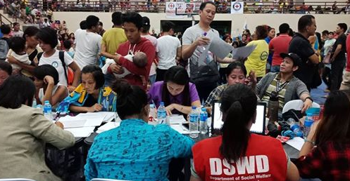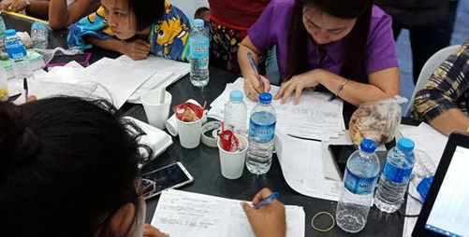

*****
The Disaster Response Operations Monitoring and Information Center (DROMIC) of the DSWD-DRMB continues to closely coordinate with concerned DSWD-Field Office for significant disaster response updates.

JAN ERWIN ANDREW I. ONTANILLAS
Releasing Officer

