DSWD DROMIC Report #11 on the
Landslide Incident in Naga City, Cebu
as of 02 October 2018, 6PM

SITUATION OVERVIEW

At around 6:00 AM on 20 September 2018, a massive landslide affected an estimated 80.12-hectare area in Sitio Sindulan, Brgy. Tinaan in Naga City, Cebu. Disaster managers said the rains may have contributed in softening the ground soil causing the sloped land to collapse. However, some residents have also pointed on the ongoing quarrying operations in the area.

Source: DSWD Field Office VII

SUMMARY

- Status of Affected Families / Persons
A total of 1,947 families or 7,863 persons were affected in 5 barangays in City of Naga, Cebu.

REGION / PROVINCE / MUNICIPALITY |  | NUMBER OF AFFECTED |  |  | NUMBER OF EVACUATION CENTERS (ECs) | NUMBER OF DISPLACED |  |  |  | TOTAL DISPLACED & SERVED
 |  |  |  |  |  | INSIDE ECs |  | OUTSIDE ECs |  | Families | Persons
 |  | Barangays | Families | Persons |  | Families | Persons | Families | Persons | Total Families | Total Persons
 |  |  |  |  | NOW | NOW | NOW | NOW | NOW | NOW | NOW
GRAND TOTAL |  | 5 | 1,947 | 7,863 | 11 | 1,689 | 6,790 | 258 | 1,073 | 1,947 | 7,863
REGION VII |  | 5 | 1,947 | 7,863 | 11 | 1,689 | 6,790 | 258 | 1,073 | 1,947 | 7,863
Cebu |  | 5 | 1,947 | 7,863 | 11 | 1,689 | 6,790 | 258 | 1,073 | 1,947 | 7,863
 | City of Naga | 5 | 1,947 | 7,863 | 10 | 1,623 | 6,546 | 258 | 1,073 | 1,881 | 7,619
 | San Fernando* | - | - | - | 1 | 66 | 244 | - | - | 66 | 244
Note: Figures reflected in the table above are subject to change as the re-validation and re-assessment are being conducted due to reported instances of double counting and ‘fake evacuees’.
There was no affected barangay and families in San Fernando, Cebu. An evacuation center was only opened in the said municipality to accommodate IDPs from Brgy. Tinaan, Naga City. Hence, the decrease in the number of affected barangays.

Source: DSWD Field Office VII

- Assistance Provided
- The City Government of Naga provided bread and coffee in the morning of 20 September 2018; food/hot meals are being served at the evacuation sites that are still open. Lunch provision came from Apo Cement, KEPCO, Provincial Board Member Yuli Daan and city government.

- Food from PSWDO for the evacuees and survivors were also distributed.
OFFICE / AGENCY | PARTICULARS | STATUS
PSWDO | 200 Rice Packs | Delivered to site
 | 200 Packs of Assorted Canned Goods
 | 600 Bottles of 500ml Water
PDRRMO | 500 food packs (Lunch) for Responders | Delivered to site

- To date, DSWD has already extended relief support and financial assistance worth ₱5,237,204.28.
DSWD ASSISTANCE | COST
Food Items | 1,736,640.00
Non-Food Items | 3,225,564.28
Cash Assistance to bereaved families | 275,000.00
Total Cost | 5,237,204.28

Situational Reports

DSWD-DRMB
DATE | SITUATIONS / ACTIONS UNDERTAKEN
02 October 2018 | - The Disaster Response Operations Monitoring and Information Center (DROMIC) of DSWD-DRMB is continuously monitoring and coordinating with DSWD-Field Office VII for significant disaster response operation updates.

FO VII
DATE | SITUATIONS / ACTIONS UNDERTAKEN
01 October 2018 | - DSWD-FO VII established an encoding station manned/supervised by its personnel. Encoding of DAFAC forms is continuously being conducted 24 hours with the help of volunteers.

PHOTO DOCUMENTATION

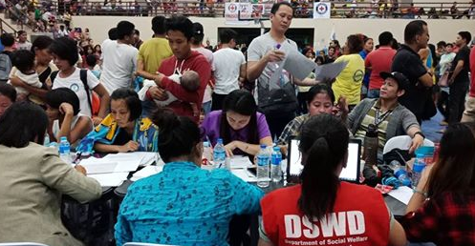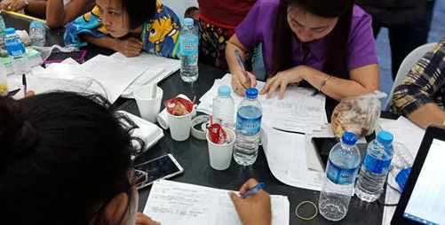

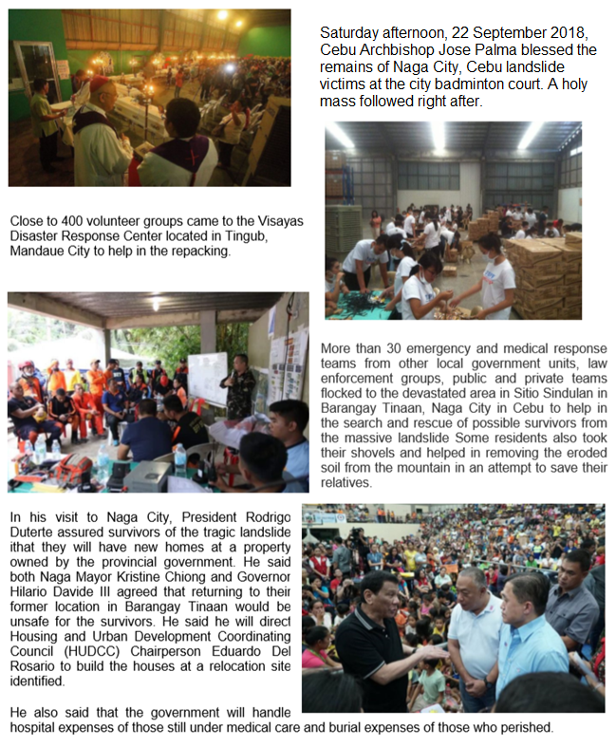*****
The Disaster Response Operations Monitoring and Information Center (DROMIC) of the DSWD-DRMB continues to closely coordinate with concerned DSWD-Field Office VII for significant disaster response updates.

JAN ERWIN ANDREW I. ONTANILLAS
Releasing Officer

