DSWD DROMIC Report #14 on the
Landslide Incident in Naga City, Cebu
as of 05 October 2018, 6PM

SITUATION OVERVIEW

At around 6:00 AM on 20 September 2018, a massive landslide affected an estimated 80.12-hectare area in Sitio Sindulan, Brgy. Tinaan in Naga City, Cebu. Disaster managers said the rains may have contributed in softening the ground soil causing the sloped land to collapse. However, some residents have also pointed on the ongoing quarrying operations in the area.

Source: DSWD Field Office VII

SUMMARY

- Status of Affected Families / Persons
A total of 1,972 families or 8,252 persons were affected in 5 barangays in City of Naga, Cebu.
REGION / PROVINCE / MUNICIPALITY |  | NUMBER OF AFFECTED |  |  | NUMBER OF EVACUATION CENTERS (ECs) | NUMBER OF INSIDE ECs |  | NUMBER OF OUTSIDE ECs |  | TOTAL DISPLACED
 |  |  |  |  |  |  |  |  |  | Total Families | Total Persons
 |  | Barangays | Families | Persons |  | Families | Persons | Families | Persons
 |  |  |  |  | NOW | NOW | NOW | NOW | NOW | NOW | NOW
GRAND TOTAL |  | 5 | 1,972 | 8,252 | 11 | 1,667 | 6,913 | 272 | 1,147 | 1,939 | 8,060
REGION VII |  | 5 | 1,972 | 8,252 | 11 | 1,667 | 6,913 | 272 | 1,147 | 1,939 | 8,060
Cebu |  | 5 | 1,972 | 8,252 | 11 | 1,667 | 6,913 | 272 | 1,147 | 1,939 | 8,060
 | City of Naga | 5 | 1,972 | 8,252 | 10 | 1,599 | 6,664 | 272 | 1,147 | 1,871 | 7,811
 | San Fernando | - | - | - | 1 | 68 | 249 | - | - | 68 | 249
Note: Figures reflected in the table above are subject to change as the re-validation and re-assessment are being conducted due to reported instances of double counting and ‘fake evacuees’.
There was no affected barangay and families in San Fernando, Cebu. An evacuation center was only opened in the said municipality to accommodate IDPs from Brgy. Tinaan, Naga City.

Source: DSWD Field Office VII

- Assistance Provided
- The City Government of Naga provided bread and coffee in the morning of 20 September 2018; food/hot meals are being served at the evacuation sites that are still open. Lunch provision came from Apo Cement, KEPCO, Provincial Board Member Yuli Daan and city government.

- Food from PSWDO for the evacuees and survivors were also distributed.
OFFICE / AGENCY | PARTICULARS | STATUS
PSWDO | 200 Rice Packs | Delivered to site
 | 200 Packs of Assorted Canned Goods
 | 600 Bottles of 500ml Water
PDRRMO | 500 food packs (Lunch) for Responders | Delivered to site

- To date, DSWD has already extended relief support and financial assistance worth ₱5,237,204.28.
DSWD ASSISTANCE | COST
Food Items | 1,736,640.00
Non-Food Items | 3,225,564.28
Cash Assistance to bereaved families | 275,000.00
Total Cost | 5,237,204.28

Situational Reports

DSWD-DRMB
DATE | SITUATIONS / ACTIONS UNDERTAKEN
05 October 2018 | - The Disaster Response Operations Monitoring and Information Center (DROMIC) of DSWD-DRMB is continuously monitoring and coordinating with DSWD-Field Office VII for significant disaster response operation updates.

FO VII
DATE | SITUATIONS / ACTIONS UNDERTAKEN
04 October 2018 | - True to its commitment, starting October 1 the city and provincial government are now taking the lead and are managing 5 big camps, namely: ECAC, Naga CES, Naga NHS, Naalad ES and Colon ES. Still DSWD camp personnel are assigned in these ECs on a 12-hour (8am-8pm & 8pm-8am shift) schedule in order to mentor/assist/guide the LGU counterparts. This was among the things discussed and agreed on by DSWD Regional Office, provincial and city government during its Camp Managers Meeting on October 1.  - Aside from the provision of technical assistance, DSWD staff inside camps are also primarily responsible for data/info management, reporting and records, including safekeeping of accurate and complete DAFAC forms.  - After the encoding of DAFAC forms, those with issues were immediately returned to each camps. DAFAC forms without stamped “encoded” were to be returned to the DSWD OpCen for updating of record. Forms forwarded to OpCen are to be returned within the day for filling. It is the duty of the CM to spearhead the tracking and validation of the DAFAC to be assisted by the Alternate CM and DSWD assigned camp personnel.  - The 24-hour DSWD Operation Center remains operational. The OpCen serves as information hub for the various stakeholders, media, government agencies and partners to get up to date statistics on IDP status.  - Inside camps, apart from data capture and info management, DSWD personnel along with donors and local counterparts, also facilitates the distribution of relief goods and packed meals, assists/facilitates volunteer groups in the various PSP activities and interventions including play therapy, stress debriefing and even orientation/learning sessions on various topics such as breastfeeding IEC for lactating mothers. Women and child friendly spaces had been established in each camp to promote their rights and welfare.  - IDPs who are homebased and/or are outside ECs were instructed to claim their assistance from the Senior Citizen/OSCA office. The schedule for the releasing and system in handling homebased IDPs is continuously being set-up and discussed in coordination with the city government of Naga.  - As agreed in the different coordination meetings conducted, a community kitchen will be put up. The list of utensils and cooking equipments provided by DSWD were already purchased by CEMEX and are available at the LGU. A menu good for two weeks was already prepared by DSWD ND III while the National Nutrition Council thru Dir. Letlet Mission has agreed to prepare the succeeding menu. With this, Camp Managers are already requested to finalize the cooks, helpers and other IDPs identified for orientation and specific assignments in the operationalization of the CK. The food to be cooked is yet to be determined vis-à-vis the menu prepared.  - DSWD continues to assist the LGU in manning the volunteers’ desk to document and guide volunteers. The LGU was taught on how to manage and assign volunteers according to their area of expertise. An orientation is being provided by DSWD to volunteers prior to their deployment.  - The Department continues to provide latest information on IDP status, responses and camp management to the different stakeholders during ICT meetings, RDRRMC, press briefings, among others.  - Since 24 September 2018, a total of 8,146 volunteers came to Naga City to offer help. Many were assigned in the repacking of donated items prior to distribution to the different camps while some volunteer groups conducted play therapy sessions, arts and crafts, and other psychosocial interventions to the families, especially the children.

PHOTO DOCUMENTATION

On 01 October 2018, another city government handed over cash assistance to Naga City. The City of Carcar headed by Mayor Nicepuro Apura turned over 1 Million Pesos to Mayor Vanessa Chiong as aid to the calamity victims. Together with Mayor Apura were Vice Mayor Barcenas and City Councilors.

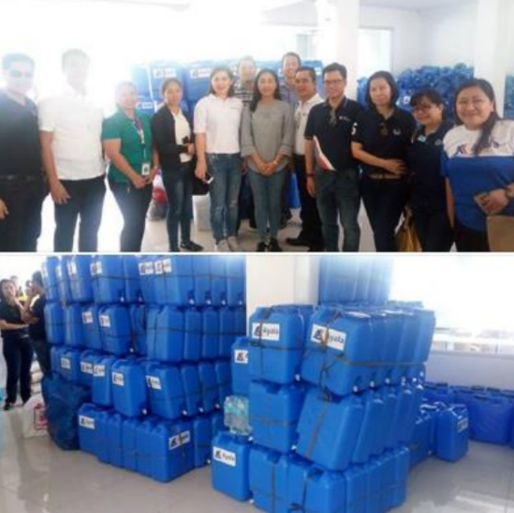

Officers of the Ayala Business Club donated 500 jerry cans and assorted relief goods to landslide victims in the City of Naga.

Aside from the relief goods and jerry cans, the water provider Cebu Manila Water Development will provide 10 cubic meters of water or one water truck to the city's evacuation centers.

The Cebu Provincial government has also announced its donation of 2.7 hectares of the 24.7-hectare Balili property to City government of Naga, for the relocation site of the landslide victims and evacuees.

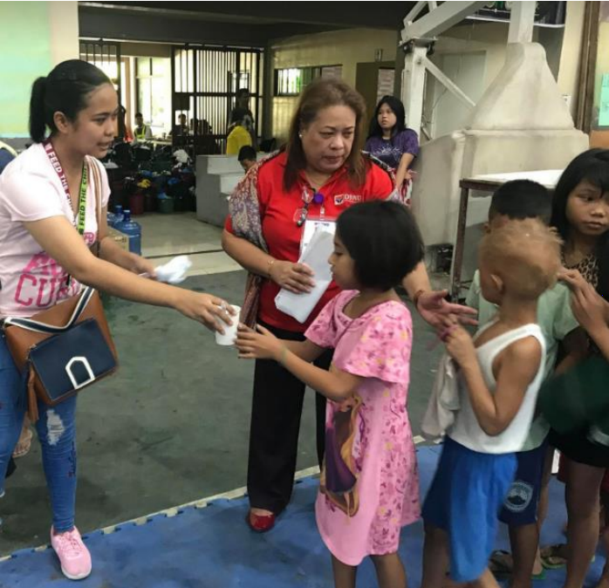
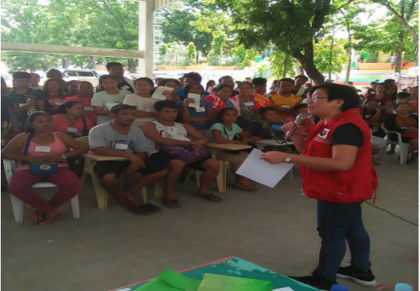
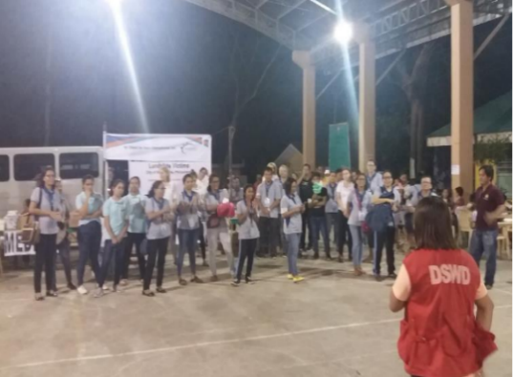
DSWD camp personnel continues to assist/facilitate volunteer groups for their relief distribution and/or activities planned for the evacuees day in and day out.

*****
The Disaster Response Operations Monitoring and Information Center (DROMIC) of the DSWD-DRMB continues to closely coordinate with concerned DSWD-Field Office VII for significant disaster response updates.

JAN ERWIN ANDREW I. ONTANILLAS
Releasing Officer

