DSWD DROMIC Report #19 on the
Landslide Incident in Naga City, Cebu
as of 5 November 2018, 7PM

SITUATION OVERVIEW

At around 6:00 AM on 20 September 2018, a massive landslide affected an estimated 80.12-hectare area in Sitio Sindulan, Brgy. Tinaan in Naga City, Cebu. Disaster managers said the rains may have contributed in softening the ground soil causing the sloped land to collapse. However, some residents have also pointed on the ongoing quarrying operations in the area.

Source: DSWD Field Office VII

SUMMARY

- Status of Affected Families / Persons
A total of 1,917 families or 7,904 persons were affected in 6 barangays in City of Naga, Cebu.

REGION / PROVINCE / MUNICIPALITY |  | NUMBER OF AFFECTED |  |  | NUMBER OF EVACUATION CENTERS (ECs) | NUMBER OF INSIDE ECs |  | NUMBER OF OUTSIDE ECs |  | TOTAL DISPLACED
 |  |  |  |  |  |  |  |  |  | Total Families | Total Persons
 |  | Barangays | Families | Persons |  | Families | Persons | Families | Persons
 |  |  |  |  | NOW | NOW | NOW | NOW | NOW | NOW | NOW
GRAND TOTAL |  | 6 | 1,998 | 7,358 | 11 | 1,558 | 6,081 | 440 | 1,277 | 1,998 | 7,358
REGION VII |  | 6 | 1,998 | 7,358 | 11 | 1,558 | 6,081 | 440 | 1,277 | 1,998 | 7,358
Cebu |  | 6 | 1,998 | 7,358 | 11 | 1,558 | 6,081 | 440 | 1,277 | 1,998 | 7,358
 | City of Naga | 6 | 1,998 | 7,358 | 10 | 1,494 | 5,858 | 440 | 1,277 | 1,934 | 7,135

Note: Figures reflected in the table above are subject to change as the re-validation and re-assessment are being conducted due to reported instances of double counting and “fake evacuees”.
There was no affected barangay and families in San Fernando, Cebu. An evacuation center was only opened in the said municipality to accommodate IDPs from Brgy. Tinaan, Naga City.

Source: DSWD Field Office VII

- Assistance Provided
- The City Government of Naga provided bread and coffee in the morning of 20 September 2018; food/hot meals are being served at the evacuation sites that are still open. Lunch provision came from Apo Cement, KEPCO, Provincial Board Member Yuli Daan and city government.

- Food from PSWDO for the evacuees and survivors were also distributed.
OFFICE / AGENCY | PARTICULARS | STATUS
PSWDO | 200 Rice Packs | Delivered to site
 | 200 Packs of Assorted Canned Goods
 | 600 Bottles of 500ml Water
PDRRMO | 500 food packs (Lunch) for Responders | Delivered to site

- The City Government of Naga spent ₱2,968,000.00 for burial expenses, and also handed check worth ₱20,000.00 to each of the 56 bereaved families amounting to ₱1,120,000.00. Medical assistance to the injured individuals were also provided as well as financial aid to those who are taking care of them in the hospital.

- To date, DSWD has already extended relief support and financial assistance worth ₱5,237,204.28.
DSWD ASSISTANCE | COST
Food Items | 1,736,640.00
Non-Food Items | 3,225,564.28
Cash Assistance to bereaved families | 275,000.00
Total Cost | 5,237,204.28

- Damaged Houses
There were 57 houses reported as totally damaged due to the landslide incident.

Source: OCD-7

Situational Reports

DSWD-DRMB
DATE | SITUATIONS / ACTIONS UNDERTAKEN
13 October 2018 | - The Disaster Response Operations Monitoring and Information Center (DROMIC) of DSWD-DRMB is continuously monitoring and coordinating with DSWD-Field Office VII for significant disaster response operation updates.

FO VII
DATE | SITUATIONS / ACTIONS UNDERTAKEN
5 November 2018 | - As of 24 October 2018, 3PM, the City Government of Naga has received a total of ₱14,214,819.20 cash donations.  - The City Government of Naga offered up to ₱150,000.00 financial assistance to an initial 444 families living in areas identified by the MGB as delineated critical or danger zones to prevent them from returning to their homes.  - Aside from the financial assistance, the affected families will also be given the option to accept the housing provided by the NHA in two identified relocation sites in the Balili property in Naga City and in Brgy. Valencia in Carcar City.  - DSWD-FO VII, together with LGU and provincial personnel continue to man camps in order to record/monitor the whereabouts of the IDPs especially as they return to camps from a long holiday in the observance of Undas.

PHOTO DOCUMENTATION

On 01 October 2018, another city government handed over cash assistance to Naga City. The City of Carcar headed by Mayor Nicepuro Apura turned over 1 Million Pesos to Mayor Vanessa Chiong as aid to the calamity victims. Together with Mayor Apura were Vice Mayor Barcenas and City Councilors.
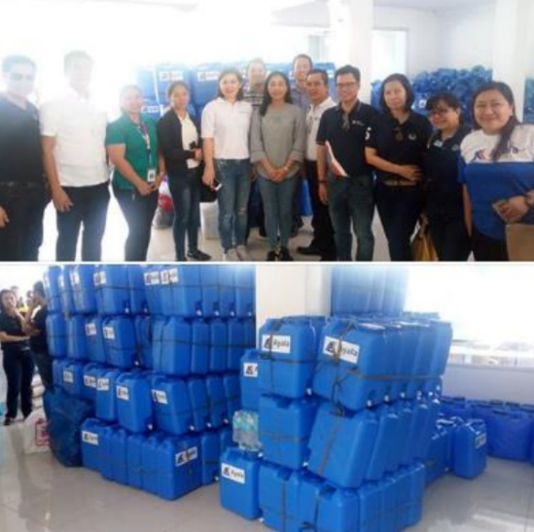

Officers of the Ayala Business Club donated 500 jerry cans and assorted relief goods to landslide victims in the City of Naga.

Aside from the relief goods and jerry cans, the water provider Cebu Manila Water Development will provide 10 cubic meters of water or one water truck to the city's evacuation centers.

The Cebu Provincial government has also announced its donation of 2.7 hectares of the 24.7-hectare Balili property to City government of Naga, for the relocation site of the landslide victims and evacuees.

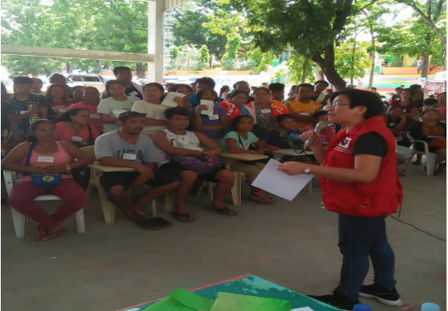
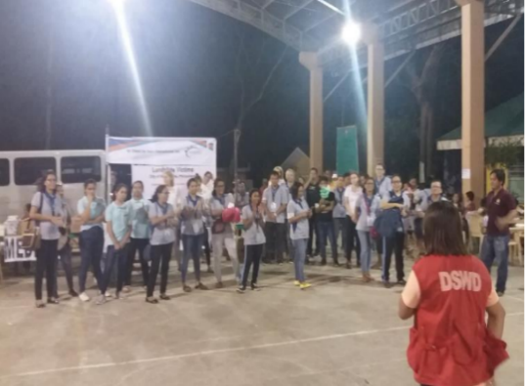
DSWD camp personnel continues to assist/facilitate volunteer groups for their relief distribution and/or activities planned for the evacuees day in and day out.

*****
The Disaster Response Operations Monitoring and Information Center (DROMIC) of the DSWD-DRMB continues to closely coordinate with concerned DSWD-Field Office VII for significant disaster response updates.

MARC LEO L. BUTAC
Releasing Officer

