DSWD DROMIC Report #2 on the
Landslide Incident in Naga City, Cebu
as of 21 September 2018, 7PM

SITUATION OVERVIEW

Days of heavy monsoon rains caused a steep slope to collapse in Brgy. Tinaan, Naga City, Cebu at around 6:00 in the morning on 20 September 2018. At least 14 houses were directly affected, buried 8 feet deep or more (Cebu PDRRM SitRep #3 as of 2000H).
Source: DSWD FO VII

SUMMARY

REGION / PROVINCE / MUNICIPALITY |  | NUMBER OF AFFECTED |  |  | NUMBER OF EVACUATION CENTERS (ECs) |  | INSIDE ECs |  |  |  | TOTAL DISPLACED
 |  |  |  |  |  |  |  |  |  |  | Families |  | Persons
 |  | Barangays | Families | Persons |  |  | Families |  | Persons |  | Total Families |  | Total Persons
 |  |  |  |  | CUM | NOW | CUM | NOW | CUM | NOW | CUM | NOW | CUM | NOW
GRAND TOTAL |  | 1 | 585 | 1,780 | 5 | 5 | 785 | 785 | 2,481 | 2,481 | 785 | 785 | 2,481 | 2,481
REGION VII |  | 1 | 585 | 1,780 | 5 | 5 | 785 | 785 | 2,481 | 2,481 | 785 | 785 | 2,481 | 2,481
Cebu |  | 1 | 585 | 1,780 | 5 | 5 | 785 | 785 | 2,481 | 2,481 | 785 | 785 | 2,481 | 2,481
 | City of Naga | 1 | 585 | 1,780 | 5 | 5 | 785 | 785 | 2,481 | 2,481 | 785 | 785 | 2,481 | 2,481
Note: Ongoing assessment and validation.
Source: DSWD FO VII

Summary of Assistance Provided
- City government provided bread and coffee in the morning of 20 September 2018, food/hot meals are being served at evacuation sites opened. Lunch provision came from Apo Cement, KEPCO, Provincial Board Member Yuli Daan and city government.
- Food from PSWDO for the evacuees and survivors were also distributed

Office/Agency | Particulars | Status
PSWDO | 200 Rice Packs  200 Packs of Assorted Canned Goods  600 Bottles of 500ml Water | Delivered to site
PDRRMO | 500 foodpacks (Lunch) for Responders | Delivered to site
- DSWD-FO VII initially provided food and non-food items worth ₱1,553,015.00 consisting of the following:
ITEM | QUANTITY | UNIT COST | TOTAL
Family Food Packs | 1,500 | 360.00 | 540,000.00
Sleeping Kit | 500 | 619.03 | 309,515.00
Dining Kit | 500 | 342.00 | 171,000.00
Malong | 1,000 | 250.00 | 250,000.00
Hygiene Kit | 500 | 365.00 | 182,500.00
Water Container | 500 | 200.00 | 100,000.00
GRAND TOTAL |  |  | 1,553,015.00

Situational Reports

DSWD-DRMB
DATE | SITUATIONS / ACTIONS UNDERTAKEN
20 September 2018 to present | - The Disaster Response Operations Monitoring and Information Center (DROMIC) of DSWD-DRMB is on 24/7 duty and continuously monitoring and coordinating with DSWD-Field Office VII for significant disaster response operations updates.

FO VII
DATE | SITUATIONS / ACTIONS UNDERTAKEN
21 September 2018 | - Class suspensions were declared to more than a dozen schools in the area as rescue operations continue.  - Additional food and non-food items will be delivered on site to respond to the increasing number of IDPs.
20 September 2018 | - ICP was set up at the basketball court of Sitio Sindulan at 9:00 in the morning on 20 September 2018. Safety briefing was conducted to all responders from various LGUs. Cebu Governor earlier called for the deployment of all rescuers and volunteers including heavy equipment to the area. DRRM responders from as far as Medellin, Bogo City, Alegria, Tabogon among others came to the site bringing with them additional excavation tools and equipment.  - Search and rescue operations began as early as 6:00 in the morning on 20 September 2018 and responders were digging through the debris and thick mud to look for survivors. However, as of 4:30PM, SAR operations of the LGU responders were temporarily suspended. Only the Province, City of Naga responders and some uniformed personnel are allowed on site (ground zero) to continue the operation.  - RDRRMC-7 conducted an emergency meeting with concerned agencies, IMT and Naga City Mayor in the afternoon in Naga City Hall.  - Incident Command System activated for the management of the operations.
20 September 2018 to present | - At least 11 staff of DSWD City Action Team are on site to assist the LGU in the intake, along with 13 other DSWD Regional staff headed by Regional Director Ma. Evelyn B. Macapobre. More staff will be augmented on site.  - DSWD-FO VII Quick Response Team is on standby for any assistance needed.

PHOTO DOCUMENTATION

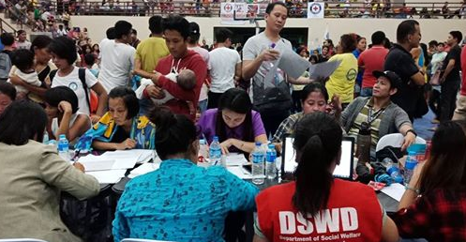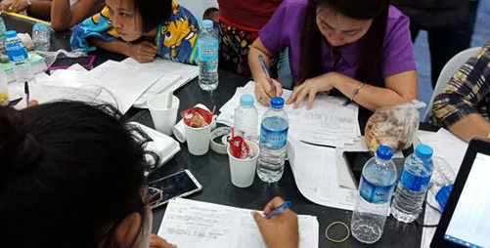

*****
The Disaster Response Operations Monitoring and Information Center (DROMIC) of the DSWD-DRMB continues to closely coordinate with concerned DSWD-Field Office for significant disaster response updates.

MARC LEO L. BUTAC
Releasing Officer

