DSWD DROMIC Report #20 on the
Landslide Incident in Naga City, Cebu
as of 13 November 2018, 6PM

SITUATION OVERVIEW

At around 6:00 AM on 20 September 2018, a massive landslide affected an estimated 80.12-hectare area in Sitio Sindulan, Brgy. Tinaan in Naga City, Cebu. Disaster managers said the rains may have contributed in softening the ground soil causing the sloped land to collapse. However, some residents have also pointed on the ongoing quarrying operations in the area.

Source: DSWD Field Office VII

SUMMARY

- Status of Affected Families / Persons
A total of 1,998 families or 7,358 persons were affected in 6 barangays in City of Naga, Cebu.
REGION / PROVINCE / MUNICIPALITY |  | NUMBER OF AFFECTED |  |  | NUMBER OF EVACUATION CENTERS (ECs) |  | INSIDE ECs |  |  |  | OUTSIDE ECs |  |  |  | TOTAL SERVED
 |  |  |  |  |  |  |  |  |  |  |  |  |  |  | Families |  | Persons
 |  | Barangays | Families | Persons |  |  | Families |  | Persons |  | Families |  | Persons |  | Total Families |  | Total Persons
 |  |  |  |  | CUM | NOW | CUM | NOW | CUM | NOW | CUM | NOW | CUM | NOW | CUM | NOW | CUM | NOW
GRAND TOTAL |  | 6 | 1,998 | 7,358 | 11 | 10 | 1,558 | 1,053 | 6,081 | 4,342 | 440 | 440 | 1,277 | 1,277 | 1,998 | 1,493 | 7,358 | 5,619
REGION VII |  | 6 | 1,998 | 7,358 | 11 | 10 | 1,558 | 1,053 | 6,081 | 4,342 | 440 | 440 | 1,277 | 1,277 | 1,998 | 1,493 | 7,358 | 5,619
Cebu |  | 6 | 1,998 | 7,358 | 11 | 10 | 1,558 | 1,053 | 6,081 | 4,342 | 440 | 440 | 1,277 | 1,277 | 1,998 | 1,493 | 7,358 | 5,619
 | City of Naga | 6 | 1,998 | 7,358 | 10 | 10 | 1,494 | 1,053 | 5,858 | 4,342 | 440 | 440 | 1,277 | 1,277 | 1,934 | 1,493 | 7,135 | 5,619
 | San Fernando | - | - | - | 1 | - | 64 | - | 223 | - | - | - | - | - | 64 | - | 223 | -
Note: Figures reflected in the table above are subject to change as the re-validation and re-assessment are being conducted due to reported instances of double counting and “fake evacuees”.
There was no affected barangay and families in San Fernando, Cebu. An evacuation center was only opened in the said municipality to accommodate IDPs from Brgy. Tinaan, Naga City.

Source: DSWD Field Office VII

- Assistance Provided
- The City Government of Naga provided bread and coffee in the morning of 20 September 2018; food/hot meals are being served at the evacuation sites that are still open. Lunch provision came from Apo Cement, KEPCO, Provincial Board Member Yuli Daan and city government.

- Food from PSWDO for the evacuees and survivors were also distributed.
OFFICE / AGENCY | PARTICULARS | STATUS
PSWDO | 200 Rice Packs | Delivered to site
 | 200 Packs of Assorted Canned Goods
 | 600 Bottles of 500ml Water
PDRRMO | 500 food packs (Lunch) for Responders | Delivered to site

- The City Government of Naga spent ₱2,968,000.00 for burial expenses, and also handed check worth ₱20,000.00 to each of the 56 bereaved families amounting to ₱1,120,000.00. Medical assistance to the injured individuals were also provided as well as financial aid to those who are taking care of them in the hospital.

- To date, DSWD has already extended relief support and financial assistance worth ₱5,237,204.28.
REGION / PROVINCE / MUNICIPALITY |  | TOTAL COST OF ASSISTANCE
 |  | DSWD | LGU | NGOs | OTHERS | GRAND TOTAL
GRAND TOTAL |  | 5,273,204.28 | 14,214,819.20 | - | - | 19,488,023.48
REGION VII |  | 5,273,204.28 | 14,214,819.20 | - | - | 19,488,023.48
Cebu |  | 5,273,204.28 | 14,214,819.20 | - | - | 19,488,023.48
 | City of Naga | 5,273,204.28 | 14,214,819.20 | - | - | 19,488,023.48

- Damaged Houses
There were 57 houses reported as totally damaged due to the landslide incident.

Source: OCD-7

Situational Reports

DSWD-DRMB
DATE | SITUATIONS / ACTIONS UNDERTAKEN
13 October 2018 - Present | - The Disaster Response Operations Monitoring and Information Center (DROMIC) of DSWD-DRMB is continuously monitoring and coordinating with DSWD-Field Office VII for significant disaster response operation updates.

FO VII
DATE | SITUATIONS / ACTIONS UNDERTAKEN
- November 2018 | - Only 10 camps remained open. EC located in San Fernando town was closed on November 9 since complex will be used by LGU. All families staying in San Fernando were transferred to Cepoc ES.  - City government of Naga, in coordination with the DENR-MGB had been conducting a series of IEC and community dialogues on October 31 until November 5 regarding the results of the delineation. Atleast 444 families fall within the danger zone or nearest the landslide area as per DENR-MGB Map. These are the families who could no longer return to their homes. During these dialogues, City Mayor also presented the Relocation Plan of the city government.  - On Friday, LGU also visited camps where there were families from Brgy. Mainit. A dialogue was also conducted and delineation map was again presented. All those whose houses considered as safe were already given the green light to go home. To date, at least 300 families from Brgy. Mainit who were staying in Naga CES and NHS camp were discharged and finally was able to go home.  - Aside from the 444 families who were already expected to exit camp, other families from Inoburan, Naalad, Pangdan, Tinaan and Cabungahan have already started to leave camps after they were given clearance by the LGU.  - At least 100 families (as of Saturday) affected by the landslide have already received their checks from the Naga City government. The city gave the financial aid regardless of whether or not the family participated in the class action suit filed last week. Distribution will continue until all 444 families will receive their checks. The 444 families were identified based on the first delineation map, which covered over 170 hectares within and surrounding ground zero.  - Processing and releasing of checks were done at the City Treasurer’s Office. Recipients were asked to present the manifest or declaration as proof that they were among those whose houses located within the critical zone identified by MGB. City Mayor encouraged the survivors to use the financial assistance to look for a place to rent while they wait for the completion of the housing units. This is also a way to decongest the evacuation centers.  - Two relocation sites were presented to the 444 families: Barangay Valencia in Carcar City, which has 200 housing units constructed by the National Housing Authority (NHA) and ready for occupancy, and the Balili Property, which will soon host 320 units from the NHA and 50 units from the LGU.  - DSWD, together with LGU and provincial (outsourced) personnel continues to man camps while DSWD OpCen, located at the City Hall building remains operational.

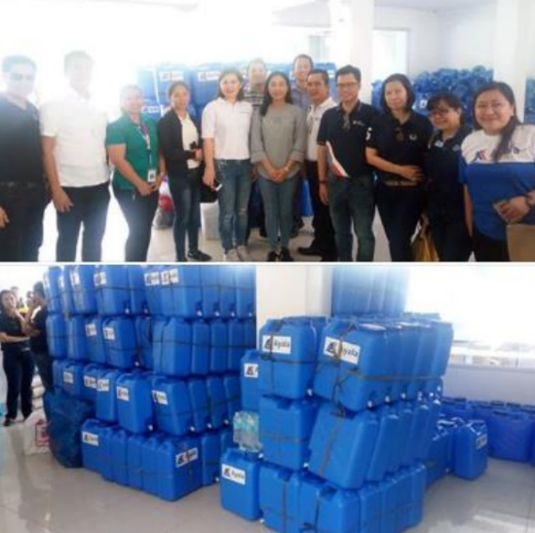
PHOTO DOCUMENTATION

On 01 October 2018, another city government handed over cash assistance to Naga City. The City of Carcar headed by Mayor Nicepuro Apura turned over 1 Million Pesos to Mayor Vanessa Chiong as aid to the calamity victims. Together with Mayor Apura were Vice Mayor Barcenas and City Councilors.

Officers of the Ayala Business Club donated 500 jerry cans and assorted relief goods to landslide victims in the City of Naga.

Aside from the relief goods and jerry cans, the water provider Cebu Manila Water Development will provide 10 cubic meters of water or one water truck to the city's evacuation centers.

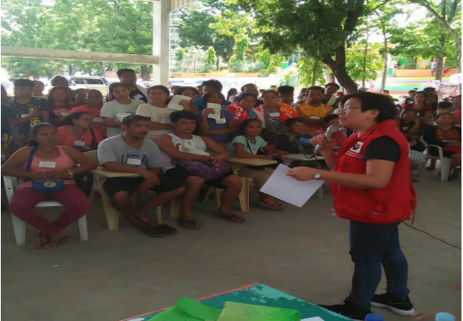
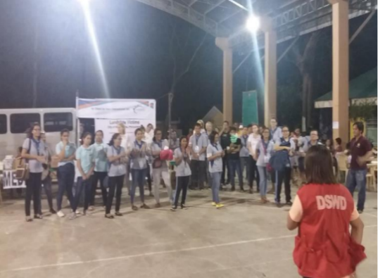

The Cebu Provincial government has also announced its donation of 2.7 hectares of the 24.7-hectare Balili property to City government of Naga, for the relocation site of the landslide victims and evacuees.

DSWD camp personnel continues to assist/facilitate volunteer groups for their relief distribution and/or activities planned for the evacuees day in and day out.

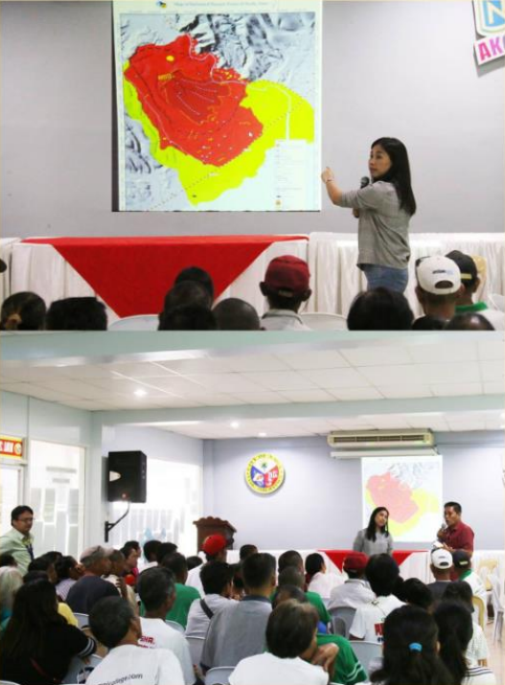
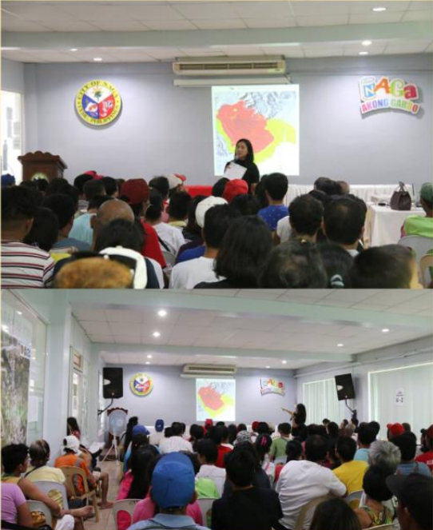

Information and Education Campaign and Community Dialogue
Purok Abaca I & II, Kawa I & II, and Tal-ot in Barangay Mainit and Purok Corssing in Barangay Naalad, November 1, 2018
Information and Education Campaign and Community Dialogue
Sitio Regla particulary Purok Gumamela in Barangay Cabungahan, November 5, 2018

*****
The Disaster Response Operations Monitoring and Information Center (DROMIC) of the DSWD-DRMB continues to closely coordinate with concerned DSWD-Field Office VII for significant disaster response updates.

JAN ERWIN ANDREW I. ONTANILLAS
Releasing Officer

