DSWD DROMIC Report #21 on the
Landslide Incident in Naga City, Cebu
as of 23 November 2018, 6PM

SITUATION OVERVIEW

At around 6:00 AM on 20 September 2018, a massive landslide affected an estimated 80.12-hectare area in Sitio Sindulan, Brgy. Tinaan in Naga City, Cebu. Disaster managers said the rains may have contributed in softening the ground soil causing the sloped land to collapse. However, some residents have also pointed on the ongoing quarrying operations in the area.

Source: DSWD Field Office VII

SUMMARY

- Status of Affected Families / Persons
A total of 2,087 families or 8,655 persons were affected in 6 barangays in City of Naga, Cebu.

REGION / PROVINCE / MUNICIPALITY |  | NUMBER OF AFFECTED |  |  | NUMBER OF EVACUATION CENTERS (ECs) |  | INSIDE ECs |  |  |  | OUTSIDE ECs |  |  |  | TOTAL SERVED
 |  |  |  |  |  |  |  |  |  |  |  |  |  |  | Families |  | Persons
 |  | Barangays | Families | Persons |  |  | Families |  | Persons |  | Families |  | Persons |  | Total Families |  | Total Persons
 |  |  |  |  | CUM | NOW | CUM | NOW | CUM | NOW | CUM | NOW | CUM | NOW | CUM | NOW | CUM | NOW
GRAND TOTAL |  | 6 | 2,087 | 8,655 | 11 | 10 | 1,585 | 1,014 | 7,303 | 3,981 | 332 | - | 1,352 | - | 1,917 | 1,014 | 8,655 | 3,981
REGION VII |  | 6 | 2,087 | 8,655 | 11 | 10 | 1,585 | 1,014 | 7,303 | 3,981 | 332 | - | 1,352 | - | 1,917 | 1,014 | 8,655 | 3,981
Cebu |  | 6 | 2,087 | 8,655 | 11 | 10 | 1,585 | 1,014 | 7,303 | 3,981 | 332 | - | 1,352 | - | 1,917 | 1,014 | 8,655 | 3,981
 | City of Naga | 6 | 2,087 | 8,655 | 10 | 10 | 1,514 | 1,014 | 7,043 | 3,981 | 332 | - | 1,352 | - | 1,846 | 1,014 | 8,395 | 3,981
 | San Fernando | - | - | - | 1 | - | 71 | - | 260 | - | - | - | - | - | 71 | - | 260 | -
Note: Figures reflected in the table above are subject to change as the re-validation and re-assessment are being conducted due to reported instances of double counting and “fake evacuees”.
Number of affected families and persons is based on the DSWD DAFAC encoding.
There was no affected barangay and families in San Fernando, Cebu. An evacuation center was only opened in the said municipality to accommodate IDPs from Brgy. Tinaan, Naga City.

Source: DSWD Field Office VII

- Assistance Provided
To date, DSWD has already extended relief support and financial assistance worth ₱5,636,804.28 and the LGU provided ₱14,214,819.20 worth of relief assistance.

REGION / PROVINCE / MUNICIPALITY |  | TOTAL COST OF ASSISTANCE
 |  | DSWD | LGU | NGOs | OTHERS | GRAND TOTAL
GRAND TOTAL |  | 5,636,804.28 | 14,214,819.20 | - | - | 19,851,623.48
REGION VII |  | 5,636,804.28 | 14,214,819.20 | - | - | 19,851,623.48
Cebu |  | 5,636,804.28 | 14,214,819.20 | - | - | 19,851,623.48
 | City of Naga | 5,636,804.28 | 14,214,819.20 | - | - | 19,851,623.48

- Damaged Houses
There were 57 houses reported as totally damaged due to the landslide incident.

Source: OCD-7

Situational Reports

DSWD-DRMB
DATE | SITUATIONS / ACTIONS UNDERTAKEN
13 October 2018 - Present | - The Disaster Response Operations Monitoring and Information Center (DROMIC) of DSWD-DRMB is continuously monitoring and coordinating with DSWD-Field Office VII for significant disaster response operation updates.

FO VII
DATE | SITUATIONS / ACTIONS UNDERTAKEN
23 November 2018 | - On 21 November 2018, DSWD delivered and distributed additional 1,010 family food packs to families inside evacuation centers in Naga City.  - On 17 November 2018, camps made their community kitchen operational with equipment and kitchenware provided by Apo Cement Corporation and ingredients from the City Government.

PHOTO DOCUMENTATION

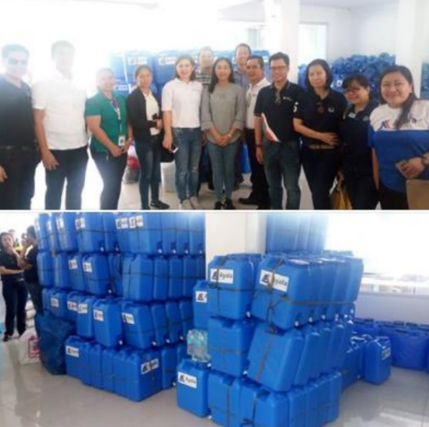

On 01 October 2018, another city government handed over cash assistance to Naga City. The City of Carcar headed by Mayor Nicepuro Apura turned over 1 Million Pesos to Mayor Vanessa Chiong as aid to the calamity victims. Together with Mayor Apura were Vice Mayor Barcenas and City Councilors.

Officers of the Ayala Business Club donated 500 jerry cans and assorted relief goods to landslide victims in the City of Naga.

Aside from the relief goods and jerry cans, the water provider Cebu Manila Water Development will provide 10 cubic meters of water or one water truck to the city's evacuation centers.

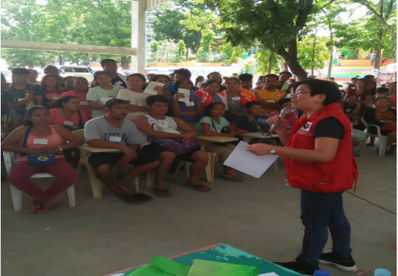
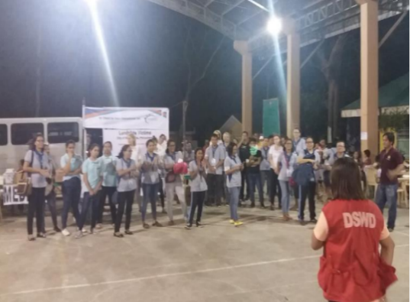

The Cebu Provincial government has also announced its donation of 2.7 hectares of the 24.7-hectare Balili property to City government of Naga, for the relocation site of the landslide victims and evacuees.

DSWD camp personnel continues to assist/facilitate volunteer groups for their relief distribution and/or activities planned for the evacuees day in and day out.

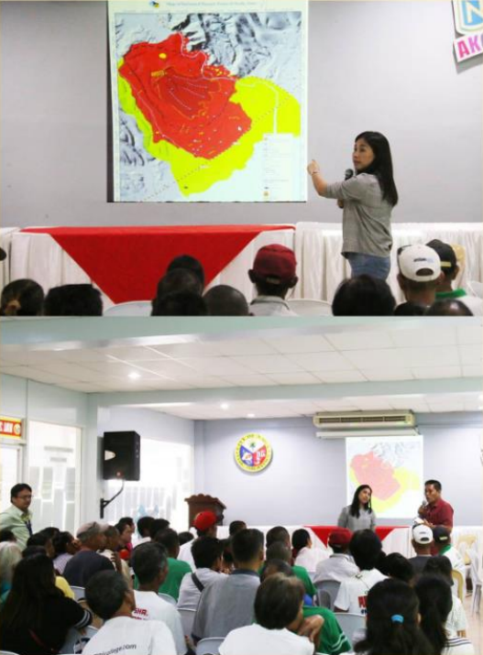
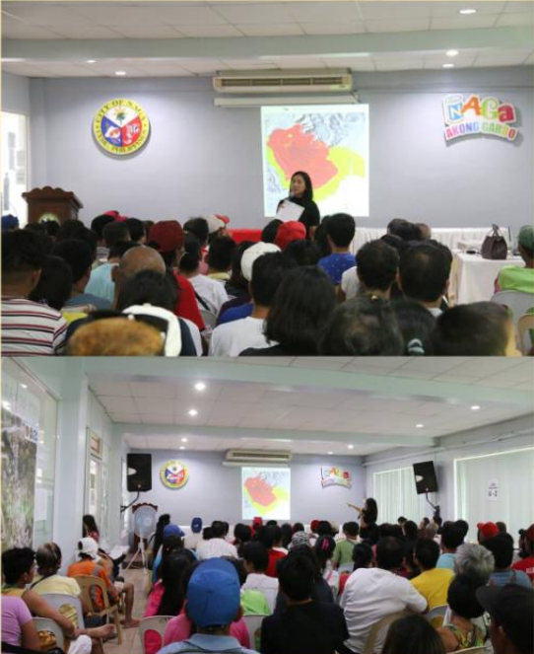

Information and Education Campaign and Community Dialogue
Purok Abaca I & II, Kawa I & II, and Tal-ot in Barangay Mainit and Purok Corssing in Barangay Naalad, November 1, 2018
Information and Education Campaign and Community Dialogue
Sitio Regla particulary Purok Gumamela in Barangay Cabungahan, November 5, 2018

*****
The Disaster Response Operations Monitoring and Information Center (DROMIC) of the DSWD-DRMB continues to closely coordinate with concerned DSWD-Field Office VII for significant disaster response updates.

MARC LEO L. BUTAC
Releasing Officer

