DSWD DROMIC Report #3 on the
Landslide Incident in Naga City, Cebu
as of 21 September 2018, 11PM

SITUATION OVERVIEW

Days of heavy monsoon rains caused a steep slope to collapse in Brgy. Tinaan, Naga City, Cebu at around 6:00 in the morning on 20 September 2018. At least 14 houses were directly affected, buried 8 feet deep or more (Cebu PDRRM SitRep #3 as of 2000H).
Source: DSWD FO VII

SUMMARY
REGION / PROVINCE / MUNICIPALITY |  | NUMBER OF AFFECTED |  |  | NUMBER OF EVACUATION CENTERS (ECs) |  | INSIDE ECs |  |  |  | TOTAL DISPLACED
 |  |  |  |  |  |  |  |  |  |  | Families |  | Persons
 |  | Barangays | Families | Persons |  |  | Families |  | Persons |  | Total Families |  | Total Persons
 |  |  |  |  | CUM | NOW | CUM | NOW | CUM | NOW | CUM | NOW | CUM | NOW
GRAND TOTAL |  | 5 | 897 | 2,836 | 5 | 5 | 897 | 897 | 2,836 | 2,836 | 897 | 897 | 2,836 | 2,836
REGION VII |  | 5 | 897 | 2,836 | 5 | 5 | 897 | 897 | 2,836 | 2,836 | 897 | 897 | 2,836 | 2,836
Cebu |  | 5 | 897 | 2,836 | 5 | 5 | 897 | 897 | 2,836 | 2,836 | 897 | 897 | 2,836 | 2,836
 | City of Naga | 5 | 897 | 2,836 | 5 | 5 | 897 | 897 | 2,836 | 2,836 | 897 | 897 | 2,836 | 2,836
Note: Ongoing assessment and validation.
Source: DSWD FO VII

Summary of Assistance Provided
- City government provided bread and coffee in the morning of 20 September 2018, food/hot meals are being served at evacuation sites opened. Lunch provision came from Apo Cement, KEPCO, Provincial Board Member Yuli Daan and city government.
- Food from PSWDO for the evacuees and survivors were also distributed

Office/Agency | Particulars | Status
PSWDO | 200 Rice Packs  200 Packs of Assorted Canned Goods  600 Bottles of 500ml Water | Delivered to site
PDRRMO | 500 foodpacks (Lunch) for Responders | Delivered to site
- DSWD-FO VII initially provided food and non-food items worth ₱2,018,919.50 consisting of the following:
Date | Item | Quantity | Cost per Item | Total
Sept 20, Thursday  P1,553,015.00 | Family Food Packs | 1,500 | 360 | 540,000.00
 | Sleeping Kit | 500 | 619.03 | 309,515.00
 | Dining Kit | 500 | 342 | 171,000.00
 | Malong | 1000 | 250 | 250,000.00
 | Hygiene Kit | 500 | 365 | 182,500.00
 | Water Container | 500 | 200 | 100,000.00
Sept 21 Friday  P465,904.50 | Family Food Packs | 450 | 360 | 162,000.00
 | Sleeping Kit | 150 | 619.03 | 92,854.50
 | Dining Kit | 150 | 342 | 51,300.00
 | Malong | 300 | 250 | 75,000.00
 | Hygiene Kit | 150 | 365 | 54,750.00
 | Water Container | 150 | 200 | 30,000.00

Situational Reports

DSWD-DRMB
DATE | SITUATIONS / ACTIONS UNDERTAKEN
20 September 2018 to present | - The Disaster Response Operations Monitoring and Information Center (DROMIC) of DSWD-DRMB is on 24/7 duty and continuously monitoring and coordinating with DSWD-Field Office VII for significant disaster response operations updates.

FO VII
DATE | SITUATIONS / ACTIONS UNDERTAKEN
21 September 2018 | - Class suspensions were declared to more than a dozen schools in the area as rescue operations continue.  - Additional food and non-food items will be delivered on site to respond to the increasing number of IDPs.  - At 1145H yesterday, 20 September 2018, City Mayor has placed 5 barangays under a state of calamity -Tinaan, Naalad, Mainit, Pangdan and Cabungahan.  - Forced evacuation ordered in Brgy. Tinaan.  - Regional Warehouse including the VDRC are now manually repacking with the help of volunteer groups mobilized from schools and universities and other private institutions. CFW are also being utilized in order to hasten production.  - At around 1830H today, PRRD visited Enan Chiong Activity Center, where close to 500 families are temporarily taking shelter. He consoled the families especially whose members were buried in the landslide. With him were SAP Bong Go, DENR Secretary and DSWD Acting Secretary Virginia Orogo.  - More than 50 DSWD regional and field staff were mobilized and spread across the opened evacuation centers in order to provide support to LGU personnel in the assessment and intake of displaced families, relief/logistical needs, including the provision of psychosocial support most especially to children in evacuation centers.
20 September 2018 | - ICP was set up at the basketball court of Sitio Sindulan at 9:00 in the morning on 20 September 2018. Safety briefing was conducted to all responders from various LGUs. Cebu Governor earlier called for the deployment of all rescuers and volunteers including heavy equipment to the area. DRRM responders from as far as Medellin, Bogo City, Alegria, Tabogon among others came to the site bringing with them additional excavation tools and equipments.  - Search and rescue operations began as early as 6:00 in the morning on 20 September 2018 and responders were digging through the debris and thick mud to look for survivors. However, as of 4:30PM, SAR operations of the LGU responders were temporarily suspended. Only the Province, City of Naga responders and some uniformed personnel are allowed on site (ground zero) to continue the operation.  - RDRRMC-7 conducted an emergency meeting with concerned agencies, IMT and Naga City Mayor in the afternoon in Naga City Hall.  - Incident Command System activated for the management of the operations.
20 September 2018 to present | - At least 11 staff of DSWD City Action Team are on site to assist the LGU in the intake, along with 13 other DSWD Regional staff headed by Regional Director Ma. Evelyn B. Macapobre. More staff will be augmented on site.  - DSWD-FO VII Quick Response Team is on standby for any assistance needed.

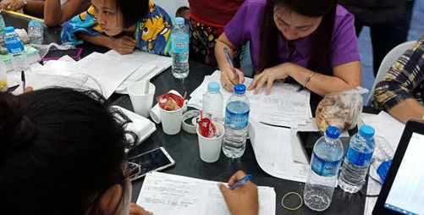
PHOTO DOCUMENTATION
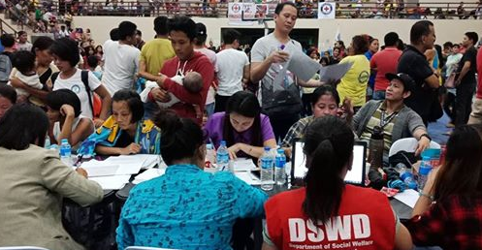

*****
The Disaster Response Operations Monitoring and Information Center (DROMIC) of the DSWD-DRMB continues to closely coordinate with concerned DSWD-Field Office for significant disaster response updates.

JAN ERWIN ANDREW I. ONTANILLAS
Releasing Officer

