DSWD DROMIC Report #7 on the
Landslide Incident in Naga City, Cebu
as of 25 September 2018, 4AM

SITUATION OVERVIEW

At around 0600H on 20 September 2018, a massive landslide affected an estimated 80.12 hectare area in Sitio Sindulan, Brgy. Tinaan in Naga City, Cebu. Disaster managers said the rains may have contributed in softening the ground soil causing the sloped land to collapse. However, some residents have also pointed on the ongoing quarrying operations in the area.

Source: DSWD FO VII

SUMMARY

- Status of Affected Families / Persons
A total of 1,493 families or 6,208 persons were affected in 5 barangays in City of Naga, Cebu.
REGION / PROVINCE / MUNICIPALITY |  | NUMBER OF AFFECTED |  |  | NUMBER OF EVACUATION CENTERS (ECs) | NUMBER OF INSIDE ECs |  | NUMBER OF OUTSIDE ECs |  | TOTAL DISPLACED
 |  |  |  |  |  |  |  |  |  | Total Families | Total Persons
 |  | Barangays | Families | Persons |  | Families | Persons | Families | Persons
 |  |  |  |  | NOW | NOW | NOW | NOW | NOW | NOW | NOW
GRAND TOTAL |  | 5 | 1,493 | 6,208 | 10 | 1,458 | 6,208 | 70 | 281 | 1,528 | 6,489
REGION VII |  | 5 | 1,493 | 6,208 | 10 | 1,458 | 6,208 | 70 | 281 | 1,528 | 6,489
Cebu |  | 5 | 1,493 | 6,208 | 10 | 1,458 | 6,208 | 70 | 281 | 1,528 | 6,489
 | City of Naga | 5 | 1,493 | 6,208 | 10 | 1,458 | 6,208 | 70 | 281 | 1,528 | 6,489
Note: Ongoing assessment and validation.
Source: DSWD FO VII

- Assistance Provided
- City government provided bread and coffee in the morning of 20 September 2018, food/hot meals are being served at evacuation sites opened. Lunch provision came from Apo Cement, KEPCO, Provincial Board Member Yuli Daan and city government.
- Food from PSWDO for the evacuees and survivors were also distributed
OFFICE/AGENCY |  | PARTICULARS | STATUS
PSWDO |  | 200 Rice Packs | Delivered to site
 |  | 200 Packs of Assorted Canned Goods
 |  | 600 Bottles of 500ml Water
PDRRMO |  | 500 food packs (Lunch) for Responders | Delivered to site

- DSWD-FO VII initially provided food and non-food items worth ₱2,018,919.50 consisting of the following:

DATE | ITEM | QUANTITY | UNIT COST | TOTAL
21 September 22, 2018, Friday | Family Food Packs | 31,414 | 360 | 1,229,040.00
 | Sleeping Kit | 1,138 | 619 | 704,456.14
 | Dining Kit | 1,138 | 342 | 389,196.00
 | Malong | 2,276 | 250 | 569,000.00
 | Hygiene Kit | 1,138 | 365 | 415,370.00
 | Water Container | 1,138 | 200 | 227,600.00
Sub-total |  |  |  | 3,534,662.14
Financial Assistance to the Bereaved Families |  |  |  | 275,000.00
Total |  |  |  | 3,809,662.14

- To date, DSWD has already extended relief support and financial assistance worth ₱3,809,662.14.

Situational Reports

DSWD-DRMB
DATE | SITUATIONS / ACTIONS UNDERTAKEN
20 September 2018 to present | - The Disaster Response Operations Monitoring and Information Center (DROMIC) of DSWD-DRMB is on 24/7 duty and continuously monitoring and coordinating with DSWD-Field Office VII for significant disaster response operations updates.

FO VII
DATE | SITUATIONS / ACTIONS UNDERTAKEN
- Inside Enan Chiong Activity Center, children gather, play games and have storytelling sessions to somehow alleviate their trauma. Activities initiated by the social workers and volunteers include art sessions, singing and playing games. Similar activities are also being conducted in the other evacuation centers opened.
- For adults, psychosocial interventions and mental health activities, along with DOH and several other volunteer groups are being conducted.
- A DSWD Operation Center was established at the lobby of the City Hall where deployed staff are required to check in prior to proceeding to assigned ECs. Data information board was also set up to reflect latest updates on the status of IDPs in each of the opened evacuations centers manned by personnel of the Department.
- DSWD regional and field staff are mobilized in shifting schedule to provide care and support to IDPs 24 hours. Staff are spread across the opened evacuation centers in order to provide support to LGU personnel in the assessment and intake of displaced families, relief/logistical needs, including the provision of psychosocial support most especially to children in evacuation centers.
- QRT members and field staff continue to promptly arrive during their assigned shift/schedule. They were instructed to sign in the logbook at the OpCen before proceeding to their assigned evacuation centers.
- Regular meetings were conducted on-site with team leader, camp managers and DSWD Regional Disaster Division personnel for coordination of tasks and synchronization of activities.

22 September 2018 | - Each bereaved family received P25,000.00 financial assistance which were handed over to them by DSWD Acting Secretary Virginia N. Orogo during PRRD’s visit last 21 September 2018. At least 11 families received the assistance.  - DSWD-FO VII has continuously providing support to the landslide-stricken families through immediate relief (food and non-food items) and psychosocial support.  - The regional warehouse and the Visasyas Disaster Resonse Center are now manually repacking goods. Help from over 370 volunteer groups came, mostly from schools and universities and other private institutions. CFW are also utilized in order to hasten production.  - More than 50 DSWD regional and field office staff are mobilized in shifting schedule, and are spread across the opened evacuation centers in order to provide support to LGU personnel in the assessment and intake of displaced families, relief/logistical needs, including the provision of psychosocial support, most especially to children in evacuation centers.  - DSWD-FO VII QRT has been activated on 21 September 2018 in order to continuously support ongoing response operations in City of Naga.

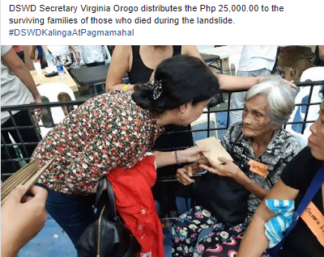
PHOTO DOCUMENTATION

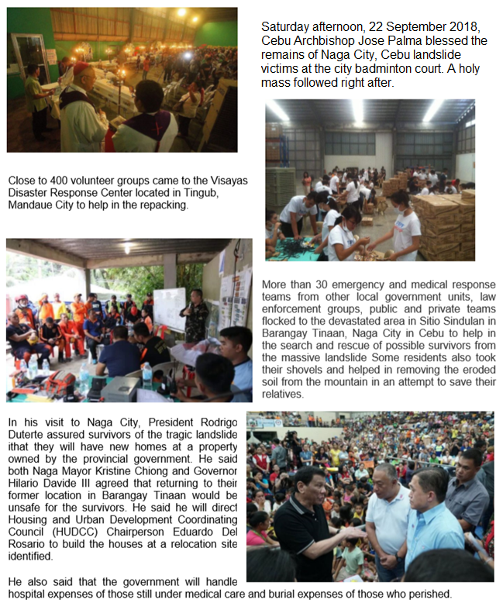
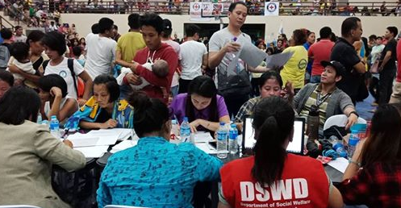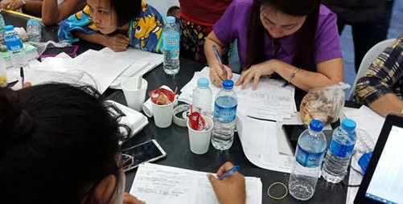

*****
The Disaster Response Operations Monitoring and Information Center (DROMIC) of the DSWD-DRMB continues to closely coordinate with concerned DSWD-Field Office VII for significant disaster response updates.

JAN ERWIN ANDREW ONTANILLAS
Releasing Officer

