DSWD DROMIC Report #9 on the
Landslide Incident in Naga City, Cebu
as of 27 September 2018, 4AM

SITUATION OVERVIEW

At around 0600H on 20 September 2018, a massive landslide affected an estimated 80.12 hectare area in Sitio Sindulan, Brgy. Tinaan in Naga City, Cebu. Disaster managers said the rains may have contributed in softening the ground soil causing the sloped land to collapse. However, some residents have also pointed on the ongoing quarrying operations in the area.

Source: DSWD FO VII

SUMMARY

- Status of Affected Families / Persons
A total of 1,751 families or 7,587 persons were affected in 6 barangays in City of Naga and San Fernando, Cebu.
REGION / PROVINCE / MUNICIPALITY |  | NUMBER OF AFFECTED |  |  | NUMBER OF EVACUATION CENTERS (ECs) | NUMBER OF INSIDE ECs |  | NUMBER OF OUTSIDE ECs |  | TOTAL DISPLACED
 |  |  |  |  |  |  |  |  |  | Total Families | Total Persons
 |  | Barangays | Families | Persons |  | Families | Persons | Families | Persons
 |  |  |  |  | NOW | NOW | NOW | NOW | NOW | NOW | NOW
GRAND TOTAL |  | 6 | 1,751 | 7,587 | 11 | 1,683 | 7,319 | 68 | 268 | 1,751 | 7,587
REGION VII |  | 6 | 1,751 | 7,587 | 11 | 1,683 | 7,319 | 68 | 268 | 1,751 | 7,587
Cebu |  | 6 | 1,751 | 7,587 | 11 | 1,683 | 7,319 | 68 | 268 | 1,751 | 7,587
 | City of Naga | 5 | 1,687 | 7,343 | 10 | 1,619 | 7,075 | 68 | 268 | 1,687 | 7,343
 | San Fernando | 1 | 64 | 244 | 1 | 64 | 244 | - | - | 64 | 244

Note: Figures reflected in the table above are subject to change as the re-validation and re-assessment are being conducted due to reported instances of double counting and ‘fake evacuees’.
Note: Decrease in the number of families and persons outside ECs is based on the progress report sent by the FO.

Source: DSWD FO VII

- Assistance Provided
- City government provided bread and coffee in the morning of 20 September 2018, food/hot meals are being served at evacuation sites opened. Lunch provision came from Apo Cement, KEPCO, Provincial Board Member Yuli Daan and city government.
- Food from PSWDO for the evacuees and survivors were also distributed
OFFICE/AGENCY |  | PARTICULARS | STATUS
PSWDO |  | 200 Rice Packs | Delivered to site
 |  | 200 Packs of Assorted Canned Goods
 |  | 600 Bottles of 500ml Water
PDRRMO |  | 500 food packs (Lunch) for Responders | Delivered to site

- To date, DSWD has already extended relief support and financial assistance worth ₱4,712,864.28.

DSWD ASSISTANCE | COST
Food and Non-Food Item Relief Support | 4,437,864.28
Financial Assistance to the Bereaved Families | 275,000.00
Total Cost | 4,712,864.28

Situational Reports

DSWD-DRMB
DATE | SITUATIONS / ACTIONS UNDERTAKEN
20 September 2018 to present | - The Disaster Response Operations Monitoring and Information Center (DROMIC) of DSWD-DRMB is on 24/7 duty and continuously monitoring and coordinating with DSWD-Field Office VII for significant disaster response operations updates.

FO VII
DATE | SITUATIONS / ACTIONS UNDERTAKEN
27 September 2018 | - On top of camp coordination and camp management as well as IDP protection and the provision of Food and Non-food Items, the Department is also on full gear, extensively re-assessing and double checking the list of evacuees so as to avoid any duplication. In a press briefing this afternoon, ARDO Shalaine Marie Lucero the DSWD Focal Person for the Naga City disaster operations, expressed the difficulty of the Department in determining which of the evacuees are legitimate residents affected by the landslide. Pending the list from the barangay officials, DSWD has yet to finalize the official list of residents as of this reporting time since re-assessment and validation continues.  - The Regional Office continues to provide care and assistance to families displaced in the various evacuation centers. It has intensified its camp coordination and camp management activities by deploying field staff, mostly Pantawid to man ECs and render 24 hours duty in shifting schedule. LGU staff are carefully guided on the processes involved in managing ECs including donations and volunteer management. Social workers, headed by the Camp Managers are continuously training LGU counterparts.  - After DENR Sec. Roy Cimatu ordered the forced evacuation of residents located 1km from ground zero, families in Brgy. Cabungahan fled their homes and rushed to Cabungahan Covered Court to seek for safety. This is the 11th EC which was opened yesterday. DSWD FO has continued the deployment of staff to man the evacuation centers together with the city government and the PSWDO. As with the other ECs established, the DSWD team has been on 24-hour duty on site.  - Each center has a camp manager and staff to man the increasing number of evacuees and monitor the conduct of scheduled camp activities.  - DSWD team on site also assists some continuing activities conducted by other concerned partner agencies, schools and Non-Government Organizations (NGOs) like handwashing activity, story-telling and role playing to the children, psychosocial debriefing, medical missions, viewing marathon of some Sinulog films entries and the like.
25 September 2018 | - Inside Enan Chiong Activity Center, children gather, play games and have storytelling sessions to somehow alleviate their trauma. Activities initiated by the social workers and volunteers include art sessions, singing and playing games. Similar activities are also being conducted in the other evacuation centers opened.  - For adults, psychosocial interventions and mental health activities, along with DOH and several other volunteer groups are being conducted.  - A DSWD Operation Center was established at the lobby of the City Hall where deployed staff are required to check in prior to proceeding to assigned ECs. Data information board was also set up to reflect latest updates on the status of IDPs in each of the opened evacuations centers manned by personnel of the Department.  - DSWD regional and field staff are mobilized in shifting schedule to provide care and support to IDPs 24 hours. Staff are spread across the opened evacuation centers in order to provide support to LGU personnel in the assessment and intake of displaced families, relief/logistical needs, including the provision of psychosocial support most especially to children in evacuation centers.  - QRT members and field staff continue to promptly arrive during their assigned shift/schedule. They were instructed to sign in the logbook at the OpCen before proceeding to their assigned evacuation centers.  - Regular meetings were conducted on-site with team leader, camp managers and DSWD Regional Disaster Division personnel for coordination of tasks and synchronization of activities.
22 September 2018 | - Each bereaved family received P25,000.00 financial assistance which were handed over to them by DSWD Acting Secretary Virginia N. Orogo during PRRD’s visit last 21 September 2018. At least 11 families received the assistance.  - DSWD-FO VII has continuously providing support to the landslide-stricken families through immediate relief (food and non-food items) and psychosocial support.  - The regional warehouse and the Visasyas Disaster Resonse Center are now manually repacking goods. Help from over 370 volunteer groups came, mostly from schools and universities and other private institutions. CFW are also utilized in order to hasten production.  - More than 50 DSWD regional and field office staff are mobilized in shifting schedule, and are spread across the opened evacuation centers in order to provide support to LGU personnel in the assessment and intake of displaced families, relief/logistical needs, including the provision of psychosocial support, most especially to children in evacuation centers.  - DSWD-FO VII QRT has been activated on 21 September 2018 in order to continuously support ongoing response operations in City of Naga.

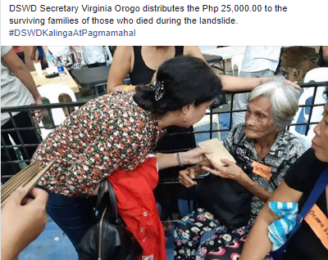
PHOTO DOCUMENTATION

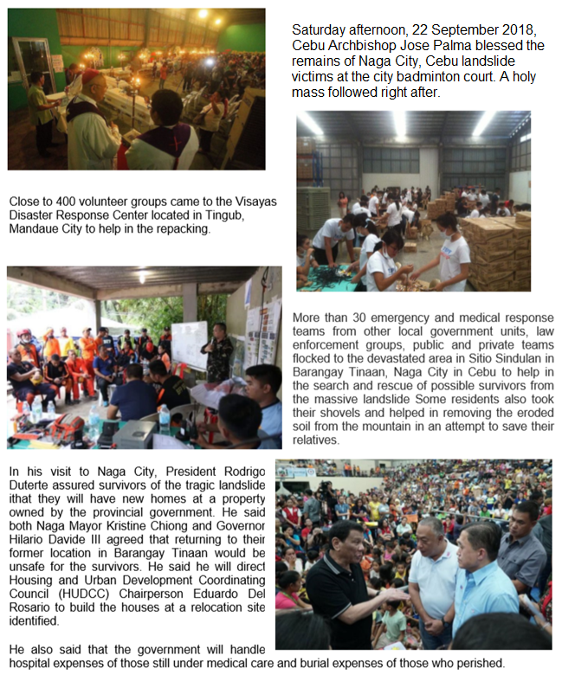
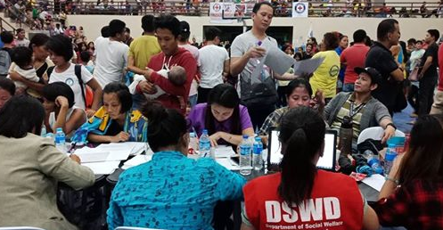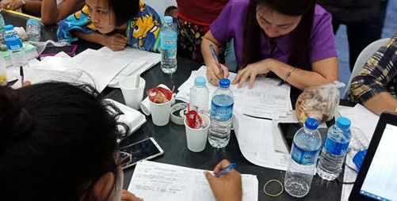

*****
The Disaster Response Operations Monitoring and Information Center (DROMIC) of the DSWD-DRMB continues to closely coordinate with concerned DSWD-Field Office VII for significant disaster response updates.

JAN ERWIN ANDREW ONTANILLAS
Releasing Officer

