DSWD DROMIC Preparedness for Response Report #1
on Typhoon “ROSITA” [I.N. YUTU]
as of 27 October 2018, 5PM

Situation Overview
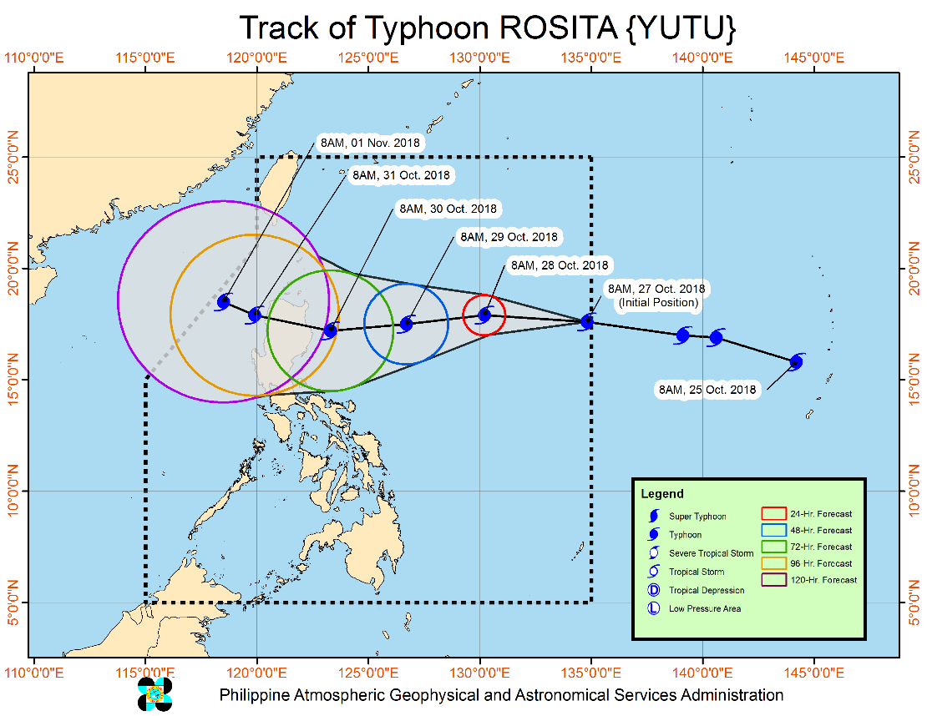
Typhoon with International Name "YUTU" has entered the Philippine Area of Responsibility (PAR) and was named "Rosita". At 10:00 AM today, the eye of Typhoon "ROSITA" was located based on all available data at 1,345 km East of Aparri, Cagayan (17.6°N, 134.3°E). It is moving west at 20 kph with a maximum sustained winds of 200 kph near the center and gustiness of up to 245 kph.

- Possible hoisting of Tropical Cyclone Warning Signals over the Eastern section of Northern and Central Luzon on Sunday evening (October 28).
- Moderate to heavy rains directly associated with the Typhoon is expected over Northern and Central Luzon starting Monday evening (October 29)
- Strong to very strong winds are expected to affect the Eastern section of Northern and Central Luzon starting Tuesday morning (October 30)
- Sea travel is risky over the Northern and Eastern seaboard of Luzon and seaboard of Samar provinces.
- Expected to make landfall over Cagayan – Isabela area by Tuesday (October 30).
- Possible raising TCWS #1 over Metro Manila by Monday evening (October 29).

Source: DOST-PAGASA Severe Weather Bulletin

Status of Prepositioned Resources: Stockpile and Standby Funds

The DSWD Central Office (CO), Field Offices (FOs), and National Resource Operations Center (NROC) have stockpiles and standby funds amounting to ₱1,386,494,700.48 with breakdown as follows:

- Standby Funds
A total of ₱463,960,181.71 standby funds in the CO and FOs. Of the said amount, ₱411,020,429.10 is the available Quick Response Fund in the CO.

- Stockpiles
A total of 384,281 Family Food Packs (FFPs) amounting to ₱140,162,598.32 and available Food and Non-food Items (FNIs) amounting to ₱782,371,920.45.

FIELD OFFICE | STANDBY FUNDS | STOCKPILE |  |  |  |  | TOTAL STANDBY FUNDS AND STOCKPILE
 |  | Family Food Packs |  | Food  (Raw Mats and Other Food Item) | Non-Food  (Raw Mats and Other NFI) | Sub-Total  (FFPs, Food and NFIs)
 |  | Quantity | Total Cost
TOTAL | 463,960,181.71 | 384,281 | 140,162,598.32 | 148,232,954.15 | 634,138,966.30 | 922,534,518.77 | 1,386,494,700.48
Central Office* | 411,020,429.10 | - | - | - | - |  | 411,020,429.10
NROC | - | 87,649 | 31,553,640.00 | 52,013,768.71 | 250,151,387.05 | 333,718,795.76 | 333,718,795.76
NCR | 3,620,973.50 | 4,367 | 1,398,882.46 | 1,376,293.53 | 8,804,557.77 | 11,579,733.76 | 15,200,707.26
CAR | 8,834,032.95 | 25,517 | 9,198,879.75 | 5,315,664.56 | 16,592,329.01 | 31,106,873.32 | 39,940,906.27
I | 3,096,281.40 | 16,184 | 5,764,680.00 | 1,896,000.00 | 24,765,104.92 | 32,425,784.92 | 35,522,066.32
II | 8,539,681.04 | 19,360 | 6,969,600.00 | 1,020,109.40 | 1,248,788.50 | 9,238,497.90 | 17,778,178.94
III | 3,407,969.00 | 22,260 | 8,150,371.00 | 180,114.60 | 12,980,819.27 | 21,311,304.87 | 24,719,273.87
CALABARZON | 3,716,000.00 | 5,267 | 1,545,315.56 | 2,267,865.33 | 6,389,777.40 | 10,202,958.29 | 13,918,958.29
MIMAROPA | 1,434,141.75 | 23,280 | 8,654,115.00 | 7,602,897.61 | 1,344,028.86 | 17,601,041.47 | 19,035,183.22
V | 2,169,791.12 | 31,193 | 12,295,590.56 | 1,432,795.00 | 53,420,476.00 | 67,148,861.56 | 69,318,652.68
VI | 1,400,000.00 | 16,559 | 5,961,240.00 | 14,283,821.61 | 8,351,381.19 | 28,596,442.80 | 29,996,442.80
VII | 534,400.00 | 55,072 | 22,765,905.95 | 20,389,617.64 | 45,809,093.37 | 88,964,616.96 | 89,499,016.96
VIII | 2,697,960.00 | 10,884 | 3,307,212.34 | 13,407,339.00 | 46,521,305.00 | 63,235,856.34 | 65,933,816.34
IX | 1,347,471.85 | 16,750 | 6,030,000.00 | 9,363,090.00 | 6,964,083.29 | 22,357,173.29 | 23,704,645.14
X | 3,140,700.00 | 12,729 | 4,301,829.00 | 6,099,492.00 | 125,178,927.86 | 135,580,248.86 | 138,720,948.86
XI | 3,000,000.00 | 22,992 | 7,536,777.60 | 6,913,600.00 | 12,592,706.34 | 27,043,083.94 | 30,043,083.94
XII | 3,000,350.00 | 3,853 | 1,545,053.00 | 1,075,368.01 | 3,114,896.67 | 5,735,317.68 | 8,735,667.68
CARAGA | 3,000,000.00 | 10,365 | 3,183,506.10 | 3,595,117.15 | 9,909,303.80 | 16,687,927.05 | 19,687,927.05
* Quick Response Fund (QRF) as of 26 October 2018

Situational Reports

DSWD-DRMB
DATE | SITUATIONS / ACTIONS UNDERTAKEN
October 27, 2018 | - The Disaster Response Operations Monitoring and Information Center (DROMIC) of the DSWD-DRMB is closely coordinating with the DSWD-Field Offices for significant disaster preparedness for response updates.

DSWD-FO I
DATE | SITUATIONS / ACTIONS UNDERTAKEN
October 26, 2018 | - DSWD-FO I is closely monitoring the possible effect of Typhoon “Rosita” and preparing pre-disaster activities in close coordination with the Office of Civil Defense Regional Office 1.

DSWD-FO II
DATE | SITUATIONS / ACTIONS UNDERTAKEN
October 26, 2018 | - The Disaster Monitoring and Response Team of the DSWD-FO II, SWAD Teams and MATs in the provinces of Batanes, Cagayan, Isabela, Quirino, and Nueva Vizcaya were alerted and would render duty in the event Typhoon Rosita affects their respective areas of jurisdiction.  - The DSWD-FO II is continuously providing weather updates and monitoring of possible areas to be affected through coordination with SWAD Teams and C/MATs for their appropriate action.

DSWD-FO MIMAROPA
DATE | SITUATIONS / ACTIONS UNDERTAKEN
October 26, 2018 | - Activated Field Office Operation Center to monitor daily local weather condition and provide situational awareness.  - Alerted all P/C/M Quick Response Teams in five provinces of MiMaRoPa to regularly monitor the situations in their areas.  - All members of R/P/C/M QRTs are on-call status and standby duty ready for deployment if needed.  - Advised P/MQRTs to coordinate with concerned LGUs to report any unusual eventualities in their respective areas and take appropriate actions.  - Information and Communication Technology Management Unit (ICTMU) is activated to ensure robust communication system.  - All members of Rapid Emergency Telecommunications Team are on on-call and standby status ready for deployment if needed.  - Ensured that the Rapid Emergency Telecommunications Equipment (GX Terminal, BGAN Terminals and Satellite Phones) are in good condition and ready for deployment to areas that will experience potential emergencies.  - Ensured that there is an on-call truck available for delivery of goods and equipment to areas that will be affected.  - Standby logistical equipment and workforce through coordination with SWADT and concerned LGUs on management of stranded passengers if there will be reported strandees in ports and terminals.  - Ensured that relief goods both food and non-food items (F/NFIs) are also ready and available at any given time.  - Closed coordination with the Office of Civil Defense (OCD) and RDRRMC MIMAROPA for any warning signal updates for monitoring purposes and response mechanism for areas that will be affected.  - On-going purchased and replenishment of stockpile and prepositioned FFPs.

DSWD-FO VIII
DATE | SITUATIONS / ACTIONS UNDERTAKEN
October 24, 2018 | - SWAD Teams and PDOs of Disaster Response Management Division assigned in the provinces were alerted and advised to closely coordinate with P/C/MSWDOs and/or P/C/MDRRMOs and immediately report any eventualities that may occur.  - All Quick Response Team (QRT) members and DRMD were alerted in case there is a need for them to render 24/7 duty.  - Disaster Response Information Management Section (DRIMS) of DRMD is monitoring the weather condition and in close coordination with SWADTs, QRTs and PDOs for any untoward incident.  - Regional Resource Operation Section (RROS) of DSWD-FO VIII was also alerted to ensure the readiness of dispatching food and non-food commodities whenever needed.

*****
The Disaster Response Operations Monitoring and Information Center (DROMIC) of the DSWD-DRMB is closely coordinating with the DSWD-Field Offices for any significant disaster preparedness for response updates.

MARC LEO L. BUTAC
Releasing Officer

