DSWD DROMIC Preparedness for Response Report #1
on the Observance of Undas 2018
as of 28 October 2018, 6PM

Situation Overview
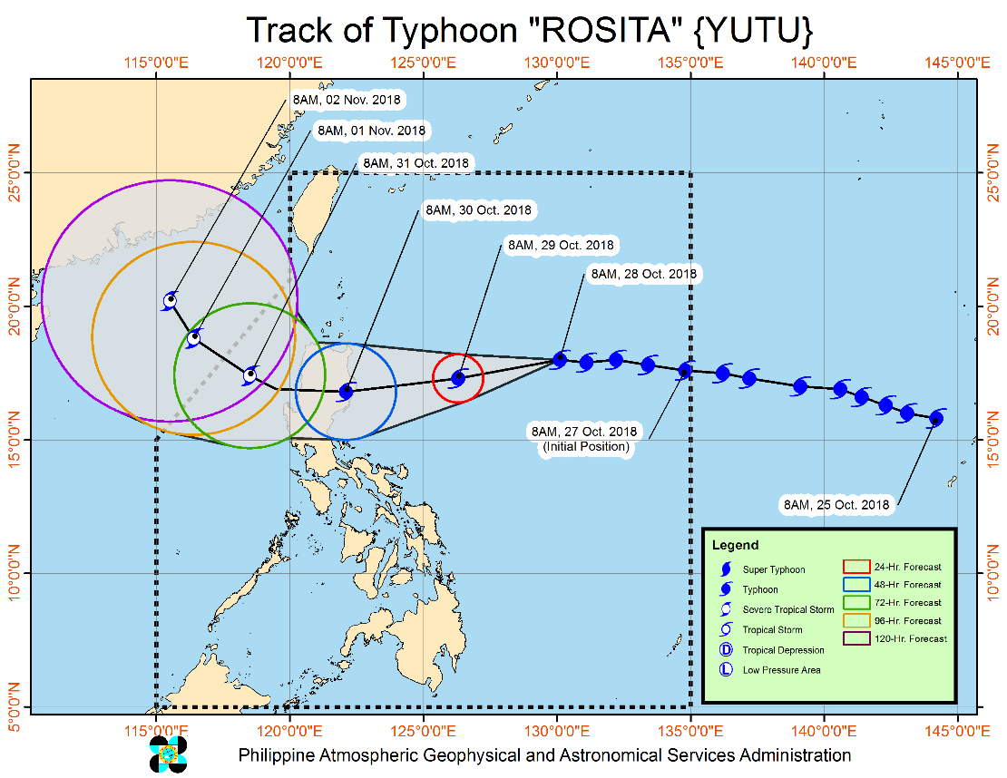
Typhoon "ROSITA" has maintained its strength and continues to move westward towards Northern Luzon. At 10:00 AM today, the eye of Typhoon "ROSITA" was located based on all available data at 875 km East of Aparri, Cagayan (18.0°N, 129.9°E). It is moving west at 20 kph with a maximum sustained winds of 200 kph near the center and gustiness of up to 245 kph.

- Possible hoisting of Tropical Cyclone Warning Signals over the Eastern section of Northern and Central Luzon tonight (October 28).
- Moderate to heavy rains directly associated with the Typhoon is expected over Northern and Central Luzon starting tomorrow evening (October 29). Flooding and landslides are possible. Travel by land and sea is risky.
- Possible raising TCWS #1 over Metro Manila by tomorrow evening (October 29).
- Strong to very strong winds are expected to affect the Eastern section of Northern and Central Luzon starting Monday evening (October 29).
- Sea travel is risky over the seaboards of Northern and Central Luzon and the eastern seaboards of Visayas and Mindanao.
- Expected to make landfall over Isabela-Cagayan area by Tuesday morning (October 30).
- Storm surge is possible over coastal areas of Isabela & Cagayan.
- Everyone is advised to refrain from outdoor activities.
- Possible exit PAR by Thursday (November 1)
Source: DOST-PAGASA Severe Weather Bulletin

Status of Prepositioned Resources: Stockpile and Standby Funds

The DSWD Central Office (CO), Field Offices (FOs), and National Resource Operations Center (NROC) have stockpiles and standby funds amounting to ₱1,405,264,304.48 with breakdown as follows:

- Standby Funds
A total of ₱465,743,481.71 standby funds in the CO and FOs. Of the said amount, ₱411,020,429.10 is the available Quick Response Fund in the CO.

- Stockpiles
A total of 371,763 Family Food Packs (FFPs) amounting to ₱135,717,678.32, and available food and non-food items (FNIs) amounting to ₱803,803,144.45.

OFFICE | STANDBY FUNDS | STOCKPILE |  |  |  |  | TOTAL STANDBY FUNDS AND STOCKPILE
 |  | Family Food Packs |  | Food  (Raw Mats and Other Food Item) | Non-Food  (Raw Mats and Other NFI) | Sub-Total  (FFPs, Food and NFIs)
 |  | Quantity | Total Cost
TOTAL | 465,743,481.71 | 371,763 | 135,717,678.32 | 146,336,954.15 | 657,466,190.30 | 939,520,822.77 | 1,405,264,304.48
Central Office* | 411,020,429.10 | - | - | - | - |  | 411,020,429.10
NROC | - | 87,649 | 31,553,640.00 | 52,013,768.71 | 250,151,387.05 | 333,718,795.76 | 333,718,795.76
NCR | 3,620,973.50 | 4,367 | 1,398,882.46 | 1,376,293.53 | 8,804,557.77 | 11,579,733.76 | 15,200,707.26
CAR | 8,834,032.95 | 25,517 | 9,198,879.75 | 5,315,664.56 | 16,592,329.01 | 31,106,873.32 | 39,940,906.27
I | 4,879,581.40 | 3,666 | 1,319,760.00 | 0.00 | 48,092,328.92 | 49,412,088.92 | 54,291,670.32
II | 8,539,681.04 | 19,360 | 6,969,600.00 | 1,020,109.40 | 1,248,788.50 | 9,238,497.90 | 17,778,178.94
III | 3,407,969.00 | 22,260 | 8,150,371.00 | 180,114.60 | 12,980,819.27 | 21,311,304.87 | 24,719,273.87
CALABARZON | 3,716,000.00 | 5,267 | 1,545,315.56 | 2,267,865.33 | 6,389,777.40 | 10,202,958.29 | 13,918,958.29
MIMAROPA | 1,434,141.75 | 23,280 | 8,654,115.00 | 7,602,897.61 | 1,344,028.86 | 17,601,041.47 | 19,035,183.22
V | 2,169,791.12 | 31,193 | 12,295,590.56 | 1,432,795.00 | 53,420,476.00 | 67,148,861.56 | 69,318,652.68
VI | 1,400,000.00 | 16,559 | 5,961,240.00 | 14,283,821.61 | 8,351,381.19 | 28,596,442.80 | 29,996,442.80
VII | 534,400.00 | 55,072 | 22,765,905.95 | 20,389,617.64 | 45,809,093.37 | 88,964,616.96 | 89,499,016.96
VIII | 2,697,960.00 | 10,884 | 3,307,212.34 | 13,407,339.00 | 46,521,305.00 | 63,235,856.34 | 65,933,816.34
IX | 1,347,471.85 | 16,750 | 6,030,000.00 | 9,363,090.00 | 6,964,083.29 | 22,357,173.29 | 23,704,645.14
X | 3,140,700.00 | 12,729 | 4,301,829.00 | 6,099,492.00 | 125,178,927.86 | 135,580,248.86 | 138,720,948.86
XI | 3,000,000.00 | 22,992 | 7,536,777.60 | 6,913,600.00 | 12,592,706.34 | 27,043,083.94 | 30,043,083.94
XII | 3,000,350.00 | 3,853 | 1,545,053.00 | 1,075,368.01 | 3,114,896.67 | 5,735,317.68 | 8,735,667.68
CARAGA | 3,000,000.00 | 10,365 | 3,183,506.10 | 3,595,117.15 | 9,909,303.80 | 16,687,927.05 | 19,687,927.05
* Quick Response Fund (QRF) as of 26 October 2018

Situational Reports

DSWD-DRMB
DATE | SITUATIONS / ACTIONS UNDERTAKEN
October 28, 2018 | - The Disaster Response Operations Monitoring and Information Center (DROMIC) of the DSWD-DRMB is closely coordinating with the DSWD-Field Offices for significant updates on disaster preparedness for response with regard to the observation of Undas 2018.

DSWD-FO NCR
DATE | SITUATIONS / ACTIONS UNDERTAKEN
October 24, 2018 | - Daily monitoring of weather conditions and other emergencies through telephone, internet, cell phone, etc. by the Disaster Response Management Division Staff and Quick Response Team Leaders.  - The Planning Section of FO-NCR and the FO-DROMIC Focal are assigned to prepare the consolidation of disaster reports in the event of 24-hour monitoring.  - Continuous provision of Disaster Assistance Family Access Card to requesting LGUs.  - The Administrative Division of DSWD-FO NCR is ensuring to maximize the availability and accessibility of at least four vehicles.  - The Quick Response Teams of DSWD FO-NCR composed of organic staff from the Field Office and Centers and Residential Care Facilities (C/RCFs) are on standby alert and will be activated and mobilized in response to any eventualities. The assignment of said staff is scheduled per day.

DSWD-FO I
DATE | SITUATIONS / ACTIONS UNDERTAKEN
October 26, 2018 | - The Disaster Response Management Division (DRMD) staff, the Social Welfare and Development (SWAD) Team, and the Quick Action Response Team (QUART) of the DSWD-FO I are on standby in the observance of All Saints’ Day and All Souls’ Day on November 1 and 2, 2018.

*****
The Disaster Response Operations Monitoring and Information Center (DROMIC) of the DSWD-DRMB is closely coordinating with the DSWD-Field Offices for any significant disaster preparedness for response updates.

MARC LEO L. BUTAC
Releasing Officer

