DSWD DROMIC Preparedness for Response Report #2
on Typhoon “ROSITA” [I.N. YUTU]
as of 28 October 2018, 6PM

Situation Overview
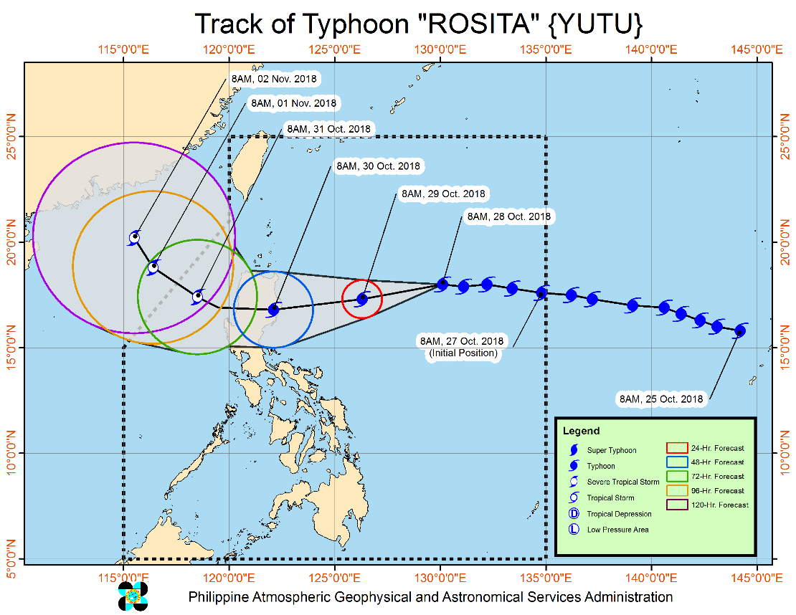
Typhoon "ROSITA" has maintained its strength and continues to move westward towards Northern Luzon. At 10:00 AM today, the eye of Typhoon "ROSITA" was located based on all available data at 875 km East of Aparri, Cagayan (18.0°N, 129.9°E). It is moving west at 20 kph with a maximum sustained winds of 200 kph near the center and gustiness of up to 245 kph.

- Possible hoisting of Tropical Cyclone Warning Signals over the Eastern section of Northern and Central Luzon tonight (October 28).
- Moderate to heavy rains directly associated with the Typhoon is expected over Northern and Central Luzon starting tomorrow evening (October 29). Flooding and landslides are possible. Travel by land and sea is risky.
- Possible raising TCWS #1 over Metro Manila by tomorrow evening (October 29).
- Strong to very strong winds are expected to affect the Eastern section of Northern and Central Luzon starting Monday evening (October 29).
- Sea travel is risky over the seaboards of Northern and Central Luzon and the eastern seaboards of Visayas and Mindanao.
- Expected to make landfall over Isabela-Cagayan area by Tuesday morning (October 30).
- Storm surge is possible over coastal areas of Isabela & Cagayan.
- Everyone is advised to refrain from outdoor activities.
- Possible exit PAR by Thursday (November 1)
Source: DOST-PAGASA Severe Weather Bulletin
Status of Prepositioned Resources: Stockpile and Standby Funds

The DSWD Central Office (CO), Field Offices (FOs), and National Resource Operations Center (NROC) have stockpiles and standby funds amounting to ₱1,405,264,304.48 with breakdown as follows:

- Standby Funds
A total of ₱465,743,481.71 standby funds in the CO and FOs. Of the said amount, ₱411,020,429.10 is the available Quick Response Fund in the CO.

- Stockpiles
A total of 371,763 Family Food Packs (FFPs) amounting to ₱135,717,678.32, and available food and non-food items (FNIs) amounting to ₱803,803,144.45.

OFFICE | STANDBY FUNDS | STOCKPILE |  |  |  |  | TOTAL STANDBY FUNDS AND STOCKPILE
 |  | Family Food Packs |  | Food  (Raw Mats and Other Food Item) | Non-Food  (Raw Mats and Other NFI) | Sub-Total  (FFPs, Food and NFIs)
 |  | Quantity | Total Cost
TOTAL | 465,743,481.71 | 371,763 | 135,717,678.32 | 146,336,954.15 | 657,466,190.30 | 939,520,822.77 | 1,405,264,304.48
Central Office* | 411,020,429.10 | - | - | - | - |  | 411,020,429.10
NROC | - | 87,649 | 31,553,640.00 | 52,013,768.71 | 250,151,387.05 | 333,718,795.76 | 333,718,795.76
NCR | 3,620,973.50 | 4,367 | 1,398,882.46 | 1,376,293.53 | 8,804,557.77 | 11,579,733.76 | 15,200,707.26
CAR | 8,834,032.95 | 25,517 | 9,198,879.75 | 5,315,664.56 | 16,592,329.01 | 31,106,873.32 | 39,940,906.27
I | 4,879,581.40 | 3,666 | 1,319,760.00 | 0.00 | 48,092,328.92 | 49,412,088.92 | 54,291,670.32
II | 8,539,681.04 | 19,360 | 6,969,600.00 | 1,020,109.40 | 1,248,788.50 | 9,238,497.90 | 17,778,178.94
III | 3,407,969.00 | 22,260 | 8,150,371.00 | 180,114.60 | 12,980,819.27 | 21,311,304.87 | 24,719,273.87
CALABARZON | 3,716,000.00 | 5,267 | 1,545,315.56 | 2,267,865.33 | 6,389,777.40 | 10,202,958.29 | 13,918,958.29
MIMAROPA | 1,434,141.75 | 23,280 | 8,654,115.00 | 7,602,897.61 | 1,344,028.86 | 17,601,041.47 | 19,035,183.22
V | 2,169,791.12 | 31,193 | 12,295,590.56 | 1,432,795.00 | 53,420,476.00 | 67,148,861.56 | 69,318,652.68
VI | 1,400,000.00 | 16,559 | 5,961,240.00 | 14,283,821.61 | 8,351,381.19 | 28,596,442.80 | 29,996,442.80
VII | 534,400.00 | 55,072 | 22,765,905.95 | 20,389,617.64 | 45,809,093.37 | 88,964,616.96 | 89,499,016.96
VIII | 2,697,960.00 | 10,884 | 3,307,212.34 | 13,407,339.00 | 46,521,305.00 | 63,235,856.34 | 65,933,816.34
IX | 1,347,471.85 | 16,750 | 6,030,000.00 | 9,363,090.00 | 6,964,083.29 | 22,357,173.29 | 23,704,645.14
X | 3,140,700.00 | 12,729 | 4,301,829.00 | 6,099,492.00 | 125,178,927.86 | 135,580,248.86 | 138,720,948.86
XI | 3,000,000.00 | 22,992 | 7,536,777.60 | 6,913,600.00 | 12,592,706.34 | 27,043,083.94 | 30,043,083.94
XII | 3,000,350.00 | 3,853 | 1,545,053.00 | 1,075,368.01 | 3,114,896.67 | 5,735,317.68 | 8,735,667.68
CARAGA | 3,000,000.00 | 10,365 | 3,183,506.10 | 3,595,117.15 | 9,909,303.80 | 16,687,927.05 | 19,687,927.05
* Quick Response Fund (QRF) as of 26 October 2018

Situational Reports

DSWD-DRMB
DATE | SITUATIONS / ACTIONS UNDERTAKEN
October 28, 2018 | - The Disaster Response Operations Monitoring and Information Center (DROMIC) of the DSWD-DRMB is closely coordinating with the DSWD-Field Offices for significant disaster preparedness for response updates.

DSWD-FO I
DATE | SITUATIONS / ACTIONS UNDERTAKEN
October 28, 2018 | - The Disaster Response Management Division (DRMD) staff together with the Provincial Operations Offices (POOs) of DSWD-FO I are closely monitoring the possible effects of the current weather condition and ensuring submission of reports when needed. Likewise, close coordination with the Office of Civil Defense (OCD) Region 1 and with the different P/C/MDRRMCs is being conducted to synchronize plans and activities that would lessen the adverse effect that might be brought by Typhoon “Rosita”.

DSWD-FO II
DATE | SITUATIONS / ACTIONS UNDERTAKEN
October 26, 2018 | - The Disaster Monitoring and Response Team of the DSWD-FO II, SWAD Teams and MATs in the provinces of Batanes, Cagayan, Isabela, Quirino, and Nueva Vizcaya were alerted and would render duty in the event Typhoon Rosita affects their respective areas of jurisdiction.  - The DSWD-FO II is continuously providing weather updates and monitoring of possible areas to be affected through coordination with SWAD Teams and C/MATs for their appropriate action.

DSWD-FO MIMAROPA
DATE | SITUATIONS / ACTIONS UNDERTAKEN
October 26, 2018 | - Activated Field Office Operation Center to monitor daily local weather condition and provide situational awareness.  - Alerted all P/C/M Quick Response Teams in five provinces of MiMaRoPa to regularly monitor the situations in their areas.  - All members of R/P/C/M QRTs are on-call status and standby duty ready for deployment if needed.  - Advised P/MQRTs to coordinate with concerned LGUs to report any unusual eventualities in their respective areas and take appropriate actions.  - Information and Communication Technology Management Unit (ICTMU) is activated to ensure robust communication system.  - All members of Rapid Emergency Telecommunications Team are on on-call and standby status ready for deployment if needed.  - Ensured that the Rapid Emergency Telecommunications Equipment (GX Terminal, BGAN Terminals and Satellite Phones) are in good condition and ready for deployment to areas that will experience potential emergencies.  - Ensured that there is an on-call truck available for delivery of goods and equipment to areas that will be affected.  - Standby logistical equipment and workforce through coordination with SWADT and concerned LGUs on management of stranded passengers if there will be reported strandees in ports and terminals.  - Ensured that relief goods both food and non-food items (F/NFIs) are also ready and available at any given time.  - Closed coordination with the Office of Civil Defense (OCD) and RDRRMC MIMAROPA for any warning signal updates for monitoring purposes and response mechanism for areas that will be affected.  - On-going purchased and replenishment of stockpile and prepositioned FFPs.

DSWD-FO VIII
DATE | SITUATIONS / ACTIONS UNDERTAKEN
October 24, 2018 | - SWAD Teams and PDOs of Disaster Response Management Division assigned in the provinces were alerted and advised to closely coordinate with P/C/MSWDOs and/or P/C/MDRRMOs and immediately report any eventualities that may occur.  - All Quick Response Team (QRT) members and DRMD were alerted in case there is a need for them to render 24/7 duty.  - Disaster Response Information Management Section (DRIMS) of DRMD is monitoring the weather condition and in close coordination with SWADTs, QRTs and PDOs for any untoward incident.  - Regional Resource Operation Section (RROS) of DSWD-FO VIII was also alerted to ensure the readiness of dispatching food and non-food commodities whenever needed.

*****
The Disaster Response Operations Monitoring and Information Center (DROMIC) of the DSWD-DRMB is closely coordinating with the DSWD-Field Offices for any significant disaster preparedness for response updates.

JAN ERWIN ANDREW I. ONTANILLAS
Releasing Officer

