DSWD DROMIC Preparedness for Response Report #2
on the Observance of Undas 2018
as of 29 October 2018, 6PM

Situation Overview

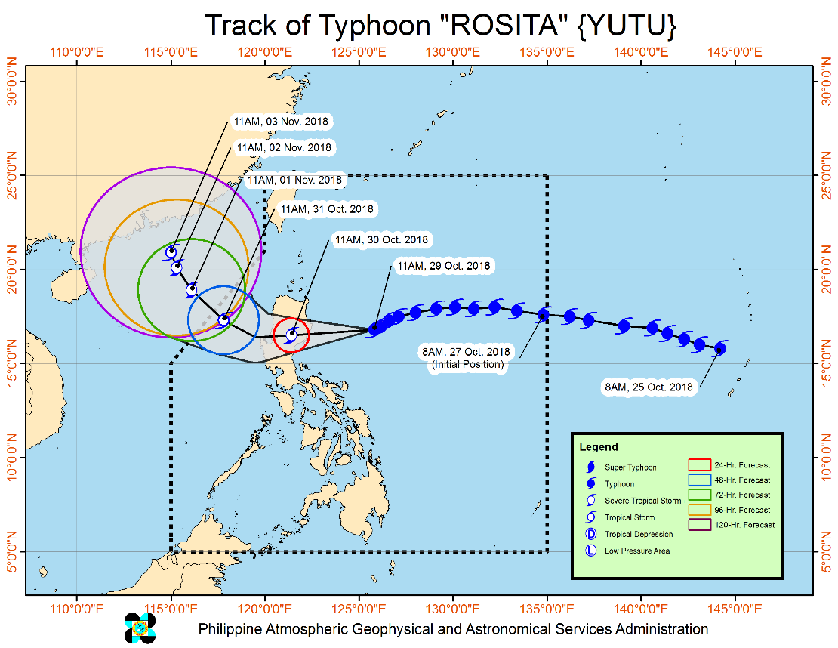
TYPHOON "ROSITA" CONTINUE THREATENING THE SOUTHERN ISABELA - NORTHERN AURORA AREA.
- Stormy Weather over the areas under Tropical Cyclone Warning Signal (TCWS) No. 3 & 2. Travel by land is risky over these areas.
- Moderate to heavy rains directly associated with the Typhoon is expected over Northern and Central Luzon starting tonight (29 Oct) Residents in these areas, especially those living near river channels, in low-lying areas and mountainous areas, are advised to take appropriate actions against possible flooding and landslides, coordinate with the local disaster risk reduction and management offices.
- Storm surge of up to 3 meters is possible over the coastal areas of Isabela, Cagayan, Aurora, Ilocos Sur, Ilocos Norte and La Union.
- Fisherfolks and those with small seacrafts are advised not to venture out over the seaboards of areas with TCWS and eastern seaboards of Southern Luzon, Visayas, and Mindanao.
- Expected to make landfall over Southern Isabela - Northern Aurora area by Tomorrow morning (30 Oct) and traverse Aurora, Isabela, Quirino, Ifugao, Nueva Vizcaya, Benguet and La Union.
- Possible exit landmass by tomorrow afternoon and will exit PAR by Wednesday evening (31 Oct.)

Source: DOST-PAGASA Severe Weather Bulletin

Status of Prepositioned Resources: Stockpile and Standby Funds

The DSWD Central Office (CO), concerned Field Offices (FOs), and National Resource Operations Center (NROC) have stockpiles and standby funds amounting to ₱1,403,575,664.48 (see Table 1) with breakdown as follows:

- Stockpiles
A total of 366,614 Family Food Packs (FFPs) (see Table 2) amounting to ₱134,029,038.32 and available Food and Non-food Items (FNIs) amounting to ₱937,832,182.77.
- Standby Funds
A total of ₱465,473,481.71 standby funds in the CO and FOs. Of the said amount, ₱411,020,429.10 is the available Quick Response Fund in the CO.

FIELD OFFICE | STANDBY FUNDS | STOCKPILE |  |  |  |  | TOTAL STANDBY FUNDS AND STOCKPILE
 |  | Family Food Packs |  | Food | Non-Food | Sub-Total  (Food and NFIs)
 |  | Quantity | Total Cost
TOTAL | 465,743,481.71 | 366,614 | 134,029,038.32 | 146,336,954.15 | 657,466,190.30 | 937,832,182.77 | 1,403,575,664.48
Central Office* | 411,020,429.10 | - | - | - | - |  | 411,020,429.10
NROC | - | 82,500 | 29,865,000.00 | 52,013,768.71 | 250,151,387.05 | 332,030,155.76 | 332,030,155.76
NCR | 3,620,973.50 | 4,367 | 1,398,882.46 | 1,376,293.53 | 8,804,557.77 | 11,579,733.76 | 15,200,707.26
CAR | 8,834,032.95 | 25,517 | 9,198,879.75 | 5,315,664.56 | 16,592,329.01 | 31,106,873.32 | 39,940,906.27
I | 4,879,581.40 | 3,666 | 1,319,760.00 | 0.00 | 48,092,328.92 | 49,412,088.92 | 54,291,670.32
II | 8,539,681.04 | 19,360 | 6,969,600.00 | 1,020,109.40 | 1,248,788.50 | 9,238,497.90 | 17,778,178.94
III | 3,407,969.00 | 22,260 | 8,150,371.00 | 180,114.60 | 12,980,819.27 | 21,311,304.87 | 24,719,273.87
CALABARZON | 3,716,000.00 | 5,267 | 1,545,315.56 | 2,267,865.33 | 6,389,777.40 | 10,202,958.29 | 13,918,958.29
MIMAROPA | 1,434,141.75 | 23,280 | 8,654,115.00 | 7,602,897.61 | 1,344,028.86 | 17,601,041.47 | 19,035,183.22
V | 2,169,791.12 | 31,193 | 12,295,590.56 | 1,432,795.00 | 53,420,476.00 | 67,148,861.56 | 69,318,652.68
VI | 1,400,000.00 | 16,559 | 5,961,240.00 | 14,283,821.61 | 8,351,381.19 | 28,596,442.80 | 29,996,442.80
VII | 534,400.00 | 55,072 | 22,765,905.95 | 20,389,617.64 | 45,809,093.37 | 88,964,616.96 | 89,499,016.96
VIII | 2,697,960.00 | 10,884 | 3,307,212.34 | 13,407,339.00 | 46,521,305.00 | 63,235,856.34 | 65,933,816.34
IX | 1,347,471.85 | 16,750 | 6,030,000.00 | 9,363,090.00 | 6,964,083.29 | 22,357,173.29 | 23,704,645.14
X | 3,140,700.00 | 12,729 | 4,301,829.00 | 6,099,492.00 | 125,178,927.86 | 135,580,248.86 | 138,720,948.86
XI | 3,000,000.00 | 22,992 | 7,536,777.60 | 6,913,600.00 | 12,592,706.34 | 27,043,083.94 | 30,043,083.94
XII | 3,000,350.00 | 3,853 | 1,545,053.00 | 1,075,368.01 | 3,114,896.67 | 5,735,317.68 | 8,735,667.68
CARAGA | 3,000,000.00 | 10,365 | 3,183,506.10 | 3,595,117.15 | 9,909,303.80 | 16,687,927.05 | 19,687,927.05

Quick Response Fund (QRF) as of 29 October 2018
Note: Ongoing repacking of FFPs in Regions with below 30,000 level of FFPs
Ongoing procurement and/or deliveries of raw materials for FFPs and NFIs

Situational Reports

DSWD-DRMB
DATE | SITUATIONS / ACTIONS UNDERTAKEN
October 29, 2018 | - The Disaster Response Operations Monitoring and Information Center (DROMIC) of the DSWD-DRMB is closely coordinating with the DSWD-Field Offices for significant updates on disaster preparedness for response with regard to the observation of Undas 2018.

DSWD-FO MIMAROPA
DATE | SITUATIONS / ACTIONS UNDERTAKEN
October 29, 2018 | - Activated Field Office Operation Center to monitor daily local weather condition and provide situational awareness.  - Alerted all P/C/M Quick Response Teams in 5 provinces of MiMaRoPa to regularly monitor the situations in their areas.  - All members of R/P/C/M QRTs are on-call status and standby duty ready for deployment if needed.  - Advised our P/MQRTs to coordinate with concerned LGUs to report any unusual eventualities in their respective areas and take appropriate actions.  - Information and Communication Technology Management Unit (ICTMU) is activated to ensure robust communication system.  - All members of Rapid Emergency Telecommunications Team are on on-call and standby status ready for deployment if needed.  - Ensured that the Rapid Emergency Telecommunications Equipment (GX Terminal, BGAN Terminals and Satellite Phones) are in good condition and ready for deployment to areas that will experience potential emergencies.  - Ensured that there is an on-call truck available for delivery of goods and equipment to areas that will be affected.  - Standby logistical equipment and workforce through coordination with SWADT and concerned LGUs on management of stranded passengers if there will be reported strandees in ports and terminals.  - Ensured that Relief Goods both Food and Non Food Item (F/NFI) are also ready and available at any given time.  - Closed coordination with the Office of Civil Defense (OCD) and RDRRMC MIMAROPA for any warning signal updates for monitoring purposes and response mechanism for areas that will be affected.  - With available stockpile of 30,317 family food packs to all SWADT and Regional Warehouses including prepositioned goods in identified GIDA/critical areas.  - With available Standby funds amounting to Php 1,434,141.75

DSWD-FO XII
DATE | SITUATIONS / ACTIONS UNDERTAKEN
October 29, 2018 | - All QRT members are on standby and ready for any event that may arise that would require immediate assistance from the Department.  - 3 Vehicles are ready for utilization in case of response activation.  - Activation of BLUE ALERT Status.

DSWD-FO I
DATE | SITUATIONS / ACTIONS UNDERTAKEN
October 29, 2018 | - The Disaster Response Management Division (DRMD) staff, the Social Welfare and Development (SWAD) Team, and the Quick Action Response Team (QUART) of the DSWD-FO I are on standby in the observance of All Saints’ Day and All Souls’ Day on November 1 and 2, 2018.  - FO I has an incoming delivery of raw materials equivalent to 30,000 FFPs on October 30, 2018

DSWD-FO NCR
DATE | SITUATIONS / ACTIONS UNDERTAKEN
October 24, 2018 | - Daily monitoring of weather conditions and other emergencies through telephone, internet, cell phone, etc. by the Disaster Response Management Division Staff and Quick Response Team Leaders.  - The Planning Section of FO-NCR and the FO-DROMIC Focal are assigned to prepare the consolidation of disaster reports in the event of 24-hour monitoring.  - Continuous provision of Disaster Assistance Family Access Card to requesting LGUs.  - The Administrative Division of DSWD-FO NCR is ensuring to maximize the availability and accessibility of at least four vehicles.  - The Quick Response Teams of DSWD FO-NCR composed of organic staff from the Field Office and Centers and Residential Care Facilities (C/RCFs) are on standby alert and will be activated and mobilized in response to any eventualities. The assignment of said staff is scheduled per day.

*****
The Disaster Response Operations Monitoring and Information Center (DROMIC) of the DSWD-DRMB is closely coordinating with the DSWD-Field Offices for any significant disaster preparedness for response updates.

JESUS M. CEBALLOS IV
Releasing Officer

