DSWD DROMIC Preparedness for Response Report #3
on Typhoon “ROSITA” [I.N. YUTU]
as of 29 October 2018, 6PM

Situation Overview

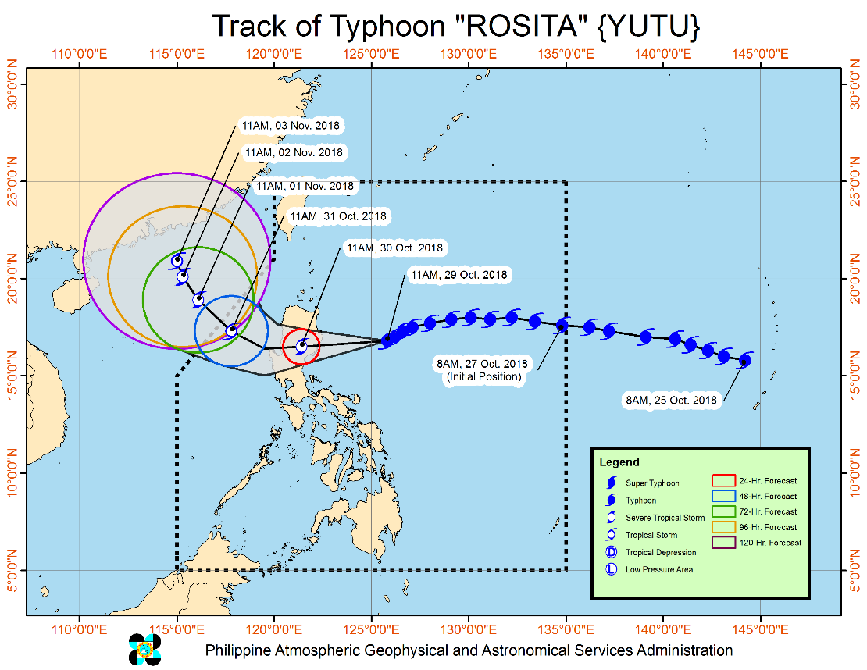
TYPHOON "ROSITA" CONTINUE THREATENING THE SOUTHERN ISABELA - NORTHERN AURORA AREA.
- Stormy Weather over the areas under Tropical Cyclone Warning Signal (TCWS) No. 3 & 2. Travel by land is risky over these areas.
- Moderate to heavy rains directly associated with the Typhoon is expected over Northern and Central Luzon starting tonight (29 Oct) Residents in these areas, especially those living near river channels, in low-lying areas and mountainous areas, are advised to take appropriate actions against possible flooding and landslides, coordinate with the local disaster risk reduction and management offices.
- Storm surge of up to 3 meters is possible over the coastal areas of Isabela, Cagayan, Aurora, Ilocos Sur, Ilocos Norte and La Union.
- Fisherfolks and those with small seacrafts are advised not to venture out over the seaboards of areas with TCWS and eastern seaboards of Southern Luzon, Visayas, and Mindanao.
- Expected to make landfall over Southern Isabela - Northern Aurora area by Tomorrow morning (30 Oct) and traverse Aurora, Isabela, Quirino, Ifugao, Nueva Vizcaya, Benguet and La Union.
- Possible exit landmass by tomorrow afternoon and will exit PAR by Wednesday evening (31 Oct.)
Source: DOST-PAGASA Severe Weather Bulletin

Status of Prepositioned Resources: Stockpile and Standby Funds

The DSWD Central Office (CO), concerned Field Offices (FOs), and National Resource Operations Center (NROC) have stockpiles and standby funds amounting to ₱1,403,575,664.48 (see Table 1) with breakdown as follows:

- Stockpiles
A total of 366,614 Family Food Packs (FFPs) (see Table 2) amounting to ₱134,029,038.32 and available Food and Non-food Items (FNIs) amounting to ₱937,832,182.77.
- Standby Funds
A total of ₱465,473,481.71 standby funds in the CO and FOs. Of the said amount, ₱411,020,429.10 is the available Quick Response Fund in the CO.

FIELD OFFICE | STANDBY FUNDS | STOCKPILE |  |  |  |  | TOTAL STANDBY FUNDS AND STOCKPILE
 |  | Family Food Packs |  | Food | Non-Food | Sub-Total  (Food and NFIs)
 |  | Quantity | Total Cost
TOTAL | 465,743,481.71 | 366,614 | 134,029,038.32 | 146,336,954.15 | 657,466,190.30 | 937,832,182.77 | 1,403,575,664.48
Central Office* | 411,020,429.10 | - | - | - | - |  | 411,020,429.10
NROC | - | 82,500 | 29,865,000.00 | 52,013,768.71 | 250,151,387.05 | 332,030,155.76 | 332,030,155.76
NCR | 3,620,973.50 | 4,367 | 1,398,882.46 | 1,376,293.53 | 8,804,557.77 | 11,579,733.76 | 15,200,707.26
CAR | 8,834,032.95 | 25,517 | 9,198,879.75 | 5,315,664.56 | 16,592,329.01 | 31,106,873.32 | 39,940,906.27
I | 4,879,581.40 | 3,666 | 1,319,760.00 | 0.00 | 48,092,328.92 | 49,412,088.92 | 54,291,670.32
II | 8,539,681.04 | 19,360 | 6,969,600.00 | 1,020,109.40 | 1,248,788.50 | 9,238,497.90 | 17,778,178.94
III | 3,407,969.00 | 22,260 | 8,150,371.00 | 180,114.60 | 12,980,819.27 | 21,311,304.87 | 24,719,273.87
CALABARZON | 3,716,000.00 | 5,267 | 1,545,315.56 | 2,267,865.33 | 6,389,777.40 | 10,202,958.29 | 13,918,958.29
MIMAROPA | 1,434,141.75 | 23,280 | 8,654,115.00 | 7,602,897.61 | 1,344,028.86 | 17,601,041.47 | 19,035,183.22
V | 2,169,791.12 | 31,193 | 12,295,590.56 | 1,432,795.00 | 53,420,476.00 | 67,148,861.56 | 69,318,652.68
VI | 1,400,000.00 | 16,559 | 5,961,240.00 | 14,283,821.61 | 8,351,381.19 | 28,596,442.80 | 29,996,442.80
VII | 534,400.00 | 55,072 | 22,765,905.95 | 20,389,617.64 | 45,809,093.37 | 88,964,616.96 | 89,499,016.96
VIII | 2,697,960.00 | 10,884 | 3,307,212.34 | 13,407,339.00 | 46,521,305.00 | 63,235,856.34 | 65,933,816.34
IX | 1,347,471.85 | 16,750 | 6,030,000.00 | 9,363,090.00 | 6,964,083.29 | 22,357,173.29 | 23,704,645.14
X | 3,140,700.00 | 12,729 | 4,301,829.00 | 6,099,492.00 | 125,178,927.86 | 135,580,248.86 | 138,720,948.86
XI | 3,000,000.00 | 22,992 | 7,536,777.60 | 6,913,600.00 | 12,592,706.34 | 27,043,083.94 | 30,043,083.94
XII | 3,000,350.00 | 3,853 | 1,545,053.00 | 1,075,368.01 | 3,114,896.67 | 5,735,317.68 | 8,735,667.68
CARAGA | 3,000,000.00 | 10,365 | 3,183,506.10 | 3,595,117.15 | 9,909,303.80 | 16,687,927.05 | 19,687,927.05

Quick Response Fund (QRF) as of 29 October 2018
Note: Ongoing repacking of FFPs in Regions with below 30,000 level of FFPs
Ongoing procurement and/or deliveries of raw materials for FFPs and NFIs

Situational Reports

DSWD-DRMB
DATE | SITUATIONS / ACTIONS UNDERTAKEN
October 29, 2018 | - The Disaster Response Operations Monitoring and Information Center (DROMIC) of the DSWD-DRMB is closely coordinating with the DSWD-Field Offices for significant disaster preparedness for response updates.

DSWD-CAR
DATE | SITUATIONS / ACTIONS UNDERTAKEN
October 29, 2018 | - Coordinated with SWAD Team Members and CRD  RRMC through the DREMD staff on duty at the Emergency Operation Center as regards the status of ongoing preparation for the expected arrival of typhoon Rosita.

DSWD-FO I
DATE | SITUATIONS / ACTIONS UNDERTAKEN
October 29, 2018 | - The Disaster Response Management Division (DRMD) staff together with the Provincial Operations Offices (POOs) are closely monitoring the possible effects of the current weather condition and ensuring submission of reports when needed. Likewise, close coordination with the Office of Civil Defense (OCD) Regional Center 1 and with the different P/C/MDRRMCs is being conducted to monitor if there are adverse effect brought by Typhoon “Rosita”.
October 28, 2018 | - The Disaster Response Management Division (DRMD) staff together with the Provincial Operations Offices (POOs) of DSWD-FO I are closely monitoring the possible effects of the current weather condition and ensuring submission of reports when needed. Likewise, close coordination with the Office of Civil Defense (OCD) Region 1 and with the different P/C/MDRRMCs is being conducted to synchronize plans and activities that would lessen the adverse effect that might be brought by Typhoon “Rosita”.

DSWD-FO IV-A CALABARZON
DATE | SITUATIONS / ACTIONS UNDERTAKEN
October 29, 2018 | - The DRMD has been maintaining contact and constant communication with the Local Social Welfare and Development Offices (LSWDOs) with pre-disaster assessments being conducted.  - The DRMD conducted in close coordination with the Local Government Units (LGUs) with regard to the preparedness efforts undertaken in the Flood, Landslide and Storm Surge Prone areas.  - Coordinated with SWAD Team Leaders and Provincial Action Team of the CALABARZON Provinces and advised them to monitor and coordinate with the LGUs to gather reports on the possible effects of the typhoon.  - Coordinated with LSWDOs and LDRRMOs of and instructed them to be on standby alert and prepare their respective evacuation centers, and family food packs should need arises.  - Coordinate with RDRRMC IV-A OpCen for updates on the preparedness level of the members of the Response Cluster of the region.  - DSWD FO IV-A has informed member agencies of the response cluster to be on-stand-by alert status and ready for mobilization in case situation arises.

DSWD-FO II
DATE | SITUATIONS / ACTIONS UNDERTAKEN
October 26, 2018 | - The Disaster Monitoring and Response Team of the DSWD-FO II, SWAD Teams and MATs in the provinces of Batanes, Cagayan, Isabela, Quirino, and Nueva Vizcaya were alerted and would render duty in the event Typhoon Rosita affects their respective areas of jurisdiction.  - The DSWD-FO II is continuously providing weather updates and monitoring of possible areas to be affected through coordination with SWAD Teams and C/MATs for their appropriate action.

DSWD-FO MIMAROPA
DATE | SITUATIONS / ACTIONS UNDERTAKEN
October 26, 2018 | - Activated Field Office Operation Center to monitor daily local weather condition and provide situational awareness.  - Alerted all P/C/M Quick Response Teams in five provinces of MiMaRoPa to regularly monitor the situations in their areas.  - All members of R/P/C/M QRTs are on-call status and standby duty ready for deployment if needed.  - Advised P/MQRTs to coordinate with concerned LGUs to report any unusual eventualities in their respective areas and take appropriate actions.  - Information and Communication Technology Management Unit (ICTMU) is activated to ensure robust communication system.  - All members of Rapid Emergency Telecommunications Team are on on-call and standby status ready for deployment if needed.  - Ensured that the Rapid Emergency Telecommunications Equipment (GX Terminal, BGAN Terminals and Satellite Phones) are in good condition and ready for deployment to areas that will experience potential emergencies.  - Ensured that there is an on-call truck available for delivery of goods and equipment to areas that will be affected.  - Standby logistical equipment and workforce through coordination with SWADT and concerned LGUs on management of stranded passengers if there will be reported strandees in ports and terminals.  - Ensured that relief goods both food and non-food items (F/NFIs) are also ready and available at any given time.  - Closed coordination with the Office of Civil Defense (OCD) and RDRRMC MIMAROPA for any warning signal updates for monitoring purposes and response mechanism for areas that will be affected.  - On-going purchased and replenishment of stockpile and prepositioned FFPs.
DSWD-FO VIII
DATE | SITUATIONS / ACTIONS UNDERTAKEN
October 24, 2018 | - SWAD Teams and PDOs of Disaster Response Management Division assigned in the provinces were alerted and advised to closely coordinate with P/C/MSWDOs and/or P/C/MDRRMOs and immediately report any eventualities that may occur.  - All Quick Response Team (QRT) members and DRMD were alerted in case there is a need for them to render 24/7 duty.  - Disaster Response Information Management Section (DRIMS) of DRMD is monitoring the weather condition and in close coordination with SWADTs, QRTs and PDOs for any untoward incident.  - Regional Resource Operation Section (RROS) of DSWD-FO VIII was also alerted to ensure the readiness of dispatching food and non-food commodities whenever needed.

*****
The Disaster Response Operations Monitoring and Information Center (DROMIC) of the DSWD-DRMB is closely coordinating with the DSWD-Field Offices for any significant disaster preparedness for response updates.

JESUS M. CEBALLOS IV
Releasing Officer

