DSWD DROMIC Preparedness for Response Report #1
on TD “SAMUEL”
as of 19 November 2018, 6PM

Situation Overview
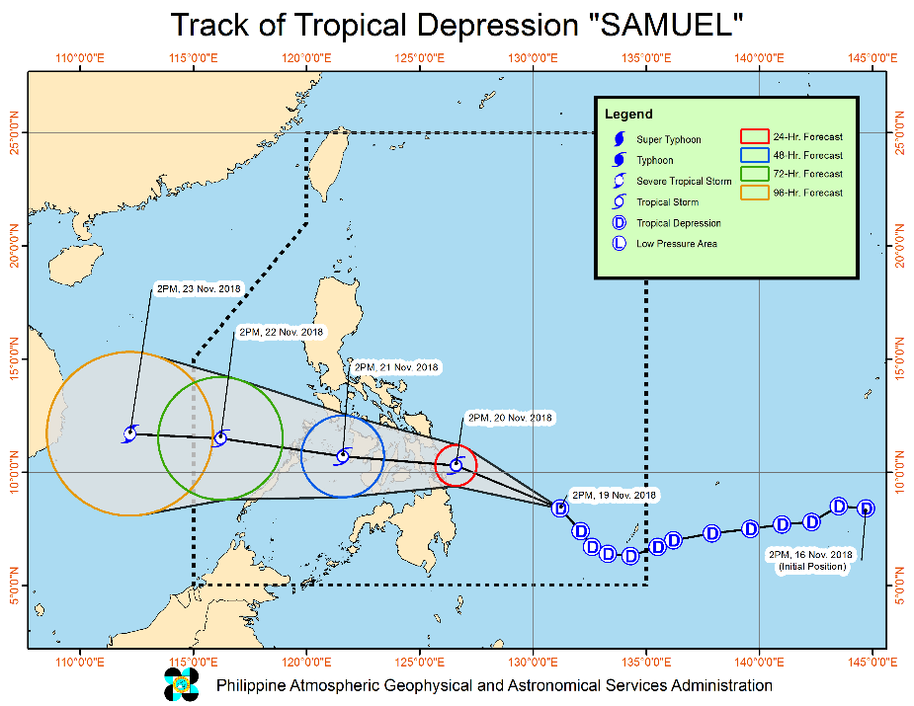

Issued at 05:00 pm, 19 November 2018, Tropical Depression "SAMUEL" has maintained its strength while moving northwestward.

- Possible raising of Tropical Cyclone Warning Signal #1 over Biliran, Cebu, Siquijor and Negros Provinces in the next severe weather bulletin.
- "SAMUEL" may intensify into a Tropical Storm prior to landfall.
- Moderate to heavy rains which may trigger flooding and landslides may occur over Caraga Region, Eastern Visayas, and the provinces of Davao Oriental, Compostela Valley, Bukidnon, Misamis Oriental, Camiguin, Bohol and Cebu. Residents of these areas, especially those living near or in river channels, low-lying and mountainous areas, are advised to take precautionary measures, coordinate with local disaster risk reduction and management offices, and continue monitoring for updates.
- Fisherfolks and those with small seacrafts are advised not to venture out over the areas under TCWS No. 1 and the eastern seaboards of Visayas and Mindanao.

Source: DOST-PAGASA Severe Weather Bulletin

Status of Prepositioned Resources: Stockpile and Standby Funds

The DSWD Central Office (CO), Field Offices (FOs), and National Resource Operations Center (NROC) have stockpiles and standby funds amounting to ₱2,137,870,055.79 with breakdown as follows:
- Standby Funds
A total of ₱1,121,491,675.15 standby funds in the CO and FOs. Of the said amount, ₱1,072,481,549.10 is the available Quick Response Fund in the CO.

- Stockpiles
A total of 374,104 Family Food Packs (FFPs) amounting to ₱137,011,608.59 and available Food and Non-food Items (FNIs) amounting to ₱879,366,772.05.

FIELD OFFICE | STANDBY FUNDS | STOCKPILE |  |  |  |  | TOTAL STANDBY FUNDS AND STOCKPILE
 |  | Family Food Packs |  | Food  (Raw Mats and Other Food Item) | Non-Food  (Raw Mats and Other NFI) | Sub-Total  (FFPs, Food and NFIs)
 |  | Quantity | Total Cost
TOTAL | 1,121,491,675.15 | 374,104 | 137,011,608.59 | 155,846,533.29 | 723,520,238.76 | 879,366,772.05 | 2,137,870,055.79
Central Office* | 1,072,481,549.10 | - | - | - | - |  | 1,072,481,549.10
NROC | - | 97,200 | 35,186,400.00 | 63,120,782.84 | 282,234,019.00 | 345,354,801.84 | 380,541,201.84
NCR | 3,620,973.50 | 4,367 | 1,398,882.46 | 1,376,293.53 | 8,804,557.77 | 10,180,851.30 | 15,200,707.26
CAR | 4,215,730.95 | 14,543 | 5,254,452.55 | 5,242,054.76 | 24,701,294.77 | 29,943,349.53 | 39,413,533.03
I | 2,786,193.79 | 6,722 | 2,419,920.00 | 3,100,485.76 | 46,294,215.73 | 49,394,701.49 | 54,600,815.28
II | 5,464,267.84 | 19,360 | 6,969,600.00 | 1,020,109.40 | 1,248,788.50 | 2,268,897.90 | 14,702,765.74
III | 1,064,319.00 | 19,978 | 7,328,381.40 | 180,114.60 | 12,920,905.50 | 13,101,020.10 | 21,493,720.50
CALABARZON | 3,304,250.00 | 5,066 | 1,720,794.14 | 3,859,418.93 | 7,591,900.68 | 11,451,319.61 | 16,476,363.75
MIMAROPA | 3,034,141.75 | 23,280 | 8,654,115.00 | 7,602,897.61 | 1,344,028.86 | 8,946,926.47 | 20,635,183.22
V | 2,169,791.12 | 31,193 | 12,536,300.00 | 1,432,794.56 | 53,411,957.36 | 54,844,751.92 | 69,550,843.04
VI | 3,000,000.00 | 17,462 | 6,286,320.00 | 14,235,821.61 | 8,551,581.19 | 22,787,402.80 | 32,073,722.80
VII | 3,534,400.00 | 54,483 | 22,099,897.80 | 19,964,628.95 | 53,579,184.27 | 73,543,813.22 | 99,178,111.02
VIII | 2,697,960.00 | 11,497 | 3,917,849.68 | 13,059,900.73 | 47,830,901.05 | 60,890,801.78 | 67,506,611.46
IX | 3,047,481.35 | 15,832 | 5,699,520.00 | 3,418,030.00 | 21,873,380.99 | 25,291,410.99 | 34,038,412.34
X | 3,140,700.00 | 12,729 | 4,301,829.00 | 6,099,492.00 | 125,178,927.86 | 131,278,419.86 | 138,720,948.86
XI | 3,000,000.00 | 22,735 | 7,452,533.00 | 6,539,200.00 | 11,170,443.04 | 17,709,643.04 | 28,162,176.04
XII | 3,000,350.00 | 3,853 | 1,545,053.00 | 1,075,368.01 | 3,114,896.67 | 4,190,264.68 | 8,735,667.68
CARAGA | 1,929,566.75 | 13,804 | 4,239,760.56 | 4,519,140.00 | 13,669,255.52 | 18,188,395.52 | 24,357,722.83
* Quick Response Fund (QRF) as of 19 November 2018

Situational Reports

DSWD-DRMB
DATE | SITUATIONS / ACTIONS UNDERTAKEN
November 19, 2018 | - The Disaster Response Operations Monitoring and Information Center (DROMIC) of the DSWD-DRMB is closely coordinating with the DSWD-Field Offices for significant disaster preparedness for response updates.

DSWD-FO MIMAROPA
DATE | SITUATIONS / ACTIONS UNDERTAKEN
November 19, 2018 | - Activated Field Office Operation Center to monitor daily local weather condition and provide situational awareness.  - Alerted all P/C/M Quick Response Teams in 5 provinces of MiMaRoPa to regularly monitor the situations in their areas.  - All members of R/P/C/M QRTs are on-call status and standby duty ready for deployment if needed.  - Ensured that the Rapid Emergency Telecommunications Equipment (GX Terminal, BGAN Terminals and Satellite Phones) are in good condition and ready for deployment to areas that will experience potential emergencies.  - Standby logistical equipment and workforce through coordination with SWADT and concerned LGUs on management of stranded passengers if there will be reported strandees in ports and terminals.  - Ensured that Relief Goods both Food and Non Food Item (F/NFI) are also ready and available at any given time.  - Closed coordination with the Office of Civil Defense (OCD) and RDRRMC MIMAROPA for any warning signal updates for monitoring purposes and response mechanism for areas that will be affected.  - With on-going purchased and replenishment of stockpile and prepositioned FFPs.

DSWD-FO VII
DATE | SITUATIONS / ACTIONS UNDERTAKEN
November 19, 2018 | - DSWD FO 7 Quick Response Team is on ready alert for any assistance and augmentation support needed from the LGUs.  - Staff from the field were already updated/alerted on the latest weather information and had been requested to monitor AOR and closely coordinate with their LDRRMC for incidents that may occur.

DSWD-FO IX
DATE | SITUATIONS / ACTIONS UNDERTAKEN
November 19, 2018 | - FO IX through its Disaster Management Division’s continuous effort to strengthen its disaster preparedness measures.  - Prepared and disseminated a memorandum on preparedness for response to officially inform the SWAD Team Leaders to monitor the situation in their respective area of responsibility.  - Continuously repacking goods to maintain the required 30,000 FFPs.

DSWD-FO XI
DATE | SITUATIONS / ACTIONS UNDERTAKEN
November 19, 2018 | - Activation of the Field Office’s and RPMOs (SWADTs, PATs, MATs, CATs) Quick Response Team as “On-Call Duty” as well as DRMD personnel.  - Close coordination with all SWADOs as well as with PSWDOs and CSWDO/MSWDOs for monitoring of the situation in the different parts of the Davao Region.  - Personnel manning in the warehouse are alerted to ensure readiness of dispatching food and non-food items and ensured that relief goods are also ready and available at any given time.  - Availability of Disaster Wing Van and Vehicles and Drivers in the event of a Relief Operation.  - Close coordination with Office of Civil Defense (OCD) XI for monitoring purposes and response mechanisms.

DSWD-FO CARAGA
DATE | SITUATIONS / ACTIONS UNDERTAKEN
November 19, 2018 | - All provinces in the region namely: Surigao del Norte, Surigao del Sur, Agusan del Norte, Agusan del Sur and the Province of Dinagat Islands are under Tropical Cyclone Warning Signal # 1.  - Suspension of classes are hereby issued to various areas.  - Quick Response Teams are hereby activated starting tomorrow, November 20, 2018.

*****
The Disaster Response Operations Monitoring and Information Center (DROMIC) of the DSWD-DRMB is closely coordinating with the DSWD-Field Offices for any significant disaster preparedness for response updates.

RODEL V. CABADDU
Releasing Officer

