DSWD DROMIC Preparedness for Response Report #2 on
Tropical Depression “SAMUEL”
as of 20 November 2018, 12NN

Situation Overview
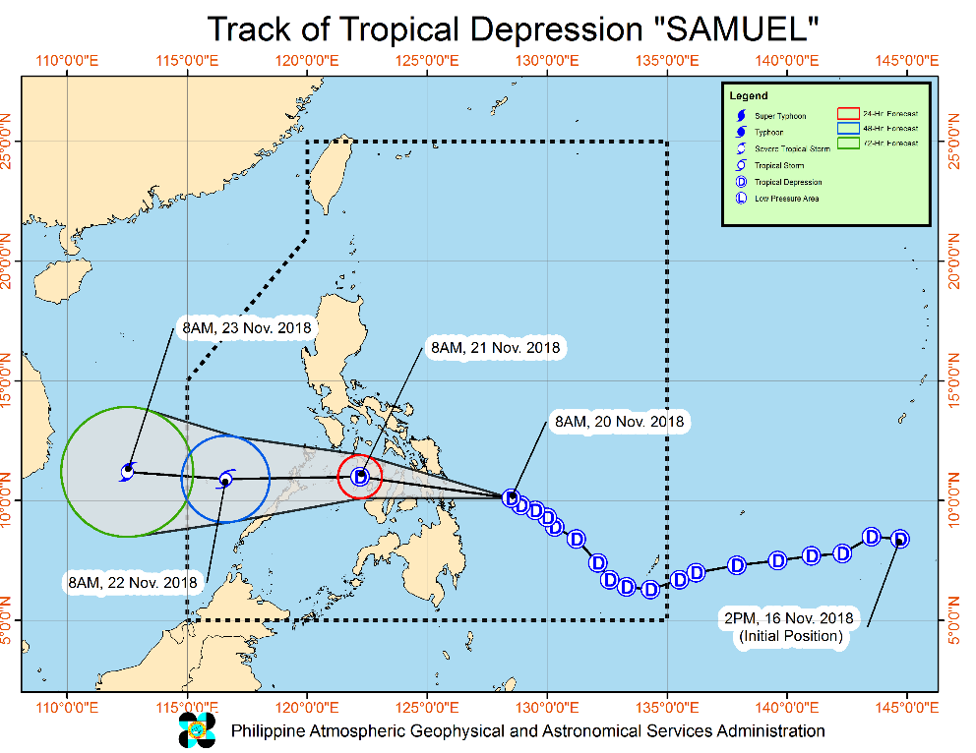
Issued at 11:00 AM today, Tropical Depression "SAMUEL" continues to move west-northwestward towards the Samar-Leyte-Dinagat area.

- Moderate to heavy rains which may trigger flooding and landslides is expected over Visayas, Sorsogon, Masbate, Romblon, Dinagat Islands and Siargao islands. Residents of these areas, especially those living near or in river channels, low-lying and mountainous areas, are advised to take precautionary measures, coordinate with local disaster risk reduction and management offices, and continue monitoring for updates.
- Fisherfolks and those with small seacrafts are advised not to venture out over the areas under TCWS #1 and the eastern seaboard of Southern Luzon.
- "SAMUEL" is expected to make landfall over the Samar-Leyte-Dinagat area tonight.

The center of Tropical Depression "SAMUEL" was estimated based on all available data at 335 km East of Maasin City, Southern Leyte (10.2°N, 127.9°E). It is moving moving West Northwest at 20 kph with a maximum sustained winds of 55 kph near the center and gustiness of up to 65 kph.

Source: DOST-PAGASA Severe Weather Bulletin

Status of Prepositioned Resources: Stockpile and Standby Funds

The DSWD Central Office (CO), Field Offices (FOs), and National Resource Operations Center (NROC) have stockpiles and standby funds amounting to ₱2,140,609,643.99 with breakdown as follows:

- Standby Funds
A total of ₱1,121,491,675.15 standby funds in the CO and FOs. Of the said amount, ₱1,072,481,549.10 is the available Quick Response Fund in the CO.

- Stockpiles
A total of 378,580 Family Food Packs (FFPs) amounting to ₱138,592,796.79 and available Food and Non-food Items (FNIs) amounting to ₱880,525,172.05.

FIELD OFFICE | STANDBY FUNDS | STOCKPILE |  |  |  |  | TOTAL STANDBY FUNDS  AND STOCKPILE
 |  | Family Food Packs |  | Food  (Raw Mats and  Other Food Items) | Non-Food  (Raw Mats and  Other NFIs) | Sub-Total  (Food and NFIs)
 |  | Quantity | Total Cost
TOTAL | 1,121,491,675.15 | 378,580 | 138,592,796.79 | 157,004,933.29 | 723,520,238.76 | 880,525,172.05 | 2,140,609,643.99
Central Office* | 1,072,481,549.10 | - | - | - | - | - | 1,072,481,549.10
NROC | - | 97,200 | 35,186,400.00 | 63,120,782.84 | 282,234,019.00 | 345,354,801.84 | 380,541,201.84
NCR | 3,620,973.50 | 4,367 | 1,398,882.46 | 1,376,293.53 | 8,804,557.77 | 10,180,851.30 | 15,200,707.26
CAR | 4,215,730.95 | 14,543 | 5,254,452.55 | 5,242,054.76 | 24,701,294.77 | 29,943,349.53 | 39,413,533.03
I | 2,786,193.79 | 6,722 | 2,419,920.00 | 3,100,485.76 | 46,294,215.73 | 49,394,701.49 | 54,600,815.28
II | 5,464,267.84 | 19,360 | 6,969,600.00 | 1,020,109.40 | 1,248,788.50 | 2,268,897.90 | 14,702,765.74
III | 1,064,319.00 | 24,454 | 8,909,569.60 | 1,338,514.60 | 12,920,905.50 | 14,259,420.10 | 24,233,308.70
CALABARZON | 3,304,250.00 | 5,066 | 1,720,794.14 | 3,859,418.93 | 7,591,900.68 | 11,451,319.61 | 16,476,363.75
MIMAROPA | 3,034,141.75 | 23,280 | 8,654,115.00 | 7,602,897.61 | 1,344,028.86 | 8,946,926.47 | 20,635,183.22
V | 2,169,791.12 | 31,193 | 12,536,300.00 | 1,432,794.56 | 53,411,957.36 | 54,844,751.92 | 69,550,843.04
VI | 3,000,000.00 | 17,462 | 6,286,320.00 | 14,235,821.61 | 8,551,581.19 | 22,787,402.80 | 32,073,722.80
VII | 3,534,400.00 | 54,483 | 22,099,897.80 | 19,964,628.95 | 53,579,184.27 | 73,543,813.22 | 99,178,111.02
VIII | 2,697,960.00 | 11,497 | 3,917,849.68 | 13,059,900.73 | 47,830,901.05 | 60,890,801.78 | 67,506,611.46
IX | 3,047,481.35 | 15,832 | 5,699,520.00 | 3,418,030.00 | 21,873,380.99 | 25,291,410.99 | 34,038,412.34
X | 3,140,700.00 | 12,729 | 4,301,829.00 | 6,099,492.00 | 125,178,927.86 | 131,278,419.86 | 138,720,948.86
XI | 3,000,000.00 | 22,735 | 7,452,533.00 | 6,539,200.00 | 11,170,443.04 | 17,709,643.04 | 28,162,176.04
XII | 3,000,350.00 | 3,853 | 1,545,053.00 | 1,075,368.01 | 3,114,896.67 | 4,190,264.68 | 8,735,667.68
CARAGA | 1,929,566.75 | 13,804 | 4,239,760.56 | 4,519,140.00 | 13,669,255.52 | 18,188,395.52 | 24,357,722.83
* Quick Response Fund (QRF) as of 20 November 2018

Situational Reports

DSWD-DRMB
DATE | SITUATIONS / ACTIONS UNDERTAKEN
November 20, 2018 | - The Disaster Response Operations Monitoring and Information Center (DROMIC) of the DSWD-DRMB is closely coordinating with the DSWD-Field Offices for significant disaster preparedness for response updates.

DSWD-FO MIMAROPA
DATE | SITUATIONS / ACTIONS UNDERTAKEN
November 19, 2018 | - DSWD-FO MIMAROPA activated its Field Office Operation Center to monitor daily local weather condition and provide situational awareness.  - All P/C/M Quick Response Teams in five (5) provinces of MiMaRoPa were alerted to regularly monitor the situations in their areas.  - All members of R/P/C/M QRTs are on-call and on standby ready for deployment if needed.  - Ensured that the Rapid Emergency Telecommunications Equipment (e.g., GX terminal, BGAN terminals and satellite phones) are in good condition and ready for deployment to areas that may experience potential emergencies.  - Standby logistical equipment and workforce through coordination with SWADT and concerned LGUs on management of stranded passengers if there will be reported strandees in ports and terminals.  - Ensured that relief goods are ready and available at any given time.  - Close coordination with the Office of Civil Defense (OCD) and RDRRMC MIMAROPA to monitor warning signal updates for response mechanism in areas that may be affected.  - With ongoing purchased and replenishment of stockpile and prepositioned FFPs.

DSWD-FO VII
DATE | SITUATIONS / ACTIONS UNDERTAKEN
November 19, 2018 | - DSWD-FO VII Quick Response Team is on standby alert for any assistance and augmentation support needed by the LGUs.  - DSWD-FO VII field staff were already alerted and updated on the latest weather information, and were requested to monitor their respective areas of responsibility and closely coordinate with their LDRRMC for any untoward incident that may occur.

DSWD-FO IX
DATE | SITUATIONS / ACTIONS UNDERTAKEN
November 19, 2018 | - DSWD-FO IX ensured availability of food and non-food items.  - DSWD-FO IX is continuously repacking goods to maintain the required 30,000 FFPs at any given time.  - DSWD-FO IX through its Disaster Response Management Division prepared and disseminated a memorandum on preparedness for response to officially inform the SWAD Team Leaders to monitor the situation in their respective areas of responsibility.

DSWD-FO X
DATE | SITUATIONS / ACTIONS UNDERTAKEN
November 20, 2018 | - DSWD-FO X has 12 Quick Response Teams composed of regional staff and C/MATs of Bukidnon and Lanao del Norte ready for deployment any time.  - DSWD-FO X is ready for possible augmentation of relief goods to communities that may be affected by the effects of TD Samuel.

DSWD-FO XI
DATE | SITUATIONS / ACTIONS UNDERTAKEN
November 17, 2018 | - DSWD-FO XI activated its Regional, RPMO (SWADTs, PATs, MATs, CATs) Quick Response Teams, and DRMD personnel, and are on-call for duty.  - DSWD-FO XI is closely coordinating with all SWADOs, PSWDOs, and CSWDO/MSWDOs to monitor on the situation in the different parts of Davao Region.  - Personnel manning in the warehouse were alerted to ensure readiness of dispatching food and non-food items and that relief goods are also ready and available at any given time.  - Ensured availability of Disaster Wing Van, vehicles and drivers in the event of a relief operation.  - Established close coordination with Office of Civil Defense (OCD) XI for monitoring purposes and response mechanisms.

DSWD-FO CARAGA
DATE | SITUATIONS / ACTIONS UNDERTAKEN
November 20, 2018 | - DSWD-FO CARAGA has activated their Quick Response Team to closely coordinate with the LSWDOs and LDRRMOs and continue monitoring the situation.  - There are 74 stranded passengers in different sea ports in CARAGA: 10 in PMO-Surigao, 58 in Lipata, and 6 in Nasipit.  - There are 356 families or 1,719 individuals who were pre-emptively evacuated in and are currently accommodated in 16 evacuation centers in Surigao del Norte, Surigao del Sur, and Dinagat Islands.  REGION / PROVINCE / MUNICIPALITY NUMBER OF EVACUATION CENTERS (ECs) INSIDE ECs  Families Persons  NOW NOW NOW  GRAND TOTAL 16 356 1,452  CARAGA 16 356 1,452  Dinagat Island 11 132 393  Basilisa (Rizal) 4 37 130  Dinagat 1 5 19  Loreto 1 14 43  San Jose (capital) 5 76 201  Surigao del Norte 4 121 437  Sison 3 86 302  Surigao City (capital) 1 35 135  Surigao del Sur 1 103 622  Cagwait 1 103 622

*****
The Disaster Response Operations Monitoring and Information Center (DROMIC) of the DSWD-DRMB is closely coordinating with the concerned DSWD-Field Offices for any significant disaster preparedness for response updates.

MARC LEO L. BUTAC
Releasing Officer

