DSWD DROMIC Preparedness for Response Report #3 on
Tropical Depression “SAMUEL”
as of 20 November 2018, 6PM

Situation Overview
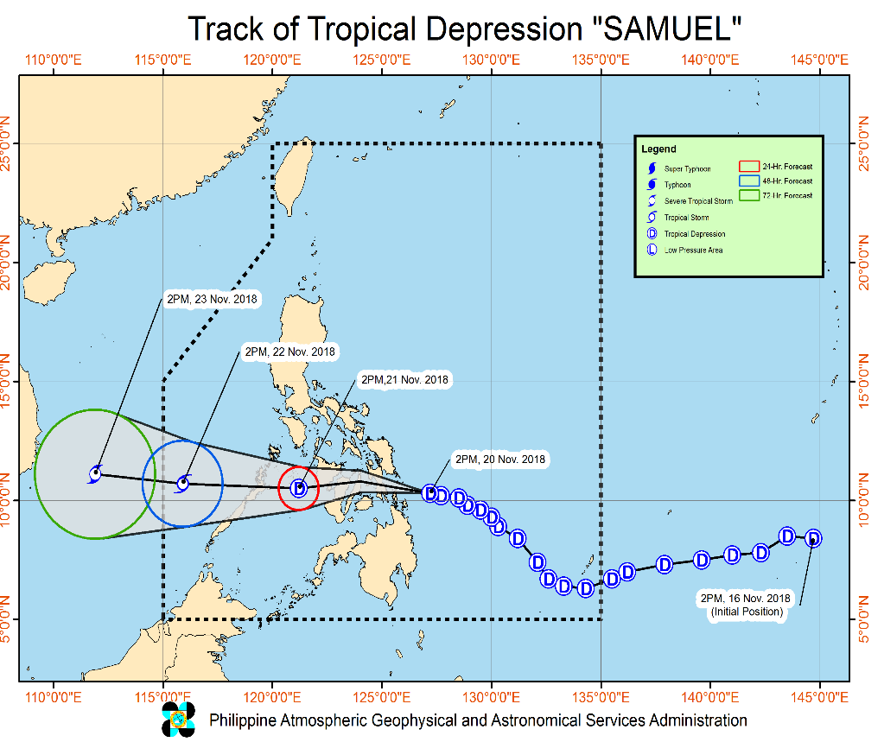

Issued at 05:00 PM today, Tropical Depression "Samuel" is continues to move west-northwestward as it approaches the Leyte gulf area.
- Moderate to heavy rains which may trigger flooding and landslides is expected over Visayas, Bicol Region, MIMAROPA, Dinagat Islands and Siargao island. Residents of these areas, especially those living near or in river channels, low-lying and mountainous areas, are advised to take appropriate measures, coordinate with local disaster risk reduction and management offices, and continue monitoring for updates.
- Fisherfolks and those with small seacrafts are advised not to venture out over the areas under TCWS #1, as well as the northern and eastern seaboards of Luzon.
- "SAMUEL" is expected to make landfall in the area between the southern portion of Eastern Samar and Dinagat Islands tonight.

At 4:00 PM today, the center of Tropical Depression "SAMUEL" was estimated based on all available data at 250 km East of Maasin City, Southern Leyte or 165 km East Southeast of Guiuan, Eastern Samar (10.4 °N, 127.1 °E)

Source: DOST-PAGASA Severe Weather Bulletin

Status of Prepositioned Resources: Stockpile and Standby Funds

The DSWD Central Office (CO), Field Offices (FOs), and National Resource Operations Center (NROC) have stockpiles and standby funds amounting to ₱2,140,609,643.99 with breakdown as follows:

- Standby Funds
A total of ₱1,121,491,675.15 standby funds in the CO and FOs. Of the said amount, ₱1,072,481,549.10 is the available Quick Response Fund in the CO.

- Stockpiles
A total of 378,580 Family Food Packs (FFPs) amounting to ₱138,592,796.79 and available Food and Non-food Items (FNIs) amounting to ₱880,525,172.05.

FIELD OFFICE | STANDBY FUNDS | STOCKPILE |  |  |  |  | TOTAL STANDBY FUNDS  AND STOCKPILE
 |  | Family Food Packs |  | Food  (Raw Mats and  Other Food Items) | Non-Food  (Raw Mats and  Other NFIs) | Sub-Total  (Food and NFIs)
 |  | Quantity | Total Cost
TOTAL | 1,121,491,675.15 | 378,580 | 138,592,796.79 | 157,004,933.29 | 723,520,238.76 | 880,525,172.05 | 2,140,609,643.99
Central Office* | 1,072,481,549.10 | - | - | - | - | - | 1,072,481,549.10
NROC | - | 97,200 | 35,186,400.00 | 63,120,782.84 | 282,234,019.00 | 345,354,801.84 | 380,541,201.84
NCR | 3,620,973.50 | 4,367 | 1,398,882.46 | 1,376,293.53 | 8,804,557.77 | 10,180,851.30 | 15,200,707.26
CAR | 4,215,730.95 | 14,543 | 5,254,452.55 | 5,242,054.76 | 24,701,294.77 | 29,943,349.53 | 39,413,533.03
I | 2,786,193.79 | 6,722 | 2,419,920.00 | 3,100,485.76 | 46,294,215.73 | 49,394,701.49 | 54,600,815.28
II | 5,464,267.84 | 19,360 | 6,969,600.00 | 1,020,109.40 | 1,248,788.50 | 2,268,897.90 | 14,702,765.74
III | 1,064,319.00 | 24,454 | 8,909,569.60 | 1,338,514.60 | 12,920,905.50 | 14,259,420.10 | 24,233,308.70
CALABARZON | 3,304,250.00 | 5,066 | 1,720,794.14 | 3,859,418.93 | 7,591,900.68 | 11,451,319.61 | 16,476,363.75
MIMAROPA | 3,034,141.75 | 23,280 | 8,654,115.00 | 7,602,897.61 | 1,344,028.86 | 8,946,926.47 | 20,635,183.22
V | 2,169,791.12 | 31,193 | 12,536,300.00 | 1,432,794.56 | 53,411,957.36 | 54,844,751.92 | 69,550,843.04
VI | 3,000,000.00 | 17,462 | 6,286,320.00 | 14,235,821.61 | 8,551,581.19 | 22,787,402.80 | 32,073,722.80
VII | 3,534,400.00 | 54,483 | 22,099,897.80 | 19,964,628.95 | 53,579,184.27 | 73,543,813.22 | 99,178,111.02
VIII | 2,697,960.00 | 11,497 | 3,917,849.68 | 13,059,900.73 | 47,830,901.05 | 60,890,801.78 | 67,506,611.46
IX | 3,047,481.35 | 15,832 | 5,699,520.00 | 3,418,030.00 | 21,873,380.99 | 25,291,410.99 | 34,038,412.34
X | 3,140,700.00 | 12,729 | 4,301,829.00 | 6,099,492.00 | 125,178,927.86 | 131,278,419.86 | 138,720,948.86
XI | 3,000,000.00 | 22,735 | 7,452,533.00 | 6,539,200.00 | 11,170,443.04 | 17,709,643.04 | 28,162,176.04
XII | 3,000,350.00 | 3,853 | 1,545,053.00 | 1,075,368.01 | 3,114,896.67 | 4,190,264.68 | 8,735,667.68
CARAGA | 1,929,566.75 | 13,804 | 4,239,760.56 | 4,519,140.00 | 13,669,255.52 | 18,188,395.52 | 24,357,722.83
* Quick Response Fund (QRF) as of 20 November 2018

Situational Reports

DSWD-DRMB
DATE | SITUATIONS / ACTIONS UNDERTAKEN
November 20, 2018 | - The Disaster Response Operations Monitoring and Information Center (DROMIC) of the DSWD-DRMB is closely coordinating with the DSWD-Field Offices for significant disaster preparedness for response updates.

DSWD-FO MIMAROPA
DATE | SITUATIONS / ACTIONS UNDERTAKEN
November 19, 2018 | - DSWD-FO MIMAROPA activated its Field Office Operation Center to monitor daily local weather condition and provide situational awareness.  - All P/C/M Quick Response Teams in five (5) provinces of MiMaRoPa were alerted to regularly monitor the situations in their areas.  - All members of R/P/C/M QRTs are on-call and on standby ready for deployment if needed.  - Ensured that the Rapid Emergency Telecommunications Equipment (e.g., GX terminal, BGAN terminals and satellite phones) are in good condition and ready for deployment to areas that may experience potential emergencies.  - Standby logistical equipment and workforce through coordination with SWADT and concerned LGUs on management of stranded passengers if there will be reported strandees in ports and terminals.  - Ensured that relief goods are ready and available at any given time.  - Close coordination with the Office of Civil Defense (OCD) and RDRRMC MIMAROPA to monitor warning signal updates for response mechanism in areas that may be affected.  - With ongoing purchased and replenishment of stockpile and prepositioned FFPs.

DSWD-FO V
DATE | SITUATIONS / ACTIONS UNDERTAKEN
November 20, 2018 | - Closely monitoring of the weather updates and information.  - Emergency Telecommunication Equipment is on standby and ready for deployment as the need arises.  - DSWD FO V QRTs were alerted and advised to be prepared for augmentation support needed from the field and/or 24/7 duty at the DRMD Operation Center.  - PAT and MAT members in the 6 provinces are on standby and were instructed to coordinate with the P/MDRRMOs for status reports and updates.

DSWD-FO VII
DATE | SITUATIONS / ACTIONS UNDERTAKEN
November 19, 2018 | - DSWD-FO VII Quick Response Team is on standby alert for any assistance and augmentation support needed by the LGUs.  - DSWD-FO VII field staff were already alerted and updated on the latest weather information, and were requested to monitor their respective areas of responsibility and closely coordinate with their LDRRMC for any untoward incident that may occur.
November 20, 2018 | - The second regional pre-disaster risk assessment was held yesterday by members of the Regional Disaster Risk Reduction and Management Council in preparation for TD Samuel.  - Bohol MDRRMCs were already directed by the Governor to closely monitor the status of their AORs.  - DSWD Quick Response Team has been activated effective today to render 24-hour duty on shifting schedule.  - Staff from the field have been continuously informed of the latest weather information and had been requested to monitor AOR and closely coordinate with their LDRRMC for incidents that may occur.  - There are 159 families or 563 individuals who were pre-emptively evacuated in and are currently accommodated in 7 evacuation centers in Bohol.  REGION / PROVINCE / MUNICIPALITY NUMBER OF EVACUATION CENTERS (ECs) INSIDE ECs  Families Persons  NOW NOW NOW  GRAND TOTAL  FO VII 7 159 563  Bohol 7 159 563  Candijay 6 145 501  Guindulman 1 14 62

DSWD-FO VIII
DATE | SITUATIONS / ACTIONS UNDERTAKEN
November 20, 2018 | - SWAD Teams and DRMD-PDOs assigned at the provinces are in close coordination with P/C/MSWDOs and/or P/C/MDRRMOs and monitoring the situation at the ground.  - Quick Response Team (QRT) members and Disaster Response Management Division (DRMD) are rendering 24/7 duty both in RDRRM Council (Office of Civil Defense) and DSWD FO VIII Operations Center.  - Disaster Response Information Management Section (DRIMS) is monitoring the weather condition and in close coordination with Disaster Response Council Members, SWADTs, QRTs and PDOs for any incident reports.  - Regional Resource Operation Section (RROS) are also alerted to ensure the readiness of dispatching the Food and Non-Food commodities whenever needed.

DSWD-FO IX
DATE | SITUATIONS / ACTIONS UNDERTAKEN
November 19, 2018 | - DSWD-FO IX ensured availability of food and non-food items.  - DSWD-FO IX is continuously repacking goods to maintain the required 30,000 FFPs at any given time.  - DSWD-FO IX through its Disaster Response Management Division prepared and disseminated a memorandum on preparedness for response to officially inform the SWAD Team Leaders to monitor the situation in their respective areas of responsibility.

DSWD-FO X
DATE | SITUATIONS / ACTIONS UNDERTAKEN
November 20, 2018 | - DSWD-FO X has 12 Quick Response Teams composed of regional staff and C/MATs of Bukidnon and Lanao del Norte ready for deployment any time.  - DSWD-FO X is ready for possible augmentation of relief goods to communities that may be affected by the effects of TD Samuel.

DSWD-FO XI
DATE | SITUATIONS / ACTIONS UNDERTAKEN
November 17, 2018 | - DSWD-FO XI activated its Regional, RPMO (SWADTs, PATs, MATs, CATs) Quick Response Teams, and DRMD personnel, and are on-call for duty.  - DSWD-FO XI is closely coordinating with all SWADOs, PSWDOs, and CSWDO/MSWDOs to monitor on the situation in the different parts of Davao Region.  - Personnel manning in the warehouse were alerted to ensure readiness of dispatching food and non-food items and that relief goods are also ready and available at any given time.  - Ensured availability of Disaster Wing Van, vehicles and drivers in the event of a relief operation.  - Established close coordination with Office of Civil Defense (OCD) XI for monitoring purposes and response mechanisms.

DSWD-FO XII
DATE | SITUATIONS / ACTIONS UNDERTAKEN
November 17, 2018 | - All QRT members are on standby and ready for any event that may arise that would require immediate assistance from the Department.  - 3 Vehicles are ready for utilization in case of response activation.  - Activation of BLUE ALERT Status.

DSWD-FO CARAGA
DATE | SITUATIONS / ACTIONS UNDERTAKEN
November 20, 2018 | - DSWD-FO CARAGA has activated their Quick Response Team to closely coordinate with the LSWDOs and LDRRMOs and continue monitoring the situation.  - There are 74 stranded passengers in different sea ports in CARAGA: 10 in PMO-Surigao, 58 in Lipata, and 6 in Nasipit.  - There are 356 families or 1,719 individuals who were pre-emptively evacuated in and are currently accommodated in 16 evacuation centers in Surigao del Norte, Surigao del Sur, and Dinagat Islands.  REGION / PROVINCE / MUNICIPALITY NUMBER OF EVACUATION CENTERS (ECs) INSIDE ECs  Families Persons  NOW NOW NOW  GRAND TOTAL 16 356 1,452  CARAGA 16 356 1,452  Dinagat Island 11 132 393  Basilisa (Rizal) 4 37 130  Dinagat 1 5 19  Loreto 1 14 43  San Jose (capital) 5 76 201  Surigao del Norte 4 121 437  Sison 3 86 302  Surigao City (capital) 1 35 135  Surigao del Sur 1 103 622  Cagwait 1 103 622

*****
The Disaster Response Operations Monitoring and Information Center (DROMIC) of the DSWD-DRMB is closely coordinating with the concerned DSWD-Field Offices for any significant disaster preparedness for response updates.

MARIEL B. FERRARIZ
Releasing Officer

