DSWD DROMIC Report #14 on
Tropical Depression “SAMUEL”
as of 17 December 2018, 4PM

Situation Overview

- Status of Affected Families / Persons
A total of 33,573 families or 124,266 persons were affected in 294 barangays, 31 cities/municipalities, and 7 provinces in Regions V and VIII (see Table 1).

Table 1. Affected Areas and Number of Affected Families / Persons
REGION / PROVINCE / MUNICIPALITY |  | NUMBER OF AFFECTED
 |  | Barangays | Cities / Municipalities | Provinces | Families | Persons
GRAND TOTAL |  | 296 | 32 | 7 | 33,573 | 124,266
REGION V |  | 5 | 1 | 1 | 77 | 281
Masbate |  | 5 | 2 |  | 77 | 281
 | Baleno | 2 |  |  | 23 | 97
 | Pio V. Corpuz (Limbuhan) | 3 |  |  | 54 | 184
REGION VIII |  | 291 | 31 | 6 | 33,496 | 123,985
Biliran |  | 10 | 1 |  | 307 | 1,199
 | Kawayan | 10 |  |  | 307 | 1,199
Eastern Samar |  | 163 | 11 | 1 | 20,915 | 67,899
 | Arteche | 9 |  |  | 1,235 | 4,438
 | Dolores | 46 |  |  | 8,211 | 13,506
 | Jipapad | 13 |  |  | 2,489 | 13,500
 | Oras | 42 |  |  | 4,488 | 17,952
 | San Julian | 2 |  |  | 52 | 234
 | San Policarpo | 3 |  |  | 472 | 1,808
 | Sulat | 1 |  |  | 6 | 28
 | Taft | 2 |  |  | 10 | 45
 | Guiuan | 29 |  |  | 1,636 | 6,540
 | Hernani | 13 |  |  | 2,295 | 9,766
 | Llorente | 3 |  |  | 21 | 82
Leyte |  | 5 | 3 | 1 | 119 | 364
 | Tacloban City (capital) | 2 |  |  | 13 | 52
 | Dulag | 1 |  |  | 5 | 22
 | La Paz | 2 |  |  | 101 | 290
Northern Samar |  | 108 | 12 | 1 | 11,955 | 53,704
 | Catarman (capital) | 4 |  |  | 14 | 73
 | Lope de Vega | 2 |  |  | 79 | 316
 | San Isidro | 1 |  |  | 19 | 76
 | Catubig | 47 |  |  | 7,625 | 35,621
 | Gamay | 1 |  |  | 17 | 68
 | Laoang | 18 |  |  | 2,690 | 10,760
 | Lapinig | 4 |  |  | 171 | 701
 | Las Navas | 4 |  |  | 89 | 365
 | Mapanas | 7 |  |  | 267 | 1,048
 | Palapag | 4 |  |  | 77 | 292
 | Pambujan | 8 |  |  | 720 | 3,715
 | San Roque | 8 |  |  | 187 | 669
Western Samar |  | 2 | 1 | 1 | 133 | 584
 | Pinabacdao | 2 |  |  | 133 | 584
Southern Leyte |  | 3 | 3 | 1 | 67 | 235
 | Tomas Oppus | 1 |  |  | 25 | 70
 | Libagon | 1 |  |  | 10 | 45
 | Saint Bernard | 1 |  |  | 32 | 120
Note: Ongoing assessment and validation
Decrease on the affected families in Jipapad, Eastern Samar was due to the further assessment of DRMD Staff during relief operation.
Sources: LGUs through the C/MSWD and C/MDRRMO

- Status of Displaced and Served Families / Persons (see Table 2)

Table 2. Number of Served Families / Persons Inside and Outside ECs
REGION / PROVINCE / MUNICIPALITY |  | NUMBER OF EVACUATION CENTERS (ECs) |  | INSIDE ECs |  |  |  | INSIDE ECs Returned Home |  | OUTSIDE ECs |  |  |  | OUTSIDE ECs Returned Home |  | TOTAL SERVED
 |  |  |  |  |  |  |  |  |  |  |  |  |  |  |  | Families |  | Persons
 |  |  |  | Families |  | Persons |  | Families | Persons | Families |  | Persons |  | Families | Persons | Total Families |  | Total Persons
 |  | CUM | NOW | CUM | NOW | CUM | NOW |  |  | CUM | NOW | CUM | NOW |  |  | CUM | NOW | CUM | NOW
GRAND TOTAL |  | 79 | 2 | 2,695 | 27 | 11,442 | 108 | 2,668 | 11,334 | 1,965 | 79 | 9,782 | 490 | 1,886 | 9,292 | 4,660 | 106 | 21,224 | 598
REGION V |  | 4 | - | 67 | - | 258 | - | 67 | 258 | 10 | - | 23 | - | 10 | 23 | 77 | - | 281 | -
Masbate |  | 4 | - | 67 | - | 258 | - | 67 | 258 | 10 | - | 23 | - | 10 | 23 | 77 | - | 281 | -
 | Baleno | 1 | - | 23 | - | 97 | - | 23 | 97 | - | - | - | - | - | - | 23 | - | 97 | -
 | Pio V. Corpuz (Limbuhan) | 3 | - | 44 | - | 161 | - | 44 | 161 | 10 | - | 23 | - | 10 | 23 | 54 | - | 184 | -
REGION VIII |  | 75 | 2 | 2,628 | 27 | 11,184 | 108 | 2,601 | 11,076 | 1,955 | 79 | 9,759 | 490 | 1,876 | 9,269 | 4,583 | 106 | 20,943 | 598
Biliran |  | - | - | - | - | - | - | - | - | 172 | - | 860 | - | 172 | 860 | 172 | - | 860 | -
 | Kawayan | - | - | - | - | - | - | - | - | 172 | - | 860 | - | 172 | 860 | 172 | - | 860 | -
Eastern Samar |  | 27 | 1 | 1,118 | 23 | 4,364 | 92 | 1,095 | 4,272 | 1,774 | 79 | 8,871 | 490 | 1,695 | 8,381 | 2,892 | 102 | 13,235 | 582
 | Arteche | 6 | - | 131 | - | 535 | - | 131 | 535 | 98 | 76 | 586 | 478 | 22 | 108 | 229 | 76 | 1,121 | 478
 | Jipapad | 9 | 1 | 527 | 23 | 1,600 | 92 | 504 | 1,508 | - | - | - | - | - | - | 527 | 23 | 1,600 | 92
 | San Julian | 1 | - | 52 | - | 234 | - | 52 | 234 | - | - | - | - | - | - | 52 | - | 234 | -
 | Sulat | 1 | - | 6 | - | 28 | - | 6 | 28 | - | - | - | - | - | - | 6 | - | 28 | -
 | Taft | - | - | - | - | - | - | - | - | 3 | 3 | 12 | 12 | - | - | 3 | 3 | 12 | 12
 | Hernani | 9 | - | 381 | - | 1,885 | - | 381 | 1,885 | 1,673 | - | 8,273 | - | 1,673 | 8,273 | 2,054 | - | 10,158 | -
 | Llorente | 1 | - | 21 | - | 82 | - | 21 | 82 | - | - | - | - | - | - | 21 | - | 82 | -
Leyte |  | 5 | - | 119 | - | 364 | - | 119 | 364 | - | - | - | - | - | - | 119 | - | 364 | -
 | Tacloban City (capital) | 2 | - | 13 | - | 52 | - | 13 | 52 | - | - | - | - | - | - | 13 | - | 52 | -
 | Dulag | 1 | - | 5 | - | 22 | - | 5 | 22 | - | - | - | - | - | - | 5 | - | 22 | -
 | La Paz | 2 | - | 101 | - | 290 | - | 101 | 290 | - | - | - | - | - | - | 101 | - | 290 | -
Northern Samar |  | 36 | 1 | 1,200 | 4 | 5,665 | 16 | 1,196 | 5,649 | - | - | - | - | - | - | 1,200 | 4 | 5,665 | 16
 | Catubig | 4 | - | 23 | - | 114 | - | 23 | 114 | - | - | - | - | - | - | 23 | - | 114 | -
 | Lapinig | 6 | - | 171 | - | 701 | - | 171 | 701 | - | - | - | - | - | - | 171 | - | 701 | -
 | Las Navas | 4 | 1 | 19 | 4 | 87 | 16 | 15 | 71 | - | - | - | - | - | - | 19 | 4 | 87 | 16
 | Mapanas | 4 | - | 267 | - | 1,048 | - | 267 | 1,048 | - | - | - | - | - | - | 267 | - | 1,048 | -
 | Pambujan | 18 | - | 720 | - | 3,715 | - | 720 | 3,715 | - | - | - | - | - | - | 720 | - | 3,715 | -
Western Samar |  | 4 | - | 133 | - | 584 | - | 133 | 584 | - | - | - | - | - | - | 133 | - | 584 | -
 | Pinabacdao | 4 | - | 133 | - | 584 | - | 133 | 584 | - | - | - | - | - | - | 133 | - | 584 | -
Southern Leyte |  | 3 | - | 58 | - | 207 | - | 58 | 207 | 9 | - | 28 | - | 9 | 28 | 67 | - | 235 | -
 | Tomas Oppus | 1 | - | 16 | - | 42 | - | 16 | 42 | 9 | - | 28 | - | 9 | 28 | 25 | - | 70 | -
 | Libagon | 1 | - | 10 | - | 45 | - | 10 | 45 | - | - | - | - | - | - | 10 | - | 45 | -
 | Saint Bernard | 1 | - | 32 | - | 120 | - | 32 | 120 | - | - | - | - | - | - | 32 | - | 120 | -
Note: Ongoing assessment and validation

Sources: LGUs through the C/MSWD and C/MDRRMO

- Damaged Houses
There are 1,631 damaged houses reported in Regions VIII; of which, 91 houses are totally damaged and 1,540 houses are partially damaged (see Table 3).

Table 3. Number of Damaged Houses
REGION / PROVINCE / MUNICIPALITY |  | NO. OF DAMAGED HOUSES
 |  | Total | Totally | Partially
GRAND TOTAL |  | 1,631 | 91 | 1,540
REGION VIII |  | 1,631 | 91 | 1,540
Eastern Samar |  | 1,607 | 84 | 1,523
 | Arteche | 1,130 | 10 | 1,120
 | Dolores | 3 | - | 3
 | Jipapad | 471 | 72 | 399
 | Taft | 3 | 2 | 1
Northern Samar |  | 24 | 7 | 17
 | Catubig | 7 | 3 | 4
 | Lapinig | 13 | - | 13
 | Las Navas | 4 | 4 | -

Note: Ongoing assessment and validation.
Decrease on the damaged houses in Arteche, Eastern Samar is due to the validated and final report of LGU.
Sources: LGUs through the C/MSWD and C/MDRRMO

- Summary of Assistance Provided (see Table 4)

Table 4. Cost of Assistance Provided to Affected Families / Persons
REGION / PROVINCE / MUNICIPALITY |  | TOTAL COST OF ASSISTANCE
 |  | DSWD | LGU | NGOs | OTHERS | GRAND TOTAL
GRAND TOTAL |  | 2,967,135.00 | 3,941,681.00 | - | - | 6,908,816.00
REGION V |  | - | 15,120.00 | - | - | 15,120.00
Masbate |  | - | 15,120.00 | - | - | 15,120.00
 | Pio V. Corpuz (Limbuhan) | - | 15,120.00 | - | - | 15,120.00
REGION VIII |  | 2,967,135.00 | 3,926,561.00 | - | - | 6,893,696.00
Biliran |  | - | 76,750.00 | - | - | 76,750.00
 | Kawayan | - | 76,750.00 | - | - | 76,750.00
Eastern Samar |  | 2,947,405.00 | 620,715.00 | - | - | 3,568,120.00
 | Arteche | 444,600.00 | 542,130.00 | - | - | 986,730.00
 | Jipapad | 1,782,805.00 | - | - | - | 1,782,805.00
 | Oras | 720,000.00 | 47,400.00 | - | - | 767,400.00
 | San Julian | - | 6,270.00 | - | - | 6,270.00
 | Hernani | - | 16,000.00 | - | - | 16,000.00
 | Llorente | - | 8,915.00 | - | - | 8,915.00
Leyte |  | - | 23,400.00 | - | - | 23,400.00
 | Tacloban City (capital) | - | 23,400.00 | - | - | 23,400.00
Northern Samar |  | - | 3,155,816.00 | - | - | 3,155,816.00
 | Catubig | - | 3,060,000.00 | - | - | 3,060,000.00
 | Mapanas | - | 95,816.00 | - | - | 95,816.00
Western Samar |  | - | 47,880.00 | - | - | 47,880.00
 | Pinabacdao | - | 47,880.00 | - | - | 47,880.00
Southern Leyte |  | 19,730.00 | 2,000.00 | - | - | 21,730.00
 | Tomas Oppus | 19,730.00 | 2,000.00 | - | - | 21,730.00
Note: Ongoing assessment and validation
*Note: The Php47,880.00 worth of relief assistance in Pinabacdao was provided by the LGU. No augmentation from DSWD has been provided yet
Sources: LGUs through the C/MSWD and C/MDRRMO, and DSWD-Field Offices

Situational Reports

DSWD-DRMB
DATE | SITUATIONS / ACTIONS UNDERTAKEN
November 18, 2018 to Present | - The Disaster Response Operations Monitoring and Information Center (DROMIC) of the DSWD-DRMB is closely coordinating with the DSWD-Field Offices for significant disaster preparedness for response updates.
DSWD-FO VIII
DATE | SITUATIONS / ACTIONS UNDERTAKEN
December 17, 2018 | - DRMD staff and PAT members in Eastern Samar had a 2nd round F/NFIs distribution in Jipapad, Eastern Samar which started last December 9, 2018. A total of 13 Barangays and 2,359 Families served with F/NFIs in 2nd round distribution. (Breakdown: 2,359 Family Food Packs, 531 Blankets, 95 Mosquito Nets and 95 Brown Mats)  - DRMD Staff had a plan meeting last December 4, 2018 for the 2nd round food and non-food items relief distribution in Jipapad, Eastern Samar which scheduled on December 9, 2018 until the day of completion of relief distribution.  - DSWD Field Office VIII will have a second-round distribution to 2,489 Families affected in Jipapad, Eastern Samar. The remaining 211 Family Food Packs balance of the 2,700 Family Food Packs delivered in Jipapad, Eastern Samar will be added on the second-round distribution.  - Disaster Response Management Division together with the composed team completed the distribution of 2,000 Family Food Packs in Oras, Eastern Samar, 1,235 Family Food Packs in Arteche, Eastern Samar and 2,489 Family Food Packs in Jipapad, Eastern Samar. This response effort is in coordination and collaboration with the Office of Civil Defense and Disaster Response Committee Members.  - On November 25, 2018, the Regional Response Cluster had a meeting with regards to the TD “Samuel” which being participated by the DRMD Chief and Staff. The agreements during the meeting in JIPAPAD are the following:  1. Formulate Contingency Plan;  2. To conduct RDANA as a basis for the declaration of State of Calamity;  3. To request MGB to conduct immediate hazards assessment;  4. To conduct training on search and Rescue;  5. Reconcile the LGU data from the validated data of DSWD;  6. Convene the MDRRMC prior to the occurrence of a disaster; and  7. Construction of evacuation Center.  - Informing that DSWD is commended by the RDRRMC being the first to provide immediate response to the affected families.  - DSWD Field Office VIII requested at Central Office to augment the 3,400 Family Food Packs (1,700 FFPs per container van x 2) currently stranded in Matnog Port. Given the available food packs in the region are 10,197 and the capacity of the bodega. Supposedly, these family food packs are for the VDRC. DRMD strategies on the delivery of Food and Non-Food Items to provinces that might need augmentation. Moreover, alerted the response committee members thru the OCD on the availability of their resources, such as military vehicles and uniformed personnel that will help in the delivery of Food and Non-Food Items.  - Quick Response Team (QRT) members and Disaster Response Management Division (DRMD) are rendering 24/7 duty both in RDRRM Council (Office of Civil Defense) and DSWD FO VIII Operations Center. Quick Response Team rendering duty at the OCD are advised to coordinate regularly with DILG for any updates on Pre-Emptive Evacuation at the LGUs.  - Disaster Response Information Management Section (DRIMS) is monitoring the weather condition, in close coordination with counterparts and prepare DROMIC Reports.  - Regional Resource Operation Section (RROS) dispatched Family Food Packs intended for affected families in Oras and Jipapad, Eastern Samar.  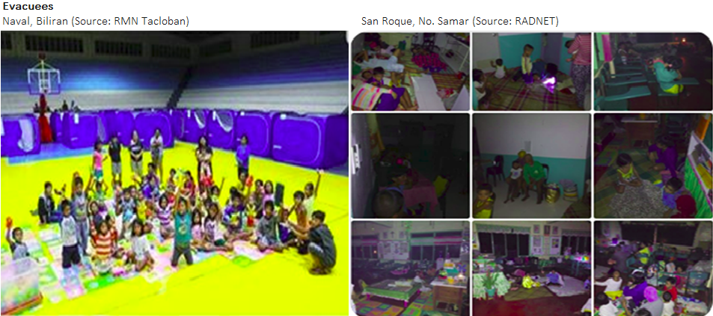  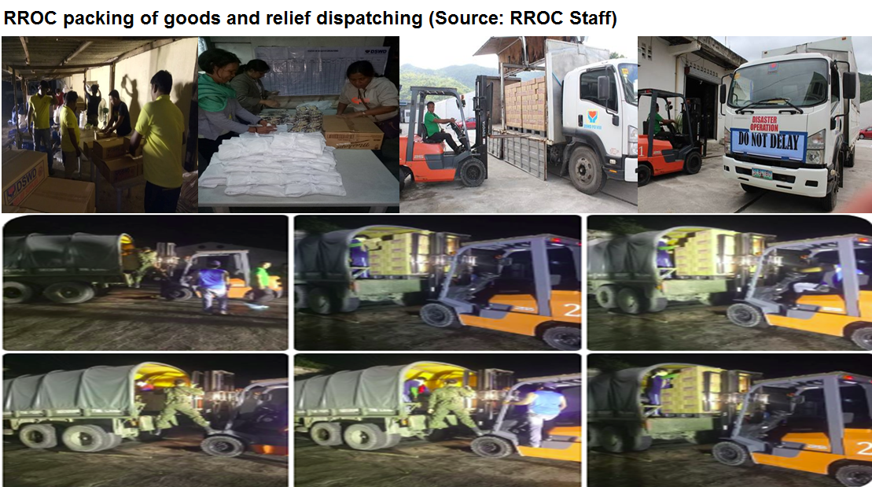  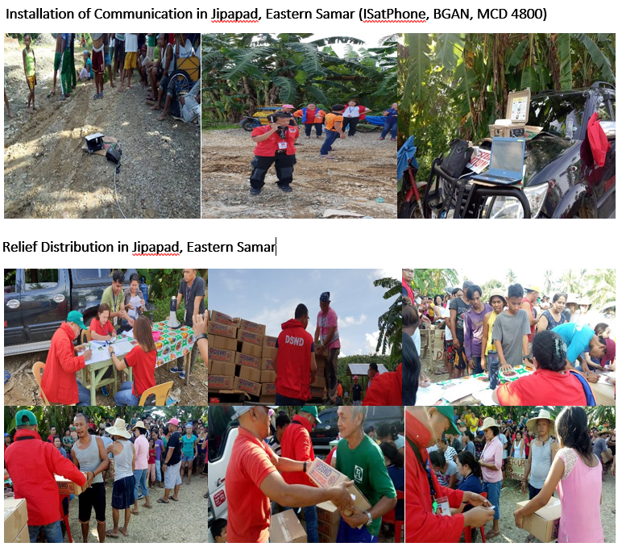

*****
The Disaster Response Operations Monitoring and Information Center (DROMIC) of the DSWD-DRMB is closely coordinating with the concerned DSWD-Field Offices for any significant disaster preparedness for response updates.

JAN ERWIN ANDREW I. ONTANILLAS
Releasing Officer

