DSWD DROMIC Report #2 on the Fire Incident
in Brgys. 39 and 42, Tacloban City
as of 22 November 2018, 6PM

SUMMARY

On 16 November 2018 at around 9:35 PM, a fire broke out in Brgys. 39 and 42, Tacloban City. The cause of the incident under investigation by the Bureau of Fire Protection.

Source: DSWD-FO VIII

- Status of Affected Families / Persons
REGION / PROVINCE / MUNICIPALITY |  | NUMBER OF AFFECTED
 |  | Barangays | Families | Persons
GRAND TOTAL |  | 2 | 43 | 171
REGION VIII |  | 2 | 43 | 171
Leyte |  | 2 | 43 | 171
 | Tacloban City (capital) | 2 | 43 | 171

Note: Ongoing assessment and validation being conducted.
Source: DSWD-FO VIII

- Status of Displaced Families / Persons Inside Evacuation Center
REGION / PROVINCE / MUNICIPALITY |  | NUMBER OF EVACUATION CENTERS (ECs) | NUMBER OF INSIDE ECs
 |  |  | Families | Persons
 |  | NOW | NOW | NOW
REGION VIII |  | 1 | 19 | 76
Leyte |  | 1 | 19 | 76
 | Tacloban City (capital) | 1 | 19 | 76
Note: Ongoing assessment and validation being conducted.
Source: DSWD-FO VIII

- Status of Displaced Families / Persons Outside Evacuation Center
REGION / PROVINCE / MUNICIPALITY |  | NUMBER OF OUTSIDE ECs
 |  | Families | Persons
 |  | NOW | NOW
REGION VIII |  | 12 | 57
Leyte |  | 12 | 57
 | Tacloban City | 12 | 57
Note: Ongoing assessment and validation being conducted.
Source: DSWD-FO VIII

- Damaged Houses
REGION / PROVINCE / MUNICIPALITY |  | NO. OF DAMAGED HOUSES
 |  | Total | Totally | Partially
GRAND TOTAL |  | 25 | 23 | 2
REGION VIII |  | 25 | 23 | 2
Leyte |  | 25 | 23 | 2
 | Tacloban City (capital) | 25 | 23 | 2
Note: Ongoing assessment and validation being conducted.
Source: DSWD-FO VIII
- Cost of Assistance
REGION / PROVINCE / MUNICIPALITY |  | TOTAL COST OF ASSISTANCE
 |  | DSWD | LGU | NGOs | OTHERS | GRAND TOTAL
REGION VIII |  | 70,587.00 | - | - | - | 70,587.00
Leyte |  | 70,587.00 | - | - | - | 70,587.00
 | Tacloban City | 70,587.00 | - | - | - | 70,587.00
Note: Ongoing assessment and validation being conducted.
Source: DSWD-FO VIII

SITUATIONAL REPORT

DSWD-DRMB
DATE | SITUATIONS / ACTIONS UNDERTAKEN
22 November 2018 | - The Disaster Response Operations Monitoring and Information Center (DROMIC) of the DSWD-DRMB continues to closely coordinate with DSWD-FO VIII for significant reports on the status of affected families, assistance, and relief efforts.

DSWD-FO VIII
DATE | SITUATIONS / ACTIONS UNDERTAKEN
22 November 2018 | - DSWD provided Food and Non-Food Items to the fire victims.  - DRMD-PDO assigned in Leyte and other staff, went on the location of the incident to conduct an on-site assessment. They also, coordinated with BLGU and CSWDO to monitor the situation of affected families or individuals and to assess as well if there is a need to augment relief goods.  - DROMIC Focal Person gathered data, coordinated with DRMD Staff and other link agencies that responded as well to the incident, especially to the City Bureau of Fire Protection (BFP).  - Regional Resource Operation Section (RROS) are also advised to be alerted to ensure the readiness of dispatching the Food and Non-Food commodities whenever needed for augmentation.  - DSWD Field Office VIII Staff are also alerted whenever there is a need of workforce in the relief operation.

*****
The Disaster Response Operations Monitoring and Information Center (DROMIC) of the DSWD-DRMB continues to closely coordinate with DSWD-FO VIII for significant disaster response updates and assistance provided.

JAN ERWIN ANDREW ONTANILLAS
Releasing Officer

PHOTO DOCUMENTATION

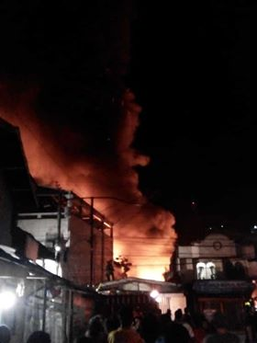
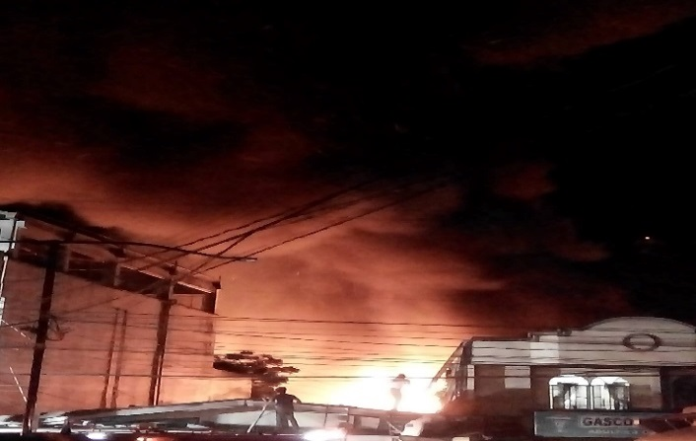
- Fire Incident (Credit to Ryan Carlo Esguerra)

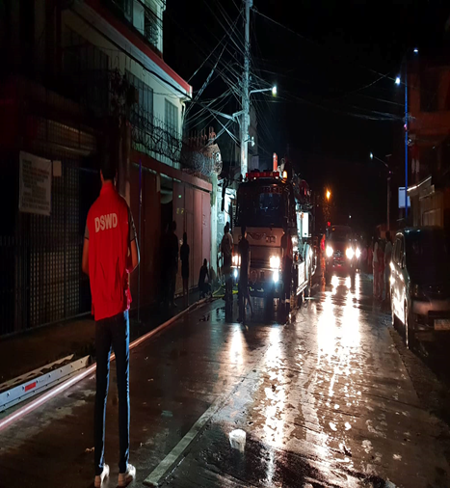
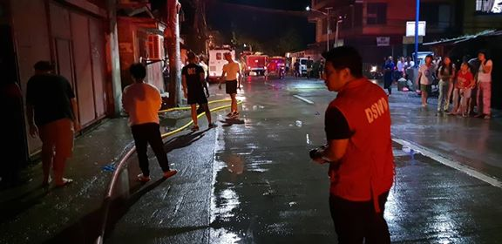
- Response

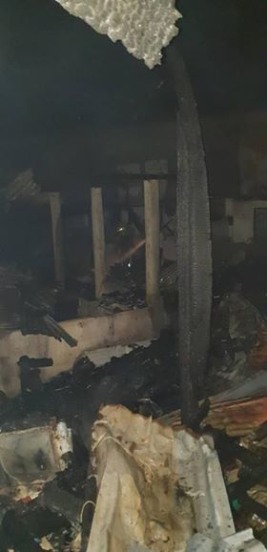
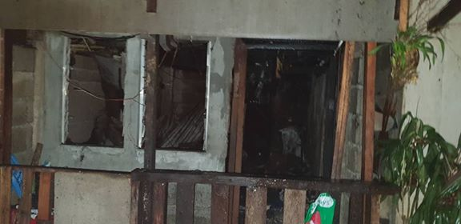
- Damaged

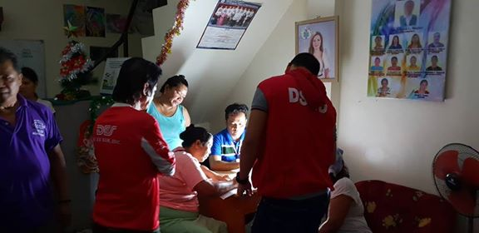
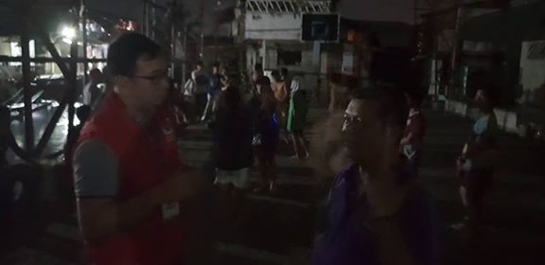
- On-site Assessment

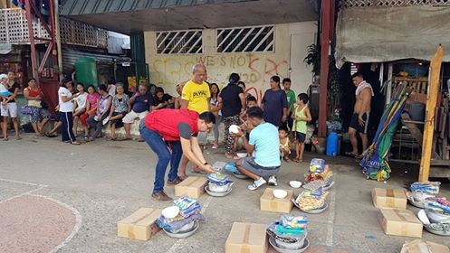
- Food and Non-Food Items

