DSWD DROMIC Report #4 on
Tropical Depression “SAMUEL”
as of 21 November 2018, 6PM

Situation Overview

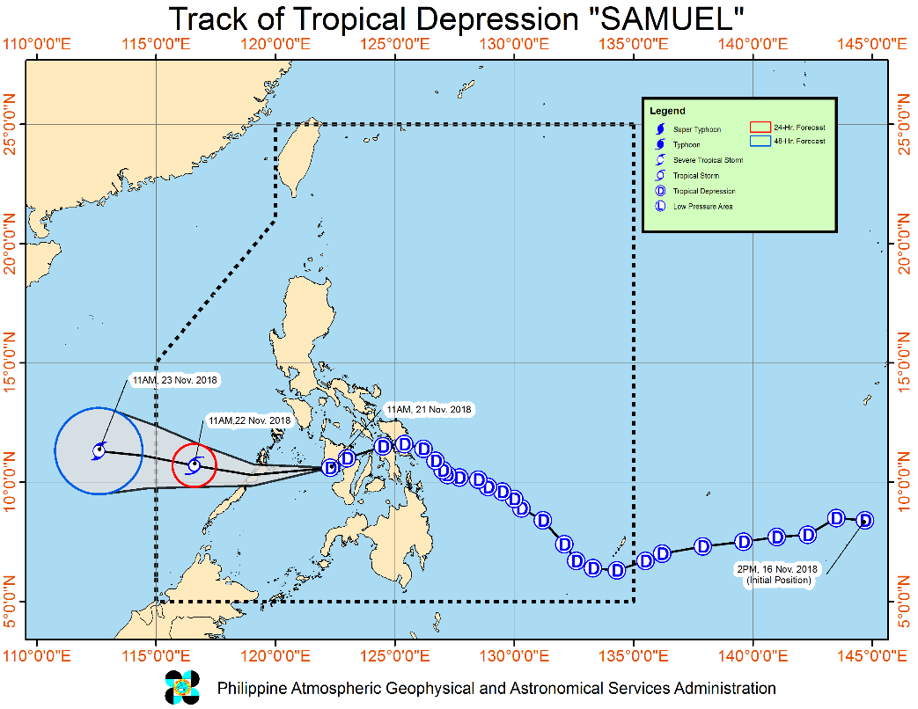
Issued at 05:00 PM today, Tropical Depression "Samuel" is now off the Southern Coast of Antique and heading towards Sulu Sea
- Tropical Cyclone Warning Signal (TCWS) #1 over northern Cebu has been lifted.
- Moderate to heavy rains, which may trigger flooding and landslides, are still expected over MIMAROPA, CALABARZON, Western Visayas, Aurora, Camarines Norte, Camarines Sur, and Catanduanes. Residents of these areas, especially those living near or in river channels, low-lying and mountainous areas, are advised to take appropriate measures, coordinate with local disaster risk reduction and management offices, and continue monitoring for updates.
- Fisherfolks and those with small seacrafts are advised not to venture out over the seaboards of areas under TCWS #1, as well as the northern and eastern seaboards of Luzon.
- “SAMUEL” may exit the Philippine Area of Responsibility (PAR) between tomorrow evening and Friday morning.
- Fisherfolks and those with small seacrafts are advised not to venture out over the areas under TCWS #1, as well as the northern and eastern seaboards of Luzon.
- "SAMUEL" is expected to make landfall in the area between the southern portion of Eastern Samar and Dinagat Islands tonight.
At 1:00 PM today, the center of Tropical Depression "SAMUEL" was estimated based on all available data at 70 km West Southwest of Iloilo City, Iloilo or 120 km East Southeast of Cuyo, Palawan (10.4 °N, 122.0 °E )
Source: DOST-PAGASA Severe Weather Bulletin

- Status of Affected Families / Persons
A total of 17,141 families or 61,574 persons were affected in 128 barangays, 12 cities/municipalities, and 6 provinces in Regions V and VIII (see Table 1).

Table 1. Affected Areas and Number of Affected Families / Persons
REGION / PROVINCE / MUNICIPALITY |  | NUMBER OF AFFECTED
 |  | Barangays | Cities / Municipalities | Provinces | Families | Persons
GRAND TOTAL |  | 128 | 12 | 6 | 17,141 | 61,574
REGION V |  | 2 | 1 | 1 | 23 | 97
Masbate |  | 2 | 1 | 1 | 23 | 97
 | Baleno | 2 |  |  | 23 | 97
REGION VIII |  | 126 | 11 | 5 | 17,118 | 61,477
Eastern Samar |  | 71 | 5 | 1 | 10,398 | 40,601
 | Arteche | 9 |  |  | 1,130 | 3,503
 | Oras | 30 |  |  | 7,574 | 30,296
 | San Julian | 2 |  |  | 52 | 234
 | Sulat | 1 |  |  | 6 | 28
 | Guiuan | 29 |  |  | 1,636 | 6,540
Leyte |  | 1 | 1 | 1 | 38 | 105
 | La Paz | 1 |  |  | 38 | 105
Northern Samar |  | 48 | 2 | 1 | 6,504 | 20,016
 | Catubig | 47 |  |  | 6,500 | 20,000
 | Las Navas | 1 |  |  | 4 | 16
Western Samar |  | 4 | 1 | 1 | 133 | 584
 | Pinabacdao | 4 |  |  | 133 | 584
Southern Leyte |  | 2 | 2 | 1 | 45 | 171
 | Tomas Oppus | 1 |  |  | 14 | 41
 | Saint Bernard | 1 |  |  | 31 | 130
Note: Ongoing assessment and validation

Sources: LGUs through the C/MSWD and C/MDRRMO

- Status of Displaced and Served Families / Persons (see Table 2)

Table 2. Number of Served Families / Persons Inside and Outside ECs
REGION / PROVINCE / MUNICIPALITY |  | NUMBER OF EVACUATION CENTERS (ECs) |  | INSIDE ECs |  |  |  | INSIDE ECs Returned Home |  | OUTSIDE ECs |  |  |  | OUTSIDE ECs Returned Home |  | TOTAL SERVED
 |  |  |  |  |  |  |  |  |  |  |  |  |  |  |  | Families |  | Persons
 |  |  |  | Families |  | Persons |  | Families | Persons | Families |  | Persons |  | Families | Persons | Total Families |  | Total Persons
 |  | CUM | NOW | CUM | NOW | CUM | NOW |  |  | CUM | NOW | CUM | NOW |  |  | CUM | NOW | CUM | NOW
GRAND TOTAL |  | 11 | 11 | 301 | 301 | 1,235 | 1,235 | - | - | 940 | 940 | 2,603 | 2,603 | - | - | 1,241 | 1,241 | 3,838 | 3,838
REGION V |  | 1 | 1 | 23 | 23 | 97 | 97 | - | - | - | - | - | - | - | - | 23 | 23 | 97 | 97
Masbate |  | 1 | 1 | 23 | 23 | 97 | 97 | - | - | - | - | - | - | - | - | 23 | 23 | 97 | 97
 | Baleno | 1 | 1 | 23 | 23 | 97 | 97 | - | - | - | - | - | - | - | - | 23 | 23 | 97 | 97
REGION VIII |  | 10 | 10 | 278 | 278 | 1,138 | 1,138 | - | - | 940 | 940 | 2,603 | 2,603 | - | - | 1,218 | 1,218 | 3,741 | 3,741
Eastern Samar |  | 2 | 2 | 58 | 58 | 262 | 262 | - | - | 940 | 940 | 2,603 | 2,603 | - | - | 998 | 998 | 2,865 | 2,865
 | Arteche | - | - | - | - | - | - | - | - | 940 | 940 | 2,603 | 2,603 | - | - | 940 | 940 | 2,603 | 2,603
 | San Julian | 1 | 1 | 52 | 52 | 234 | 234 | - | - | - | - | - | - | - | - | 52 | 52 | 234 | 234
 | Sulat | 1 | 1 | 6 | 6 | 28 | 28 | - | - | - | - | - | - | - | - | 6 | 6 | 28 | 28
Leyte |  | 1 | 1 | 38 | 38 | 105 | 105 | - | - | - | - | - | - | - | - | 38 | 38 | 105 | 105
 | La Paz | 1 | 1 | 38 | 38 | 105 | 105 | - | - | - | - | - | - | - | - | 38 | 38 | 105 | 105
Northern Samar |  | 1 | 1 | 4 | 4 | 16 | 16 | - | - | - | - | - | - | - | - | 4 | 4 | 16 | 16
 | Las Navas | 1 | 1 | 4 | 4 | 16 | 16 | - | - | - | - | - | - | - | - | 4 | 4 | 16 | 16
Western Samar |  | 4 | 4 | 133 | 133 | 584 | 584 | - | - | - | - | - | - | - | - | 133 | 133 | 584 | 584
 | Pinabacdao | 4 | 4 | 133 | 133 | 584 | 584 | - | - | - | - | - | - | - | - | 133 | 133 | 584 | 584
Southern Leyte |  | 2 | 2 | 45 | 45 | 171 | 171 | - | - | - | - | - | - | - | - | 45 | 45 | 171 | 171
 | Tomas Oppus | 1 | 1 | 14 | 14 | 41 | 41 | - | - | - | - | - | - | - | - | 14 | 14 | 41 | 41
 | Saint Bernard | 1 | 1 | 31 | 31 | 130 | 130 | - | - | - | - | - | - | - | - | 31 | 31 | 130 | 130
Note: Ongoing assessment and validation

Sources: LGUs through the C/MSWD and C/MDRRMO

- Summary of Assistance Provided (see Table 4)

Table 4. Cost of Assistance Provided to Affected Families / Persons
REGION / PROVINCE / MUNICIPALITY |  | TOTAL COST OF ASSISTANCE
 |  | DSWD | LGU | NGOs | OTHERS | GRAND TOTAL
GRAND TOTAL |  | 47,880.00 | - | - | - | 47,880.00
REGION VIII |  | 47,880.00 | - | - | - | 47,880.00
Western Samar |  | 47,880.00 | - | - | - | 47,880.00
 | Pinabacdao | 47,880.00 | - | - | - | 47,880.00
Note: Ongoing assessment and validation
Sources: LGUs through the C/MSWD and C/MDRRMO, and DSWD-Field Offices

Situational Reports

DSWD-DRMB
DATE | SITUATIONS / ACTIONS UNDERTAKEN
November 18, 2018 to Present | - The Disaster Response Operations Monitoring and Information Center (DROMIC) of the DSWD-DRMB is closely coordinating with the DSWD-Field Offices for significant disaster preparedness for response updates.

DSWD-FO MIMAROPA
DATE | SITUATIONS / ACTIONS UNDERTAKEN
November 21, 2018 | - As of November 21, 2018, Philippine Ports Authority provided hot meals worth Four Hundred Pesos (Php 400.00) at 7:00 AM while 2Go shipping lines distributed breads amounting to Three Thousand Five Hundred Fifty Pesos (Php 3,550.00) to the Three Hundred Fifty-Five (355) stranded passengers in Odiongan Port.  - SWADT-Romblon provided Two (2) sacks of rice worth Three Thousand Two Hundred Pesos (Php 3,200.00), Two (2) boxes of coffee worth Two Thousand Five Hundred Ninety-Two Pesos (Php 2,592.00) and One (1) box of sardines worth One Thousand Five Hundred Fifty-Eight Pesos (Php 1,558.00) to stranded passengers in Odiongan port.  - Hot meals amounting to Seven Hundred Fifty Pesos (Php 750.00) were provided to the stranded passengers in Odiongan port at 8:00 AM by the Philippine Ports Authority.  - PSWDO distributed family food packs to the stranded passengers during lunch time which amounts to Six Thousand Eight Hundred Seventy Pesos (Php 6,870.00).  - All ports in Romblon are cancelled while Roxas and Bulalacao ports are still cancelled in Oriental Mindoro. All trips are cancelled in Balabac port, Palawan as of November 21, 2018  - There are no open evacuation centers in the MiMaRoPa provinces but close coordination to MDRRMO/MSWDO/PDRRMO is continuously done.  - The SWADT Offices ensure the availability of pre-positioned goods in selected GID Areas;  - With continuous coordination with P/C/MSWDOs for possible augmentation to affected LGUs;  - The Disaster Response Management Division through the DROMIC staff is continuously coordinating with SWAD Offices, P/C/MSWDOs, P/C/MDRRMOs and other concerned agencies for significant disaster preparedness especially those areas that are most likely to be affected;  - Activated the RQRT operation center to continuously monitor weather disturbances within the Provinces of MiMaRoPa and provide situational awareness if necessary;  - Close coordination to MDRRMO/MSWDO/PDRRMO to effectively monitor the situation and weather disturbance within the affected areas of Romblon, Southern parts of Occidental/Oriental Mindoro, Northern part of Palawan including Cuyo and Calamian islands, where TCWS #1 is raised;  - Disaster Response and Management Regional Staff are currently deployed in Palawan.

DSWD-FO V
DATE | SITUATIONS / ACTIONS UNDERTAKEN
November 20, 2018 | - Closely monitoring of the weather updates and information.  - Emergency Telecommunication Equipment is on standby and ready for deployment as the need arises.  - DSWD FO V QRTs were alerted and advised to be prepared for augmentation support needed from the field and/or 24/7 duty at the DRMD Operation Center.  - PAT and MAT members in the 6 provinces are on standby and were instructed to coordinate with the P/MDRRMOs for status reports and updates.

DSWD-FO VII
DATE | SITUATIONS / ACTIONS UNDERTAKEN
November 21, 2018 | - LGUs started evacuating residents living in coastal areas as early as Monday. Cebu PDRRMOraised the alert status to red from blue yesterday, urging local governments to strictly implement the mandated evacuation of residents living in danger zones and discouraged local disaster officers from signing ‘waiver’ forms that would exempt families from the evacuation.  - Cebu City government deployed ambulances and heavy equipments like a backhoe, payloader and dumptrucks to the mountain barangays of Lusaran, Agsungot, Tabunan and Taptap in case of a landslide. A rescue team was deployed in strategic locations in order to respond to any emergencies. No landslide incidents were recorded as of this reporting time.  - An incident command post was established in Bogo City, Cebu – where at least 44 families or 118 individuals were assisted. A bus was readied to transport displaced families and an ambulance on standby at the evacuation camp. City government also distributed relief goods to the affected families. Photos shared by CDRRMO.  - There were 9 cities and towns who implemented pre-emptive evacuation in Bohol and Cebu provinces. At least 2,479 individuals or 1,008 families were evacuated to 31 camps opened yesterday as the Region prepared for TD Samuel. To date, only 2 camps remained open in Poro, Camotes and in Carmen, both in the province of Cebu.  - Cebu City DRRM Office evacuated at least 150 persons in Sitio Sandayong in Brgy. Buhisan. The families live next to a mountain crack on its side that was reportedly caused by the earthquake in 2013.  - All evacuation camps in Bohol are now closed as families returned to their homes due to an improved weather condition. Both Candijay and Guindulman LGUs provided for the needs of the evacuees in partnership with the barangay officials. Meanwhile, all camps opened in Cebu towns are expected to close today as families start to return to their homes. Local governments also provided relief goods to the displaced families.  - Sea trips previously suspended are now lifted. Regular schedules for all vessels or watercrafts have already resumed  - Classes in the many parts of Central Visayas are still suspended today due to inclement weather condition brought by TD Samuel.
DSWD-FO IX
DATE | SITUATIONS / ACTIONS UNDERTAKEN
November 19, 2018 | - DSWD-FO IX ensured availability of food and non-food items.  - DSWD-FO IX is continuously repacking goods to maintain the required 30,000 FFPs at any given time.  - DSWD-FO IX through its Disaster Response Management Division prepared and disseminated a memorandum on preparedness for response to officially inform the SWAD Team Leaders to monitor the situation in their respective areas of responsibility.

DSWD-FO X
DATE | SITUATIONS / ACTIONS UNDERTAKEN
November 20, 2018 | - DSWD-FO X has 12 Quick Response Teams composed of regional staff and C/MATs of Bukidnon and Lanao del Norte ready for deployment any time.  - DSWD-FO X is ready for possible augmentation of relief goods to communities that may be affected by the effects of TD Samuel.

DSWD-FO XI
DATE | SITUATIONS / ACTIONS UNDERTAKEN
November 17, 2018 | - DSWD-FO XI activated its Regional, RPMO (SWADTs, PATs, MATs, CATs) Quick Response Teams, and DRMD personnel, and are on-call for duty.  - DSWD-FO XI is closely coordinating with all SWADOs, PSWDOs, and CSWDO/MSWDOs to monitor on the situation in the different parts of Davao Region.  - Personnel manning in the warehouse were alerted to ensure readiness of dispatching food and non-food items and that relief goods are also ready and available at any given time.  - Ensured availability of Disaster Wing Van, vehicles and drivers in the event of a relief operation.  - Established close coordination with Office of Civil Defense (OCD) XI for monitoring purposes and response mechanisms.

DSWD-FO XII
DATE | SITUATIONS / ACTIONS UNDERTAKEN
November 17, 2018 | - All QRT members are on standby and ready for any event that may arise that would require immediate assistance from the Department.  - 3 Vehicles are ready for utilization in case of response activation.  - Activation of BLUE ALERT Status.

DSWD-FO CARAGA
DATE | SITUATIONS / ACTIONS UNDERTAKEN
November 20, 2018 | - DSWD-FO CARAGA has activated their Quick Response Team to closely coordinate with the LSWDOs and LDRRMOs and continue monitoring the situation.  - There are 74 stranded passengers in different sea ports in CARAGA: 10 in PMO-Surigao, 58 in Lipata, and 6 in Nasipit.  - There are 356 families or 1,719 individuals who were pre-emptively evacuated in and are currently accommodated in 16 evacuation centers in Surigao del Norte, Surigao del Sur, and Dinagat Islands.  REGION / PROVINCE / MUNICIPALITY NUMBER OF EVACUATION CENTERS (ECs) INSIDE ECs  Families Persons  NOW NOW NOW  GRAND TOTAL 16 356 1,452  CARAGA 16 356 1,452  Dinagat Island 11 132 393  Basilisa (Rizal) 4 37 130  Dinagat 1 5 19  Loreto 1 14 43  San Jose (capital) 5 76 201  Surigao del Norte 4 121 437  Sison 3 86 302  Surigao City (capital) 1 35 135  Surigao del Sur 1 103 622  Cagwait 1 103 622

*****
The Disaster Response Operations Monitoring and Information Center (DROMIC) of the DSWD-DRMB is closely coordinating with the concerned DSWD-Field Offices for any significant disaster preparedness for response updates.

JAN ERWIN ANDREW ONTANILLAS
Releasing Officer

