DSWD DROMIC Report #8 on
Tropical Depression “SAMUEL”
as of 27 November 2018, 6PM

Situation Overview

- Status of Affected Families / Persons
A total of 33,771 families or 124,213 persons were affected in 294 barangays, 31 cities/municipalities, and 7 provinces in Regions V and VIII (see Table 1).

Table 1. Affected Areas and Number of Affected Families / Persons
REGION / PROVINCE / MUNICIPALITY |  | NUMBER OF AFFECTED
 |  | Barangays | Cities / Municipalities | Provinces | Families | Persons
GRAND TOTAL |  | 294 | 31 | 7 | 33,771 | 124,213
REGION V |  | 5 | 1 | 1 | 77 | 281
Masbate |  | 5 | 2 |  | 77 | 281
 | Baleno | 2 |  |  | 23 | 97
 | Pio V. Corpuz (Limbuhan) | 3 |  |  | 54 | 184
REGION VIII |  | 289 | 30 | 6 | 33,694 | 123,932
Biliran |  | 10 | 1 |  | 307 | 1,199
 | Kawayan | 10 |  |  | 307 | 1,199
Eastern Samar |  | 163 | 11 | 1 | 21,126 | 67,898
 | Arteche | 9 |  |  | 1,235 | 4,438
 | Dolores | 46 |  |  | 8,211 | 13,506
 | Jipapad | 13 |  |  | 2,700 | 13,500
 | Oras | 42 |  |  | 4,488 | 17,952
 | San Julian | 2 |  |  | 52 | 234
 | San Policarpo | 3 |  |  | 472 | 1,808
 | Sulat | 1 |  |  | 6 | 28
 | Taft | 2 |  |  | 10 | 45
 | Guiuan | 29 |  |  | 1,636 | 6,540
 | Hernani | 13 |  |  | 2,295 | 9,766
 | Llorente | 3 |  |  | 21 | 81
Leyte |  | 3 | 2 | 1 | 106 | 312
 | Dulag | 1 |  |  | 5 | 22
 | La Paz | 2 |  |  | 101 | 290
Northern Samar |  | 108 | 12 | 1 | 11,955 | 53,704
 | Catarman (capital) | 4 |  |  | 14 | 73
 | Lope de Vega | 2 |  |  | 79 | 316
 | San Isidro | 1 |  |  | 19 | 76
 | Catubig | 47 |  |  | 7,625 | 35,621
 | Gamay | 1 |  |  | 17 | 68
 | Laoang | 18 |  |  | 2,690 | 10,760
 | Lapinig | 4 |  |  | 171 | 701
 | Las Navas | 4 |  |  | 89 | 365
 | Mapanas | 7 |  |  | 267 | 1,048
 | Palapag | 4 |  |  | 77 | 292
 | Pambujan | 8 |  |  | 720 | 3,715
 | San Roque | 8 |  |  | 187 | 669
Western Samar |  | 2 | 1 | 1 | 133 | 584
 | Pinabacdao | 2 |  |  | 133 | 584
Southern Leyte |  | 3 | 3 | 1 | 67 | 235
 | Tomas Oppus | 1 |  |  | 25 | 70
 | Libagon | 1 |  |  | 10 | 45
 | Saint Bernard | 1 |  |  | 32 | 120
Note: Ongoing assessment and validation
Sources: LGUs through the C/MSWD and C/MDRRMO

- Status of Displaced and Served Families / Persons (see Table 2)

Table 2. Number of Served Families / Persons Inside and Outside ECs
REGION / PROVINCE / MUNICIPALITY |  | NUMBER OF EVACUATION CENTERS (ECs) |  | INSIDE ECs |  |  |  | INSIDE ECs Returned Home |  | OUTSIDE ECs |  |  |  | OUTSIDE ECs Returned Home |  | TOTAL SERVED
 |  |  |  |  |  |  |  |  |  |  |  |  |  |  |  | Families |  | Persons
 |  |  |  | Families |  | Persons |  | Families | Persons | Families |  | Persons |  | Families | Persons | Total Families |  | Total Persons
 |  | CUM | NOW | CUM | NOW | CUM | NOW |  |  | CUM | NOW | CUM | NOW |  |  | CUM | NOW | CUM | NOW
GRAND TOTAL |  | 77 | 2 | 2,682 | 27 | 11,389 | 108 | 2,655 | 11,281 | 1,965 | 79 | 9,782 | 490 | 1,886 | 9,292 | 4,647 | 106 | 21,171 | 598
REGION V |  | 4 | - | 67 | - | 258 | - | 67 | 258 | 10 | - | 23 | - | 10 | 23 | 77 | - | 281 | -
Masbate |  | 4 | - | 67 | - | 258 | - | 67 | 258 | 10 | - | 23 | - | 10 | 23 | 77 | - | 281 | -
 | Baleno | 1 | - | 23 | - | 97 | - | 23 | 97 | - | - | - | - | - | - | 23 | - | 97 | -
 | Pio V. Corpuz (Limbuhan) | 3 | - | 44 | - | 161 | - | 44 | 161 | 10 | - | 23 | - | 10 | 23 | 54 | - | 184 | -
REGION VIII |  | 73 | 2 | 2,615 | 27 | 11,131 | 108 | 2,588 | 11,023 | 1,955 | 79 | 9,759 | 490 | 1,876 | 9,269 | 4,570 | 106 | 20,890 | 598
Eastern Samar |  | 27 | 1 | 1,118 | 23 | 4,363 | 92 | 1,095 | 4,271 | 1,774 | 79 | 8,871 | 490 | 1,695 | 8,381 | 2,892 | 102 | 13,234 | 582
 | Arteche | 6 | - | 131 | - | 535 | - | 131 | 535 | 98 | 76 | 586 | 478 | 22 | 108 | 229 | 76 | 1,121 | 478
 | Jipapad | 9 | 1 | 527 | 23 | 1,600 | 92 | 504 | 1,508 | - | - | - | - | - | - | 527 | 23 | 1,600 | 92
 | San Julian | 1 | - | 52 | - | 234 | - | 52 | 234 | - | - | - | - | - | - | 52 | - | 234 | -
 | Sulat | 1 | - | 6 | - | 28 | - | 6 | 28 | - | - | - | - | - | - | 6 | - | 28 | -
 | Hernani | 9 | - | 381 | - | 1,885 | - | 381 | 1,885 | 1,673 | - | 8,273 | - | 1,673 | 8,273 | 2,054 | - | 10,158 | -
 | Llorente | 1 | - | 21 | - | 81 | - | 21 | 81 | - | - | - | - | - | - | 21 | - | 81 | -
Leyte |  | 3 | - | 106 | - | 312 | - | 106 | 312 | - | - | - | - | - | - | 106 | - | 312 | -
 | Dulag | 1 | - | 5 | - | 22 | - | 5 | 22 | - | - | - | - | - | - | 5 | - | 22 | -
 | La Paz | 2 | - | 101 | - | 290 | - | 101 | 290 | - | - | - | - | - | - | 101 | - | 290 | -
Northern Samar |  | 36 | 1 | 1,200 | 4 | 5,665 | 16 | 1,196 | 5,649 | - | - | - | - | - | - | 1,200 | 4 | 5,665 | 16
 | Catubig | 4 | - | 23 | - | 114 | - | 23 | 114 | - | - | - | - | - | - | 23 | - | 114 | -
 | Lapinig | 6 | - | 171 | - | 701 | - | 171 | 701 | - | - | - | - | - | - | 171 | - | 701 | -
 | Las Navas | 4 | 1 | 19 | 4 | 87 | 16 | 15 | 71 | - | - | - | - | - | - | 19 | 4 | 87 | 16
 | Mapanas | 4 | - | 267 | - | 1,048 | - | 267 | 1,048 | - | - | - | - | - | - | 267 | - | 1,048 | -
 | Pambujan | 18 | - | 720 | - | 3,715 | - | 720 | 3,715 | - | - | - | - | - | - | 720 | - | 3,715 | -
Western Samar |  | 4 | - | 133 | - | 584 | - | 133 | 584 | - | - | - | - | - | - | 133 | - | 584 | -
 | Pinabacdao | 4 | - | 133 | - | 584 | - | 133 | 584 | - | - | - | - | - | - | 133 | - | 584 | -
Southern Leyte |  | 3 | - | 58 | - | 207 | - | 58 | 207 | 9 | - | 28 | - | 9 | 28 | 67 | - | 235 | -
 | Tomas Oppus | 1 | - | 16 | - | 42 | - | 16 | 42 | 9 | - | 28 | - | 9 | 28 | 25 | - | 70 | -
 | Libagon | 1 | - | 10 | - | 45 | - | 10 | 45 | - | - | - | - | - | - | 10 | - | 45 | -
 | Saint Bernard | 1 | - | 32 | - | 120 | - | 32 | 120 | - | - | - | - | - | - | 32 | - | 120 | -
Note: Ongoing assessment and validation

Sources: LGUs through the C/MSWD and C/MDRRMO
- Damaged Houses
There are 1,740 damaged houses reported in Regions VIII; of which, 93 houses are totally damaged and 1,647 houses are partially damaged (see Table 3).

Table 3. Number of Damaged Houses
REGION / PROVINCE / MUNICIPALITY |  | NO. OF DAMAGED HOUSES
 |  | Total | Totally | Partially
GRAND TOTAL |  | 1,740 | 93 | 1,647
REGION VIII |  | 1,740 | 93 | 1,647
Eastern Samar |  | 1,716 | 86 | 1,630
 | Arteche | 1,239 | 12 | 1,227
 | Dolores | 3 | - | 3
 | Jipapad | 471 | 72 | 399
 | Taft | 3 | 2 | 1
Northern Samar |  | 24 | 7 | 17
 | Catubig | 7 | 3 | 4
 | Lapinig | 13 | - | 13
 | Las Navas | 4 | 4 | -
Note: Ongoing assessment and validation.
Sources: LGUs through the C/MSWD and C/MDRRMO

- Summary of Assistance Provided (see Table 4)

Table 4. Cost of Assistance Provided to Affected Families / Persons
REGION / PROVINCE / MUNICIPALITY |  | TOTAL COST OF ASSISTANCE
 |  | DSWD | LGU | NGOs | OTHERS | GRAND TOTAL
REGION V |  | - | 15,120.00 | - | - | 15,120.00
Masbate |  | - | 15,120.00 | - | - | 15,120.00
 | Pio V. Corpuz (Limbuhan) | - | 15,120.00 | - | - | 15,120.00
REGION VIII |  | 2,054,090.00 | 3,903,161.00 | - | - | 5,957,251.00
Biliran |  | - | 76,750.00 | - | - | 76,750.00
 | Kawayan | - | 76,750.00 | - | - | 76,750.00
Eastern Samar |  | 2,034,360.00 | 620,715.00 | - | - | 2,655,075.00
 | Arteche | 444,600.00 | 542,130.00 | - | - | 986,730.00
 | Jipapad | 869,760.00 | - | - | - | 869,760.00
 | Oras | 720,000.00 | 47,400.00 | - | - | 767,400.00
 | San Julian | - | 6,270.00 | - | - | 6,270.00
 | Hernani | - | 16,000.00 | - | - | 16,000.00
 | Llorente | - | 8,915.00 | - | - | 8,915.00
Northern Samar |  | - | 3,155,816.00 | - | - | 3,155,816.00
 | Catubig | - | 3,060,000.00 | - | - | 3,060,000.00
 | Mapanas | - | 95,816.00 | - | - | 95,816.00
Western Samar |  | - | 47,880.00 | - | - | 47,880.00
 | Pinabacdao | - | 47,880.00 | - | - | 47,880.00
Southern Leyte |  | 19,730.00 | 2,000.00 | - | - | 21,730.00
 | Tomas Oppus | 19,730.00 | 2,000.00 | - | - | 21,730.00
Note: Ongoing assessment and validation
*Note: The Php47,880.00 worth of relief assistance in Pinabacdao was provided by the LGU. No augmentation from DSWD has been provided yet
Sources: LGUs through the C/MSWD and C/MDRRMO, and DSWD-Field Offices

Situational Reports

DSWD-DRMB
DATE | SITUATIONS / ACTIONS UNDERTAKEN
November 18, 2018 to Present | - The Disaster Response Operations Monitoring and Information Center (DROMIC) of the DSWD-DRMB is closely coordinating with the DSWD-Field Offices for significant disaster preparedness for response updates.

DSWD-FO MIMAROPA
DATE | SITUATIONS / ACTIONS UNDERTAKEN
November 27, 2018 | PRE-EMPTIVE EVACUATION CENTERS  REGION / PROVINCE / MUNICIPALITY NUMBER OF EVACUATION CENTERS (ECs) INSIDE ECs  Families Persons  CUM NOW CUM NOW CUM NOW  GRAND TOTAL 17 - 758 - 3,038 -  REGION MIMAROPA 17 - 758 - 3,038 -  Palawan 17 - 758 - 3,038 -  Araceli 5 - 140 - 477 -  Cuyo 7 - 349 - 1,656 -  Magsaysay 3 - 99 - 357 -  Taytay 2 - 170 - 548 -  - FO MIMAROPA submitted terminal report on TD Samuel.  - A total of P76,850.00 worth of assistance provided to the affected. P52,808.00 for the families affected in Taytay, Palawan and P24,042.00 cost of assistance was provided to the stranded passengers at Odiongan Port, Odiongan, Romblon.

DSWD-FO V
DATE | SITUATIONS / ACTIONS UNDERTAKEN
November 23, 2018 | - Closely monitoring of the weather updates and information.  - Emergency Telecommunication Equipment is on standby and ready for deployment as the need arises.  - DSWD FO V QRTs were alerted and advised to be prepared for augmentation support needed from the field and/or 24/7 duty at the DRMD Operation Center.  - PAT and MAT members in the 6 provinces are on standby and were instructed to coordinate with the P/MDRRMOs for status reports and updates.  PRE-EMPTIVE EVACUATION CENTER  REGION / PROVINCE / MUNICIPALITY NUMBER OF EVACUATION CENTERS (ECs) INSIDE ECs  Families Persons  CUM NOW CUM NOW CUM NOW  GRAND TOTAL 1 1 23 23 97 97  REGION V 1 1 23 23 97 97  Masbate 1 1 23 23 97 97  Baleno 1 1 23 23 97 97

DSWD-FO VII
DATE | SITUATIONS / ACTIONS UNDERTAKEN
November 23, 2018 | - LGUs started evacuating residents living in coastal areas as early as Monday. Cebu PDRRMOraised the alert status to red from blue yesterday, urging local governments to strictly implement the mandated evacuation of residents living in danger zones and discouraged local disaster officers from signing ‘waiver’ forms that would exempt families from the evacuation.  - Cebu City government deployed ambulances and heavy equipments like a backhoe, payloader and dumptrucks to the mountain barangays of Lusaran, Agsungot, Tabunan and Taptap in case of a landslide. A rescue team was deployed in strategic locations in order to respond to any emergencies. No landslide incidents were recorded as of this reporting time.  - An incident command post was established in Bogo City, Cebu – where at least 44 families or 118 individuals were assisted. A bus was readied to transport displaced families and an ambulance on standby at the evacuation camp. City government also distributed relief goods to the affected families. Photos shared by CDRRMO.  - There were 9 cities and towns who implemented pre-emptive evacuation in Bohol and Cebu provinces. At least 2,479 individuals or 1,008 families were evacuated to 31 camps opened yesterday as the Region prepared for TD Samuel. To date, only 2 camps remained open in Poro, Camotes and in Carmen, both in the province of Cebu.  - Cebu City DRRM Office evacuated at least 150 persons in Sitio Sandayong in Brgy. Buhisan. The families live next to a mountain crack on its side that was reportedly caused by the earthquake in 2013.  - All evacuation camps in Bohol are now closed as families returned to their homes due to an improved weather condition. Both Candijay and Guindulman LGUs provided for the needs of the evacuees in partnership with the barangay officials. Meanwhile, all camps opened in Cebu towns are expected to close today as families start to return to their homes. Local governments also provided relief goods to the displaced families.  - Sea trips previously suspended are now lifted. Regular schedules for all vessels or watercrafts have already resumed  - Classes in the many parts of Central Visayas are still suspended today due to inclement weather condition brought by TD Samuel.  PRE-EMPTIVE EVACUATION CENTERS  REGION / PROVINCE / MUNICIPALITY NUMBER OF EVACUATION CENTERS (ECs) INSIDE ECs  Families Persons  CUM NOW CUM NOW CUM NOW  GRAND TOTAL 31 - 1,008 - 2,479 -  REGION VII 31 - 1,008 - 2,479 -  Bohol 7 - 219 - 849 -  Candijay 6 - 143 - 525 -  Guindulman 1 - 76 - 324 -  Cebu 24 - 789 - 1,630 -  City of Bogo 4 - 44 - 118 -  Carmen 2 - 45 - 158 -  Cebu City (capital) 1 - 27 - 150 -  Daanbantayan 9 - 195 - 481 -  Danao City 5 - 455 - 612 -  Poro 1 - 8 - 45 -  Sogod 2 - 15 - 66 -

DSWD-FO VIII
DATE | SITUATIONS / ACTIONS UNDERTAKEN
November 27, 2018 | - The Provincial Action Team in Northern and Eastern Samar continuously had a series of coordination meetings and validation in all affected areas.  - Quick Response Team (QRT) members and Disaster Response Management Division (DRMD) are rendering 24/7 duty both in RDRRM Council (Office of Civil Defense) and DSWD FO VIII Operations Center. Quick Response Team rendering duty at the OCD are advised to coordinate regularly with DILG for any updates on Pre-Emptive Evacuation at the LGUs.  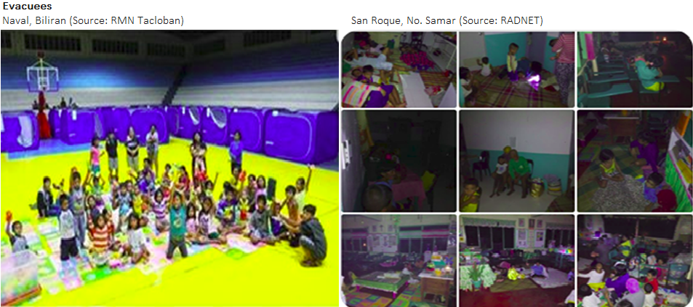  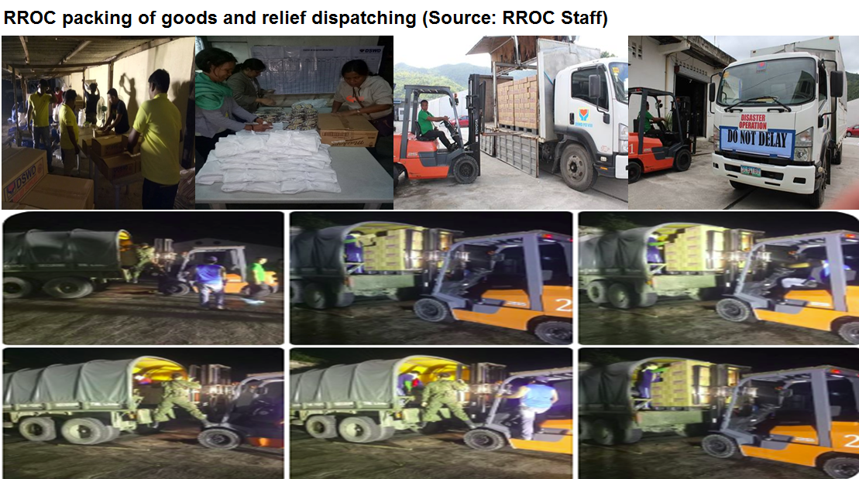  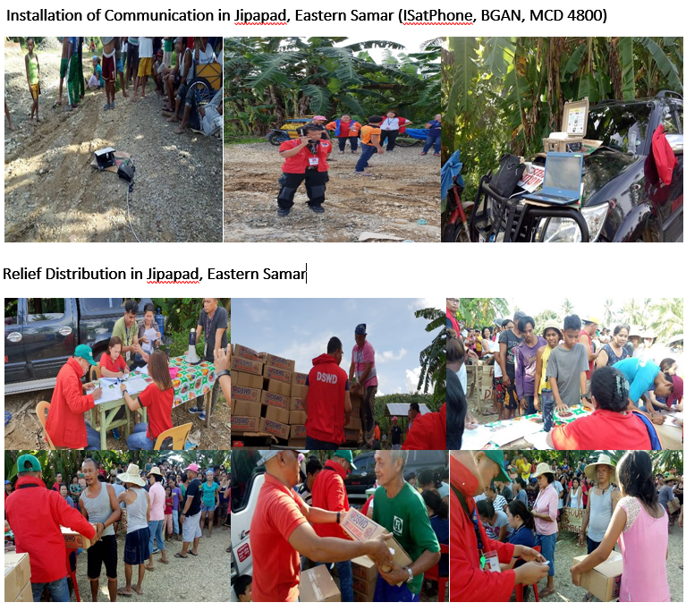

DSWD-FO CARAGA
DATE | SITUATIONS / ACTIONS UNDERTAKEN
November 23, 2018 | - FO CARAGA submitted Terminal Report  - All sea travels has been restored to normal operation since yesterday afternoon,November 22, 2018  PRE-EMPTIVE EVACUATION CENTER  REGION / PROVINCE / MUNICIPALITY NUMBER OF EVACUATION CENTERS (ECs) INSIDE ECs  Families Persons  CUM NOW CUM NOW CUM NOW  GRAND TOTAL 59 - 1,560 - 5,620 -  CARAGA 59 - 1,560 - 5,620 -  Dinagat Island 29 - 627 - 1,969 -  Basilisa (Rizal) 13 - 203 - 703 -  Cagdianao 3 - 95 - 384 -  Dinagat 3 - 42 - 107 -  Libjo (Albor) 1 - 31 - 91 -  Loreto 1 - 20 - 49 -  San Jose (capital) 6 - 190 - 463 -  Tubajon 2 - 46 - 172 -  Surigao del Norte 25 - 725 - 2,504 -  Dapa 1 - 1 - 7 -  Del Carmen 1 - 9 - 37 -  Mainit 2 - 17 - 76 -  Malimono 3 - 180 - 618 -  San Isidro 2 - 56 - 177 -  Santa Monica (Sapao) 1 - 6 - 27 -  Sison 3 - 86 - 302 -  Surigao City (capital) 8 - 300 - 984 -  Tubod 4 - 70 - 276 -  Surigao del Sur 5 - 208 - 1,147 -  Cagwait 1 - 103 - 622 -  Carrascal 4 - 105 - 525 -

*****
The Disaster Response Operations Monitoring and Information Center (DROMIC) of the DSWD-DRMB is closely coordinating with the concerned DSWD-Field Offices for any significant disaster preparedness for response updates.

JAN ERWIN ANDREW ONTANILLAS
Releasing Officer

