DSWD DROMIC Preparedness for Response Report #1 on
Tropical Depression “USMAN”
as of 26 December 2018, 6PM

Situation Overview
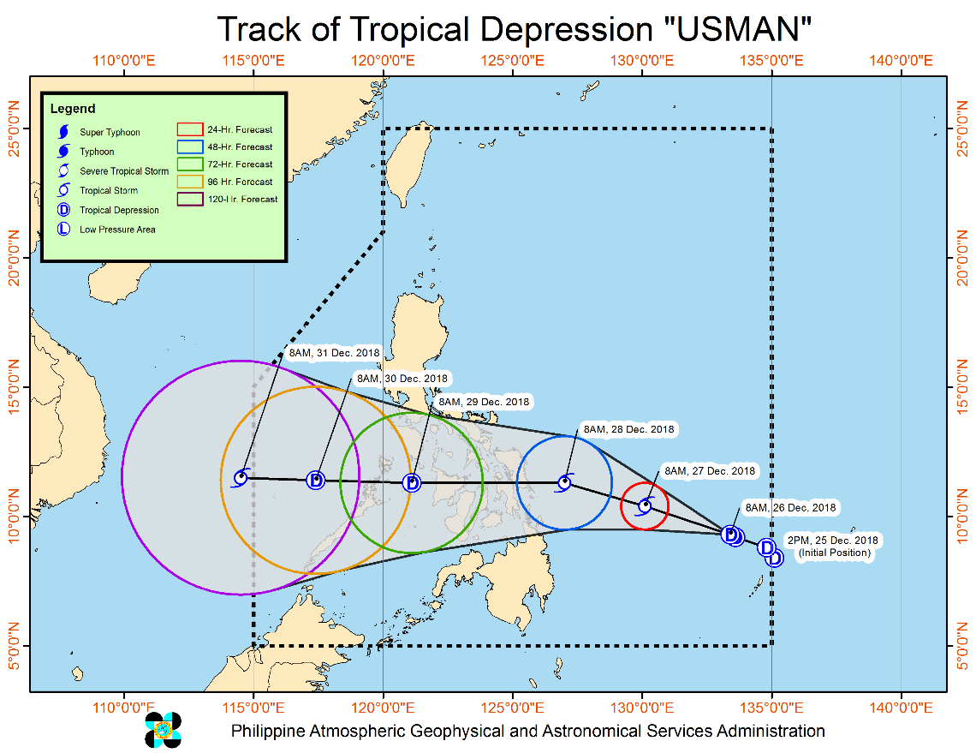

Issued at 11:00 AM today, Tropical Depression USMAN has slightly intensified as it continues to move west-northwestward.
- Tropical Cyclone Warning Signal (TCWS) #1 may be raised over the provinces in Eastern Visayas and northern Caraga tonight or tomorrow morning (December 27). Possible disruption in maritime travel should be expected in these areas.
- "USMAN" has no direct effect on any part of the country at the moment. However, moderate to heavy rains, which may trigger floodings and landslides, is expected over Bicol Region, Eastern Visayas, Surigao del Norte and Dinagat Islands tomorrow (December 27). Residents of these areas, especially those living near river channels and in low-lying and mountainous areas, are advised to take precautionary measures, coordinate with local disaster risk reduction and management offices, and continue monitoring for updates.
- Fisherfolks and those with small seacrafts are advised not to venture out over the eastern seaboards of Eastern Samar, Dinagat Islands and Surigao Provinces due to rough seas associated with "USMAN".

At 10:00 AM today, the center of Tropical Depression USMAN was estimated based on all available data at (9.5°N, 133.3°E). It is moving West Northwest at 15 kph with a maximum sustained winds of 55 kph near the center and gustiness of up to 65 kph.

Forecast Position
- 24 Hours (Tomorrow morning) | 470 km East Northeast of Hinatuan, Surigao del Sur (10.4°N, 130.1°E)
- 48 Hours (Friday morning) | 140 km East Northeast of Guiuan, Eastern Samar (11.3°N, 127.0°E)
- 72 Hours (Saturday morning) | 50 km North Northeast of Cuyo, Palawan (11.3°N, 121.1°E)
- 96 Hours (Sunday morning) | 235 km Northwest of Puerto Princesa City, Palawan (11.4°N, 117.4°E)
- 120 Hours (Monday morning) | 505 km West Northwest of Puerto Princesa City, Palawan (OUTSIDE PAR) (11.5°N, 114.5°E)

Source: DOST-PAGASA Severe Weather Bulletin

Status of Prepositioned Resources: Stockpile and Standby Funds

The DSWD Central Office (CO), Field Offices (FOs), and National Resource Operations Center (NROC) have stockpiles and standby funds amounting to ₱1,279,393,332.91 with breakdown as follows (see Table 1):

- Standby Funds
A total of ₱214,618,182.08 standby funds in the CO and FOs. Of the said amount, ₱174,019,938.35 is the available Quick Response Fund (QRF) in the CO.

- Stockpiles
A total of 404,948 Family Food Packs (FFPs) amounting to ₱144,875,074.92 and available Food and Non-food Items (FNIs) amounting to ₱919,900,075.91.

FIELD OFFICE | STANDBY FUNDS | STOCKPILE |  |  |  |  | TOTAL STANDBY FUNDS AND STOCKPILE
 |  | Family Food Packs |  | Food  (Raw Mats and Other Food Item) | Non-Food  (Raw Mats and Other NFI) | Sub-Total  (Food and NFIs)
 |  | Quantity | Total Cost
TOTAL | 214,618,182.08 | 404,948 | 144,875,074.92 | 175,285,283.71 | 744,614,792.20 | 919,900,075.91 | 1,279,393,332.91
Central Office* | 174,019,938.35 | - | - | - | - |  | 174,019,938.35
NROC | - | 101,300 | 36,955,132.00 | 78,851,170.00 | 309,110,246.13 | 387,961,416.13 | 424,916,548.13
NCR | 3,620,973.50 | 3,363 | 1,068,963.18 | 1,871,013.02 | 12,645,754.85 | 14,516,767.87 | 19,206,704.55
CAR | 4,215,730.95 | 13,325 | 4,808,578.40 | 5,282,386.76 | 22,690,765.52 | 27,973,152.28 | 36,997,461.63
I | 2,341,193.79 | 4,127 | 1,485,720.00 | 2,644,549.76 | 44,212,072.23 | 46,856,621.99 | 50,683,535.78
II | 5,464,267.84 | 12,988 | 4,674,600.00 | 2,694,585.60 | 152,730.00 | 2,847,315.60 | 12,986,183.44
III | 590,719.00 | 20,596 | 7,446,845.00 | 1,338,514.60 | 12,920,626.10 | 14,259,140.70 | 22,296,704.70
CALABARZON | 950,250.00 | 3,215 | 1,027,676.90 | 3,350,950.52 | 7,591,900.68 | 10,942,851.20 | 12,920,778.10
MIMAROPA | 3,034,141.75 | 26,123 | 10,919,414.00 | 7,602,897.61 | 1,344,028.86 | 8,946,926.47 | 22,900,482.22
V | 1,464,108.80 | 31,193 | 12,536,300.00 | 1,432,794.56 | 53,411,957.36 | 54,844,751.92 | 68,845,160.72
VI | 3,000,000.00 | 16,862 | 6,070,320.00 | 13,370,721.61 | 8,551,581.19 | 21,922,302.80 | 30,992,622.80
VII | 0.00 | 76,128 | 24,274,089.60 | 18,636,903.40 | 52,306,737.52 | 70,943,640.92 | 95,217,730.52
VIII | 2,697,960.00 | 23,147 | 8,365,121.34 | 5,419,868.02 | 45,880,932.17 | 51,300,800.19 | 62,363,881.53
IX | 3,047,481.35 | 16,832 | 6,059,520.00 | 2,738,280.00 | 21,873,380.99 | 24,611,660.99 | 33,718,662.34
X | 2,241,500.00 | 12,545 | 4,114,865.00 | 5,278,407.00 | 126,429,376.54 | 131,707,783.54 | 138,064,148.54
XI | 3,000,000.00 | 22,632 | 7,418,769.60 | 15,474,000.00 | 11,032,441.57 | 26,506,441.57 | 36,925,211.17
XII | 3,000,350.00 | 3,853 | 1,545,053.00 | 1,030,294.35 | 3,114,896.67 | 4,145,191.02 | 8,690,594.02
CARAGA | 1,929,566.75 | 16,719 | 6,104,106.90 | 8,267,946.90 | 11,345,363.82 | 19,613,310.72 | 27,646,984.37
* QRF as of 25 December 2018

Situational Reports

DSWD-DRMB
DATE | SITUATIONS / ACTIONS UNDERTAKEN
26 December 2018 | - The Disaster Response Operations Monitoring and Information Center (DROMIC) of the DSWD-DRMB is closely coordinating with the concerned DSWD-Field Offices for significant disaster preparedness for response updates.

DSWD-FO V
DATE | SITUATIONS / ACTIONS UNDERTAKEN
25 December 2018 | - DSWD-FO V Disaster Response Management Division (DRMD) is closely monitoring the weather updates and information.  - Emergency Telecommunication (ETC) equipment is on standby and ready for deployment as the need arises.  - DSWD-FO V Quick Response Teams (QRTs) were alerted and advised to be prepared for possible augmentation to the field and/or 24/7 duty at the DRMD Operation Center.  - Provincial/Municipal Action Team (P/MAT) members in the six provinces are on standby and were instructed to coordinate with the Provincial/City/Municipal Disaster Risk Reduction and Management Offices (P/C/MDRRMOs) for status reports and updates.

DSWD-FO VIII
DATE | SITUATIONS / ACTIONS UNDERTAKEN
25 December 2018 | - Social Welfare and Development Teams (SWADTs) and DRMD-Project Development Officers (PDOs) assigned in the province were alerted and advised to closely coordinate with Provincial/City/Municipal Social Welfare and Development Offices (P/C/MSWDOs) or P/C/MDRRMOs and immediately report any eventualities.  - All QRT members and DRMD staff were alerted in case there is a need to render 24/7 duty.  - The Disaster Response Information Management Section (DRIMS) is monitoring the weather condition and in close coordination with SWADTs, QRTs, and PDOs for any untoward incident caused by the effects of TD Usman.  - The Regional Resource Operation Section (RROS) were alerted to ensure the readiness of dispatching the food and non-food commodities whenever needed.

*****
The Disaster Response Operations Monitoring and Information Center (DROMIC) of the DSWD-DRMB is closely monitoring the effects of TD Usman and is coordinating with the concerned DSWD-Field Offices for any significant updates.

MARC LEO L. BUTAC
Releasing Officer

