DSWD DROMIC Preparedness for Response Report #2
on Tropical Depression “USMAN”
as of 27 December 2018, 6PM

Situation Overview

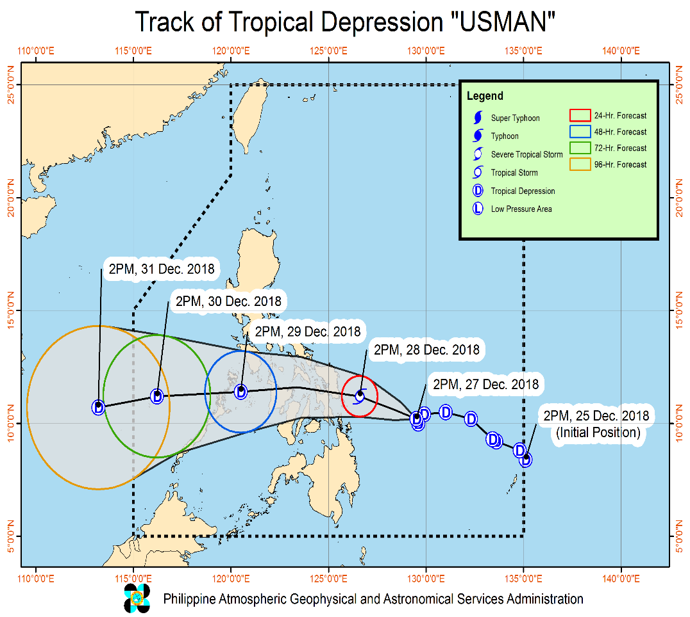
Issued at 5:00 PM today, Tropical Depression USMAN has further slowed down while moving generally westward.
- Possible raising of Tropical Cyclone Warning Signal #1 (TCWS #1) over Camarines Norte, southern Quezon, Marinduque, southern Oriental Mindoro, Antique, rest of Iloilo, and Guimaras in the next Severe Weather Bulletin at 8:00 PM today. Possible disruption of maritime travel is expected over these areas.
- "USMAN" may intensify into a Tropical Storm prior to landfall over Eastern Samar tomorrow afternoon (28 December).
- Moderate to heavy rains, which may trigger flooding and landslides, are expected over Bicol Region, Eastern Visayas and Dinagat Islands today (December 27). Meanwhile, moderate to heavy rains are also expected over Visayas, Bicol Region, Mindoro Provinces, Marinduque, Romblon, and Quezon tomorrow (28 December). Residents of these areas, especially those living near river channels and in low-lying and mountainous areas, are advised to take appropriate measures, coordinate with local disaster risk reduction and management offices, and continue monitoring for updates.
- Fisherfolks and those with small seacrafts are advised not to venture out over the seaboards of areas under TCWS #1, the seaboards of Northern Luzon, the eastern seaboards of Central and Southern Luzon, and the eastern seaboard of Surigao Provinces due to the approaching Tropical Depression and the surge of the Northeast Monsoon.
- "USMAN" may exit the Philippine Area of Responsibility between Sunday evening (December 30) and Monday morning (December 31).

At 4:00 PM today, the center of Tropical Depression "USMAN" was estimated based on all available data at 410 km East of Guiuan, Eastern Samar (10.3 °N, 129.4 °E).

Forecast Position
- 24 Hour (Tomorrow afternoon) | 95 km East of Guiuan, Eastern Samar(11.2°N, 126.6°E)
- 48 Hour (Saturday afternoon) | 75 km South Southeast of Coron, Palawan(11.4°N, 120.5°E)
- 72 Hour (Sunday afternoon) | 320 km West Northwest of Puerto Princesa City, Palawan(11.2°N, 116.2°E)
- 96 Hour (Monday afternoon) | 615 km West of Puerto Princesa City, Palawan(10.7°N, 113.2°E)

Tropical Cyclone Warning Signal No. 1
Luzon | Visayas | Mindanao
- Romblon  - Catanduanes  - Camarines Sur  - Albay  - Sorsogon  - Masbate  - including Ticao and Burias Islands | - Eastern Samar  - Northern Samar  - Samar  - Biliran  - Leyte  - Southern Leyte  - Northern Cebu including Camotes Islands  - Aklan  - Capiz  - Northern Iloilo and Northern Negros Occidental | - Dinagat Island

Source: DOST-PAGASA Severe Weather Bulletin

Predictive Analytics for Humanitarian Response

Based on the GSM and WRF data of PAGASA initialized on 27 December 2018, 8AM, the DSWD Predictive Analytics for Humanitarian Response results show 749,298 families (see Figure 1) exposed to high susceptibility of flooding and rain-induced landslide in the next 72 hours; of which, 200,316 families are poor (see Figure 2).

Figure 1. Exposed Population (PSA), Required FFPs, and Cost
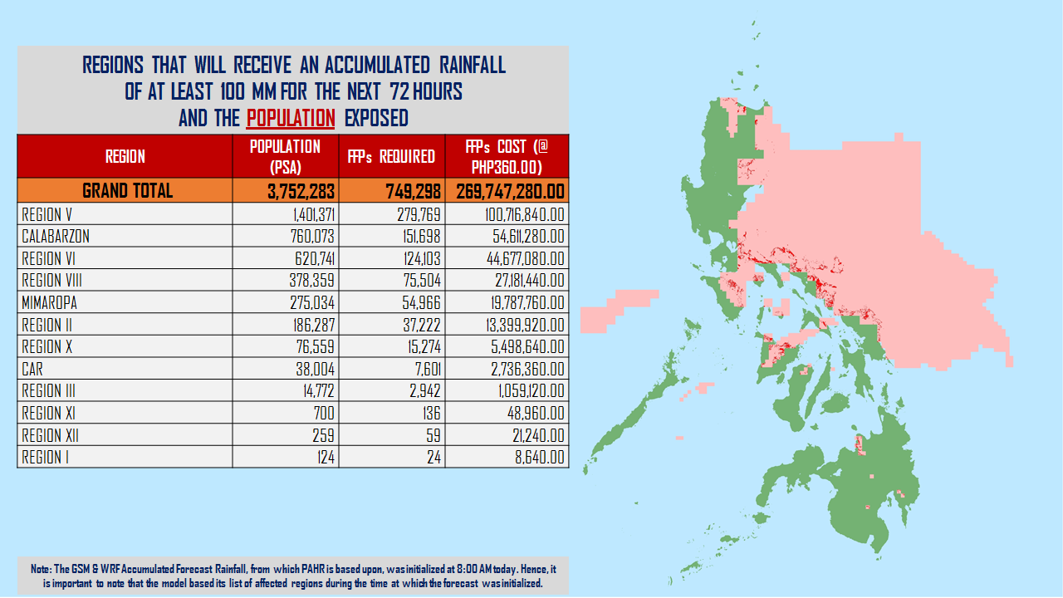

Figure 2. Exposed Poor Families (DSWD), Required FFPs, and Cost
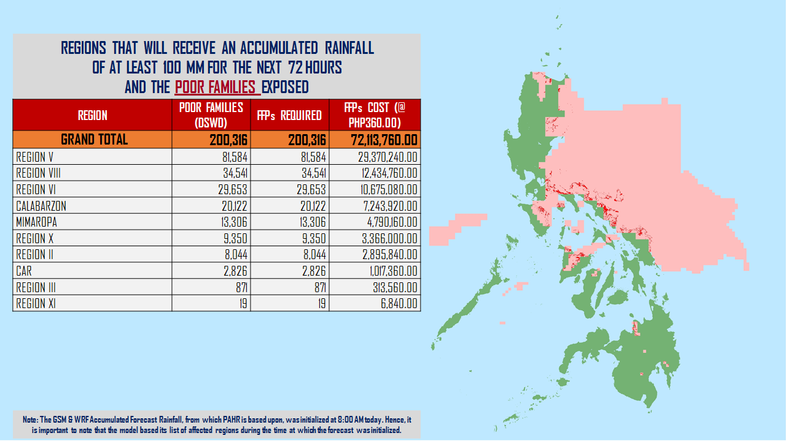

Status of Prepositioned Resources: Stockpile and Standby Funds

The DSWD Central Office (CO), Field Offices (FOs), and National Resource Operations Center (NROC) have stockpiles and standby funds amounting to ₱1,274,278,561.78 with breakdown as follows:

- Standby Funds
A total of ₱212,218,182.08 standby funds in the CO and FOs. Of the said amount, ₱174,019,938.35 is the available Quick Response Fund (QRF) in the CO.

- Stockpiles
A total of 398,431 Family Food Packs (FFPs) amounting to ₱142,448,930.32 and available Food and Non-food Items (FNIs) amounting to ₱919,611,449.38.

FIELD OFFICE | STANDBY FUNDS | STOCKPILE |  |  |  |  | TOTAL STANDBY FUNDS AND STOCKPILE
 |  | Family Food Packs |  | Food  (Raw Mats and Other Food Item) | Non-Food  (Raw Mats and Other NFI) | Sub-Total  (Food and NFIs)
 |  | Quantity | Total Cost
TOTAL | 212,218,182.08 | 398,431 | 142,448,930.32 | 175,694,567.70 | 743,916,881.68 | 919,611,449.38 | 1,274,278,561.78
Central Office* | 174,019,938.35 | - | - | - | - |  | 174,019,938.35
NROC | - | 101,300 | 36,955,132.00 | 78,851,170.00 | 309,110,246.13 | 387,961,416.13 | 424,916,548.13
NCR | 3,620,973.50 | 3,363 | 1,068,963.18 | 1,871,013.02 | 12,645,754.85 | 14,516,767.87 | 19,206,704.55
CAR | 4,215,730.95 | 13,325 | 4,808,578.40 | 5,282,386.76 | 22,690,765.52 | 27,973,152.28 | 36,997,461.63
I | 2,341,193.79 | 4,127 | 1,485,720.00 | 2,644,549.76 | 44,212,072.23 | 46,856,621.99 | 50,683,535.78
II | 3,064,267.84 | 12,988 | 4,674,600.00 | 2,694,585.60 | 152,730.00 | 2,847,315.60 | 10,586,183.44
III | 590,719.00 | 11,181 | 4,056,564.40 | 1,338,514.60 | 12,903,187.58 | 14,241,702.18 | 18,888,985.58
CALABARZON | 950,250.00 | 3,215 | 1,027,676.90 | 3,350,950.52 | 7,591,900.68 | 10,942,851.20 | 12,920,778.10
MIMAROPA | 3,034,141.75 | 25,020 | 10,458,360.00 | 7,602,897.61 | 1,344,028.86 | 8,946,926.47 | 22,439,428.22
V | 1,464,108.80 | 31,193 | 12,536,300.00 | 1,432,794.56 | 53,411,957.36 | 54,844,751.92 | 68,845,160.72
VI | 3,000,000.00 | 18,458 | 6,644,880.00 | 11,900,894.10 | 8,551,581.19 | 20,452,475.29 | 30,097,355.29
VII | 0.00 | 76,128 | 24,274,089.60 | 18,636,903.40 | 52,306,737.52 | 70,943,640.92 | 95,217,730.52
VIII | 2,697,960.00 | 23,147 | 8,365,121.34 | 5,419,868.02 | 45,880,932.17 | 51,300,800.19 | 62,363,881.53
IX | 3,047,481.35 | 19,607 | 7,058,520.00 | 2,816,220.00 | 21,192,908.99 | 24,009,128.99 | 34,115,130.34
X | 2,241,500.00 | 12,545 | 4,114,865.00 | 5,278,407.00 | 126,429,376.54 | 131,707,783.54 | 138,064,148.54
XI | 3,000,000.00 | 22,632 | 7,418,769.60 | 15,474,000.00 | 11,032,441.57 | 26,506,441.57 | 36,925,211.17
XII | 3,000,350.00 | 3,483 | 1,396,683.00 | 2,831,465.85 | 3,114,896.67 | 5,946,362.52 | 10,343,395.52
CARAGA | 1,929,566.75 | 16,719 | 6,104,106.90 | 8,267,946.90 | 11,345,363.82 | 19,613,310.72 | 27,646,984.37

Situational Reports

DSWD-DRMB
DATE | SITUATIONS / ACTIONS UNDERTAKEN
27 December 2018 | - DSWD-DRMB Operations Center is on Blue Alert.  - The Disaster Response Operations Monitoring and Information Center (DROMIC) of the DSWD-DRMB is closely coordinating with the concerned DSWD-Field Offices for significant disaster preparedness for response updates.

FO CALABARZON
DATE | SITUATION / PREPAREDNESS ACTIONS
27 December 2018 | - The DSWD-FO IV-A has activated its Emergency Operations Center (EOC) being manned by personnel of DRMD to heighten alert status.  - The DRMD has been intensifying its monitoring activity since the formation of TD “Usman”.  - The DRMD is actively coordinating with all Local Social Welfare and Development Offices (LSWDOs) to identify potential immediate humanitarian needs as well as technical support that can be deployed or augmented from Field Office.  - Regional and Provincial Quick Response Team (QRT) members are placed on standby alert status and ready for mobilization in case need arises.

FO MIMAROPA
DATE | SITUATION / PREPAREDNESS ACTIONS
27 December 2018 | - DSWD-FO MIMAROPA activated its Operation Center to monitor local weather condition and provide situational awareness.  - All P/C/M Quick Response Teams in the five provinces of MIMAROPA were alerted to regularly monitor the situations in their areas.  - All members of R/P/C/M QRTs are on-call status and standby duty ready for deployment if needed.  - Information and Communication Technology Management Unit (ICTMU) is activated to ensure robust communication system.  - All members of Rapid Emergency Telecommunications Team are on-call and standby status ready for deployment if needed.  - DSWD-FO MIMAROPA ensured that the Rapid Emergency Telecommunications Equipment (GX Terminal, BGAN Terminals and satellite phones) are in good condition and ready for deployment to areas that will experience potential emergencies.  - Availability of an on-call truck is ensured for delivery of goods and equipment to areas that will be affected.  - There are standby logistical equipment and workforce in coordination with SWADT and concerned LGUs on management of stranded passengers if there will be reports from ports and terminals.  - Relief goods both food and non-food items (FNI) are ready and available at any given time.  - Closed coordination with the Office of Civil Defense (OCD) and RDRRMC MIMAROPA for any warning signal updates for monitoring purposes and response mechanism for areas that will be affected.  - Purchase and replenishment of stockpile and prepositioned FFPs are ongoing.
FO V
DATE | SITUATION / PREPAREDNESS ACTIONS
27 December 2018 | - DSWD-FO V Disaster Response Management Division (DRMD) is closely monitoring the weather updates and information.  - Ongoing repacking of Family Food Packs (FFPs).  - Emergency Telecommunication (ETC) equipment is on standby and ready for deployment as the need arises.  - DSWD-FO V Quick Response Teams (QRTs) were alerted and advised to be prepared for possible augmentation to the field and/or 24/7 duty at the DRMD Operation Center.  - Provincial/Municipal Action Team (P/MAT) members in the six provinces are on standby and were instructed to coordinate with the Provincial/City/Municipal Disaster Risk Reduction and Management Offices (P/C/MDRRMOs) for status reports and updates.

FO VI
DATE | SITUATION / PREPAREDNESS ACTIONS
27 December 2018 | - All QRT members are on-standby.  - RDRRMC Operation Center is now activated as the status was elevated into Blue Alert.  - The Social Marketing Unit (SMU) is now alerted to inform the public of the possible effects of TD Usman and will utilize social media in reaching the public and informing them to take precautionary measures and coordinating with their Local DRRM Office.  - DSWD-FO VI QRT is now in close coordination with MDRRMOs and MSWDOs in their respective areas as per instruction of the Regional Director.  - DROMIC-FO VI is continuously monitoring the weather status.

DSWD-FO VIII
DATE | SITUATIONS / ACTIONS UNDERTAKEN
25 December 2018 | - Social Welfare and Development Teams (SWADTs) and DRMD-Project Development Officers (PDOs) assigned in the province were alerted and advised to closely coordinate with Provincial/City/Municipal Social Welfare and Development Offices (P/C/MSWDOs) or P/C/MDRRMOs and immediately report any eventualities.  - All QRT members and DRMD staff were alerted in case there is a need to render 24/7 duty.  - The Disaster Response Information Management Section (DRIMS) is monitoring the weather condition and in close coordination with SWADTs, QRTs, and PDOs for any untoward incident caused by the effects of TD Usman.  - The Regional Resource Operation Section (RROS) were alerted to ensure the readiness of dispatching the food and non-food commodities whenever needed.

FO CARAGA
DATE | SITUATION / PREPAREDNESS ACTIONS
27 December 2018 | - The Regional Disaster Risk Reduction and Management Council (RDRRMC) has already activated the Operations Center and is now on Blue alert status, and all protocols and systems are in place.  - The Philippine Coast Guard-Surigao del Norte has already suspended all sea travels from Surigao City, Siargao and Dinagat Islands.  - QRTs in Surigao del Norte and the Province of Dinagat Islands are already activated.  - DRMD staff are also on Blue alert status and continually monitoring the situation in the affected provinces.

*****

The Disaster Response Operations Monitoring and Information Center (DROMIC) of the DSWD-DRMB continues to closely coordinate with the concerned DSWD-Field Offices for any significant disaster preparedness for response updates.

MARC LEO L. BUTAC
Releasing Officer

