DSWD DROMIC Preparedness for Response Report #3
on Tropical Depression “USMAN”
as of 28 December 2018, 6PM

Situation Overview

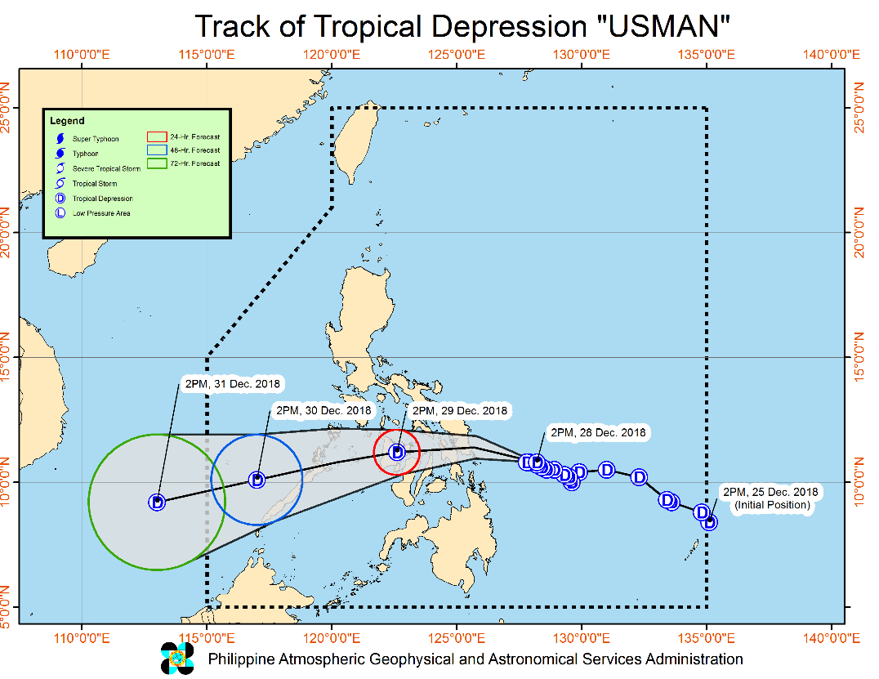
Issued at 5:00 PM today, TROPICAL DEPRESSION "USMAN" CONTINUES TO MOVE ERRATICALLY OVER THE PHILIPPINE SEA.
- "USMAN" is expected to make landfall over Eastern Samar between tonight (28 December) or tomorrow early morning (29 December).
- Moderate to heavy rains will continue over Bicol Region, Eastern Visayas, and Quezon, while light to moderate with occasional heavy rains will prevail over Metro Manila, MIMAROPA, Aurora and the rest of CALABARZON and of Visayas tonight (28 December). Meanwhile, tomorrow (29 December), moderate to heavy rains will prevail over Metro Manila, CALABARZON, MIMAROPA, and Bicol Region while light to moderate with at times heavy rains is expected over Visayas and Aurora.
- Fisherfolks and those with small seacrafts are advised not to venture out over the seaboards of areas under TCWS #1, the seaboards of Northern Luzon, the eastern seaboards of Central and Southern Luzon, and the eastern seaboard of Surigao Provinces due to the approaching Tropical Depression and the surge of the Northeast Monsoon.
- "USMAN" may exit the Philippine Area of Responsibility between Sunday evening (December 30) and Monday morning (December 31).

At 4:00 PM today, the center of Tropical Depression "USMAN" was estimated based on all available data at 285 km East of Guiuan, Eastern Samar (10.7 °N, 128.3 °E)

Forecast Position
- 24 Hour (Tomorrow afternoon) | In the vicinity of Passi City, Iloilo(11.2°N, 122.6°E)
- 48 Hour (Saturday afternoon) | 195 km West Northwest of Puerto Princesa City, Palawan(10.1°N, 117.0°E)
- 72 Hour (Sunday afternoon) | 630 km West of Puerto Princesa City, Palawan (OUTSIDE PAR)(9.2°N, 113.0°E)

Tropical Cyclone Warning Signal No. 1
Luzon | Visayas | Mindanao
- Northern Palawan including Calamian and Cuyo Groups of Islands  - southern Quezon  - Marinduque  - Romblon  - Catanduanes  - Camarines Norte  - Camarines Sur  - Albay  - Sorsogon  - Masbate  - including Ticao and Burias Islands  - Southern Occidental Mindoro  - Southern Oriental Mindoro | - Eastern Samar  - Northern Samar  - Samar  - Biliran  - Leyte  - Southern Leyte  - Northern Cebu including Camotes Islands  - Aklan  - Capiz  - Iloilo  - Antique  - Northern Negros Occidental  - Northern Iloilo and Northern Negros Occidental | - Dinagat Island

Source: DOST-PAGASA Severe Weather Bulletin

Predictive Analytics for Humanitarian Response

Based on the GSM and WRF data of PAGASA initialized on 27 December 2018, 8AM, the DSWD Predictive Analytics for Humanitarian Response results show 749,298 families (see Figure 1) exposed to high susceptibility of flooding and rain-induced landslide in the next 72 hours; of which, 200,316 families are poor (see Figure 2).

Figure 1. Exposed Population (PSA), Required FFPs, and Cost
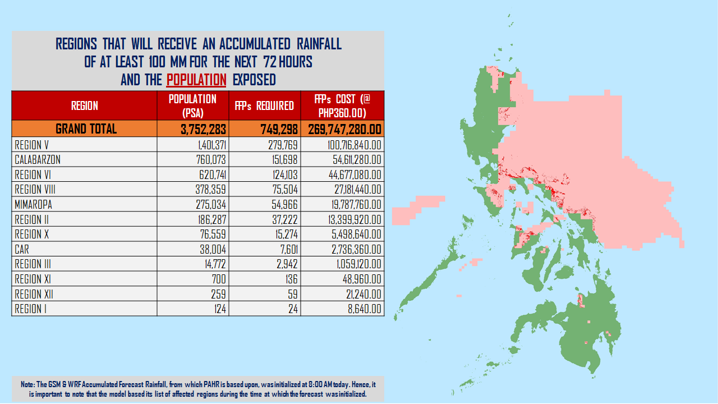

Figure 2. Exposed Poor Families (DSWD), Required FFPs, and Cost
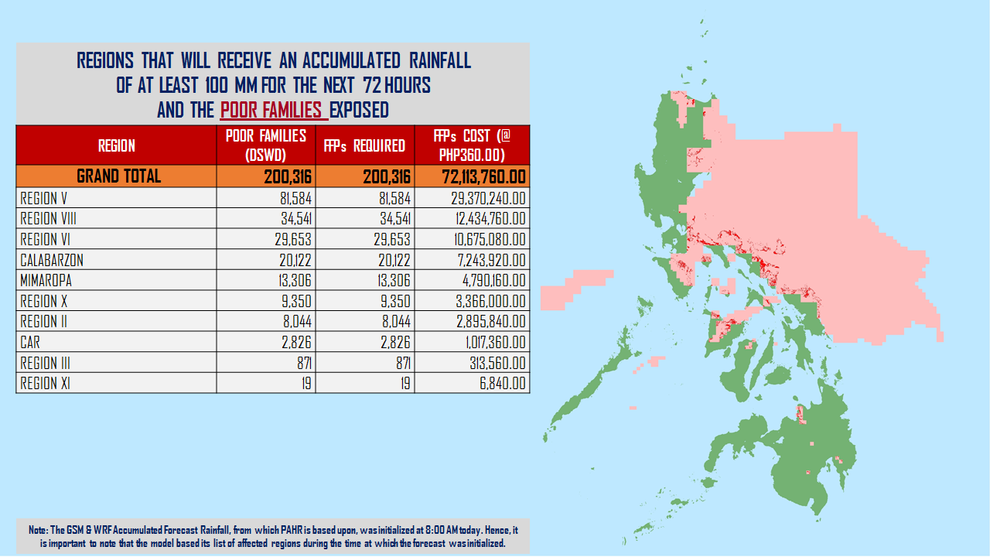

Status of Prepositioned Resources: Stockpile and Standby Funds

The DSWD Central Office (CO), Field Offices (FOs), and National Resource Operations Center (NROC) have stockpiles and standby funds amounting to ₱1,274,278,561.78 with breakdown as follows:

- Standby Funds
A total of ₱212,218,182.08 standby funds in the CO and FOs. Of the said amount, ₱174,019,938.35 is the available Quick Response Fund (QRF) in the CO.

- Stockpiles
A total of 398,431 Family Food Packs (FFPs) amounting to ₱142,448,930.32 and available Food and Non-food Items (FNIs) amounting to ₱919,611,449.38.

FIELD OFFICE | STANDBY FUNDS | STOCKPILE |  |  |  |  | TOTAL STANDBY FUNDS AND STOCKPILE
 |  | Family Food Packs |  | Food  (Raw Mats and Other Food Item) | Non-Food  (Raw Mats and Other NFI) | Sub-Total  (Food and NFIs)
 |  | Quantity | Total Cost
TOTAL | 212,218,182.08 | 398,431 | 142,448,930.32 | 175,694,567.70 | 743,916,881.68 | 919,611,449.38 | 1,274,278,561.78
Central Office* | 174,019,938.35 | - | - | - | - |  | 174,019,938.35
NROC | - | 101,300 | 36,955,132.00 | 78,851,170.00 | 309,110,246.13 | 387,961,416.13 | 424,916,548.13
NCR | 3,620,973.50 | 3,363 | 1,068,963.18 | 1,871,013.02 | 12,645,754.85 | 14,516,767.87 | 19,206,704.55
CAR | 4,215,730.95 | 13,325 | 4,808,578.40 | 5,282,386.76 | 22,690,765.52 | 27,973,152.28 | 36,997,461.63
I | 2,341,193.79 | 4,127 | 1,485,720.00 | 2,644,549.76 | 44,212,072.23 | 46,856,621.99 | 50,683,535.78
II | 3,064,267.84 | 12,988 | 4,674,600.00 | 2,694,585.60 | 152,730.00 | 2,847,315.60 | 10,586,183.44
III | 590,719.00 | 11,181 | 4,056,564.40 | 1,338,514.60 | 12,903,187.58 | 14,241,702.18 | 18,888,985.58
CALABARZON | 950,250.00 | 3,215 | 1,027,676.90 | 3,350,950.52 | 7,591,900.68 | 10,942,851.20 | 12,920,778.10
MIMAROPA | 3,034,141.75 | 25,020 | 10,458,360.00 | 7,602,897.61 | 1,344,028.86 | 8,946,926.47 | 22,439,428.22
V | 1,464,108.80 | 31,193 | 12,536,300.00 | 1,432,794.56 | 53,411,957.36 | 54,844,751.92 | 68,845,160.72
VI | 3,000,000.00 | 18,458 | 6,644,880.00 | 11,900,894.10 | 8,551,581.19 | 20,452,475.29 | 30,097,355.29
VII | 0.00 | 76,128 | 24,274,089.60 | 18,636,903.40 | 52,306,737.52 | 70,943,640.92 | 95,217,730.52
VIII | 2,697,960.00 | 23,147 | 8,365,121.34 | 5,419,868.02 | 45,880,932.17 | 51,300,800.19 | 62,363,881.53
IX | 3,047,481.35 | 19,607 | 7,058,520.00 | 2,816,220.00 | 21,192,908.99 | 24,009,128.99 | 34,115,130.34
X | 2,241,500.00 | 12,545 | 4,114,865.00 | 5,278,407.00 | 126,429,376.54 | 131,707,783.54 | 138,064,148.54
XI | 3,000,000.00 | 22,632 | 7,418,769.60 | 15,474,000.00 | 11,032,441.57 | 26,506,441.57 | 36,925,211.17
XII | 3,000,350.00 | 3,483 | 1,396,683.00 | 2,831,465.85 | 3,114,896.67 | 5,946,362.52 | 10,343,395.52
CARAGA | 1,929,566.75 | 16,719 | 6,104,106.90 | 8,267,946.90 | 11,345,363.82 | 19,613,310.72 | 27,646,984.37

Situational Reports

DSWD-DRMB
DATE | SITUATIONS / ACTIONS UNDERTAKEN
28 December 2018 | - DSWD-DRMB Operations Center is on Blue Alert.  - The Disaster Response Operations Monitoring and Information Center (DROMIC) of the DSWD-DRMB is closely coordinating with the concerned DSWD-Field Offices for significant disaster preparedness for response updates.

FO CALABARZON
DATE | SITUATION / PREPAREDNESS ACTIONS
28 December 2018 | - DSWD FO IV-A Emergency Operations Center is already activated to monitor the possible effects of TD Usman.  - The DRMD has been maintaining contact and constant communication with the Local Social Welfare and Development Offices (LSWDOs) with pre-disaster assessments being conducted.  - The DRMD conducted close coordination with the Local Government Units (LGUs) with regard to the preparedness efforts undertaken in the Flood, Landslide and Storm Surge prone areas.  - Coordinated with SWAD Team Leaders and Provincial Action Team of the CALABARZON Provinces and advised them to monitor and coordinate with the LGUs to gather reports on the possible effects of TD Usman.  - Coordinated with LSWDOs and LDRRMOs and instructed them to be on standby alert and prepare their respective evacuation centers, and family food packs should need arises.  - Coordinate with RDRRMC IV-A OpCen for updates on the preparedness level of the members of the Response Cluster of the region.  - DSWD FO IV-A has informed member agencies of the response cluster to be on-stand-by alert status and ready for mobilization in case situation arises.  - Posting of Advisory to all the DSWD FO IV-A building to inform and alert all the RPQRT for possible activation once the effect of TY Usman escalates.
27 December 2018 | - The DSWD-FO IV-A has activated its Emergency Operations Center (EOC) being manned by personnel of DRMD to heighten alert status.  - The DRMD has been intensifying its monitoring activity since the formation of TD “Usman”.  - The DRMD is actively coordinating with all Local Social Welfare and Development Offices (LSWDOs) to identify potential immediate humanitarian needs as well as technical support that can be deployed or augmented from Field Office.  - Regional and Provincial Quick Response Team (QRT) members are placed on standby alert status and ready for mobilization in case need arises.

FO MIMAROPA
DATE | SITUATION / PREPAREDNESS ACTIONS
27 December 2018 | - DSWD-FO MIMAROPA activated its Operation Center to monitor local weather condition and provide situational awareness.  - All P/C/M Quick Response Teams in the five provinces of MIMAROPA were alerted to regularly monitor the situations in their areas.  - All members of R/P/C/M QRTs are on-call status and standby duty ready for deployment if needed.  - Information and Communication Technology Management Unit (ICTMU) is activated to ensure robust communication system.  - All members of Rapid Emergency Telecommunications Team are on-call and standby status ready for deployment if needed.  - DSWD-FO MIMAROPA ensured that the Rapid Emergency Telecommunications Equipment (GX Terminal, BGAN Terminals and satellite phones) are in good condition and ready for deployment to areas that will experience potential emergencies.  - Availability of an on-call truck is ensured for delivery of goods and equipment to areas that will be affected.  - There are standby logistical equipment and workforce in coordination with SWADT and concerned LGUs on management of stranded passengers if there will be reports from ports and terminals.  - Relief goods both food and non-food items (FNI) are ready and available at any given time.  - Closed coordination with the Office of Civil Defense (OCD) and RDRRMC MIMAROPA for any warning signal updates for monitoring purposes and response mechanism for areas that will be affected.  - Purchase and replenishment of stockpile and prepositioned FFPs are ongoing.

FO V
DATE | SITUATION / PREPAREDNESS ACTIONS
27 December 2018 | - DSWD-FO V Disaster Response Management Division (DRMD) is closely monitoring the weather updates and information.  - Ongoing repacking of Family Food Packs (FFPs).  - Emergency Telecommunication (ETC) equipment is on standby and ready for deployment as the need arises.  - DSWD-FO V Quick Response Teams (QRTs) were alerted and advised to be prepared for possible augmentation to the field and/or 24/7 duty at the DRMD Operation Center.  - Provincial/Municipal Action Team (P/MAT) members in the six provinces are on standby and were instructed to coordinate with the Provincial/City/Municipal Disaster Risk Reduction and Management Offices (P/C/MDRRMOs) for status reports and updates.

FO VI
DATE | SITUATION / PREPAREDNESS ACTIONS
28 December 2018 | - DROMIC on 24/7 monitoring of the status of TD Usman and sending of advisories to DSWD FO VI QRT.  - DSWD VI is in close coordination with LGUs on monitoring of the status of the weather disturbance  - Issued Memorandum on the elevation of “Blue Alert Status” for FO VI. QRT members are now on call and in close coordination with their LSWDOs and LDRRMOs.  - DSWD FO VI immediately responded to the needs of stranded passengers in Iloilo and Dumangas Port. Due to the cancellation of trips bound to Palawan The field office provided 1 FFP/person. A total of 870 FFPs were released to 870 stranded passengers.
27 December 2018 | - All QRT members are on-standby.  - RDRRMC Operation Center is now activated as the status was elevated into Blue Alert.  - The Social Marketing Unit (SMU) is now alerted to inform the public of the possible effects of TD Usman and will utilize social media in reaching the public and informing them to take precautionary measures and coordinating with their Local DRRM Office.  - DSWD-FO VI QRT is now in close coordination with MDRRMOs and MSWDOs in their respective areas as per instruction of the Regional Director.  - DROMIC-FO VI is continuously monitoring the weather status.

DSWD-FO VIII
DATE | SITUATIONS / ACTIONS UNDERTAKEN
28 December 2018 | - DSWD prepared a deployment plan for the Inmarsat Satellite Equipment’s last December 26, 2018. The following are the areas for deployment;  - PROVINCE OF EASTERN SAMAR- Global Express (GX) Terminals  - PROVINCE OF BILIRAN- Explorer 710 (Manual) Broadband Global Area Network (BGAN)  - PROVINCE OF WESTERN SAMAR- MCD 4800 “football” (Automatic) Push Button Internet Access  - DRMD OFFICE- 2 (two) iSatPhone  - DRMD had an Emergency Meeting together with the Quick Response Team Leader and discussed the following:  - Identification of QRT members who will be involved in disaster relief operation of affected areas;  - QRT members who will render duty at the Office of Civil Defense and at the Disaster Operation Center (DRMD) on rotation basis 24/7;  - Sharing of experiences on the implementation of the directive of Secretary Bautista for the DSWD to be the one managing the distribution of relief assistance to the affected families/communities during TD “Samuel”;  - Planning and determining better strategies to improve disaster response activities to disaster-stricken areas; and  - Scheduling of ORT Responders to TD “Usman” affected areas.  - SWAD Teams and DRMD-PDOs assigned at the provinces are alerted and closely coordinating with P/C/MSWDOs and/or P/C/MDRRMOs for any eventualities on the ground.  - Quick Response Team (QRT) members and Disaster Response Management Division (DRMD) are rendering 24/7 duty in RDRRMC-OPCEN (location OCD VIII Office, Avenida Veteranos, Tacloban City), DSWD OPCEN and EOC (location YVI Center, Marasbaras, Tacloban City).  - Disaster Response Information Management Section (DRIMS) is continuously monitoring the weather condition, in close coordination with SWADTs, QRTs and PDOs for any incident reports and attended the PDRA-RDRRMC.
25 December 2018 | - Social Welfare and Development Teams (SWADTs) and DRMD-Project Development Officers (PDOs) assigned in the province were alerted and advised to closely coordinate with Provincial/City/Municipal Social Welfare and Development Offices (P/C/MSWDOs) or P/C/MDRRMOs and immediately report any eventualities.  - All QRT members and DRMD staff were alerted in case there is a need to render 24/7 duty.  - The Disaster Response Information Management Section (DRIMS) is monitoring the weather condition and in close coordination with SWADTs, QRTs, and PDOs for any untoward incident caused by the effects of TD Usman.  - The Regional Resource Operation Section (RROS) were alerted to ensure the readiness of dispatching the food and non-food commodities whenever needed.

FO CARAGA
DATE | SITUATION / PREPAREDNESS ACTIONS
27 December 2018 | - The Regional Disaster Risk Reduction and Management Council (RDRRMC) has already activated the Operations Center and is now on Blue alert status, and all protocols and systems are in place.  - The Philippine Coast Guard-Surigao del Norte has already suspended all sea travels from Surigao City, Siargao and Dinagat Islands.  - QRTs in Surigao del Norte and the Province of Dinagat Islands are already activated.  - DRMD staff are also on Blue alert status and continually monitoring the situation in the affected provinces.

*****

The Disaster Response Operations Monitoring and Information Center (DROMIC) of the DSWD-DRMB continues to closely coordinate with the concerned DSWD-Field Offices for any significant disaster preparedness for response updates.

MARIEL B. FERRARIZ
Releasing Officer

