DSWD DROMIC Report #4 on
Tropical Depression “USMAN”
as of 29 December 2018, 4PM

Situation Overview

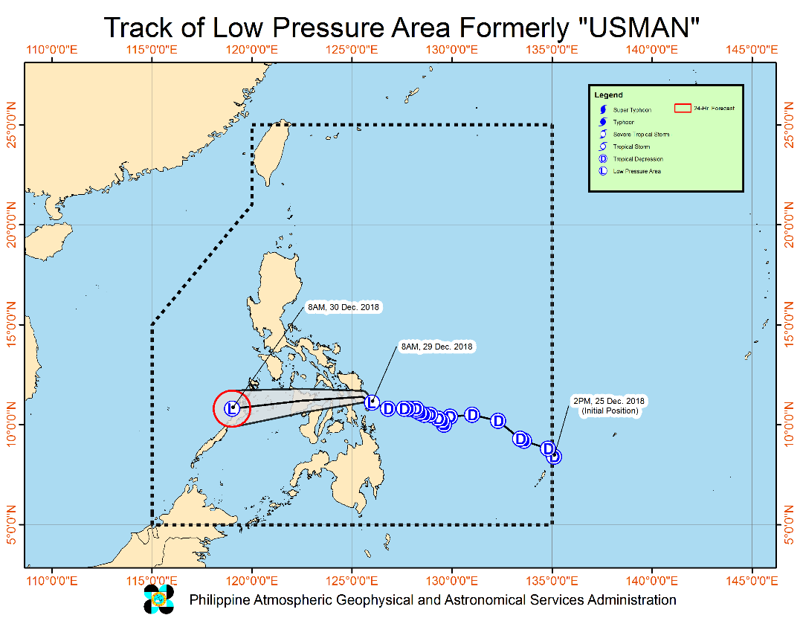
Issued at 08:00 am today, TROPICAL DEPRESSION "USMAN" HAS MADE LANDFALL IN THE VICINITY OF BORONGAN, EASTERN SAMAR AND HAS WEAKENED INTO A LOW PRESSURE AREA (LPA)

- At 6:00 AM today, TD “USMAN” has made landfall over Borongan City, Eastern Samar.
- All Tropical Cyclone Warning Signals have been lifted.
- Moderate to heavy rains will prevail over CALABARZON, MIMAROPA, Bicol Region and Aurora, while light to moderate with at times heavy rains is expected over Metro Manila the rest of central Luzon and Visayas.
- Residents of the aforementioned areas, especially those living near river channels and in low-lying and mountainous areas, are advised to take appropriate measures against possible flooding and landslides, coordinate with local disaster risk reduction and management offices, and continue monitoring for updates.
- Fisherfolks and those with small seacrafts are advised not to venture out over the seaboards of Northern and Central Luzon, the eastern and western seaboards of Southern Luzon and the eastern seaboard of Visayas due to surge of the Northeast Monsoon.

At 7:00 AM today, the center of LPA was estimated based on all available data at
In the vicinity of Llorente, Eastern Samar (11.3 °N, 125.4 °E)

- Status of Affected Families / Persons
A total of 1,175 Families or 4,348 persons were affected in 33 barangays, 11 cities/municipalities, and 5 provinces in Region VIII (see Table 1).

Table 1. Affected Areas and Number of Affected Families / Persons
REGION / PROVINCE / MUNICIPALITY |  | NUMBER OF AFFECTED
 |  | Barangays | Cities / Municipalities | Provinces | Families | Persons
GRAND TOTAL |  | 33 | 11 | 5 | 1,175 | 4,348
REGION V |  | 32 | 10 | 4 | 1,158 | 4,310
Albay |  | 4 | 1 | 1 | 734 | 2,600
 | Camalig | 4 |  |  | 734 | 2,600
Catanduanes |  | 10 | 3 | 1 | 263 | 1,055
 | San Andres (Calolbon) | 3 |  |  | 79 | 180
 | San Miguel | 3 |  |  | 98 | 492
 | Viga | 4 |  |  | 86 | 383
Masbate |  | 10 | 4 | 1 | 78 | 330
 | Mobo | 2 |  |  | 19 | 73
 | San Fernando | 2 |  |  | 12 | 35
 | San Jacinto | 2 |  |  | 13 | 68
 | Uson | 4 |  |  | 34 | 154
Sorsogon |  | 8 | 2 | 1 | 83 | 325
 | Bulusan | 3 |  |  | 33 | 108
 | Irosin | 5 |  |  | 50 | 217
REGION VIII |  | 1 | 1 | 1 | 17 | 38
Western Samar |  | 1 | 1 | 1 | 17 | 38
 | Calbayog City | 1 |  |  | 17 | 38
Note: Ongoing assessment and validation

Sources: LGUs through the C/MSWD and C/MDRRM

- Status of Displaced and Served Families / Persons (see Table 2)

Table 2. Number of Served Families / Persons Inside and Outside ECs
REGION / PROVINCE / MUNICIPALITY |  | NUMBER OF EVACUATION CENTERS (ECs) |  | INSIDE ECs |  |  |  | INSIDE ECs Returned Home |  | OUTSIDE ECs |  |  |  | OUTSIDE ECs Returned Home |  | TOTAL SERVED
 |  |  |  |  |  |  |  |  |  |  |  |  |  |  |  | Families |  | Persons
 |  |  |  | Families |  | Persons |  | Families | Persons | Families |  | Persons |  | Families | Persons | Total Families |  | Total Persons
 |  | CUM | NOW | CUM | NOW | CUM | NOW |  |  | CUM | NOW | CUM | NOW |  |  | CUM | NOW | CUM | NOW
GRAND TOTAL |  | 24 | 21 | 953 | 941 | 3,361 | 3,306 | 12 | 55 | 222 | 222 | 987 | 987 | - | - | 1,175 | 1,163 | 4,348 | 4,293
REGION V |  | 23 | 20 | 936 | 924 | 3,323 | 3,268 | 12 | 55 | 222 | 222 | 987 | 987 | - | - | 1,158 | 1,146 | 4,310 | 4,255
Albay |  | 4 | 4 | 734 | 734 | 2,600 | 2,600 | - | - | - | - | - | - | - | - | 734 | 734 | 2,600 | 2,600
 | Camalig | 4 | 4 | 734 | 734 | 2,600 | 2,600 | - | - | - | - | - | - | - | - | 734 | 734 | 2,600 | 2,600
Catanduanes |  | 6 | 6 | 102 | 102 | 295 | 295 | - | - | 161 | 161 | 760 | 760 | - | - | 263 | 263 | 1,055 | 1,055
 | San Andres (Calolbon) | 5 | 5 | 78 | 78 | 175 | 175 | - | - | 1 | 1 | 5 | 5 | - | - | 79 | 79 | 180 | 180
 | San Miguel | 1 | 1 | 24 | 24 | 120 | 120 | - | - | 74 | 74 | 372 | 372 | - | - | 98 | 98 | 492 | 492
Masbate |  | 9 | 6 | 55 | 43 | 233 | 178 | 12 | 55 | 23 | 23 | 97 | 97 | - | - | 78 | 66 | 330 | 275
 | Mobo | 3 | 3 | 19 | 19 | 73 | 73 | - | - | - | - | - | - | - | - | 19 | 19 | 73 | 73
 | San Fernando | 2 | 1 | 12 | 8 | 35 | 25 | 4 | 10 | - | - | - | - | - | - | 12 | 8 | 35 | 25
 | Uson | 4 | 2 | 24 | 16 | 125 | 80 | 8 | 45 | 10 | 10 | 29 | 29 | - | - | 34 | 26 | 154 | 109
Sorsogon |  | 4 | 4 | 45 | 45 | 195 | 195 | - | - | 38 | 38 | 130 | 130 | - | - | 83 | 83 | 325 | 325
 | Irosin | 4 | 4 | 45 | 45 | 195 | 195 | - | - | 5 | 5 | 22 | 22 | - | - | 50 | 50 | 217 | 217
REGION VIII |  | 1 | 1 | 17 | 17 | 38 | 38 | - | - | - | - | - | - | - | - | 17 | 17 | 38 | 38
Western Samar |  | 1 | 1 | 17 | 17 | 38 | 38 | - | - | - | - | - | - | - | - | 17 | 17 | 38 | 38
 | Calbayog City | 1 | 1 | 17 | 17 | 38 | 38 | - | - | - | - | - | - | - | - | 17 | 17 | 38 | 38
Note: Ongoing assessment and validation

Sources: LGUs through the C/MSWD and C/MDRRMO

Situational Reports

DSWD-DRMB
DATE | SITUATIONS / ACTIONS UNDERTAKEN
29 December 2018 | - The Disaster Response Operations Monitoring and Information Center (DROMIC) of the DSWD-DRMB is closely coordinating with the DSWD-Field Offices for significant disaster preparedness for response updates.

FO CALABARZON
DATE | SITUATION / PREPAREDNESS ACTIONS
28 December 2018 | - DSWD FO IV-A Emergency Operations Center is already activated to monitor the possible effects of TD Usman.  - The DRMD has been maintaining contact and constant communication with the Local Social Welfare and Development Offices (LSWDOs) with pre-disaster assessments being conducted.  - The DRMD conducted close coordination with the Local Government Units (LGUs) with regard to the preparedness efforts undertaken in the Flood, Landslide and Storm Surge prone areas.  - Coordinated with SWAD Team Leaders and Provincial Action Team of the CALABARZON Provinces and advised them to monitor and coordinate with the LGUs to gather reports on the possible effects of TD Usman.  - Coordinated with LSWDOs and LDRRMOs and instructed them to be on standby alert and prepare their respective evacuation centers, and family food packs should need arises.  - Coordinate with RDRRMC IV-A OpCen for updates on the preparedness level of the members of the Response Cluster of the region.  - DSWD FO IV-A has informed member agencies of the response cluster to be on-stand-by alert status and ready for mobilization in case situation arises.  - Posting of Advisory to all the DSWD FO IV-A building to inform and alert all the RPQRT for possible activation once the effect of TY Usman escalates.
27 December 2018 | - The DSWD-FO IV-A has activated its Emergency Operations Center (EOC) being manned by personnel of DRMD to heighten alert status.  - The DRMD has been intensifying its monitoring activity since the formation of TD “Usman”.  - The DRMD is actively coordinating with all Local Social Welfare and Development Offices (LSWDOs) to identify potential immediate humanitarian needs as well as technical support that can be deployed or augmented from Field Office.  - Regional and Provincial Quick Response Team (QRT) members are placed on standby alert status and ready for mobilization in case need arises.

FO MIMAROPA
DATE | SITUATION / PREPAREDNESS ACTIONS
27 December 2018 | - DSWD-FO MIMAROPA activated its Operation Center to monitor local weather condition and provide situational awareness.  - All P/C/M Quick Response Teams in the five provinces of MIMAROPA were alerted to regularly monitor the situations in their areas.  - All members of R/P/C/M QRTs are on-call status and standby duty ready for deployment if needed.  - Information and Communication Technology Management Unit (ICTMU) is activated to ensure robust communication system.  - All members of Rapid Emergency Telecommunications Team are on-call and standby status ready for deployment if needed.  - DSWD-FO MIMAROPA ensured that the Rapid Emergency Telecommunications Equipment (GX Terminal, BGAN Terminals and satellite phones) are in good condition and ready for deployment to areas that will experience potential emergencies.  - Availability of an on-call truck is ensured for delivery of goods and equipment to areas that will be affected.  - There are standby logistical equipment and workforce in coordination with SWADT and concerned LGUs on management of stranded passengers if there will be reports from ports and terminals.  - Relief goods both food and non-food items (FNI) are ready and available at any given time.  - Closed coordination with the Office of Civil Defense (OCD) and RDRRMC MIMAROPA for any warning signal updates for monitoring purposes and response mechanism for areas that will be affected.  - Purchase and replenishment of stockpile and prepositioned FFPs are ongoing.

FO V
DATE | SITUATION / PREPAREDNESS ACTIONS
29 December 2018 | - DSWD FOV provided 216 family food packs to LGU Pilar, Sorsogon intended for the strandees amounting to P93,744.00.  - LGU San Miguel, Catanduanes distributed food packs to affected families amouting P3,600.00.  - LGU Irosin, Sorsogon provided assistance to affected families in a form of hot meals and relief goods amounting P109,000.00.  - LGU Masbate provided meals for the strandees amounting to P4,225.00  - LGU Catanduanes provided food packs to 18 affected families amounting to P2,520.00  - LGU Bulan provided hot meals to the strandees amounting to P3,900.00  - Ongoing repacking of family food packs.  - PAT and MAT members in the 6 provinces are on standby and were instructed to coordinate with the P/MDRRMOs for status reports and updates.
27 December 2018 | - DSWD-FO V Disaster Response Management Division (DRMD) is closely monitoring the weather updates and information.  - Ongoing repacking of Family Food Packs (FFPs).  - Emergency Telecommunication (ETC) equipment is on standby and ready for deployment as the need arises.  - DSWD-FO V Quick Response Teams (QRTs) were alerted and advised to be prepared for possible augmentation to the field and/or 24/7 duty at the DRMD Operation Center.  - Provincial/Municipal Action Team (P/MAT) members in the six provinces are on standby and were instructed to coordinate with the Provincial/City/Municipal Disaster Risk Reduction and Management Offices (P/C/MDRRMOs) for status reports and updates.
FO VI
DATE | SITUATION / PREPAREDNESS ACTIONS
29 December 2018 | - QRT Aklan are now repacking the prepositioned goods. This will be released once there is a request from LGU for augmentation.  - Continuous close coordination with LGUs (LSWDOs and LDRRMOs). As of today, there is a close monitoring to Aklan river. All are instructed for preemptive evacuation if needed.  - Continuing assistance and assessment to stranded passengers in Dumangas Port, Iloilo yesterday, Dec. 28, 2018. As of today, the distribution was terminated since port operation is now back to normal.  - QRT Negros Occidental extended manpower augmentation to Bacolod City in providing hot meals to 404 stranded passengers who were temporarily sheltered at Education and Training Center School and another 400 stranded passengers at Bacolod Wharf.  - A total of 140 Families took preemptive evacuation just this morning around 09:00 AM in Jamindan, Capiz. 10 families evacuated from Magsaysay Street, Brgy. Poblacion to Jamindan Gym. 100 families evacuated from Jagnaya to Jagnaya Brgy. Hall and private houses. 20 families evacuated from Esperanza to Esperanza Brgy. Hall and 10 families evacuated from Lapaz to Lapaz Day Care Center. Each brgy. provided relief goods to the affected families. All affected are now back to their respective residences.
28 December 2018 | - DROMIC on 24/7 monitoring of the status of TD Usman and sending of advisories to DSWD FO VI QRT.  - DSWD VI is in close coordination with LGUs on monitoring of the status of the weather disturbance  - Issued Memorandum on the elevation of “Blue Alert Status” for FO VI. QRT members are now on call and in close coordination with their LSWDOs and LDRRMOs.  - DSWD FO VI immediately responded to the needs of stranded passengers in Iloilo and Dumangas Port. Due to the cancellation of trips bound to Palawan The field office provided 1 FFP/person. A total of 870 FFPs were released to 870 stranded passengers.
27 December 2018 | - All QRT members are on-standby.  - RDRRMC Operation Center is now activated as the status was elevated into Blue Alert.  - The Social Marketing Unit (SMU) is now alerted to inform the public of the possible effects of TD Usman and will utilize social media in reaching the public and informing them to take precautionary measures and coordinating with their Local DRRM Office.  - DSWD-FO VI QRT is now in close coordination with MDRRMOs and MSWDOs in their respective areas as per instruction of the Regional Director.  - DROMIC-FO VI is continuously monitoring the weather status.

FO VII
DATE | SITUATION / PREPAREDNESS ACTIONS
- December 2018 | - Cebu PDRRMO has raised a Red Alert status PDRRMO asked local disaster offices to mobilize their resources and equipment ahead of the landfall in Eastern Samar  - Regional QRT, C/MATs in the field are rendering disaster duties in coordination with the LDRRM in providing assistance to stranded and evacuees including distribution of packed meals as well as providing latest status/sitreps to the Regional Office.  - DRMD staff checked on the status of stranded in Cebu City Ports to assess of their immediate needs. Dinner worth P6,325.00 was provided to at least 75 individuals in Pier 3.  - DSWD FO7 in coordination with the C/MATs on duty along with the local disaster units in the field will continue to monitor on the situation and provide updates for any adverse effects that TD Usman will bring to the Region.  There are 18 families or 75 individuals who were pre-emptively evacuated in and are currently accommodated in 2 evacuation centers in Cebu city.  REGION / PROVINCE / MUNICIPALITY NUMBER OF EVACUATION CENTERS (ECs) NUMBER OF INSIDE ECs  Families Persons  NOW NOW NOW  REGION VII 2 18 75  Cebu 2 18 75  City of Bogo 1 8 27  Daanbantayan 1 10 48
28 December 2018 | - Staff from the field were already updated/alerted on the latest weather information and had been requested to monitor AOR and closely coordinate with their LDRRMC for incidents that may occur  - DSWD FO 7 Quick Response Team is already activated and Team 3 will be on duty for 24 hours until 8:00AM on Saturday, Dec. 28, 2018.
- December 2018 | - Staff from the field were already updated/alerted on the latest weather information and had been requested to monitor AOR and closely coordinate with their LDRRMC for incidents that may occur.  - The LDRRMC’s of Bantayan were already preparing for TD Usman. Disaster Response equipment were readied for use.  - DSWD FO 7 Quick Response Team is already activated and Team 2 will be on duty for 24 hours until 8:00AM on Friday, Dec. 28, 2018.

DSWD-FO VIII
DATE | SITUATIONS / ACTIONS UNDERTAKEN
28 December 2018 | - DSWD prepared a deployment plan for the Inmarsat Satellite Equipment’s last December 26, 2018. The following are the areas for deployment;  - PROVINCE OF EASTERN SAMAR- Global Express (GX) Terminals  - PROVINCE OF BILIRAN- Explorer 710 (Manual) Broadband Global Area Network (BGAN)  - PROVINCE OF WESTERN SAMAR- MCD 4800 “football” (Automatic) Push Button Internet Access  - DRMD OFFICE- 2 (two) iSatPhone  - DRMD had an Emergency Meeting together with the Quick Response Team Leader and discussed the following:  - Identification of QRT members who will be involved in disaster relief operation of affected areas;  - QRT members who will render duty at the Office of Civil Defense and at the Disaster Operation Center (DRMD) on rotation basis 24/7;  - Sharing of experiences on the implementation of the directive of Secretary Bautista for the DSWD to be the one managing the distribution of relief assistance to the affected families/communities during TD “Samuel”;  - Planning and determining better strategies to improve disaster response activities to disaster-stricken areas; and  - Scheduling of ORT Responders to TD “Usman” affected areas.  - SWAD Teams and DRMD-PDOs assigned at the provinces are alerted and closely coordinating with P/C/MSWDOs and/or P/C/MDRRMOs for any eventualities on the ground.  - Quick Response Team (QRT) members and Disaster Response Management Division (DRMD) are rendering 24/7 duty in RDRRMC-OPCEN (location OCD VIII Office, Avenida Veteranos, Tacloban City), DSWD OPCEN and EOC (location YVI Center, Marasbaras, Tacloban City).  - Disaster Response Information Management Section (DRIMS) is continuously monitoring the weather condition, in close coordination with SWADTs, QRTs and PDOs for any incident reports and attended the PDRA-RDRRMC.  There are 456 families or 2,111 individuals who were pre-emptively evacuated in and are currently accommodated in 34 evacuation centers in Biliran, Eastern Samar and Leyte.  REGION / PROVINCE / MUNICIPALITY NUMBER OF EVACUATION CENTERS (ECs) NUMBER OF INSIDE ECs  Families Persons  NOW NOW NOW  GRAND TOTAL 34 456 2,111  REGION VIII 34 456 2,111  Biliran 8 85 340  Kawayan 3 26 72  Naval (capital) 1 47 242  Biliran 3 10 17  Maripipi 1 2 9  Eastern Samar 19 212 1,044  Giporlos 5 32 157  Hernani 1 1 5  Maydolong 13 179 882  Leyte 7 159 727  Tacloban City (capital) 6 79 327  Dulag 1 80 400
25 December 2018 | - Social Welfare and Development Teams (SWADTs) and DRMD-Project Development Officers (PDOs) assigned in the province were alerted and advised to closely coordinate with Provincial/City/Municipal Social Welfare and Development Offices (P/C/MSWDOs) or P/C/MDRRMOs and immediately report any eventualities.  - All QRT members and DRMD staff were alerted in case there is a need to render 24/7 duty.  - The Disaster Response Information Management Section (DRIMS) is monitoring the weather condition and in close coordination with SWADTs, QRTs, and PDOs for any untoward incident caused by the effects of TD Usman.  - The Regional Resource Operation Section (RROS) were alerted to ensure the readiness of dispatching the food and non-food commodities whenever needed.

FO CARAGA
DATE | SITUATION / PREPAREDNESS ACTIONS
27 December 2018 | - The Regional Disaster Risk Reduction and Management Council (RDRRMC) has already activated the Operations Center and is now on Blue alert status, and all protocols and systems are in place.  - The Philippine Coast Guard-Surigao del Norte has already suspended all sea travels from Surigao City, Siargao and Dinagat Islands.  - QRTs in Surigao del Norte and the Province of Dinagat Islands are already activated.  - DRMD staff are also on Blue alert status and continually monitoring the situation in the affected provinces.

*****
The Disaster Response Operations Monitoring and Information Center (DROMIC) of the DSWD-DRMB is closely coordinating with the concerned DSWD-Field Offices for any significant disaster preparedness for response updates.

MARIEL B. FERRARIZ
Releasing Officer

