DSWD DROMIC Report #1 on
Tropical Depression “AMANG”
as of 20 January 2019, 4PM

Situation Overview

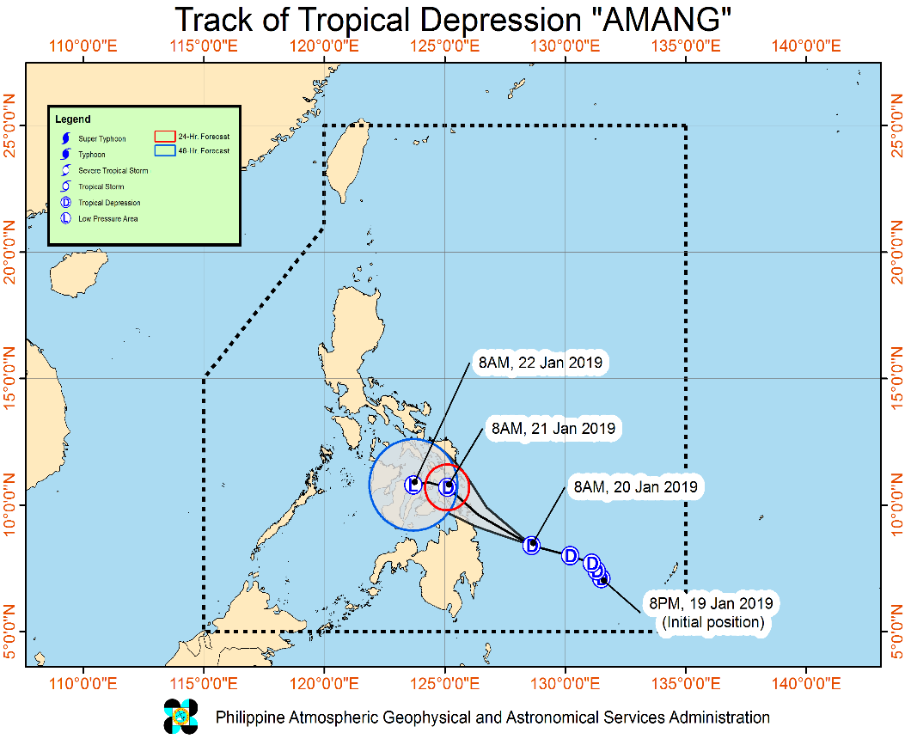
Issued at 08:00 am today, TROPICAL DEPRESSION "AMANG" IS HEADING TOWARDS SURIGAO DEL NORTE WHILE MOVING WEST-NORTHWESTWARD.
- TD "AMANG" is expected to make landfall over Surigao del Norte mainland - Siargao Islands today (20 January) between afternoon and evening.
- Beginning today (20 January), moderate to heavy rains will prevail over Caraga, Northern Mindanao, Compostela Valley, Davao Oriental, Eastern Visayas, Central Visayas, Bicol Region, Southern Quezon, Marinduque and Romblon. Meanwhile, tomorrow (21 January), moderate to heavy rains may prevail over Visayas, Bicol Region, Southern Quezon, Marinduque, and Romblon. On Tuesday (22 January), moderate to heavy rains may be experienced over Albay, Sorsogon, Catanduanes, Masbate, Eastern Visayas and Central Visayas. Residents in these areas, especially those living in areas at high risk of flooding and landslides are advised to take precautionary measures.
- Fisherfolks and those with small seacrafts are advised not to venture out over the seaboards of areas under TCWS #1, the northern seaboard of Northern Luzon, and eastern seaboards of Luzon, Visayas and Mindanao due to the approaching Tropical Depression and the surge of Northeast Monsoon.
At 7:00 AM today, the center of Tropical Depression "AMANG" was estimated based on all available data at 360 km East of Hinatuan, Surigao del Sur (08.0 °N, 129.6 °E).

- Status of Affected Families / Persons
A total of 36 Families or 170 persons were affected in 3 barangays, 2 cities/municipalities, and 1 province in Region CARAGA (see Table 1).

Table 1. Affected Areas and Number of Affected Families / Persons
REGION / PROVINCE / MUNICIPALITY |  | NUMBER OF AFFECTED
 |  | Barangays | Cities / Municipalities | Provinces | Families | Persons
GRAND TOTAL |  | 3 | 2 | 1 | 36 | 170
CARAGA |  | 3 | 2 | 1 | 36 | 170
Surigao del Sur |  | 3 | 2 | 1 | 36 | 170
 | Barobo | 2 |  |  | 28 | 140
 | Lanuza | 1 |  |  | 8 | 30
Note: Ongoing assessment and validation

Sources: LGUs through the C/MSWD and C/MDRRM

- Status of Displaced and Served Families / Persons (see Table 2)

Table 2. Number of Served Families / Persons Inside and Outside ECs
REGION / PROVINCE / MUNICIPALITY |  | NUMBER OF EVACUATION CENTERS (ECs) |  | INSIDE ECs |  |  |  | INSIDE ECs Returned Home |  | OUTSIDE ECs |  |  |  | OUTSIDE ECs Returned Home |  | TOTAL SERVED
 |  |  |  |  |  |  |  |  |  |  |  |  |  |  |  | Families |  | Persons
 |  |  |  | Families |  | Persons |  | Families | Persons | Families |  | Persons |  | Families | Persons | Total Families |  | Total Persons
 |  | CUM | NOW | CUM | NOW | CUM | NOW |  |  | CUM | NOW | CUM | NOW |  |  | CUM | NOW | CUM | NOW
GRAND TOTAL |  | 3 | 3 | 36 | 36 | 170 | 170 | - | - | - | - | - | - | - | - | 36 | 36 | 170 | 170
CARAGA |  | 3 | 3 | 36 | 36 | 170 | 170 | - | - | - | - | - | - | - | - | 36 | 36 | 170 | 170
Surigao del Sur |  | 3 | 3 | 36 | 36 | 170 | 170 | - | - | - | - | - | - | - | - | 36 | 36 | 170 | 170
 | Barobo | 2 | 2 | 28 | 28 | 140 | 140 | - | - | - | - | - | - | - | - | 28 | 28 | 140 | 140
 | Lanuza | 1 | 1 | 8 | 8 | 30 | 30 | - | - | - | - | - | - | - | - | 8 | 8 | 30 | 30
Note: Ongoing assessment and validation

Sources: LGUs through the C/MSWD and C/MDRRMO

Situational Reports

DSWD-DRMB
DATE | SITUATIONS / ACTIONS UNDERTAKEN
20 January 2019 | - The Disaster Response Operations Monitoring and Information Center (DROMIC) of the DSWD-DRMB is closely coordinating with the DSWD-Field Offices for significant disaster preparedness for response updates.

FO CARAGA
DATE | SITUATION / PREPAREDNESS ACTIONS
20 January 2019 | - DSWD-FO CARAGA raised alert status to RED.  - Activated Field Office and Provincial Quick Response Teams for the continuous monitoring in the field for the provision of timely updates.  - Prepositioned 2,500 FFPs amounting to PhP 912,750.00 in DPWH Surigao City Warehouse.  - Coordinated with the respective LSWDOs and LDRRMOs for the provision of timely updates regarding their situation and their disaster response operation.  - Will coordinate with the LSWDO and PPA for the status and immediate assistance of the stranded passengers.

FO VIII
DATE | SITUATION / PREPAREDNESS ACTIONS
20 January 2019 | - DRMD PDOs assigned at the Provinces, PATs and C/MATs are alerted, monitoring the situation on the AOR, and in close coordination with P/C/MSWDOs and P/C/MDRRMOs for any eventualities on the ground.  - Disaster Response Management Division (DRMD) are alerted and rendering 24/7 duty.  - All Quick Response Team (QRT) members are also alerted.  - Disaster Response Information Management Section (DRIMS) is monitoring the weather condition and in close coordination with SWADTs, QRTs and PDOs for any updates on the ground.  - Regional Resource Operation Section (RROS) are also alerted to ensure the readiness of dispatching the Food and Non-Food commodities whenever needed.  There were 146 Cargo/Vessel with 25 families and 570 Individuals reportedly stranded.  Ports/Terminals No. Of Cargo/Vessel Stranded Families Stranded Individuals  Leyte  Isabel Port 1-Rolling Cargo 30  Hilongos Port 1-Rolling Cargo 30  Southern Leyte  Liloan Port 67-Rolling Cargo 3- Ships 28 (estimate) 126  San Ricardo Port 42- Rolling Cargo 212  San Juan Port 1-Vessel  Northern Samar  Dapdap Port 2- Rolling Cargo 8  Looc Port 19- Rolling Cargo 156  Western Samar  Calbayog Port 9-Rolling Cargo 1-Vessel 8  Total 146 28 (estimate) 570

*****
The Disaster Response Operations Monitoring and Information Center (DROMIC) of the DSWD-DRMB is closely coordinating with the concerned DSWD-Field Offices for any significant disaster preparedness for response updates.

JAN ERWIN ANDREW I. ONTANILLAS
Releasing Officer

