DSWD DROMIC Report #10 on
Tropical Depression “USMAN”
as of 04 January 2019, 5PM

SUMMARY

Tropical Depression “USMAN” entered the Philippine Area of Responsibility (PAR) on 25 December 2018. It has made landfall in the vicinity of Borongan, Eastern Samar and has weakened into a Low Pressure Area (LPA) on 29 December 2018.

- Status of Affected Families / Persons
A total of 139,878 families or 623,287 persons were affected in 864 barangays, 116 cities/municipalities, and 14 provinces in Regions V, VIII, CALABARZON, and MIMAROPA (see Table 1; Annex A for details).

Table 1. Affected Areas and Number of Affected Families / Persons
REGION | NUMBER OF AFFECTED
 | Barangays | Cities / Municipalities | Provinces | Families | Persons
GRAND TOTAL | 864 | 116 | 14 | 139,878 | 623,287
CALABARZON | 45 | 21 | 3 | 407 | 1,688
MIMAROPA | 48 | 11 | 2 | 3,065 | 12,907
REGION V | 396 | 56 | 6 | 74,360 | 347,000
REGION VIII | 375 | 28 | 3 | 62,046 | 261,692
Note: Ongoing assessment and validation

Sources: LGUs through the C/MSWD and C/MDRRM

- Status of Displaced and Served Families / Persons (see Table 2; Annex B for details)

Table 2. Number of Served Families / Persons Inside and Outside ECs
REGION | NUMBER OF EVACUATION CENTERS (ECs) |  | INSIDE ECs |  |  |  | INSIDE ECs Returned Home |  | OUTSIDE ECs |  |  |  | OUTSIDE ECs Returned Home |  | TOTAL SERVED
 |  |  |  |  |  |  |  |  |  |  |  |  |  |  | Families |  | Persons
 |  |  | Families |  | Persons |  | Families | Persons | Families |  | Persons |  | Families | Persons | Total Families |  | Total Persons
 | CUM | NOW | CUM | NOW | CUM | NOW |  |  | CUM | NOW | CUM | NOW |  |  | CUM | NOW | CUM | NOW
GRAND TOTAL | 605 | 119 | 33,221 | 13,007 | 145,437 | 57,135 | 20,214 | 88,302 | 64,586 | 22,633 | 281,314 | 107,540 | 41,953 | 173,774 | 97,807 | 35,640 | 426,751 | 164,675
CALABARZON | 42 | 1 | 398 | 1 | 1,676 | 4 | 397 | 1,672 | 9 | - | 42 | - | 9 | 42 | 407 | 1 | 1,718 | 4
REGION MIMAROPA | 58 | 2 | 2,845 | 3 | 11,887 | 14 | 2,842 | 11,873 | 195 | - | 895 | - | 195 | 895 | 3,040 | 3 | 12,782 | 14
REGION V | 466 | 112 | 27,391 | 12,828 | 121,006 | 56,417 | 14,563 | 64,589 | 46,969 | 22,206 | 225,994 | 105,832 | 24,763 | 120,162 | 74,360 | 35,034 | 347,000 | 162,249
REGION VIII | 39 | 4 | 2,587 | 175 | 10,868 | 700 | 2,412 | 10,168 | 17,413 | 427 | 54,383 | 1,708 | 16,986 | 52,675 | 20,000 | 602 | 65,251 | 2,408
Note: Ongoing assessment and validation
Sources: LGUs through the C/MSWD and C/MDRRMO

- Damaged Houses
There are 6,005 damaged houses reported in Regions CALABARZON, MIMAROPA, and Region VIII, of which, 1,081 houses are totally damaged and 4,924 houses are partially damaged (see Table 3).

Table 3. Number of Damaged Houses
REGION / PROVINCE / MUNICIPALITY |  | NO. OF DAMAGED HOUSES
 |  | Total | Totally | Partially
GRAND TOTAL |  | 6,005 | 1,081 | 4,924
CALABARZON |  | 22 | 8 | 14
Batangas |  | 12 | 3 | 9
 | Cuenca | 8 | - | 8
 | Lobo | 1 | 1 | -
 | Santa Teresita | 3 | 2 | 1
Laguna |  | 2 | 2 | -
 | San Pablo City | 2 | 2 | -
Quezon |  | 8 | 3 | 5
 | Gumaca | 1 | 1 | -
 | Infanta | 5 | - | 5
 | Pagbilao | 2 | 2 | -
REGION MIMAROPA |  | 258 | 48 | 210
Oriental Mindoro |  | 258 | 48 | 210
 | Baco | 35 | 5 | 30
 | Bansud | 199 | 35 | 164
 | Naujan | 3 | 3 | -
 | Pinamalayan | 17 | 1 | 16
 | Victoria | 4 | 4 | -
REGION V |  | 3,095 | 380 | 2,715
Albay |  | 97 | 77 | 20
 | Camalig | 1 | - | 1
 | Guinobatan | 1 | 1 | -
 | Legazpi City (capital) | 1 | 1 | -
 | Libon | 19 | - | 19
 | Malinao | 2 | 2 | -
 | Tiwi | 73 | 73 | -
Camarines Sur |  | 2,998 | 303 | 2,695
 | Baao | 1,624 | 4 | 1,620
 | Cabusao | 1 | 1 | -
 | Caramoan | 1,038 | 283 | 755
 | Nabua | 1 | 1 | -
 | Tinambac | 334 | 14 | 320
REGION VIII |  | 2,630 | 645 | 1,985
Northern Samar |  | 2,630 | 645 | 1,985
 | Catarman (capital) | 755 | 205 | 550
 | Lope de Vega | 1,870 | 439 | 1,431
 | San Roque | 5 | 1 | 4
Note: Ongoing assessment and validation

Sources: LGUs through the C/MSWD and C/MDRRMO

- Summary of Assistance Provided (see Table 4)

A total of ₱14,840,077.50 worth of assistance was provided by; DSWD (₱12,981,075.50), LGUs (₱1,579,852.00), and NGOs (₱279,150.00) (see Table 4).

Table 4. Cost of Assistance Provided to Affected Families / Persons
REGION / PROVINCE / MUNICIPALITY |  | TOTAL COST OF ASSISTANCE
 |  | DSWD | LGU | NGOs | OTHERS | GRAND TOTAL
GRAND TOTAL |  | 12,981,075.50 | 1,579,852.00 | 279,150.00 | - | 14,840,077.50
MIMAROPA |  | 449,872.00 | 325,398.00 | 180,000.00 | - | 955,270.00
Oriental Mindoro |  | 317,392.00 | 288,298.00 | - | - | 605,690.00
 | Baco | 125,400.00 | 117,107.00 | - | - | 242,507.00
 | Bansud | 30,932.00 | 3,250.00 | - | - | 34,182.00
 | Bongabong | - | 176.00 | - | - | 176.00
 | City of Calapan (capital) | 12,958.00 | 36,019.00 | - | - | 48,977.00
 | Gloria | 79,002.00 | - | - | - | 79,002.00
 | Pinamalayan | - | 103,740.00 | - | - | 103,740.00
 | Pola | - | 28,006.00 | - | - | 28,006.00
 | Roxas | 69,100.00 | - | - | - | 69,100.00
Palawan |  | 125,400.00 | 25,600.00 | - | - | 151,000.00
 | Magsaysay | 125,400.00 | 25,600.00 | - | - | 151,000.00
Romblon |  | 7,080.00 | 11,500.00 | 180,000.00 | - | 198,580.00
 | Odiongan | 7,080.00 | 11,500.00 | 180,000.00 | - | 198,580.00
REGION V |  | 12,529,403.50 | 481,402.00 | 99,150.00 | - | 13,109,955.50
Albay |  | 2,774,924.00 | 300,287.00 | 93,600.00 | - | 3,168,811.00
 | Guinobatan | - | 166,272.00 | - | - | 166,272.00
 | Libon | 1,129,410.00 | - | 93,600.00 | - | 1,223,010.00
 | Malilipot | 56,854.00 | - | - | - | 56,854.00
 | Malinao | - | 134,015.00 | - | - | 134,015.00
 | Tiwi | 1,588,660.00 | - | - | - | 1,588,660.00
Camarines Sur |  | 8,560,882.50 | 41,056.00 | 5,550.00 | - | 8,607,488.50
 | Bato | - | 35,056.00 | - | - | 35,056.00
 | Buhi | 3,594,220.00 | - | - | - | 3,594,220.00
 | Canaman | - | 6,000.00 | 5,550.00 | - | 11,550.00
 | Iriga City | 3,736,700.00 | - | - | - | 3,736,700.00
 | Naga City | 57,600.00 | - | - | - | 57,600.00
 | Sagñay | 1,172,362.50 | - | - | - | 1,172,362.50
Catanduanes |  | 1,000,033.00 | 22,934.00 | - | - | 1,022,967.00
 | Bato | 1,000,033.00 | 10,764.00 | - | - | 1,010,797.00
 | San Andres (Calolbon) | - | 2,520.00 | - | - | 2,520.00
 | San Miguel | - | 8,850.00 | - | - | 8,850.00
 | Virac (capital) | - | 800.00 | - | - | 800.00
Masbate |  | - | 4,225.00 | - | - | 4,225.00
 | Cataingan | - | 4,225.00 | - | - | 4,225.00
Sorsogon |  | 193,564.00 | 112,900.00 | - | - | 306,464.00
 | Bulan | - | 3,900.00 | - | - | 3,900.00
 | Irosin | 99,820.00 | 109,000.00 | - | - | 208,820.00
 | Pilar | 93,744.00 | - | - | - | 93,744.00
REGION VIII |  | 1,800.00 | 773,052.00 | - | - | 774,852.00
Eastern Samar |  | - | 25,060.00 | - | - | 25,060.00
 | Maydolong | - | 25,060.00 | - | - | 25,060.00
Leyte |  | - | 20,300.00 | - | - | 20,300.00
 | Tacloban City (capital) | - | 20,300.00 | - | - | 20,300.00
Western Samar |  | 1,800.00 | 727,692.00 | - | - | 729,492.00
 | Calbayog City | - | 612,000.00 | - | - | 612,000.00
 | San Jorge | - | 83,512.00 | - | - | 83,512.00
 | Tagapul-an | 1,800.00 | 2,300.00 | - | - | 4,100.00
 | Hinabangan | - | 3,960.00 | - | - | 3,960.00
 | Pinabacdao | - | 25,920.00 | - | - | 25,920.00
Note: Relief assistance were provided to stranded passengers at Odiongan Port, Tagapul-an, Hinabangan, Pinabacdao, Maydolong, Tacloban and Pinabacdao.

Sources: DSWD-FOs and LGUs through the C/MSWD and C/MDRRMO

Situational Reports

DSWD-DRMB
DATE | SITUATIONS / ACTIONS UNDERTAKEN
04 January 2019 | - The Disaster Response Operations Monitoring and Information Center (DROMIC) of the DSWD-DRMB is closely coordinating with concerned DSWD-Field Offices for significant response updates.

FO CALABARZON
DATE | SITUATION / PREPAREDNESS ACTIONS
03 January 2019 | - The alert level at the DSWD-FO CALABARZON Disaster Operation Center has been lowered from BLUE to WHITE. However, it will still continue to monitor the IDPs in the evacuation center in Pangil, Laguna.  - DSWD-FO CALABARZON submitted their terminal report.

FO MIMAROPA
DATE | SITUATION / PREPAREDNESS ACTIONS
04 January 2019 | - DSWD-FO MIMAROPA is continuously coordinating with P/C/MSWDOs for possible augmentation to affected LGUs.  - The DSWD-FO MIMAROPA DRMD is continuously coordinating with SWAD Offices and other concerned agencies for disaster response operation.  - DSWD-FO MIMAROPA DRMD staff are on 24/7 duty to further monitor the situation and condition of the affected areas and population within the Region in order to provide immediate information to decision makers as basis for the provision of intervention.  - R/P/C/MQRT Operation Centers are all activated to continuously monitor weather disturbances within the provinces of MIMAROPA and provide situational awareness, if necessary.  - DSWD-FO MIMAROPA continues to coordinate with P/C/MDRRMOs in monitoring the situation and weather disturbance within the affected areas of the Region to ensure that reports are curated/captured, validated and verified.

FO V
DATE | SITUATION / PREPAREDNESS ACTIONS
04 January 2019 | - DSWD-FO V completed the documentary requirements for the provision of financial assistance to bereaved families and injured individuals.  - Other actions being taken are:  - Implementation of Psycho-social interventions  - Integration of Protection Policies in evacuation centers (i.e., child and women protection)  - Continuous provision of resource augmentation (food and non-food items) to the affected areas  - Deployment of Emergency Telecommunication Equipment in Sagnay, Camarines Sur  - Deployment of QRT in affected communities  - Continuous monitoring of weather information, status reports and updates

FO VIII
DATE | SITUATION / PREPAREDNESS ACTIONS
- January 2019 | - DSWD-FO VIII has an ongoing distribution of food and non-food items in Catarman and Lope de Vega, Northern Samar.  - DSWD-FO VIII deployed workforce for the relief operations in Lope De Vega and Catarman, Northern Samar.

FO CARAGA
DATE | SITUATION / PREPAREDNESS ACTIONS
29 December 2018 | - DSWD-FO CARAGA QRT is already deactivated.  - DSWD-FO CARAGA submitted their terminal report.

*****
The Disaster Response Operations Monitoring and Information Center (DROMIC) of the DSWD-DRMB is closely coordinating with the concerned DSWD-Field Offices for any significant disaster preparedness for response updates.

MARIEL B. FERRARIZ
Releasing Officer

ANNEX A. Affected Areas and Number of Affected Families / Persons

REGION / PROVINCE / MUNICIPALITY |  | NUMBER OF AFFECTED
 |  | Barangays | Cities / Municipalities | Provinces | Families | Persons
GRAND TOTAL |  | 864 | 116 | 14 | 139,878 | 623,287
CALABARZON |  | 45 | 21 | 3 | 407 | 1,688
Batangas |  | 4 | 3 | 1 | 12 | 47
 | Cuenca | 2 |  |  | 8 | 30
 | Lobo | 1 |  |  | 1 | 3
 | Santa Teresita | 1 |  |  | 3 | 14
Laguna |  | 8 | 6 | 1 | 82 | 322
 | City of Calamba | 1 |  |  | 16 | 58
 | Calauan | 1 |  |  | 2 | 5
 | Liliw | 1 |  |  | 7 | 36
 | Los Baños | 2 |  |  | 32 | 128
 | Pangil | 1 |  |  | 3 | 11
 | San Pablo City | 2 |  |  | 22 | 84
Quezon |  | 33 | 12 | 1 | 313 | 1,319
 | Agdangan | 1 |  |  | 6 | 30
 | Atimonan | 6 |  |  | 37 | 163
 | Gumaca | 7 |  |  | 76 | 326
 | Infanta | 3 |  |  | 5 | 25
 | Lopez | 2 |  |  | 8 | 32
 | Macalelon | 2 |  |  | 5 | 16
 | Mauban | 2 |  |  | 14 | 40
 | Pagbilao | 1 |  |  | 48 | 240
 | Pitogo | 3 |  |  | 38 | 132
 | Plaridel | 4 |  |  | 22 | 94
 | Quezon | 1 |  |  | 2 | 6
 | Real | 1 |  |  | 52 | 215
MIMAROPA |  | 48 | 11 | 2 | 3,065 | 12,907
Oriental Mindoro |  | 47 | 10 | 1 | 2,937 | 12,379
 | Baco | 7 |  |  | 851 | 3,496
 | Bansud | 2 |  |  | 58 | 289
 | Bongabong | 3 |  |  | 791 | 3,324
 | City of Calapan (capital) | 5 |  |  | 259 | 1,242
 | Gloria | 6 |  |  | 189 | 876
 | Naujan | 7 |  |  | 49 | 241
 | Pinamalayan | 8 |  |  | 364 | 1,350
 | Pola | 2 |  |  | 92 | 460
 | Socorro | 4 |  |  | 197 | 795
 | Victoria | 3 |  |  | 87 | 306
Palawan |  | 1 | 1 | 1 | 128 | 528
 | Magsaysay | 1 |  |  | 128 | 528
REGION V |  | 396 | 56 | 6 | 74,360 | 347,000
Albay |  | 62 | 11 | 1 | 4,400 | 17,920
 | Bacacay | 4 |  |  | 146 | 617
 | Camalig | 2 |  |  | 21 | 88
 | Guinobatan | 4 |  |  | 872 | 2,912
 | Jovellar | 1 |  |  | 55 | 330
 | Libon | 24 |  |  | 1,418 | 5,398
 | Malilipot | 3 |  |  | 152 | 797
 | Malinao | 3 |  |  | 131 | 435
 | Manito | 4 |  |  | 71 | 366
 | Pio Duran | 3 |  |  | 15 | 59
 | Polangui | 2 |  |  | 34 | 78
 | Tiwi | 12 |  |  | 1,485 | 6,840
Camarines Norte |  | 49 | 7 | 1 | 3,595 | 15,711
 | Basud | 1 |  |  | 953 | 3,271
 | Capalonga | 2 |  |  | 5 | 19
 | Daet (capital) | 24 |  |  | 1,931 | 9,655
 | Jose Panganiban | 1 |  |  | 7 | 35
 | Mercedes | 9 |  |  | 365 | 1,533
 | San Vicente | 4 |  |  | 35 | 79
 | Vinzons | 8 |  |  | 299 | 1,119
Camarines Sur |  | 243 | 25 | 1 | 65,724 | 310,775
 | Baao | 12 |  |  | 1,704 | 7,747
 | Bato | 11 |  |  | 896 | 3,611
 | Bombon | 3 |  |  | 65 | 447
 | Buhi | 19 |  |  | 6,410 | 30,430
 | Bula | 7 |  |  | 11,795 | 56,845
 | Cabusao | 5 |  |  | 43 | 163
 | Calabanga | 2 |  |  | 44 | 356
 | Camaligan | 4 |  |  | 14 | 79
 | Canaman | 11 |  |  | 188 | 745
 | Caramoan | 16 |  |  | 1,423 | 3,746
 | Del Gallego | 14 |  |  | 174 | 660
 | Goa | 5 |  |  | 19 | 85
 | Iriga City | 36 |  |  | 13,865 | 73,256
 | Lagonoy | 2 |  |  | 45 | 165
 | Libmanan | 35 |  |  | 12,965 | 61,343
 | Lupi | 2 |  |  | 45 | 221
 | Magarao | 1 |  |  | 11 | 46
 | Milaor | 11 |  |  | 508 | 2,563
 | Minalabac | 6 |  |  | 254 | 1,053
 | Nabua | 24 |  |  | 12,866 | 56,726
 | Naga City | 3 |  |  | 80 | 372
 | Ocampo | 3 |  |  | 9 | 46
 | Pasacao | 1 |  |  | 27 | 109
 | Sagñay | 4 |  |  | 1,967 | 8,574
 | Tinambac | 6 |  |  | 307 | 1,387
Catanduanes |  | 23 | 6 | 1 | 462 | 1,873
 | Bato | 5 |  |  | 69 | 292
 | Panganiban (Payo) | 1 |  |  | 9 | 16
 | San Andres (Calolbon) | 3 |  |  | 79 | 180
 | San Miguel | 6 |  |  | 183 | 854
 | Viga | 4 |  |  | 86 | 383
 | Virac (capital) | 4 |  |  | 36 | 148
Masbate |  | 11 | 5 | 1 | 96 | 396
 | City of Masbate (capital) | 1 |  |  | 16 | 59
 | Mobo | 2 |  |  | 19 | 73
 | San Fernando | 2 |  |  | 14 | 42
 | San Jacinto | 2 |  |  | 13 | 68
 | Uson | 4 |  |  | 34 | 154
Sorsogon |  | 8 | 2 | 1 | 83 | 325
 | Bulusan | 3 |  |  | 33 | 108
 | Irosin | 5 |  |  | 50 | 217
REGION VIII |  | 375 | 28 | 3 | 62,046 | 261,692
Eastern Samar |  | 12 | 4 | 1 | 322 | 1,276
 | Jipapad | 4 |  |  | 185 | 667
 | Maslog | 2 |  |  | 31 | 124
 | Sulat | 3 |  |  | 79 | 374
 | Balangkayan | 3 |  |  | 27 | 111
Northern Samar |  | 256 | 20 | 1 | 47,468 | 203,540
 | Allen | 9 |  |  | 1,344 | 6,720
 | Bobon | 9 |  |  | 687 | 2,748
 | Capul | 5 |  |  | 70 | 130
 | Catarman (capital) | 51 |  |  | 18,367 | 84,539
 | Lavezares | 1 |  |  | 136 | 630
 | Lope de Vega | 22 |  |  | 3,963 | 14,750
 | Mondragon | 7 |  |  | 200 | 945
 | Rosario | 1 |  |  | 25 | 100
 | San Antonio | 3 |  |  | 18 | 90
 | San Isidro | 14 |  |  | 2,100 | 7,000
 | San Jose | 3 |  |  | 17 | 85
 | San Vicente | 7 |  |  | 2,036 | 8,123
 | Catubig | 47 |  |  | 8,504 | 35,708
 | Gamay | 2 |  |  | 63 | 241
 | Laoang | 5 |  |  | 544 | 2,567
 | Las Navas | 19 |  |  | 3,877 | 17,188
 | Mapanas | 5 |  |  | 354 | 1,288
 | Palapag | 5 |  |  | 155 | 576
 | San Roque | 15 |  |  | 1,491 | 3,969
 | Silvino Lobos | 26 |  |  | 3,517 | 16,143
Western Samar |  | 107 | 4 | 1 | 14,256 | 56,876
 | Calbayog City | 60 |  |  | 9,724 | 38,896
 | San Jorge | 32 |  |  | 3,331 | 13,242
 | Calbiga | 11 |  |  | 430 | 1,720
 | Santa Rita | 4 |  |  | 771 | 3,018

ANNEX B. Number of Served Families / Persons Inside and Outside ECs

REGION / PROVINCE / MUNICIPALITY |  | NUMBER OF EVACUATION CENTERS (ECs) |  | INSIDE ECs |  |  |  | INSIDE ECs Returned Home |  | OUTSIDE ECs |  |  |  | OUTSIDE ECs Returned Home |  | TOTAL SERVED
 |  |  |  |  |  |  |  |  |  |  |  |  |  |  |  | Families |  | Persons
 |  |  |  | Families |  | Persons |  | Families | Persons | Families |  | Persons |  | Families | Persons | Total Families |  | Total Persons
 |  | CUM | NOW | CUM | NOW | CUM | NOW |  |  | CUM | NOW | CUM | NOW |  |  | CUM | NOW | CUM | NOW
GRAND TOTAL |  | 605 | 119 | 33,221 | 13,007 | 145,437 | 57,135 | 20,214 | 88,302 | 64,586 | 22,633 | 281,314 | 107,540 | 41,953 | 173,774 | 97,807 | 35,640 | 426,751 | 164,675
CALABARZON |  | 42 | 1 | 398 | 1 | 1,676 | 4 | 397 | 1,672 | 9 | - | 42 | - | 9 | 42 | 407 | 1 | 1,718 | 4
Batangas |  | 1 | - | 8 | - | 30 | - | 8 | 30 | 4 | - | 17 | - | 4 | 17 | 12 | - | 47 | -
 | Cuenca | 1 | - | 8 | - | 30 | - | 8 | 30 | - | - | - | - | - | - | 8 | - | 30 | -
 | Lobo | - | - | - | - | - | - | - | - | 1 | - | 3 | - | 1 | 3 | 1 | - | 3 | -
 | Santa Teresita | - | - | - | - | - | - | - | - | 3 | - | 14 | - | 3 | 14 | 3 | - | 14 | -
Laguna |  | 7 | 1 | 82 | 1 | 322 | 4 | 81 | 318 | - | - | - | - | - | - | 82 | 1 | 322 | 4
 | City of Calamba | 1 | - | 16 | - | 58 | - | 16 | 58 | - | - | - | - | - | - | 16 | - | 58 | -
 | Calauan | 1 | - | 2 | - | 5 | - | 2 | 5 | - | - | - | - | - | - | 2 | - | 5 | -
 | Liliw | 1 | - | 7 | - | 36 | - | 7 | 36 | - | - | - | - | - | - | 7 | - | 36 | -
 | Los Baños | 2 | - | 32 | - | 128 | - | 32 | 128 | - | - | - | - | - | - | 32 | - | 128 | -
 | Pangil | 1 | 1 | 3 | 1 | 11 | 4 | 2 | 7 | - | - | - | - | - | - | 3 | 1 | 11 | 4
 | San Pablo City | 1 | - | 22 | - | 84 | - | 22 | 84 | - | - | - | - | - | - | 22 | - | 84 | -
Quezon |  | 34 | - | 308 | - | 1,324 | - | 308 | 1,324 | 5 | - | 25 | - | 5 | 25 | 313 | - | 1,349 | -
 | Agdangan | 1 | - | 6 | - | 30 | - | 6 | 30 | - | - | - | - | - | - | 6 | - | 30 | -
 | Atimonan | 6 | - | 37 | - | 193 | - | 37 | 193 | - | - | - | - | - | - | 37 | - | 193 | -
 | Gumaca | 9 | - | 76 | - | 326 | - | 76 | 326 | - | - | - | - | - | - | 76 | - | 326 | -
 | Infanta | - | - | - | - | - | - | - | - | 5 | - | 25 | - | 5 | 25 | 5 | - | 25 | -
 | Lopez | 2 | - | 8 | - | 32 | - | 8 | 32 | - | - | - | - | - | - | 8 | - | 32 | -
 | Macalelon | 3 | - | 5 | - | 16 | - | 5 | 16 | - | - | - | - | - | - | 5 | - | 16 | -
 | Mauban | 2 | - | 14 | - | 40 | - | 14 | 40 | - | - | - | - | - | - | 14 | - | 40 | -
 | Pagbilao | 2 | - | 48 | - | 240 | - | 48 | 240 | - | - | - | - | - | - | 48 | - | 240 | -
 | Pitogo | 3 | - | 38 | - | 132 | - | 38 | 132 | - | - | - | - | - | - | 38 | - | 132 | -
 | Plaridel | 4 | - | 22 | - | 94 | - | 22 | 94 | - | - | - | - | - | - | 22 | - | 94 | -
 | Quezon | 1 | - | 2 | - | 6 | - | 2 | 6 | - | - | - | - | - | - | 2 | - | 6 | -
 | Real | 1 | - | 52 | - | 215 | - | 52 | 215 | - | - | - | - | - | - | 52 | - | 215 | -
REGION MIMAROPA |  | 58 | 2 | 2,845 | 3 | 11,887 | 14 | 2,842 | 11,873 | 195 | - | 895 | - | 195 | 895 | 3,040 | 3 | 12,782 | 14
Oriental Mindoro |  | 56 | 2 | 2,717 | 3 | 11,359 | 14 | 2,714 | 11,345 | 195 | - | 895 | - | 195 | 895 | 2,912 | 3 | 12,254 | 14
 | Baco | 7 | - | 798 | - | 3,231 | - | 798 | 3,231 | 53 | - | 265 | - | 53 | 265 | 851 | - | 3,496 | -
 | Bansud | 3 | 1 | 57 | 1 | 285 | 4 | 56 | 281 | 1 | - | 4 | - | 1 | 4 | 58 | 1 | 289 | 4
 | Bongabong | 3 | - | 791 | - | 3,324 | - | 791 | 3,324 | - | - | - | - | - | - | 791 | - | 3,324 | -
 | City of Calapan (capital) | 6 | - | 230 | - | 1,097 | - | 230 | 1,097 | 29 | - | 145 | - | 29 | 145 | 259 | - | 1,242 | -
 | Gloria | 7 | - | 149 | - | 676 | - | 149 | 676 | 40 | - | 200 | - | 40 | 200 | 189 | - | 876 | -
 | Naujan | 8 | - | 49 | - | 241 | - | 49 | 241 | - | - | - | - | - | - | 49 | - | 241 | -
 | Pinamalayan | 11 | - | 364 | - | 1,350 | - | 364 | 1,350 | - | - | - | - | - | - | 364 | - | 1,350 | -
 | Pola | 4 | - | 67 | - | 335 | - | 67 | 335 | - | - | - | - | - | - | 67 | - | 335 | -
 | Socorro | 4 | - | 125 | - | 514 | - | 125 | 514 | 72 | - | 281 | - | 72 | 281 | 197 | - | 795 | -
 | Victoria | 3 | 1 | 87 | 2 | 306 | 10 | 85 | 296 | - | - | - | - | - | - | 87 | 2 | 306 | 10
Palawan |  | 2 | - | 128 | - | 528 | - | 128 | 528 | - | - | - | - | - | - | 128 | - | 528 | -
 | Magsaysay | 2 | - | 128 | - | 528 | - | 128 | 528 | - | - | - | - | - | - | 128 | - | 528 | -
REGION V |  | 466 | 112 | 27,391 | 12,828 | 121,006 | 56,417 | 14,563 | 64,589 | 46,969 | 22,206 | 225,994 | 105,832 | 24,763 | 120,162 | 74,360 | 35,034 | 347,000 | 162,249
Albay |  | 61 | 7 | 3,326 | 190 | 13,072 | 842 | 3,136 | 12,230 | 1,074 | 626 | 4,848 | 3,108 | 448 | 1,740 | 4,400 | 816 | 17,920 | 3,950
 | Bacacay | 4 | - | 146 | - | 617 | - | 146 | 617 | - | - | - | - | - | - | 146 | - | 617 | -
 | Camalig | 1 | - | 8 | - | 31 | - | 8 | 31 | 13 | - | 57 | - | 13 | 57 | 21 | - | 88 | -
 | Guinobatan | 5 | - | 872 | - | 2,912 | - | 872 | 2,912 | - | - | - | - | - | - | 872 | - | 2,912 | -
 | Jovellar | - | - | - | - | - | - | - | - | 55 | - | 330 | - | 55 | 330 | 55 | - | 330 | -
 | Libon | 26 | 3 | 1,053 | 99 | 4,142 | 438 | 954 | 3,704 | 365 | 7 | 1,256 | 13 | 358 | 1,243 | 1,418 | 106 | 5,398 | 451
 | Malilipot | 3 | - | 152 | - | 797 | - | 152 | 797 | - | - | - | - | - | - | 152 | - | 797 | -
 | Malinao | 3 | 1 | 131 | 2 | 435 | 14 | 129 | 421 | - | - | - | - | - | - | 131 | 2 | 435 | 14
 | Manito | 3 | - | 49 | - | 256 | - | 49 | 256 | 22 | - | 110 | - | 22 | 110 | 71 | - | 366 | -
 | Pio Duran | 1 | - | 15 | - | 59 | - | 15 | 59 | - | - | - | - | - | - | 15 | - | 59 | -
 | Polangui | 2 | - | 34 | - | 78 | - | 34 | 78 | - | - | - | - | - | - | 34 | - | 78 | -
 | Tiwi | 13 | 3 | 866 | 89 | 3,745 | 390 | 777 | 3,355 | 619 | 619 | 3,095 | 3,095 | - | - | 1,485 | 708 | 6,840 | 3,485
Camarines Norte |  | 41 | - | 3,545 | - | 15,461 | - | 3,545 | 15,461 | 50 | - | 250 | - | 50 | 250 | 3,595 | - | 15,711 | -
 | Basud | 1 | - | 953 | - | 3,271 | - | 953 | 3,271 | - | - | - | - | - | - | 953 | - | 3,271 | -
 | Capalonga | 2 | - | 5 | - | 19 | - | 5 | 19 | - | - | - | - | - | - | 5 | - | 19 | -
 | Daet (capital) | 17 | - | 1,881 | - | 9,405 | - | 1,881 | 9,405 | 50 | - | 250 | - | 50 | 250 | 1,931 | - | 9,655 | -
 | Jose Panganiban | 1 | - | 7 | - | 35 | - | 7 | 35 | - | - | - | - | - | - | 7 | - | 35 | -
 | Mercedes | 10 | - | 365 | - | 1,533 | - | 365 | 1,533 | - | - | - | - | - | - | 365 | - | 1,533 | -
 | San Vicente | 2 | - | 35 | - | 79 | - | 35 | 79 | - | - | - | - | - | - | 35 | - | 79 | -
 | Vinzons | 8 | - | 299 | - | 1,119 | - | 299 | 1,119 | - | - | - | - | - | - | 299 | - | 1,119 | -
Camarines Sur |  | 335 | 105 | 20,179 | 12,638 | 91,151 | 55,575 | 7,541 | 35,576 | 45,545 | 21,580 | 219,624 | 102,724 | 23,965 | 116,900 | 65,724 | 34,218 | 310,775 | 158,299
 | Baao | 20 | 3 | 343 | 57 | 1,854 | 320 | 286 | 1,534 | 1,361 | 275 | 5,893 | 1,065 | 1,086 | 4,828 | 1,704 | 332 | 7,747 | 1,385
 | Bato | 19 | 19 | 516 | 516 | 2,218 | 2,218 | - | - | 380 | 380 | 1,393 | 1,393 | - | - | 896 | 896 | 3,611 | 3,611
 | Bombon | 3 | - | 65 | - | 447 | - | 65 | 447 | - | - | - | - | - | - | 65 | - | 447 | -
 | Buhi | 24 | 23 | 857 | 847 | 3,784 | 3,747 | 10 | 37 | 5,553 | 5,538 | 26,646 | 26,584 | 15 | 62 | 6,410 | 6,385 | 30,430 | 30,331
 | Bula | 9 | 8 | 156 | 142 | 671 | 626 | 14 | 45 | 11,639 | 10,862 | 56,174 | 51,838 | 777 | 4,336 | 11,795 | 11,004 | 56,845 | 52,464
 | Cabusao | 6 | 3 | 43 | 11 | 163 | 51 | 32 | 112 | - | - | - | - | - | - | 43 | 11 | 163 | 51
 | Calabanga | 3 | - | 44 | - | 356 | - | 44 | 356 | - | - | - | - | - | - | 44 | - | 356 | -
 | Camaligan | 2 | - | 14 | - | 79 | - | 14 | 79 | - | - | - | - | - | - | 14 | - | 79 | -
 | Canaman | 16 | - | 143 | - | 606 | - | 143 | 606 | 45 | - | 139 | - | 45 | 139 | 188 | - | 745 | -
 | Caramoan | 16 | - | 1,423 | - | 3,746 | - | 1,423 | 3,746 | - | - | - | - | - | - | 1,423 | - | 3,746 | -
 | Del Gallego | - | - | - | - | - | - | - | - | 174 | - | 660 | - | 174 | 660 | 174 | - | 660 | -
 | Goa | 5 | 5 | 19 | 19 | 85 | 85 | - | - | - | - | - | - | - | - | 19 | 19 | 85 | 85
 | Iriga City | 97 | 1 | 4,345 | 20 | 22,873 | 150 | 4,325 | 22,723 | 9,520 | 348 | 50,383 | 2,959 | 9,172 | 47,424 | 13,865 | 368 | 73,256 | 3,109
 | Lagonoy | 2 | - | 45 | - | 165 | - | 45 | 165 | - | - | - | - | - | - | 45 | - | 165 | -
 | Libmanan | 59 | 1 | 675 | 1 | 3,610 | 7 | 674 | 3,603 | 12,290 | - | 57,733 | - | 12,290 | 57,733 | 12,965 | 1 | 61,343 | 7
 | Lupi | 2 | - | 45 | - | 221 | - | 45 | 221 | - | - | - | - | - | - | 45 | - | 221 | -
 | Magarao | 1 | - | 11 | - | 46 | - | 11 | 46 | - | - | - | - | - | - | 11 | - | 46 | -
 | Milaor | 11 | 11 | 163 | 163 | 779 | 779 | - | - | 345 | 345 | 1,784 | 1,784 | - | - | 508 | 508 | 2,563 | 2,563
 | Minalabac | 6 | 6 | 61 | 61 | 232 | 232 | - | - | 193 | 193 | 821 | 821 | - | - | 254 | 254 | 1,053 | 1,053
 | Nabua | 24 | 24 | 10,683 | 10,683 | 46,877 | 46,877 | - | - | 2,183 | 2,183 | 9,849 | 9,849 | - | - | 12,866 | 12,866 | 56,726 | 56,726
 | Naga City | 3 | - | 76 | - | 360 | - | 76 | 360 | 4 | 4 | 12 | 12 | - | - | 80 | 4 | 372 | 12
 | Ocampo | - | - | - | - | - | - | - | - | 9 | - | 46 | - | 9 | 46 | 9 | - | 46 | -
 | Pasacao | 1 | - | 27 | - | 109 | - | 27 | 109 | - | - | - | - | - | - | 27 | - | 109 | -
 | Sagñay | 1 | 1 | 118 | 118 | 483 | 483 | - | - | 1,849 | 1,452 | 8,091 | 6,419 | 397 | 1,672 | 1,967 | 1,570 | 8,574 | 6,902
 | Tinambac | 5 | - | 307 | - | 1,387 | - | 307 | 1,387 | - | - | - | - | - | - | 307 | - | 1,387 | -
Catanduanes |  | 14 | - | 223 | - | 828 | - | 223 | 828 | 239 | - | 1,045 | - | 239 | 1,045 | 462 | - | 1,873 | -
 | Bato | 4 | - | 55 | - | 268 | - | 55 | 268 | 14 | - | 24 | - | 14 | 24 | 69 | - | 292 | -
 | Panganiban (Payo) | - | - | - | - | - | - | - | - | 9 | - | 16 | - | 9 | 16 | 9 | - | 16 | -
 | San Andres (Calolbon) | 5 | - | 78 | - | 175 | - | 78 | 175 | 1 | - | 5 | - | 1 | 5 | 79 | - | 180 | -
 | San Miguel | 2 | - | 63 | - | 268 | - | 63 | 268 | 120 | - | 586 | - | 120 | 586 | 183 | - | 854 | -
 | Viga | - | - | - | - | - | - | - | - | 86 | - | 383 | - | 86 | 383 | 86 | - | 383 | -
 | Virac (capital) | 3 | - | 27 | - | 117 | - | 27 | 117 | 9 | - | 31 | - | 9 | 31 | 36 | - | 148 | -
Masbate |  | 11 | - | 73 | - | 299 | - | 73 | 299 | 23 | - | 97 | - | 23 | 97 | 96 | - | 396 | -
 | City of Masbate (capital) | 1 | - | 16 | - | 59 | - | 16 | 59 | - | - | - | - | - | - | 16 | - | 59 | -
 | Mobo | 3 | - | 19 | - | 73 | - | 19 | 73 | - | - | - | - | - | - | 19 | - | 73 | -
 | San Fernando | 3 | - | 14 | - | 42 | - | 14 | 42 | - | - | - | - | - | - | 14 | - | 42 | -
 | San Jacinto | - | - | - | - | - | - | - | - | 13 | - | 68 | - | 13 | 68 | 13 | - | 68 | -
 | Uson | 4 | - | 24 | - | 125 | - | 24 | 125 | 10 | - | 29 | - | 10 | 29 | 34 | - | 154 | -
Sorsogon |  | 4 | - | 45 | - | 195 | - | 45 | 195 | 38 | - | 130 | - | 38 | 130 | 83 | - | 325 | -
 | Bulusan | - | - | - | - | - | - | - | - | 33 | - | 108 | - | 33 | 108 | 33 | - | 108 | -
 | Irosin | 4 | - | 45 | - | 195 | - | 45 | 195 | 5 | - | 22 | - | 5 | 22 | 50 | - | 217 | -
REGION VIII |  | 39 | 4 | 2,587 | 175 | 10,868 | 700 | 2,412 | 10,168 | 17,413 | 427 | 54,383 | 1,708 | 16,986 | 52,675 | 20,000 | 602 | 65,251 | 2,408
Eastern Samar |  | 5 | - | 110 | - | 498 | - | 110 | 498 | 27 | - | 111 | - | 27 | 111 | 137 | - | 609 | -
 | Maslog | 1 | - | 31 | - | 124 | - | 31 | 124 | - | - | - | - | - | - | 31 | - | 124 | -
 | Sulat | 4 | - | 79 | - | 374 | - | 79 | 374 | - | - | - | - | - | - | 79 | - | 374 | -
 | Balangkayan | - | - | - | - | - | - | - | - | 27 | - | 111 | - | 27 | 111 | 27 | - | 111 | -
Northern Samar |  | 22 | 4 | 2,307 | 175 | 9,693 | 700 | 2,132 | 8,993 | 12,004 | 427 | 54,085 | 1,708 | 11,577 | 52,377 | 14,311 | 602 | 63,778 | 2,408
 | Bobon | 1 | - | 69 | - | 276 | - | 69 | 276 | - | - | - | - | - | - | 69 | - | 276 | -
 | Catarman (capital) | 2 | 1 | 1,214 | 5 | 5,562 | 20 | 1,209 | 5,542 | 8,305 | - | 39,267 | - | 8,305 | 39,267 | 9,519 | 5 | 44,829 | 20
 | Lavezares | 1 | - | 136 | - | 630 | - | 136 | 630 | - | - | - | - | - | - | 136 | - | 630 | -
 | Lope de Vega | 3 | 3 | 471 | 170 | 1,456 | 680 | 301 | 776 | 3,347 | 427 | 13,294 | 1,708 | 2,920 | 11,586 | 3,818 | 597 | 14,750 | 2,388
 | Gamay | 2 | - | 63 | - | 241 | - | 63 | 241 | - | - | - | - | - | - | 63 | - | 241 | -
 | San Roque | 13 | - | 354 | - | 1,528 | - | 354 | 1,528 | 352 | - | 1,524 | - | 352 | 1,524 | 706 | - | 3,052 | -
Western Samar |  | 12 | - | 170 | - | 677 | - | 170 | 677 | 5,382 | - | 187 | - | 5,382 | 187 | 5,552 | - | 864 | -
 | Calbayog City | 1 | - | 17 | - | 38 | - | 17 | 38 | 5,340 | - | - | - | 5,340 | - | 5,357 | - | 38 | -
 | San Jorge | 2 | - | 73 | - | 292 | - | 73 | 292 | - | - | - | - | - | - | 73 | - | 292 | -
 | Calbiga | 6 | - | 31 | - | 122 | - | 31 | 122 | 2 | - | 7 | - | 2 | 7 | 33 | - | 129 | -
 | Santa Rita | 3 | - | 49 | - | 225 | - | 49 | 225 | 40 | - | 180 | - | 40 | 180 | 89 | - | 405 | -

ANNEX C. Photo Documentation

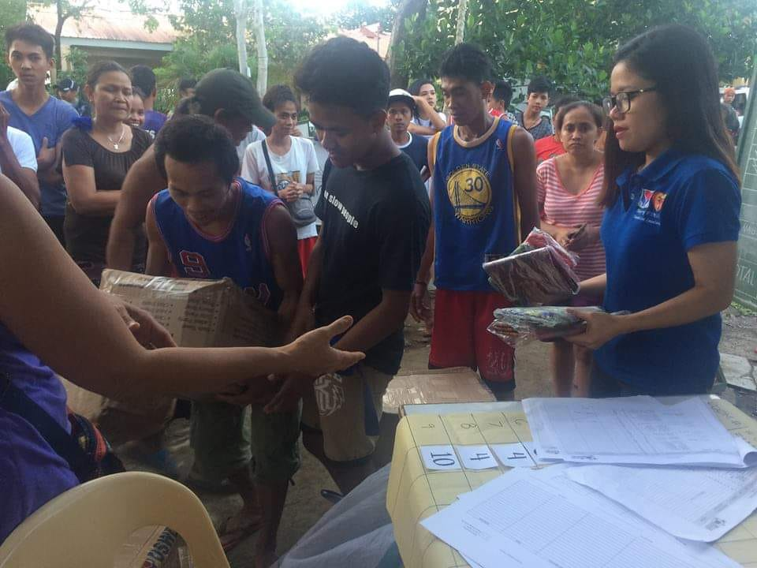  Distribution of 61 DSWD family kits and malong to the IDPs of Brgys. Maynonong and Naga at Naga National High School, Tiwi, Albay (03 January 2019) | 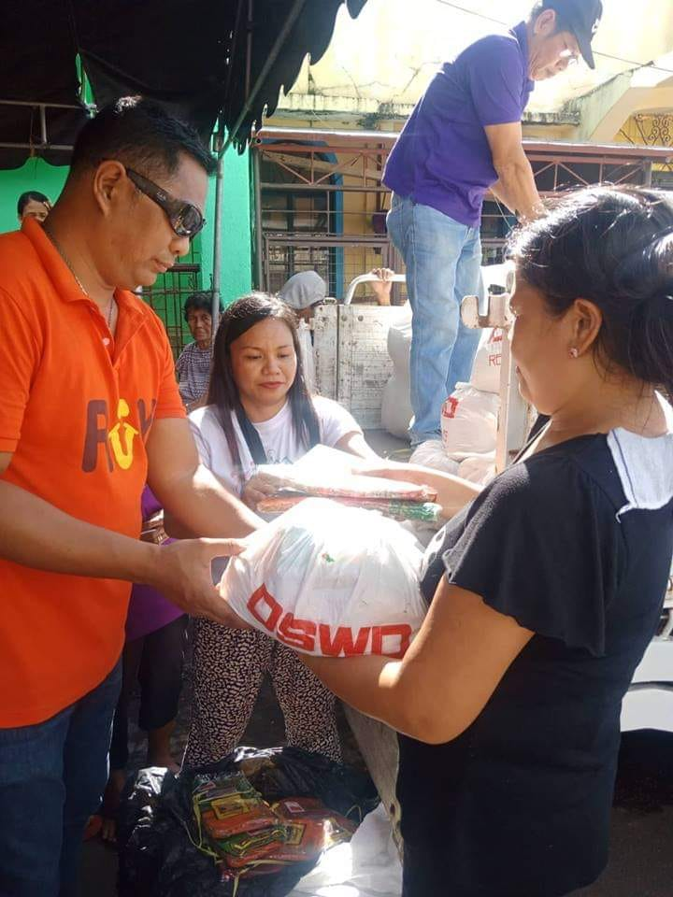  DSWD-Field Office V distributed family food packs (FFPs) in Brgy. Sta. Clara, Buhi, Camarines Sur (02 January 2019)

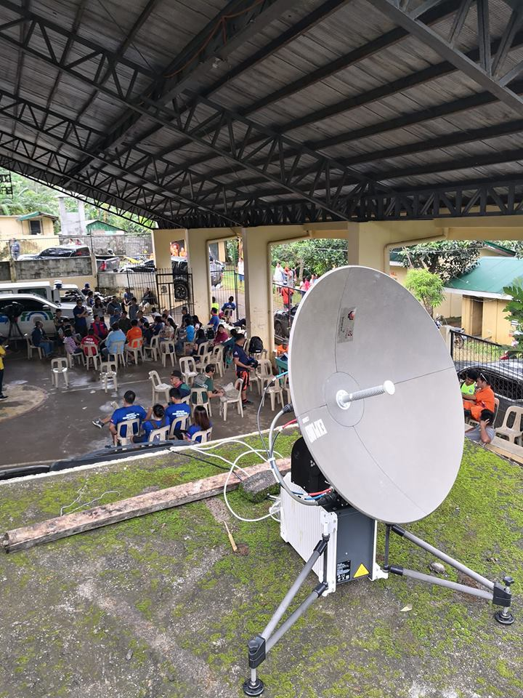  DSWD-Field Office V deployed its Regional Emergency Telecommunication Equipment in Patitinan, Sagnay, Camarines Sur to transmit updates useful to different government agencies for their immediate action (01 January 2019) | 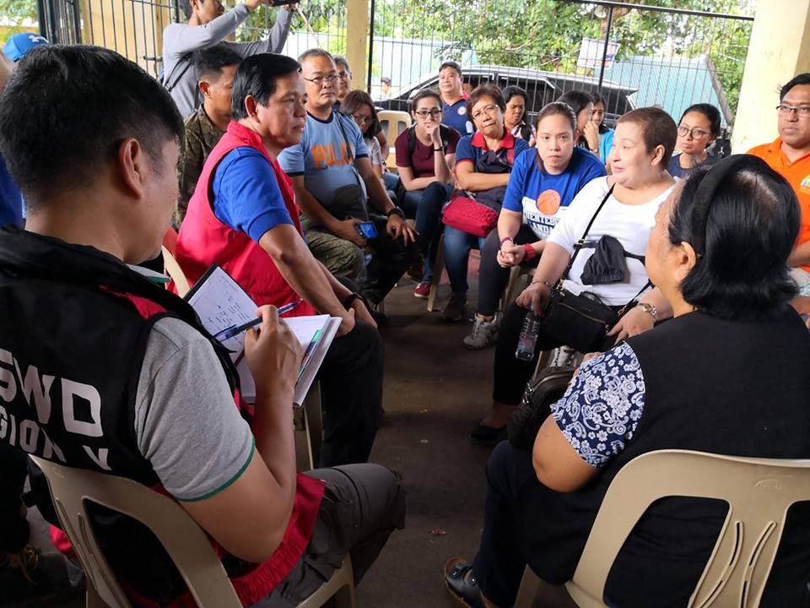  DSWD Sec. Rolando Bautista visited Patitinan, Sagnay in Camarines Sur to meet with key officials and coordinate DSWD relief efforts to the most affected families in the said village

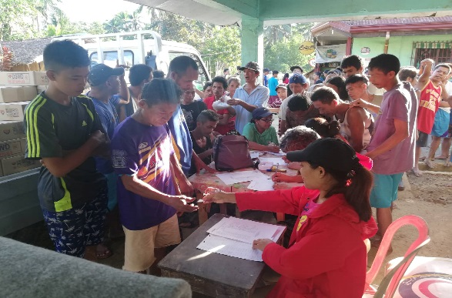 | 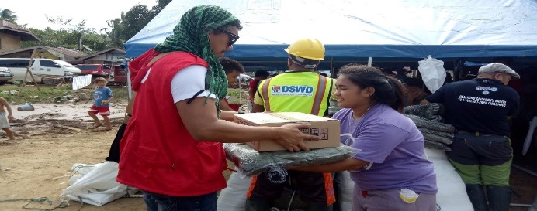
DSWD-FO VIII conducted relief distribution in Lope De Vega; a total of 893 families in three (3) Barangays (Bayho, Bonifacio and Lower Caynaga) were provided with FFPs (03 January 2019)

