DSWD DROMIC Report #19 on
Tropical Depression “USMAN”
as of 13 January 2019, 4PM

SUMMARY

Tropical Depression “USMAN” entered the Philippine Area of Responsibility (PAR) on 25 December 2018. It has made landfall in the vicinity of Borongan, Eastern Samar and has weakened into a Low Pressure Area (LPA) on 29 December 2018.

- Status of Affected Families / Persons
A total of 220,326 families or 925,636 persons were affected in 1,271 barangays, 136
cities/municipalities, and 14 provinces in Regions V, VIII, CALABARZON, and MIMAROPA (see Table 1; Annex A for details).

Table 1. Affected Areas and Number of Affected Families / Persons
REGION | NUMBER OF AFFECTED
 | Barangays | Cities / Municipalities | Provinces | Families | Persons
GRAND TOTAL | 1,271 | 136 | 14 | 220,326 | 925,636
CALABARZON | 45 | 21 | 3 | 407 | 1,688
MIMAROPA | 191 | 12 | 2 | 37,470 | 148,385
REGION V | 533 | 70 | 6 | 88,703 | 412,855
REGION VIII | 502 | 33 | 3 | 93,746 | 362,708
Note: Ongoing assessment and validation

Sources: LGUs through the C/MSWD and C/MDRRM

- Status of Displaced and Served Families / Persons (see Table 2; Annex B for details)

Table 2. Number of Served Families / Persons Inside and Outside ECs
REGION | NUMBER OF EVACUATION CENTERS (ECs) |  | INSIDE ECs |  |  |  | INSIDE ECs Returned Home |  | OUTSIDE ECs |  |  |  | OUTSIDE ECs Returned Home |  | TOTAL SERVED
 |  |  |  |  |  |  |  |  |  |  |  |  |  |  | Families |  | Persons
 |  |  | Families |  | Persons |  | Families | Persons | Families |  | Persons |  | Families | Persons | Total Families |  | Total Persons
 | CUM | NOW | CUM | NOW | CUM | NOW |  |  | CUM | NOW | CUM | NOW |  |  | CUM | NOW | CUM | NOW
GRAND TOTAL | 715 | 33 | 27,662 | 661 | 119,646 | 2,712 | 27,001 | 116,934 | 115,551 | 1,269 | 493,425 | 5,410 | 114,282 | 488,015 | 143,213 | 1,930 | 613,071 | 8,122
CALABARZON | 42 | 1 | 398 | 1 | 1,676 | 4 | 397 | 1,672 | 9 | - | 42 | - | 9 | 42 | 407 | 1 | 1,718 | 4
MIMAROPA | 67 | 1 | 3,588 | 1 | 15,396 | 4 | 3,587 | 15,392 | 33,882 | - | 132,989 | - | 33,882 | 132,989 | 37,470 | 1 | 148,385 | 4
REGION V | 567 | 27 | 21,089 | 484 | 91,706 | 2,004 | 20,605 | 89,702 | 64,247 | 842 | 306,011 | 3,702 | 63,405 | 302,309 | 85,336 | 1,326 | 397,717 | 5,706
REGION VIII | 39 | 4 | 2,587 | 175 | 10,868 | 700 | 2,412 | 10,168 | 17,413 | 427 | 54,383 | 1,708 | 16,986 | 52,675 | 20,000 | 602 | 65,251 | 2,408
Note: Ongoing assessment and validation

Sources: LGUs through the C/MSWD and C/MDRRMO

- Damaged Houses
There are 22,908 damaged houses reported in Regions V, VIII, CALABARZON, and MIMAROPA of which, 2,288 houses are totally damaged and 20,620 houses are partially damaged (see Table 3).

Table 3. Number of Damaged Houses
REGION / PROVINCE / MUNICIPALITY |  | NO. OF DAMAGED HOUSES
 |  | Total | Totally | Partially
GRAND TOTAL |  | 22,908 | 2,288 | 20,620
MIMAROPA |  | 802 | 367 | 435
Oriental Mindoro |  | 802 | 367 | 435
 | Baco | 295 | 62 | 233
 | Bansud | 199 | 35 | 164
 | Bongabong | 45 | 19 | 26
 | City of Calapan (capital) | 215 | 211 | 4
 | Gloria | 4 | 4 | -
 | Naujan | 11 | 11 | -
 | Pinamalayan | 12 | 4 | 8
REGION V |  | 5,849 | 545 | 5,304
Albay |  | 113 | 93 | 20
 | Guinobatan | 1 | 1 | -
 | Libon | 19 | - | 19
 | Malinao | 2 | 2 | -
 | Tiwi | 73 | 73 | -
Camarines Sur |  | 4,815 | 395 | 4,420
 | Baao | 1,995 | 6 | 1,989
 | Bato | 799 | - | 799
 | Iriga City | 5 | 5 | -
 | Nabua | 211 | 5 | 206
 | Presentacion (Parubcan) | 30 | 5 | 25
 | Tinambac | 604 | 77 | 527
Sorsogon |  | 3 | - | 3
REGION VIII |  | 16,235 | 1,368 | 14,867
Northern Samar |  | 3,791 | 946 | 2,845
 | Catarman (capital) | 1,083 | 360 | 723
 | Lope de Vega | 2,686 | 576 | 2,110
Western Samar |  | 12,444 | 422 | 12,022
 | Calbayog City | 9,417 | 164 | 9,253
 | San Jorge | 3,024 | 256 | 2,768
Note: Ongoing assessment and validation
*The decreased of the data was due to some validations because of the discrepancy of the data

Sources: LGUs through the C/MSWD and C/MDRRMO

- Summary of Assistance Provided (see Table 4)
A total of ₱91,888,213.69 worth of assistance was provided by; DSWD (₱35,585,146.69), LGUs (₱11,838,666.00), and NGOs (₱44,464,401.00) (see Table 4).

Table 4. Cost of Assistance Provided to Affected Families / Persons
REGION / PROVINCE / MUNICIPALITY |  | TOTAL COST OF ASSISTANCE
 |  | DSWD | LGU | NGOs | GRAND TOTAL
GRAND TOTAL |  | 35,585,146.69 | 11,838,666.00 | 44,464,401.00 | 91,888,213.69
MIMAROPA |  | 1,130,278.00 | 2,866,765.00 | 1,192,500.00 | 5,189,543.00
Oriental Mindoro |  | 997,798.00 | 2,829,665.00 | 1,012,500.00 | 4,839,963.00
 | Baco | 209,000.00 | 303,175.00 | - | 512,175.00
 | Bansud | 239,932.00 | 500,000.00 | 150,000.00 | 889,932.00
 | Bongabong | - | 1,192,676.00 | - | 1,192,676.00
 | City of Calapan (capital) | 14,212.00 | 41,268.00 | - | 55,480.00
 | Gloria | 79,002.00 | - | - | 79,002.00
 | Naujan | 72,732.00 | 329,250.00 | 862,500.00 | 1,264,482.00
 | Pinamalayan | 83,600.00 | 103,740.00 | - | 187,340.00
 | Pola | - | 28,006.00 | - | 28,006.00
 | Roxas | 69,100.00 | - | - | 69,100.00
 | Socorro | 189,354.00 | 299,250.00 | - | 488,604.00
 | Victoria | 40,866.00 | 32,300.00 | - | 73,166.00
Palawan |  | 125,400.00 | 25,600.00 | - | 151,000.00
 | Magsaysay | 125,400.00 | 25,600.00 | - | 151,000.00
Romblon |  | 7,080.00 | 11,500.00 | 180,000.00 | 198,580.00
 | Odiongan | 7,080.00 | 11,500.00 | 180,000.00 | 198,580.00
REGION V |  | 25,342,140.75 | 6,168,024.00 | 43,271,901.00 | 74,782,065.75
Albay |  | 5,146,151.00 | 320,095.00 | 43,266,351.00 | 48,732,597.00
 | Guinobatan | - | 166,272.00 | - | 166,272.00
 | Legazpi City (capital) | 10,000.00 | - | - | 10,000.00
 | Libon | 1,182,012.00 | - | 93,600.00 | 1,275,612.00
 | City of Ligao | 58,008.00 | - | - | 58,008.00
 | Malilipot | 56,854.00 | - | - | 56,854.00
 | Malinao | 64,177.50 | 134,015.00 | - | 198,192.50
 | Tiwi | 3,775,099.50 | 19,808.00 | 43,172,751.00 | 46,967,658.50
Camarines Norte |  | 40,000.00 | 127,000.00 | - | 167,000.00
 | Basud | 5,000.00 | 40,000.00 | - | 45,000.00
 | Jose Panganiban | 15,000.00 | 80,000.00 | - | 95,000.00
 | Labo | 20,000.00 | 4,000.00 | - | 24,000.00
 | Vinzons | - | 3,000.00 | - | 3,000.00
Camarines Sur |  | 19,957,425.75 | 5,580,870.00 | 5,550.00 | 25,543,845.75
 | Baao | 430,000.00 | 2,276,815.00 | - | 2,706,815.00
 | Bato | 1,000,033.00 | 143,107.00 | - | 1,143,140.00
 | Bombon | - | 160,000.00 | - | 160,000.00
 | Buhi | 5,321,290.00 | - | - | 5,321,290.00
 | Bula | 3,392,480.00 | - | - | 3,392,480.00
 | Canaman | - | 6,000.00 | 5,550.00 | 11,550.00
 | Iriga City | 3,770,117.50 | 2,961,248.00 | - | 6,731,365.50
 | Milaor | 495,153.25 | - | - | 495,153.25
 | Nabua | 1,685,980.00 | - | - | 1,685,980.00
 | Naga City | 57,600.00 | - | - | 57,600.00
 | Sagñay | 2,032,362.50 | - | - | 2,032,362.50
 | Tinambac | 1,772,409.50 | 33,700.00 | - | 1,806,109.50
Catanduanes |  | - | 22,934.00 | - | 22,934.00
 | Bato | - | 10,764.00 | - | 10,764.00
 | San Andres (Calolbon) | - | 2,520.00 | - | 2,520.00
 | San Miguel | - | 8,850.00 | - | 8,850.00
 | Virac (capital) | - | 800.00 | - | 800.00
Masbate |  | 5,000.00 | 4,225.00 | - | 9,225.00
 | Cataingan | - | 4,225.00 | - | 4,225.00
 | Mobo | 5,000.00 | - | - | 5,000.00
Sorsogon |  | 193,564.00 | 112,900.00 | - | 306,464.00
 | Bulan | - | 3,900.00 | - | 3,900.00
 | Irosin | 99,820.00 | 109,000.00 | - | 208,820.00
 | Pilar | 93,744.00 | - | - | 93,744.00
REGION VIII |  | 9,112,727.94 | 2,803,877.00 | - | 11,916,604.94
Eastern Samar |  | - | 25,060.00 | - | 25,060.00
 | Maydolong | - | 25,060.00 | - | 25,060.00
Leyte |  | - | 20,300.00 | - | 20,300.00
 | Tacloban City (capital) | - | 20,300.00 | - | 20,300.00
Northern Samar |  | 9,110,927.94 | 2,030,825.00 | - | 11,141,752.94
 | Catarman (capital) | 6,215,786.44 | 1,665,515.00 | - | 7,881,301.44
 | Lope de Vega | 2,895,141.50 | - | - | 2,895,141.50
 | San Roque | - | 365,310.00 | - | 365,310.00
Western Samar |  | 1,800.00 | 727,692.00 | - | 729,492.00
 | Calbayog City | - | 612,000.00 | - | 612,000.00
 | San Jorge | - | 83,512.00 | - | 83,512.00
 | Tagapul-an | 1,800.00 | 2,300.00 | - | 4,100.00
 | Hinabangan | - | 3,960.00 | - | 3,960.00
 | Pinabacdao | - | 25,920.00 | - | 25,920.00
Note: Relief assistance were provided to stranded passengers at Odiongan Port, Tagapul-an, Hinabangan, Pinabacdao, Maydolong, Tacloban, Pinabacdao, Cataingan, and Bulan.
*₱10,000.00 Burial Assistance provided to the buried families in Legazpi City Albay due to Landslide
Sources: DSWD-FOs and LGUs through the C/MSWD and C/MDRRMO

Situational Reports

DSWD-DRMB
DATE | SITUATIONS / ACTIONS UNDERTAKEN
13 January 2019 | - The Disaster Response Operations Monitoring and Information Center (DROMIC) of the DSWD-DRMB is closely coordinating with concerned DSWD-Field Offices for significant response updates.

FO CALABARZON
DATE | SITUATIONS / ACTIONS UNDERTAKEN
03 January 2019 | - The alert level at the DSWD-FO CALABARZON Disaster Operation Center has been lowered from BLUE to WHITE.  - DSWD-FO CALABARZON submitted their terminal report.

FO MIMAROPA
DATE | SITUATIONS / ACTIONS UNDERTAKEN
11 January 2019 | - DSWD-FO MIMAROPA is in close coordination with its SWADT Oriental Mindoro for the schedule of distribution of relief assistance and release of augmentation support to affected LGUs.  - DSWD-FO MIMAROPA is continuously coordinating with P/C/MSWDOs pertaining to the assistance distributed for the affected families and individuals.  - The DSWD-FO MIMAROPA DRMD is continuously coordinating with SWAD Offices and other concerned agencies for disaster response operation especially in the province of Oriental Mindoro.  - DRMD staff of DSWD-FO MIMAROPA were deployed to Oriental Mindoro on 6 January 2019 to further assess, monitor, and validate the situation and condition of the affected LGUs in order to provide immediate information to decision-makers of the Region as basis for the provision of interventions and services.  - DSWD-FO MIMAROPA continues to coordinate with P/C/MDRRMOs in monitoring the situation and weather disturbance within the affected areas of the Region to ensure that reports are curated/captured, validated and verified.

FO V
DATE | SITUATIONS / ACTIONS UNDERTAKEN
- January 2019 | - Provided 5,777 family food packs as Food for Work in collaboration with DepEd amounting P2,079,720.00.  - Regional Director Arnel Garcia attended a meeting with Pres. Rodrigo Duterte re: updates on TD Usman Operations.  - Provided cash assistance (burial/medical) to the immediate families of casualties and injured persons.  - Implementation of Psycho-social interventions.  - Integration of Protection Policies in evacuation centers (Child and Women Protection).  - Facilitated the visit of Sec. Rolando Joselito D. Bautista to the affected municipalities in Camarines Sur and briefing with OCD 5 Director Yucot.  - DSWD-FO V continuously provides resource augmentation (food and non-food items) to the affected areas.  - The QRT of DSWD-FO V continues to monitor disaster relief operations at the regional, provincial and LGU levels.  - Other actions being taken are:  - Implementation of Psycho-social interventions  - Integration of Protection Policies in evacuation centers (i.e., child and women protection)  - Continuous provision of resource augmentation (food and non-food items) to the affected areas  - Deployment of Emergency Telecommunication Equipment in Sagnay, Camarines Sur  - Deployment of QRT in affected communities  - Continuous monitoring of weather information, status reports and updates

FO VIII
DATE | SITUATIONS / ACTIONS UNDERTAKEN
11 January 2019 | - SWAD Teams and DRMD-PDOs assigned at the provinces are in close coordination with P/C/MSWDOs and/or P/C/MDRRMOs for the consolidation of their final/terminal report.

FO CARAGA
DATE | SITUATIONS / ACTIONS UNDERTAKEN
29 December 2018 | - DSWD-FO CARAGA QRT is already deactivated.  - DSWD-FO CARAGA submitted their terminal report.

*****
The Disaster Response Operations Monitoring and Information Center (DROMIC) of the DSWD-DRMB is closely coordinating with the concerned DSWD-Field Offices for any significant disaster preparedness for response updates.

MARIEL B. FERRARIZ
Releasing Officer

ANNEX A. Affected Areas and Number of Affected Families / Persons

REGION / PROVINCE / MUNICIPALITY |  | NUMBER OF AFFECTED
 |  | Barangays | Cities / Municipalities | Provinces | Families | Persons
GRAND TOTAL |  | 1,271 | 136 | 14 | 220,326 | 925,636
CALABARZON |  | 45 | 21 | 3 | 407 | 1,688
Batangas |  | 4 | 3 | 1 | 12 | 47
 | Cuenca | 2 |  |  | 8 | 30
 | Lobo | 1 |  |  | 1 | 3
 | Santa Teresita | 1 |  |  | 3 | 14
Laguna |  | 8 | 6 | 1 | 82 | 322
 | City of Calamba | 1 |  |  | 16 | 58
 | Calauan | 1 |  |  | 2 | 5
 | Liliw | 1 |  |  | 7 | 36
 | Los Baños | 2 |  |  | 32 | 128
 | Pangil | 1 |  |  | 3 | 11
 | San Pablo City | 2 |  |  | 22 | 84
Quezon |  | 33 | 12 | 1 | 313 | 1,319
 | Agdangan | 1 |  |  | 6 | 30
 | Atimonan | 6 |  |  | 37 | 163
 | Gumaca | 7 |  |  | 76 | 326
 | Infanta | 3 |  |  | 5 | 25
 | Lopez | 2 |  |  | 8 | 32
 | Macalelon | 2 |  |  | 5 | 16
 | Mauban | 2 |  |  | 14 | 40
 | Pagbilao | 1 |  |  | 48 | 240
 | Pitogo | 3 |  |  | 38 | 132
 | Plaridel | 4 |  |  | 22 | 94
 | Quezon | 1 |  |  | 2 | 6
 | Real | 1 |  |  | 52 | 215
MIMAROPA |  | 191 | 12 | 2 | 37,470 | 148,385
Oriental Mindoro |  | 190 | 11 | 1 | 37,342 | 147,857
 | Baco | 27 |  |  | 8,509 | 16,188
 | Bansud | 13 |  |  | 2,703 | 13,515
 | Bongabong | 18 |  |  | 4,770 | 21,662
 | City of Calapan (capital) | 18 |  |  | 4,279 | 19,429
 | Gloria | 9 |  |  | 395 | 1,808
 | Mansalay | 4 |  |  | 104 | 583
 | Naujan | 34 |  |  | 7,206 | 36,030
 | Pinamalayan | 11 |  |  | 1,464 | 4,993
 | Pola | 23 |  |  | 4,160 | 19,226
 | Socorro | 17 |  |  | 3,358 | 13,474
 | Victoria | 16 |  |  | 394 | 949
Palawan |  | 1 | 1 | 1 | 128 | 528
 | Magsaysay | 1 |  |  | 128 | 528
REGION V |  | 533 | 70 | 6 | 88,703 | 412,855
Albay |  | 67 | 13 | 1 | 4,638 | 18,902
 | Bacacay | 4 |  |  | 146 | 617
 | Camalig | 2 |  |  | 21 | 88
 | Guinobatan | 4 |  |  | 872 | 2,912
 | Jovellar | 1 |  |  | 55 | 330
 | Legazpi City (capital) | 1 |  |  | 5 | 20
 | Libon | 24 |  |  | 1,438 | 5,491
 | City of Ligao | 1 |  |  | 16 | 58
 | Malilipot | 3 |  |  | 152 | 797
 | Malinao | 3 |  |  | 139 | 475
 | Manito | 4 |  |  | 71 | 366
 | Pio Duran | 3 |  |  | 15 | 59
 | Polangui | 2 |  |  | 34 | 78
 | Tiwi | 15 |  |  | 1,674 | 7,611
Camarines Norte |  | 103 | 10 | 1 | 10,178 | 43,703
 | Basud | 2 |  |  | 1,887 | 5,762
 | Capalonga | 2 |  |  | 5 | 19
 | Daet (capital) | 25 |  |  | 1,981 | 9,905
 | Jose Panganiban | 9 |  |  | 299 | 1,204
 | Labo | 22 |  |  | 1,937 | 7,475
 | Mercedes | 10 |  |  | 461 | 2,173
 | Paracale | 4 |  |  | 66 | 246
 | San Vicente | 4 |  |  | 660 | 3,204
 | Talisay | 14 |  |  | 2,199 | 10,995
 | Vinzons | 11 |  |  | 683 | 2,720
Camarines Sur |  | 320 | 34 | 1 | 73,246 | 347,656
 | Baao | 15 |  |  | 1,773 | 8,297
 | Bato | 11 |  |  | 897 | 3,639
 | Bombon | 3 |  |  | 65 | 447
 | Buhi | 19 |  |  | 7,312 | 34,845
 | Bula | 10 |  |  | 12,399 | 60,246
 | Cabusao | 5 |  |  | 43 | 163
 | Calabanga | 2 |  |  | 44 | 356
 | Camaligan | 4 |  |  | 14 | 79
 | Canaman | 11 |  |  | 188 | 745
 | Caramoan | 16 |  |  | 1,423 | 3,746
 | Del Gallego | 14 |  |  | 195 | 753
 | Gainza | 5 |  |  | 77 | 288
 | Garchitorena | 5 |  |  | 376 | 1,577
 | Goa | 7 |  |  | 28 | 124
 | Iriga City | 37 |  |  | 13,870 | 73,275
 | Lagonoy | 2 |  |  | 45 | 165
 | Libmanan | 35 |  |  | 12,965 | 61,343
 | Lupi | 2 |  |  | 45 | 221
 | Magarao | 1 |  |  | 11 | 46
 | Milaor | 13 |  |  | 508 | 2,563
 | Minalabac | 6 |  |  | 254 | 1,053
 | Nabua | 24 |  |  | 13,976 | 62,595
 | Naga City | 3 |  |  | 80 | 372
 | Ocampo | 3 |  |  | 9 | 46
 | Pasacao | 1 |  |  | 27 | 109
 | Presentacion (Parubcan) | 11 |  |  | 258 | 1,300
 | Ragay | 4 |  |  | 86 | 380
 | Sagñay | 4 |  |  | 2,103 | 9,132
 | San fernando | 2 |  |  | 28 | 40
 | San Jose | 2 |  |  | 97 | 483
 | Sipocot | 2 |  |  | 76 | 338
 | Siruma | 17 |  |  | 176 | 886
 | Tigaon | 14 |  |  | 2,191 | 9,293
 | Tinambac | 10 |  |  | 1,607 | 8,711
Catanduanes |  | 23 | 6 | 1 | 462 | 1,873
 | Bato | 5 |  |  | 69 | 292
 | Panganiban (Payo) | 1 |  |  | 9 | 16
 | San Andres (Calolbon) | 3 |  |  | 79 | 180
 | San Miguel | 6 |  |  | 183 | 854
 | Viga | 4 |  |  | 86 | 383
 | Virac (capital) | 4 |  |  | 36 | 148
Masbate |  | 11 | 5 | 1 | 96 | 396
 | City of Masbate (capital) | 1 |  |  | 16 | 59
 | Mobo | 2 |  |  | 19 | 73
 | San Fernando | 2 |  |  | 14 | 42
 | San Jacinto | 2 |  |  | 13 | 68
 | Uson | 4 |  |  | 34 | 154
Sorsogon |  | 9 | 2 | 1 | 83 | 325
 | Bulusan | 3 |  |  | 33 | 108
 | Irosin | 6 |  |  | 50 | 217
REGION VIII |  | 502 | 33 | 3 | 93,746 | 362,708
Eastern Samar |  | 12 | 4 | 1 | 322 | 1,276
 | Jipapad | 4 |  |  | 185 | 667
 | Maslog | 2 |  |  | 31 | 124
 | Sulat | 3 |  |  | 79 | 374
 | Balangkayan | 3 |  |  | 27 | 111
Northern Samar |  | 331 | 23 | 1 | 74,083 | 294,642
 | Allen | 12 |  |  | 1,534 | 6,720
 | Biri | 8 |  |  | 2,942 | 11,767
 | Bobon | 9 |  |  | 687 | 2,748
 | Capul | 5 |  |  | 181 | 741
 | Catarman (capital) | 55 |  |  | 23,522 | 86,347
 | Lavezares | 1 |  |  | 136 | 630
 | Lope de Vega | 22 |  |  | 3,981 | 15,421
 | Mondragon | 24 |  |  | 10,850 | 47,371
 | Rosario | 4 |  |  | 263 | 1,315
 | San Antonio | 3 |  |  | 18 | 90
 | San Isidro | 14 |  |  | 2,100 | 7,000
 | San Jose | 3 |  |  | 17 | 85
 | San Vicente | 7 |  |  | 2,036 | 8,123
 | Catubig | 47 |  |  | 8,504 | 35,708
 | Gamay | 2 |  |  | 63 | 241
 | Laoang | 5 |  |  | 544 | 2,567
 | Lapinig | 2 |  |  | 230 | 598
 | Las Navas | 53 |  |  | 10,432 | 40,344
 | Mapanas | 5 |  |  | 354 | 1,288
 | Palapag | 5 |  |  | 183 | 692
 | Pambujan | 3 |  |  | 207 | 909
 | San Roque | 16 |  |  | 1,782 | 7,794
 | Silvino Lobos | 26 |  |  | 3,517 | 16,143
Western Samar |  | 159 | 6 | 1 | 19,341 | 66,790
 | Calbayog City | 85 |  |  | 12,822 | 41,020
 | Gandara | 15 |  |  | 827 | 3,833
 | San Jorge | 32 |  |  | 3,331 | 13,242
 | Calbiga | 11 |  |  | 430 | 1,720
 | Paranas (Wright) | 12 |  |  | 1,160 | 3,957
 | Santa Rita | 4 |  |  | 771 | 3,018

ANNEX B. Number of Served Families / Persons Inside and Outside ECs
REGION / PROVINCE / MUNICIPALITY |  | NUMBER OF EVACUATION CENTERS (ECs) |  | INSIDE ECs |  |  |  | INSIDE ECs Returned Home |  | OUTSIDE ECs |  |  |  | OUTSIDE ECs Returned Home |  | TOTAL SERVED
 |  |  |  |  |  |  |  |  |  |  |  |  |  |  |  | Families |  | Persons
 |  |  |  | Families |  | Persons |  | Families | Persons | Families |  | Persons |  | Families | Persons | Total Families |  | Total Persons
 |  | CUM | NOW | CUM | NOW | CUM | NOW |  |  | CUM | NOW | CUM | NOW |  |  | CUM | NOW | CUM | NOW
GRAND TOTAL |  | 715 | 33 | 27,662 | 661 | 119,646 | 2,712 | 27,001 | 116,934 | 115,551 | 1,269 | 493,425 | 5,410 | 114,282 | 488,015 | 143,213 | 1,930 | 613,071 | 8,122
CALABARZON |  | 42 | 1 | 398 | 1 | 1,676 | 4 | 397 | 1,672 | 9 | - | 42 | - | 9 | 42 | 407 | 1 | 1,718 | 4
Laguna |  | 7 | 1 | 82 | 1 | 322 | 4 | 81 | 318 | - | - | - | - | - | - | 82 | 1 | 322 | 4
 | Pangil | 1 | 1 | 3 | 1 | 11 | 4 | 2 | 7 | - | - | - | - | - | - | 3 | 1 | 11 | 4
MIMAROPA |  | 67 | 1 | 3,588 | 1 | 15,396 | 4 | 3,587 | 15,392 | 33,882 | - | 132,989 | - | 33,882 | 132,989 | 37,470 | 1 | 148,385 | 4
Oriental Mindoro |  | 65 | 1 | 3,460 | 1 | 14,868 | 4 | 3,459 | 14,864 | 33,882 | - | 132,989 | - | 33,882 | 132,989 | 37,342 | 1 | 147,857 | 4
 | Bansud | 7 | 1 | 611 | 1 | 3,055 | 4 | 610 | 3,051 | 2,092 | - | 10,460 | - | 2,092 | 10,460 | 2,703 | 1 | 13,515 | 4
REGION V |  | 567 | 27 | 21,089 | 484 | 91,706 | 2,004 | 20,605 | 89,702 | 64,247 | 842 | 306,011 | 3,702 | 63,405 | 302,309 | 85,336 | 1,326 | 397,717 | 5,706
Albay |  | 69 | 9 | 3,546 | 270 | 13,970 | 1,096 | 3,276 | 12,874 | 1,087 | 23 | 4,912 | 91 | 1,064 | 4,821 | 4,633 | 293 | 18,882 | 1,187
 | Libon | 30 | 2 | 1,073 | 8 | 4,235 | 46 | 1,065 | 4,189 | 365 | 4 | 1,256 | 13 | 361 | 1,243 | 1,438 | 12 | 5,491 | 59
 | City of Ligao | 1 | 1 | 13 | 13 | 44 | 44 | - | - | 3 | 3 | 14 | 14 | - | - | 16 | 16 | 58 | 58
 | Malinao | 3 | 1 | 139 | 10 | 475 | 54 | 129 | 421 | - | - | - | - | - | - | 139 | 10 | 475 | 54
 | Tiwi | 16 | 5 | 1,045 | 239 | 4,466 | 952 | 806 | 3,514 | 629 | 16 | 3,145 | 64 | 613 | 3,081 | 1,674 | 255 | 7,611 | 1,016
Camarines Sur |  | 403 | 18 | 12,920 | 214 | 57,600 | 908 | 12,706 | 56,692 | 60,321 | 819 | 290,056 | 3,611 | 59,502 | 286,445 | 73,241 | 1,033 | 347,656 | 4,519
 | Bato | 19 | 10 | 517 | 145 | 2,246 | 593 | 372 | 1,653 | 375 | 1 | 1,393 | 5 | 374 | 1,388 | 892 | 146 | 3,639 | 598
 | Bula | 15 | 3 | 386 | 27 | 1,882 | 131 | 359 | 1,751 | 12,013 | 17 | 58,364 | 84 | 11,996 | 58,280 | 12,399 | 44 | 60,246 | 215
 | Cabusao | 6 | 1 | 43 | 1 | 163 | 6 | 42 | 157 | - | - | - | - | - | - | 43 | 1 | 163 | 6
 | Iriga City | 98 | 1 | 4,350 | 4 | 22,892 | 15 | 4,346 | 22,877 | 9,520 | - | 50,383 | - | 9,520 | 50,383 | 13,870 | 4 | 73,275 | 15
 | Nabua | 28 | 2 | 2,116 | 3 | 7,148 | 22 | 2,113 | 7,126 | 11,860 | - | 55,447 | - | 11,860 | 55,447 | 13,976 | 3 | 62,595 | 22
 | Sagñay | 3 | 1 | 150 | 34 | 575 | 141 | 116 | 434 | 1,953 | 801 | 8,557 | 3,522 | 1,152 | 5,035 | 2,103 | 835 | 9,132 | 3,663
REGION VIII |  | 39 | 4 | 2,587 | 175 | 10,868 | 700 | 2,412 | 10,168 | 17,413 | 427 | 54,383 | 1,708 | 16,986 | 52,675 | 20,000 | 602 | 65,251 | 2,408
Northern Samar |  | 22 | 4 | 2,307 | 175 | 9,693 | 700 | 2,132 | 8,993 | 12,004 | 427 | 54,085 | 1,708 | 11,577 | 52,377 | 14,311 | 602 | 63,778 | 2,408
 | Catarman (capital) | 2 | 1 | 1,214 | 5 | 5,562 | 20 | 1,209 | 5,542 | 8,305 | - | 39,267 | - | 8,305 | 39,267 | 9,519 | 5 | 44,829 | 20
 | Lope de Vega | 3 | 3 | 471 | 170 | 1,456 | 680 | 301 | 776 | 3,347 | 427 | 13,294 | 1,708 | 2,920 | 11,586 | 3,818 | 597 | 14,750 | 2,388

ANNEX C. Photo Documentation

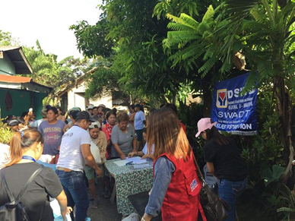  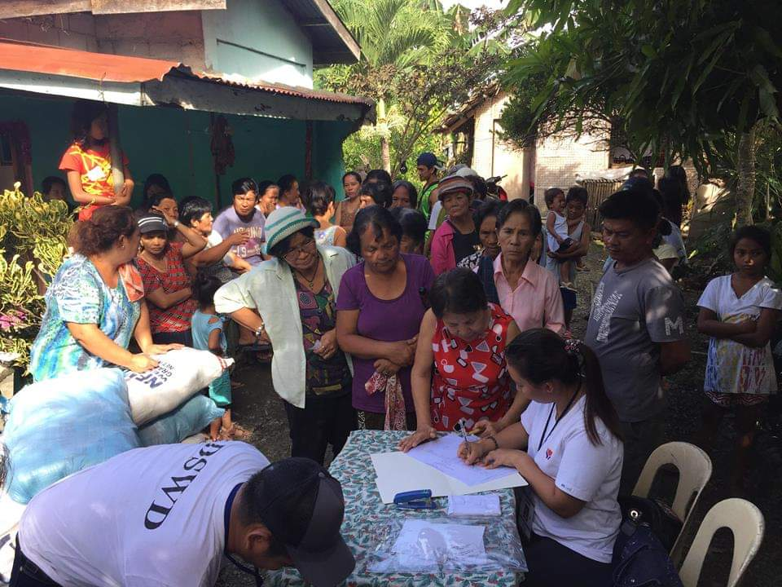  Relief Distribution in Brgy. Salcedo, Bansud, Oriental Mindoro | 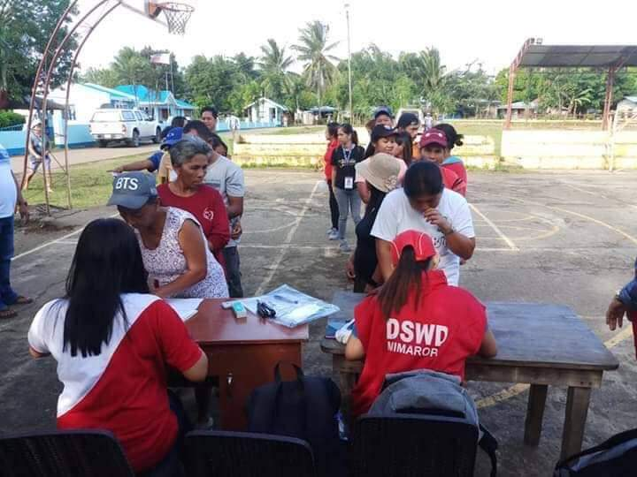  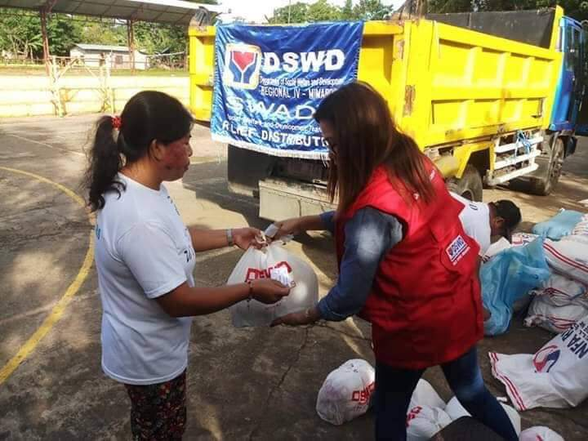  Relief Distribution in Brgy. Rosacara, Bansud, Oriental Mindoro | 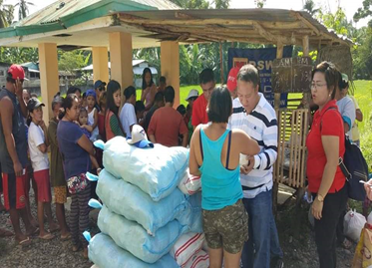  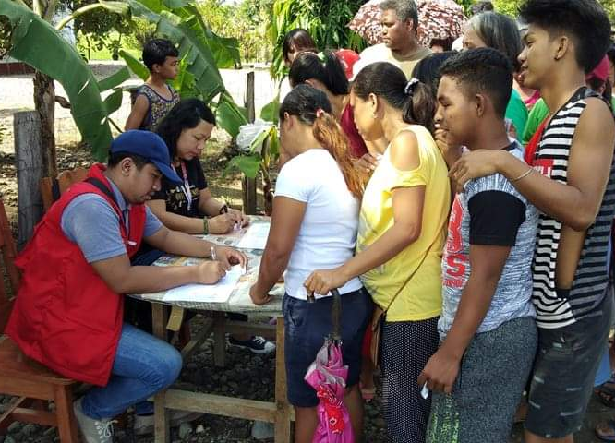  Relief Distribution in Brgy. Sumagui, Bansud, Oriental Mindoro

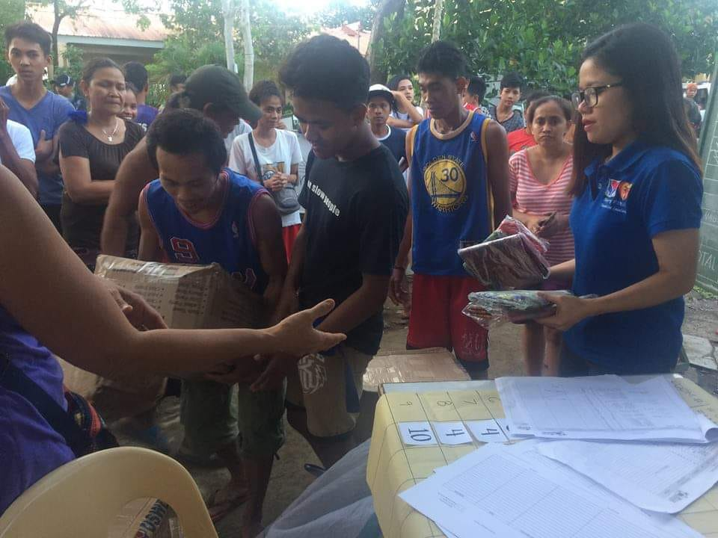  Distribution of 61 DSWD family kits and malong to the IDPs of Brgys. Maynonong and Naga at Naga National High School, Tiwi, Albay (03 January 2019) | 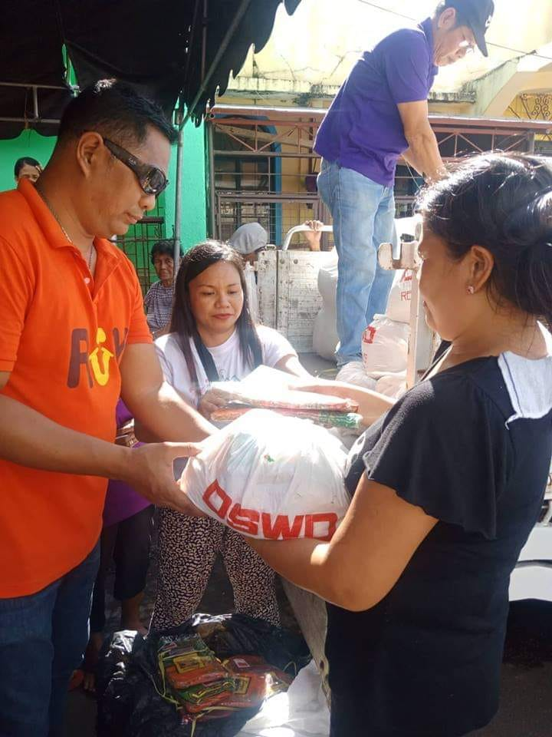  DSWD-Field Office V distributed family food packs (FFPs) in Brgy. Sta. Clara, Buhi, Camarines Sur (02 January 2019)

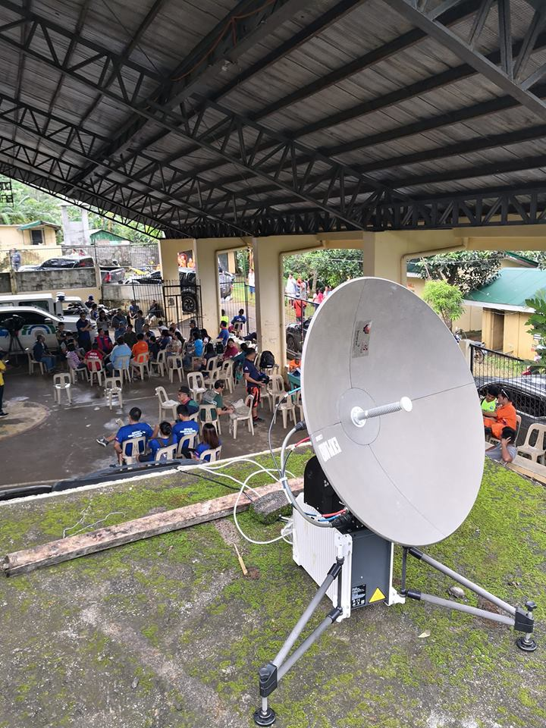  DSWD-Field Office V deployed its Regional Emergency Telecommunication Equipment in Patitinan, Sagnay, Camarines Sur to transmit updates useful to different government agencies for their immediate action (01 January 2019) | 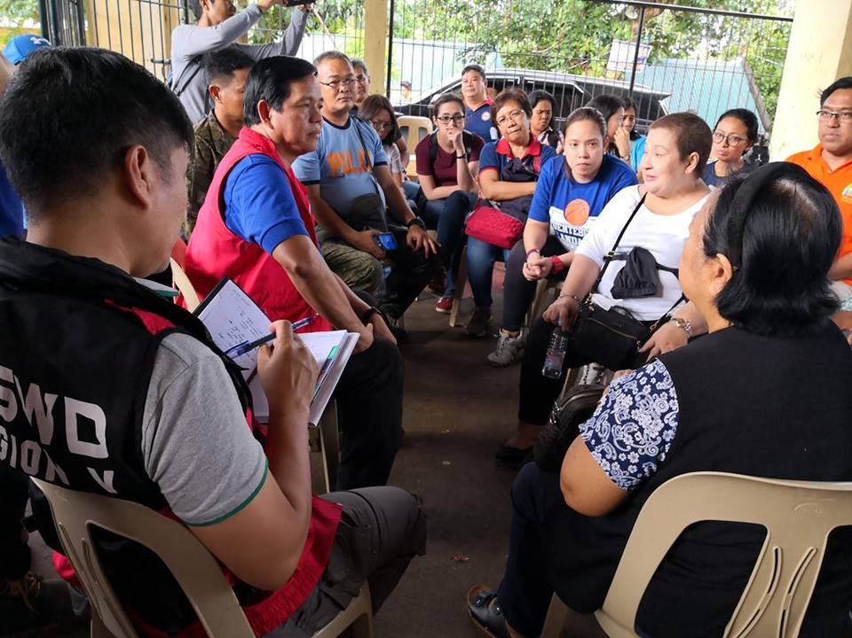  DSWD Sec. Rolando Bautista visited Patitinan, Sagnay in Camarines Sur to meet with key officials and coordinate DSWD relief efforts to the most affected families in the said village

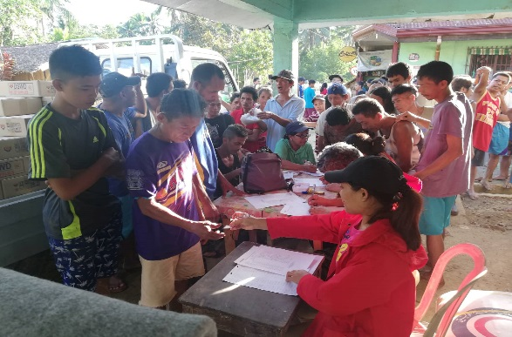 | 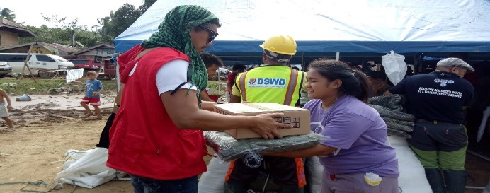
DSWD-FO VIII conducted relief distribution in Lope De Vega; a total of 893 families in three (3) Barangays (Bayho, Bonifacio and Lower Caynaga) were provided with FFPs (03 January 2019)

