DSWD DROMIC Report #2 on
Tropical Depression “AMANG”
as of 21 January 2019, 4PM

Situation Overview

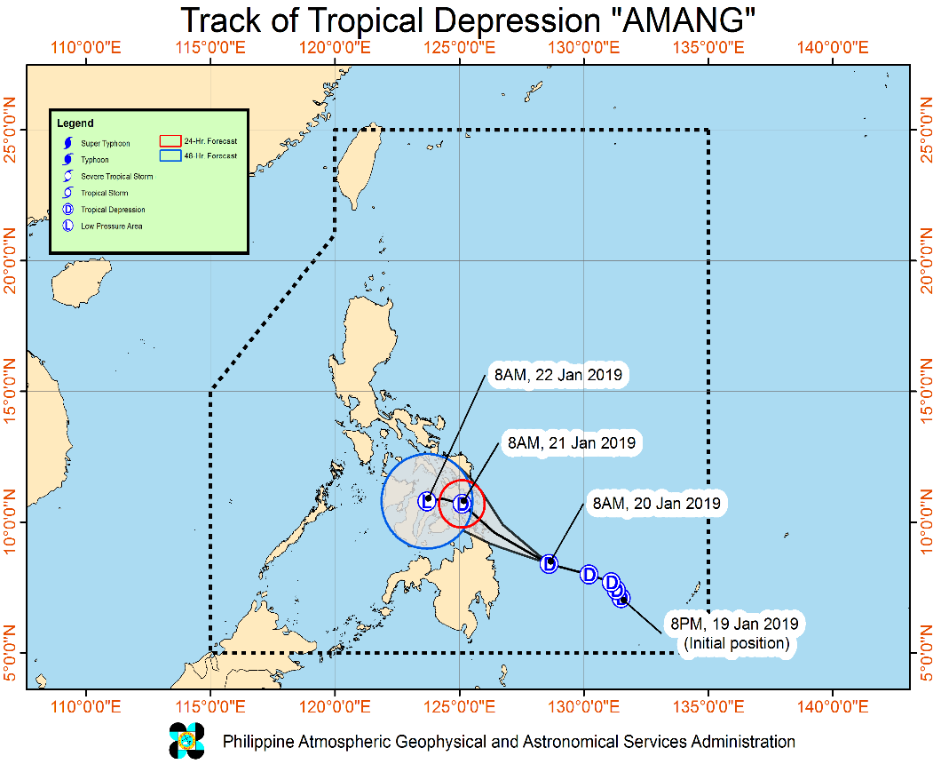
Issued at 02:00 PM today, TROPICAL DEPRESSION AMANG CONTINUES TO MOVE GENERALLY NORTHWARD OVER THE EASTERN SEABOARD OF EASTERN SAMAR
- Moderate to heavy rains are still expected over Sorsogon, Albay, Catanduanes, Northern Samar, Eastern Samar and Samar today. Meanwhile, tomorrow (22 January), moderate to heavy rains may be experienced over Eastern Visayas, Catanduanes, Albay, Sorsogon and Masbate. Residents of these areas, especially those living in areas at high risk of flooding and landslides, are advised to take appropriate actions, coordinate with local disaster risk reduction and management offices, and continue monitoring for updates, especially the Severe Weather Bulletins and the Heavy Rainfall Warnings from PAGASA Regional Services Divisions.
- Fisherfolks and those with small seacrafts are advised not to venture out over the seaboards of Northern Luzon and the eastern seaboards of Central Luzon, Southern Luzon, Visayas, Dinagat Islands and Surigao del Norte, including all seaboards of areas under TCWS #1 due to Tropical Depression AMANG and the surge of Northeast Monsoon.

At 1:00 PM today, the center of Tropical Depression "AMANG" was estimated based on all available data at 80 km North Northeast of Borongan City, Eastern Samar or 120 km East of Catarman, Northern Samar (12.3 °N, 125.7 °E)

- Status of Affected Families / Persons
A total of 1,158 Families or 4,639 persons were affected in 33 barangays, 14 cities/municipalities, and 4 provinces in Region CARAGA (see Table 1).

Table 1. Affected Areas and Number of Affected Families / Persons
REGION / PROVINCE / MUNICIPALITY |  | NUMBER OF AFFECTED
 |  | Barangays | Cities / Municipalities | Provinces | Families | Persons
GRAND TOTAL |  | 33 | 14 | 4 | 1,158 | 4,639
CARAGA |  | 33 | 14 | 4 | 1,158 | 4,639
Agusan del Norte |  | 4 | 2 | 1 | 243 | 1,200
 | Butuan City (capital) | 2 |  |  | 229 | 1,141
 | Jabonga | 2 |  |  | 14 | 59
Dinagat Island |  | 4 | 2 | 1 | 53 | 141
 | Basilisa (Rizal) | 2 |  |  | 18 | 63
 | San Jose (capital) | 2 |  |  | 35 | 78
Surigao del Norte |  | 13 | 5 | 1 | 671 | 2,600
 | General Luna | 3 |  |  | 29 | 123
 | Gigaquit | 4 |  |  | 89 | 313
 | Malimono | 2 |  |  | 251 | 1,073
 | Sison | 3 |  |  | 134 | 490
 | Surigao City (capital) | 1 |  |  | 168 | 601
Surigao del Sur |  | 12 | 5 | 1 | 191 | 698
 | Barobo | 2 |  |  | 34 | 131
 | Bayabas | 3 |  |  | 62 | 201
 | Carrascal | 2 |  |  | 29 | 114
 | Lanuza | 4 |  |  | 45 | 188
 | Tagbina | 1 |  |  | 21 | 64
Note: Ongoing assessment and validation
*The decrease in the number of affected families in municipalities of Barobo, Surigao Del Sur is the validated report from MSWDO.

Sources: LGUs through the C/MSWD and C/MDRRM

- Status of Displaced and Served Families / Persons (see Table 2)

Table 2. Number of Served Families / Persons Inside and Outside ECs
REGION / PROVINCE / MUNICIPALITY |  | NUMBER OF EVACUATION CENTERS (ECs) |  | INSIDE ECs |  |  |  | INSIDE ECs Returned Home |  | OUTSIDE ECs |  |  |  | OUTSIDE ECs Returned Home |  | TOTAL SERVED
 |  |  |  |  |  |  |  |  |  |  |  |  |  |  |  | Families |  | Persons
 |  |  |  | Families |  | Persons |  | Families | Persons | Families |  | Persons |  | Families | Persons | Total Families |  | Total Persons
 |  | CUM | NOW | CUM | NOW | CUM | NOW |  |  | CUM | NOW | CUM | NOW |  |  | CUM | NOW | CUM | NOW
GRAND TOTAL |  | 34 | 23 | 1,158 | 682 | 4,639 | 2,711 | 476 | 1,928 | - | - | - | - | - | - | 1,158 | 682 | 4,639 | 2,711
CARAGA |  | 34 | 23 | 1,158 | 682 | 4,639 | 2,711 | 476 | 1,928 | - | - | - | - | - | - | 1,158 | 682 | 4,639 | 2,711
Agusan del Norte |  | 4 | 4 | 243 | 243 | 1,200 | 1,200 | - | - | - | - | - | - | - | - | 243 | 243 | 1,200 | 1,200
 | Butuan City (capital) | 2 | 2 | 229 | 229 | 1,141 | 1,141 | - | - | - | - | - | - | - | - | 229 | 229 | 1,141 | 1,141
 | Jabonga | 2 | 2 | 14 | 14 | 59 | 59 | - | - | - | - | - | - | - | - | 14 | 14 | 59 | 59
Dinagat Island |  | 5 | 5 | 53 | 53 | 141 | 141 | - | - | - | - | - | - | - | - | 53 | 53 | 141 | 141
 | Basilisa (Rizal) | 3 | 3 | 18 | 18 | 63 | 63 | - | - | - | - | - | - | - | - | 18 | 18 | 63 | 63
 | San Jose (capital) | 2 | 2 | 35 | 35 | 78 | 78 | - | - | - | - | - | - | - | - | 35 | 35 | 78 | 78
Surigao del Norte |  | 16 | 7 | 671 | 257 | 2,600 | 914 | 414 | 1,686 | - | - | - | - | - | - | 671 | 257 | 2,600 | 914
 | General Luna | 4 | - | 29 | - | 123 | - | 29 | 123 | - | - | - | - | - | - | 29 | - | 123 | -
 | Gigaquit | 6 | 6 | 89 | 89 | 313 | 313 | - | - | - | - | - | - | - | - | 89 | 89 | 313 | 313
 | Malimono | 2 | - | 251 | - | 1,073 | - | 251 | 1,073 | - | - | - | - | - | - | 251 | - | 1,073 | -
 | Sison | 3 | - | 134 | - | 490 | - | 134 | 490 | - | - | - | - | - | - | 134 | - | 490 | -
 | Surigao City (capital) | 1 | 1 | 168 | 168 | 601 | 601 | - | - | - | - | - | - | - | - | 168 | 168 | 601 | 601
Surigao del Sur |  | 9 | 7 | 191 | 129 | 698 | 456 | 62 | 242 | - | - | - | - | - | - | 191 | 129 | 698 | 456
 | Barobo | 2 | 2 | 34 | 34 | 131 | 131 | - | - | - | - | - | - | - | - | 34 | 34 | 131 | 131
 | Bayabas | 2 | 2 | 62 | 62 | 201 | 201 | - | - | - | - | - | - | - | - | 62 | 62 | 201 | 201
 | Carrascal | 2 | 2 | 29 | 29 | 114 | 114 | - | - | - | - | - | - | - | - | 29 | 29 | 114 | 114
 | Lanuza | 2 | - | 45 | - | 188 | - | 45 | 188 | - | - | - | - | - | - | 45 | - | 188 | -
 | Tagbina | 1 | 1 | 21 | 4 | 64 | 10 | 17 | 54 | - | - | - | - | - | - | 21 | 4 | 64 | 10
Note: Ongoing assessment and validation

Sources: LGUs through the C/MSWD and C/MDRR

Situational Reports

DSWD-DRMB
DATE | SITUATIONS / ACTIONS UNDERTAKEN
21 January 2019 | - The Disaster Response Operations Monitoring and Information Center (DROMIC) of the DSWD-DRMB is closely coordinating with the DSWD-Field Offices for significant disaster preparedness for response updates.

FO CARAGA
DATE | SITUATION / PREPAREDNESS ACTIONS
21 January 2019 | - OCD as per report, the signal is lower down to “Blue Color, this is still on warning alert.  - Field Office and Provincial Quick Response Teams has rendered 24-hour duty for the monitoring in the field and provision of timely updates.  - DSWD Caraga has also detailed two staff on a 24/7-duty to augment in the OCD Emergency Operations Center.  - Coordination with AFP is on-going for the distribution of family food packs to requesting LGUs.  - On-going purchase of raw materials for the repacking of additional Family Food Packs.  - Coordinated with the respective LSWDOs and LDRRMOs for the provision of timely updates regarding their situation and their disaster response operation.

FO VIII
DATE | SITUATION / PREPAREDNESS ACTIONS
21 January 2019 | - DRMD PDOs assigned at the Provinces, PATs and C/MATs are alerted, monitoring the situation on the AOR, and in close coordination with P/C/MSWDOs and P/C/MDRRMOs for any eventualities on the ground.  - Disaster Response Management Division (DRMD) are alerted and rendering 24/7 duty.  - All Quick Response Team (QRT) members are also alerted.  - Disaster Response Information Management Section (DRIMS) is monitoring the weather condition and in close coordination with SWADTs, QRTs and PDOs for any updates on the ground.  - Regional Resource Operation Section (RROS) are also alerted to ensure the readiness of dispatching the Food and Non-Food commodities whenever needed.  There are 19 families or 84 individuals who were pre-emptively evacuated in and are currently accommodated in 3 evacuation centers in Catarman and Lope de vega.  REGION / PROVINCE / MUNICIPALITY NUMBER OF EVACUATION CENTERS (ECs) NUMBER OF INSIDE ECs  Families Persons  NOW NOW NOW  GRAND TOTAL 3 19 84  REGION VIII 3 19 84  Northern Samar 3 19 84  Catarman (capital) 1 3 15  Lope de Vega 2 16 69

*****
The Disaster Response Operations Monitoring and Information Center (DROMIC) of the DSWD-DRMB is closely coordinating with the concerned DSWD-Field Offices for any significant disaster preparedness for response updates.

MARIEL B. FERRARIZ
Releasing Officer

