DSWD DROMIC Terminal Report on the Fire Incident
in Brgys. 39 and 42, Tacloban City
as of 19 December 2018, 4PM

SUMMARY

This is the final report on a fire incident that transpired in Brgys. 39 and 42, Tacloban City, Leyte.
Source: DSWD-FO VIII

- Status of Affected Families / Persons
REGION / PROVINCE / MUNICIPALITY |  | NUMBER OF AFFECTED
 |  | Barangays | Families | Persons
GRAND TOTAL |  | 2 | 36 | 153
REGION VIII |  | 2 | 36 | 153
Leyte |  | 2 | 36 | 153
 | Tacloban City (capital) | 2 | 36 | 153
Note: Decrease in the number of affected families and persons is due to the final assessment/validation of LGU Tacloban.
Source: DSWD-FO VIII

- Status of Displaced Families / Persons Inside Evacuation Center
REGION / PROVINCE / MUNICIPALITY |  | NUMBER OF EVACUATION CENTERS (ECs) |  | INSIDE ECs
 |  |  |  | Families |  | Persons
 |  | CUM | NOW | CUM | NOW | CUM | NOW
GRAND TOTAL |  | 1 | - | 19 | - | 76 | -
REGION VIII |  | 1 | - | 19 | - | 76 | -
Leyte |  | 1 | - | 19 | - | 76 | -
 | Tacloban City (capital) | 1 | - | 19 | - | 76 | -
Source: DSWD-FO VIII

- Damaged Houses
REGION / PROVINCE / MUNICIPALITY |  | NO. OF DAMAGED HOUSES
 |  | Total | Totally | Partially
GRAND TOTAL |  | 23 | 20 | 3
REGION VIII |  | 23 | 20 | 3
Leyte |  | 23 | 20 | 3
 | Tacloban City (capital) | 23 | 20 | 3
Note: Decrease in the number of damaged houses is due to the final assessment/validation of LGU Tacloban.
Source: DSWD-FO VIII

- Cost of Assistance
REGION / PROVINCE / MUNICIPALITY |  | TOTAL COST OF ASSISTANCE
 |  | DSWD | LGU | NGOs | OTHERS | GRAND TOTAL
REGION VIII |  | 88,143.00 | 395,000.00 | - | - | 483,143.00
Leyte |  | 88,143.00 | 395,000.00 | - | - | 483,143.00
 | Tacloban City (capital) | 88,143.00 | 395,000.00 | - | - | 483,143.00
Source: DSWD-FO VIII

SITUATIONAL REPORT

DSWD-DRMB
DATE | SITUATIONS / ACTIONS UNDERTAKEN
19 December 2018 | - The Disaster Response Operations Monitoring and Information Center (DROMIC) of the DSWD-DRMB continues to closely coordinate with DSWD-FO VIII for any requests of Technical Assistance and Resource Augmentation (TARA).

DSWD-FO VIII
DATE | SITUATIONS / ACTIONS UNDERTAKEN
19 December 2018 | - FO-VIII submitted Terminal Report.  - DSWD provided Food and Non-Food Items to the fire victims.  - DRMD-PDO assigned in Leyte and other staff, went on the location of the incident to conduct an on-site assessment. They also, coordinated with BLGU and CSWDO to monitor the situation of affected families or individuals and to assess as well if there is a need to augment relief goods.  - DROMIC Focal Person gathered data, coordinated with DRMD Staff and other link agencies that responded as well to the incident, especially to the City Bureau of Fire Protection (BFP).  - Regional Resource Operation Section (RROS) are also advised to be alerted to ensure the readiness of dispatching the Food and Non-Food commodities whenever needed for augmentation.  - DSWD Field Office VIII Staff are also alerted whenever there is a need of workforce in the relief operation.

*****
The Disaster Response Operations Monitoring and Information Center (DROMIC) of the DSWD-DRMB continues to closely coordinate with DSWD-FO VIII for any requests of Technical Assistance and Resource Augmentation (TARA).

MA. CONSUELO J. DEL PRADO
Releasing Officer

PHOTO DOCUMENTATION

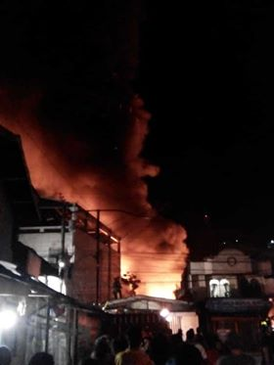
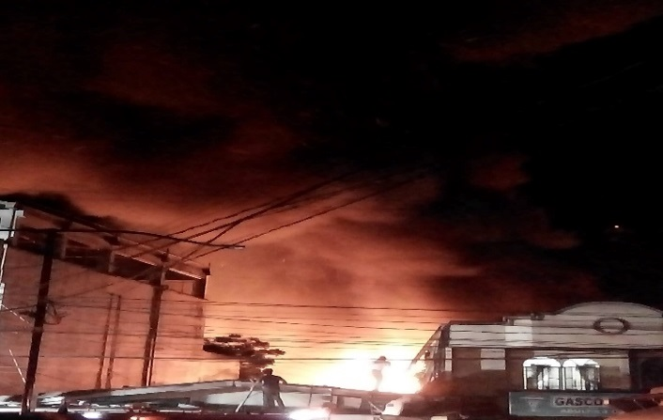
- Fire Incident (Credit to Ryan Carlo Esguerra)

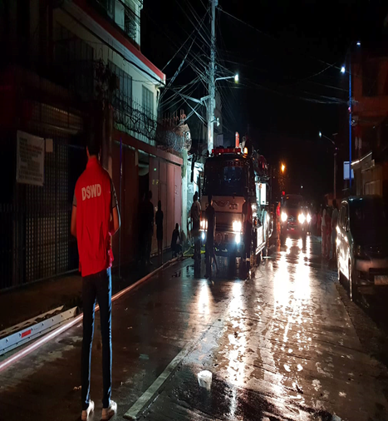
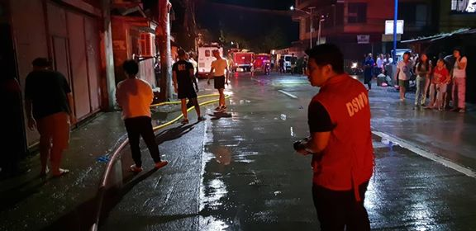
- Response

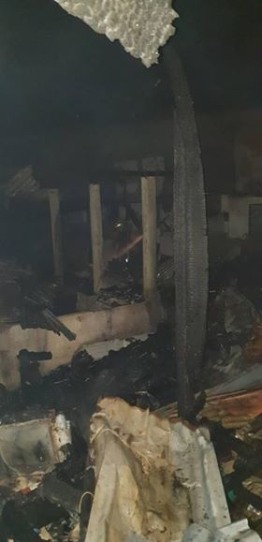
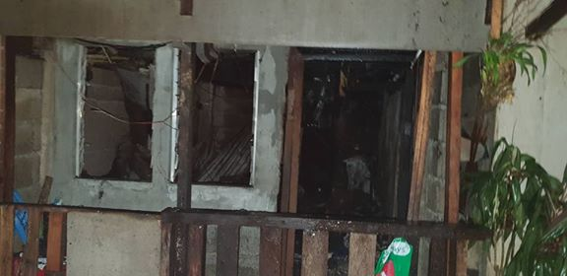
- Damaged

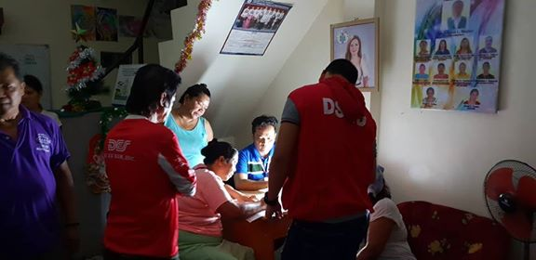
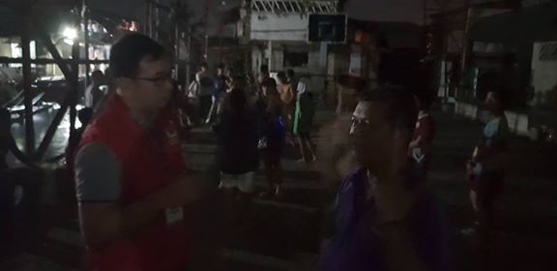
- On-site Assessment

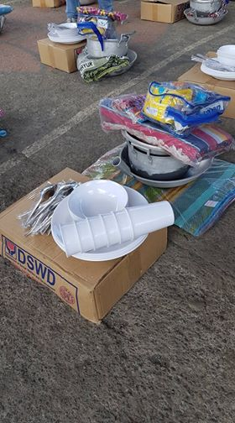
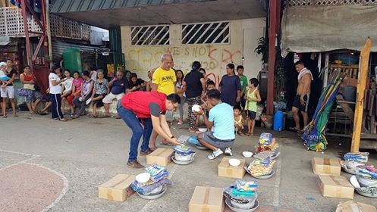
- Food and Non-Food Items

