DSWD DROMIC Report #1
on the Fire Incident in Las Piñas and Parañaque City
as of 27 February 2019, 6PM

SUMMARY

On 22 February 2019, a fire incident occurred in a residential area at BF Martinville, Brgy. Manuyo Dos, Las Piñas City and Sitio San Roque SAV-12, Brgy. San Isidro, Parañaque City. The fire started at 12:16 PM and was declared under control at 1:41 PM.

Source: DSWD-NCR

Status of Affected Families / Persons
A total of 226 families or 941 persons are affected in Las Piñas and Parañaque City (see Table 1).

Table 1. Affected Families / Persons
REGION / PROVINCE / MUNICIPALITY | NUMBER OF AFFECTED
 | Barangays | Families | Persons
GRAND TOTAL | 2 | 226 | 941
NCR | 2 | 226 | 941
Las Piñas | 1 | 107 | 465
Parañaque City | 1 | 119 | 476
Note: Ongoing assessment and validation.
Source: DSWD-NCR

- Status of Displaced Families / Persons
- There are 75 families or 300 persons currently staying inside an evacuation center (see Table 2).

Table 2. Displaced Families / Persons Inside Evacuation Center
REGION / PROVINCE / MUNICIPALITY | NUMBER OF EVACUATION CENTERS (ECs) |  | INSIDE ECs
 |  |  | Families |  | Persons
 | CUM | NOW | CUM | NOW | CUM | NOW
GRAND TOTAL | 1 | 1 | 75 | 75 | 300 | 300
NCR | 1 | 1 | 75 | 75 | 300 | 300
Parañaque City | 1 | 1 | 75 | 75 | 300 | 300
Note: Ongoing assessment and validation.
Source: DSWD-NCR

- There are 151 families or 641 persons currently staying with their relatives and/or families (see Table 3).

Table 3. Displaced Families / Persons Outside Evacuation Center
REGION / PROVINCE / MUNICIPALITY | OUTSIDE ECs
 | Families |  | Persons
 | CUM | NOW | CUM | NOW
GRAND TOTAL | 151 | 151 | 641 | 641
NCR | 151 | 151 | 641 | 641
Las Piñas | 107 | 107 | 465 | 465
Parañaque City | 44 | 44 | 176 | 176
Note: Ongoing assessment and validation.
Source: DSWD-NCR

- Damaged Houses
There are 76 totally damaged houses on the fire incident (see Table 4).

Table 4. Damaged Houses
REGION / PROVINCE / MUNICIPALITY | NO. OF DAMAGED HOUSES
 | Total | Totally | Partially
GRAND TOTAL | 76 | 76 | -
NCR | 76 | 76 | -
Las Piñas | 37 | 37 | -
Parañaque City | 39 | 39 | -
Note: Ongoing assessment and validation being conducted.
Source: DSWD-NCR

- Summary of Assistance Provided
A total of ₱135,316.88 worth of assistance was provided to the affected families (see Table 5).

Table 5. Cost of Assistance Provided to Affected Families / Persons
REGION / PROVINCE / MUNICIPALITY | TOTAL COST OF ASSISTANCE
 | DSWD | LGU | NGOs | OTHERS | GRAND TOTAL
GRAND TOTAL | 536,825.61 | - | - | - | 536,825.61
NCR | 536,825.61 | - | - | - | 536,825.61
Las Pinas | 225,300.27 | - | - | - | 225,300.27
Paranaque City | 311,525.34 | - | - | - | 311,525.34
Note: Ongoing assessment and validation being conducted.
Source: DSWD-NCR

SITUATIONAL REPORTS

DSWD-DRMB
DATE | SITUATIONS / ACTIONS UNDERTAKEN
27 February 2019 | - The Disaster Response Operations Monitoring and Information Center (DROMIC) of the DSWD-DRMB is closely coordinating with concerned DSWD-NCR for significant disaster response updates.

DSWD-NCR
DATE | SITUATIONS / ACTIONS UNDERTAKEN
27 February 2019 | - DSWD-NCR provided Family Food Packs (FFPs) and hygiene kits to the affected families in Las Piñas City thru Las Piñas City Social Welfare and Development Office (CSWDO).  - DSWD-NCR also provided Family Food Packs (FFPs) and sleeping kits to the affected families in Parañaque City thru Parañaque City Social Welfare and Development Office (CSWDO).  - DSWD-NCR is closely monitoring and coordinating with the Las Piñas and Parañaque City CSWDOs for updates and for possible augmentation.

*****

The Disaster Response Operations Monitoring and Information Center (DROMIC) of the DSWD-DRMB is closely coordinating with the concerned DSWD-NCR for any significant disaster response updates.

JAN ERWIN ANDREW I. ONTANILLAS
Releasing Officer

PHOTO DOCUMENTATION

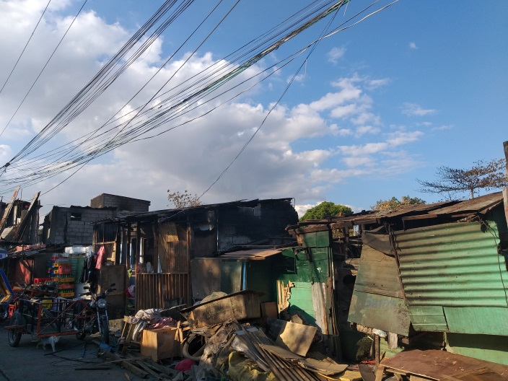
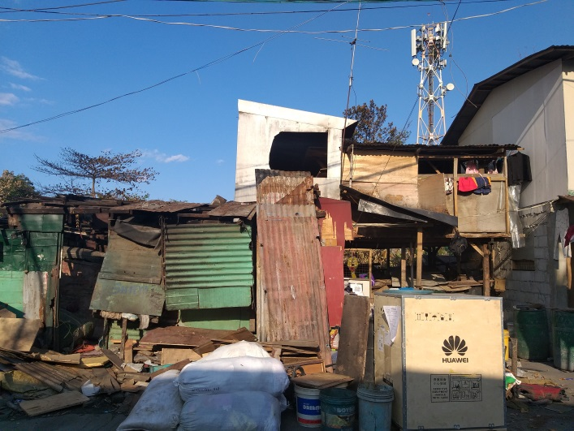
Pictures of Fire Location

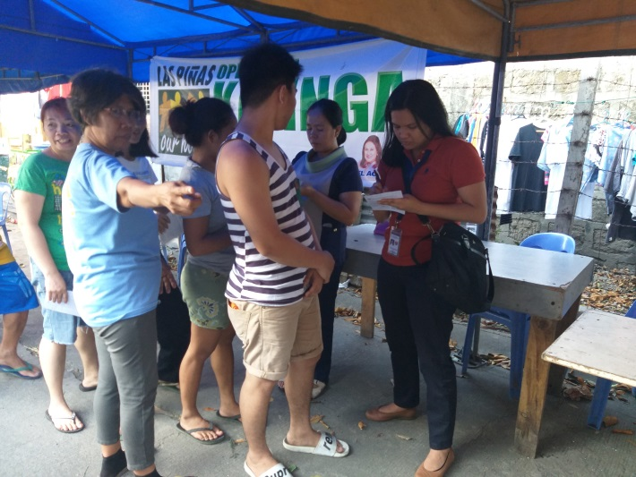
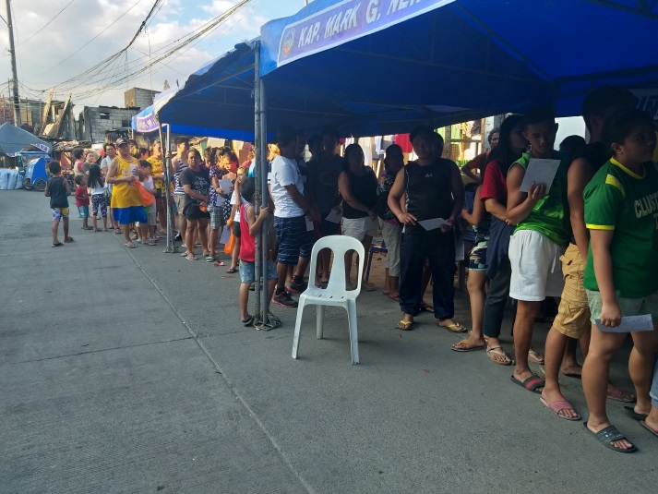
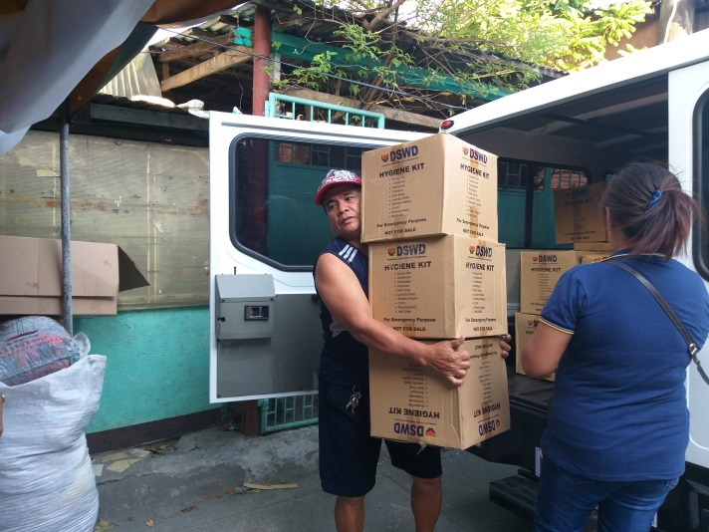
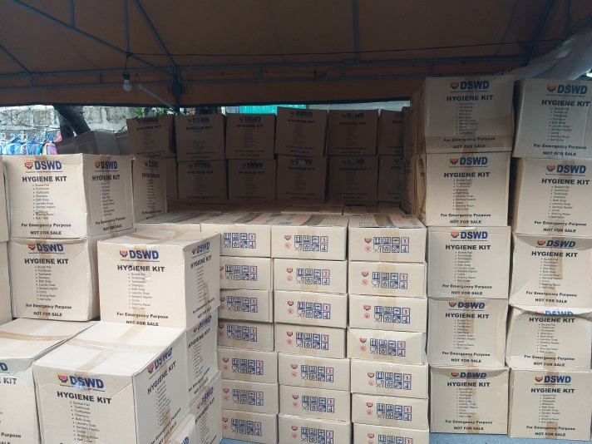
Distribution in Las Piñas City

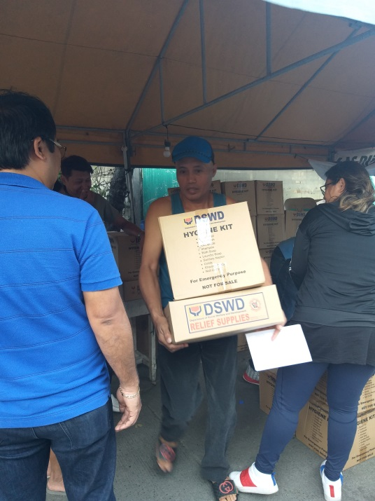
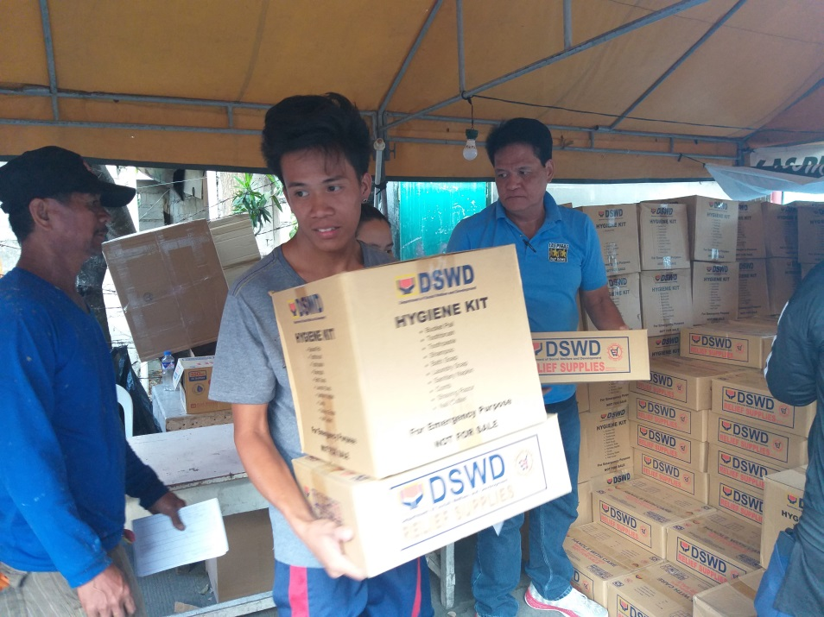

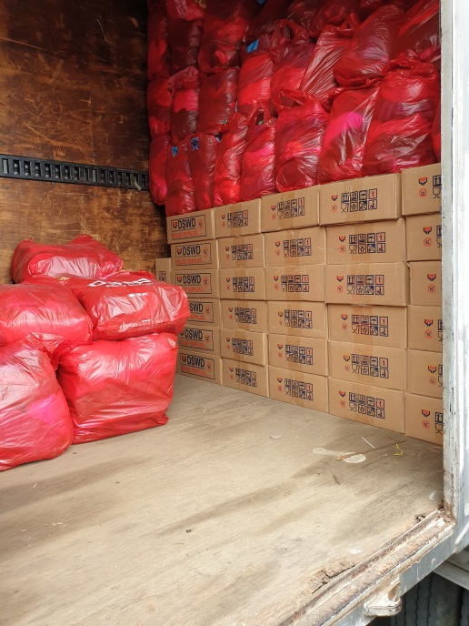
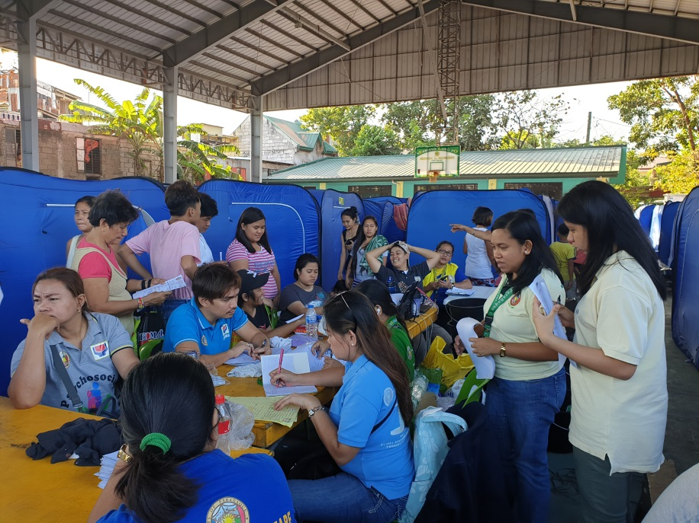
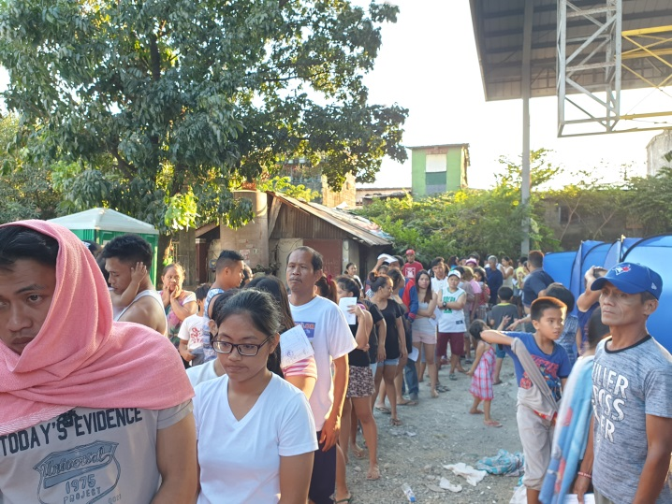
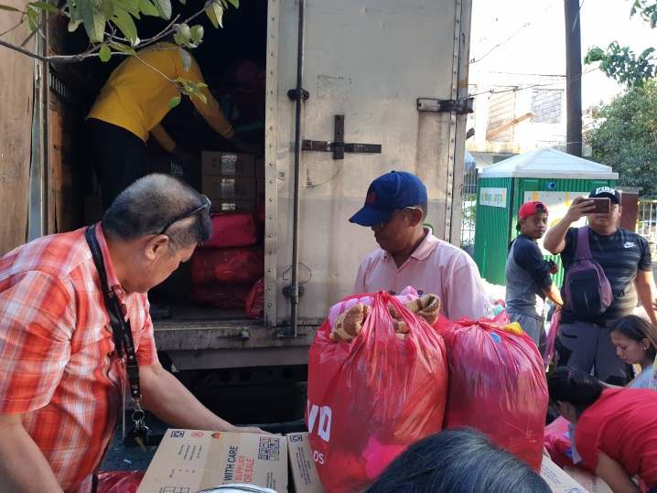
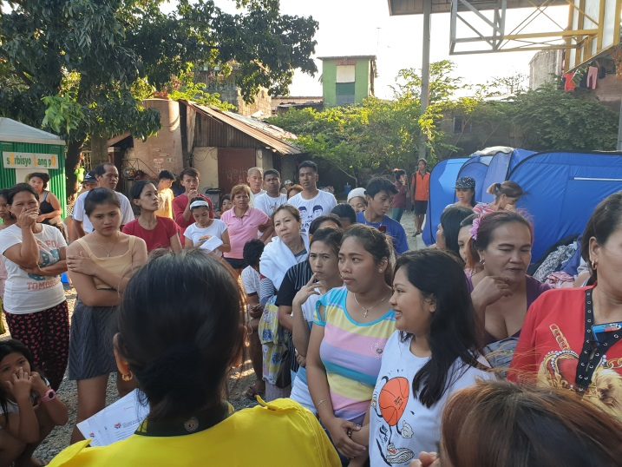
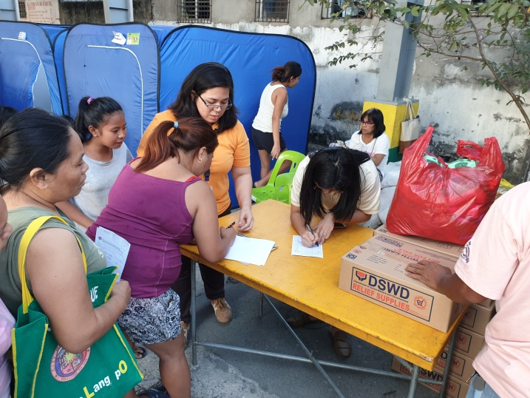
Distribution in PARANAQUE City

