DSWD DROMIC Terminal Report on the Fire Incident in Sitio Bohol, Brgy. Jardin, Culion, Palawan
as of 07 February 2019, 6PM

SUMMARY

This is the final report on the fire incident occurred at Sitio Bohol, Brgy. Jardin, Culion, Palawan on 2 February 2019 at 4:30 AM.
Source: DSWD-FO FO MIMAROPA

- Status of Affected Families / Persons

A total of 33 families or 198 persons were affected by the fire incident in Sitio Bohol, Brgy. Jardin, Culion, Palawan. (see Table 1).

Table 1. Affected Families / Persons
REGION / PROVINCE / MUNICIPALITY |  | NUMBER OF AFFECTED
 |  | Barangays | Families | Persons
GRAND TOTAL |  | 1 | 33 | 198
REGION MIMAROPA |  | 1 | 33 | 198
Palawan |  | 1 | 33 | 198
 | Culion | 1 | 33 | 198
Source: DSWD-FO MIMAROPA

- Status of Displaced Families/ Persons (see Table 2).

Table 2. Number of Served Families / Persons Outside ECs
REGION / PROVINCE / MUNICIPALITY |  | OUTSIDE ECs
 |  | Families |  | Persons
 |  | CUM | NOW | CUM | NOW
GRAND TOTAL |  | 33 | - | 198 | -
REGION MIMAROPA |  | 33 | - | 198 | -
Palawan |  | 33 | - | 198 | -
 | Culion | 33 | - | 198 | -
Source: DSWD-FO MIMAROPA
- Damaged Houses (see Table 3).

Table 3. Damaged Houses
REGION / PROVINCE / MUNICIPALITY |  | NO. OF DAMAGED HOUSES
 |  | Total | Totally | Partially
GRAND TOTAL |  | 33 | 26 | 7
REGION MIMAROPA |  | 33 | 26 | 7
Palawan |  | 33 | 26 | 7
 | Culion | 33 | 26 | 7
Source: DSWD-FO MIMAROPA
- Cost of Assistance (see Table 4).

Table 4. Cost of Assistance Provided to Affected Families / Persons
REGION / PROVINCE / MUNICIPALITY |  | TOTAL COST OF ASSISTANCE
 |  | DSWD | LGU | NGOs | OTHERS | GRAND TOTAL
GRAND TOTAL |  | 82,260.00 | 1,977,277.00 | - | - | 2,059,537.00
REGION MIMAROPA |  | 82,260.00 | 1,977,277.00 | - | - | 2,059,537.00
Palawan |  | 82,260.00 | 1,977,277.00 | - | - | 2,059,537.00
 | Culion | 82,260.00 | 1,977,277.00 | - | - | 2,059,537.00
Source: DSWD-FO MIMAROPA

SITUATIONAL REPORT

DSWD-DRMB
DATE | SITUATIONS / ACTIONS UNDERTAKEN
07 February 2019 | - The Disaster Response Operations Monitoring and Information Center (DROMIC) of the DSWD-DRMB continues to closely coordinate with DSWD-FO MIMAROPA for significant disaster response updates and assistance provided.  - The Report was received on February 7, 2019 at 5:00PM.

DSWD-FO MIMAROPA
DATE | SITUATIONS / ACTIONS UNDERTAKEN
07 February 2019 | - DSWD FO MIMAROPA submitted Terminal Report  - As per coordination with the LGU of Culion, each family will receive Seventy Thousand Pesos (Php 70,000.00) as Emergency Shelter Assistance through House Materials and Monetary/Financial Assistance. A total of One Million Eight Hundred Twenty Thousand Pesos (Php 1,820,000.00) will be released to Twenty Six (26) families whose houses were totally damaged by the fire incident.
07 February 2019 | - Food assistance composed of water, coffee and biscuits with a total of Fifteen Thousand Pesos (Php 15,000.00) were provided to the affected families while provision of other intervention is currently being assessed by the concerned LGU.  - As of February 06, 2019, ten (10) sets of clothes, one (1) piece of bath soap, one (1) dozen of shampoo and one (1) piece of toothpaste were distributed to the affected families. (Amounts are still for verification)  - A total of One Million Nine Hundred One Thousand Pesos (Php 1,901,000.00) were allocated for the boarding house expenses of Twenty-Seven (27) students while the amount for School and Uniform Supplies are still for verification.  - As per validation, there were Twenty-Six (26) Totally Damaged Houses and Seven (7) Partially Damaged Houses. At present, they are temporarily staying with their relatives and friends.  - DSWD through the SWADT Office Palawan will provide Hygiene Kits, Sleeping Kits and Family Foods Packs to the families whose houses were totally damaged.  - As per coordination with the LGU of Culion, they will provide Emergency Shelter Assistance through house materials and monetary assistance worth One Million Eight Hundred Twenty Thousand Pesos (Php 1,820,000.00) to the Twenty-Six families whose houses were totally damaged by the fire incident.
*****
The Disaster Response Operations Monitoring and Information Center (DROMIC) of the DSWD-DRMB continues to closely coordinate with DSWD-FO MIMAROPA for significant disaster response updates and assistance provided.

JAN ERWIN ANDREW I. ONTANILLAS
Releasing Officer

PHOTO DOCUMENTATION

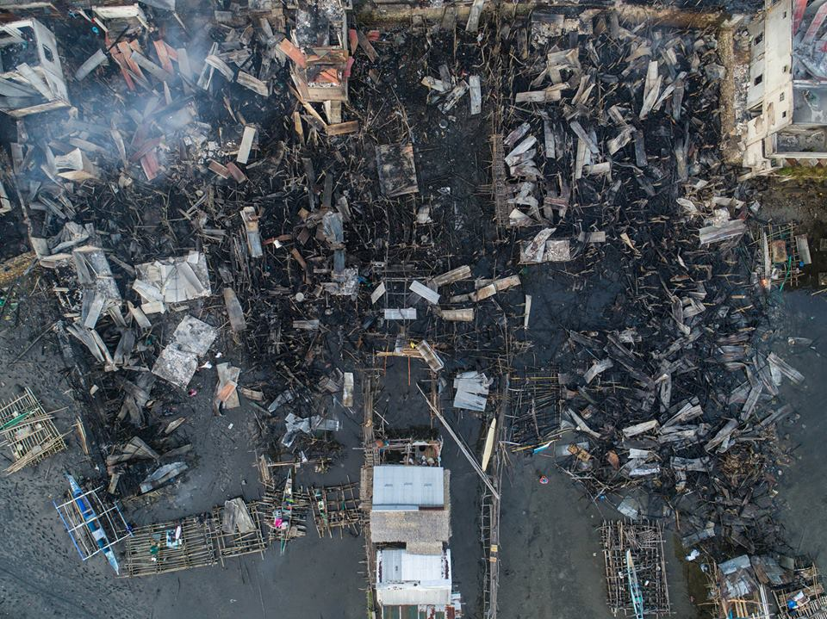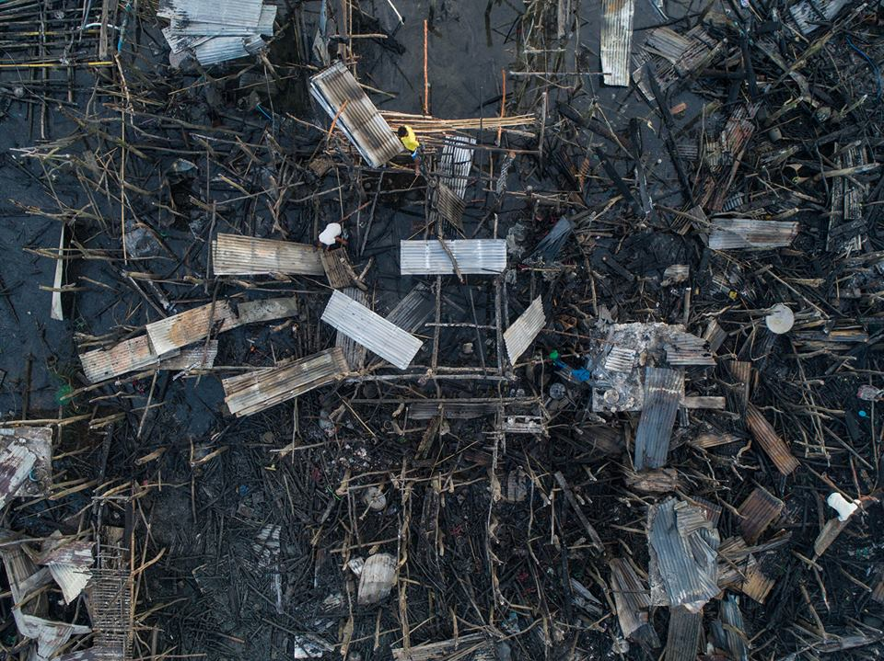
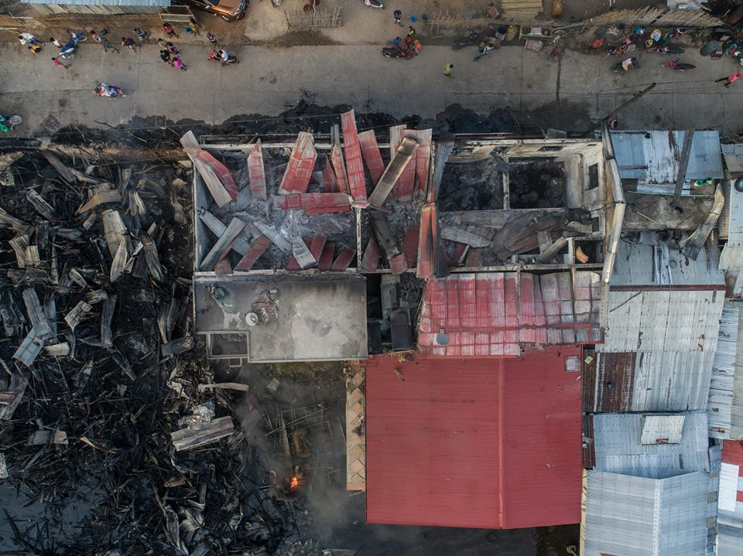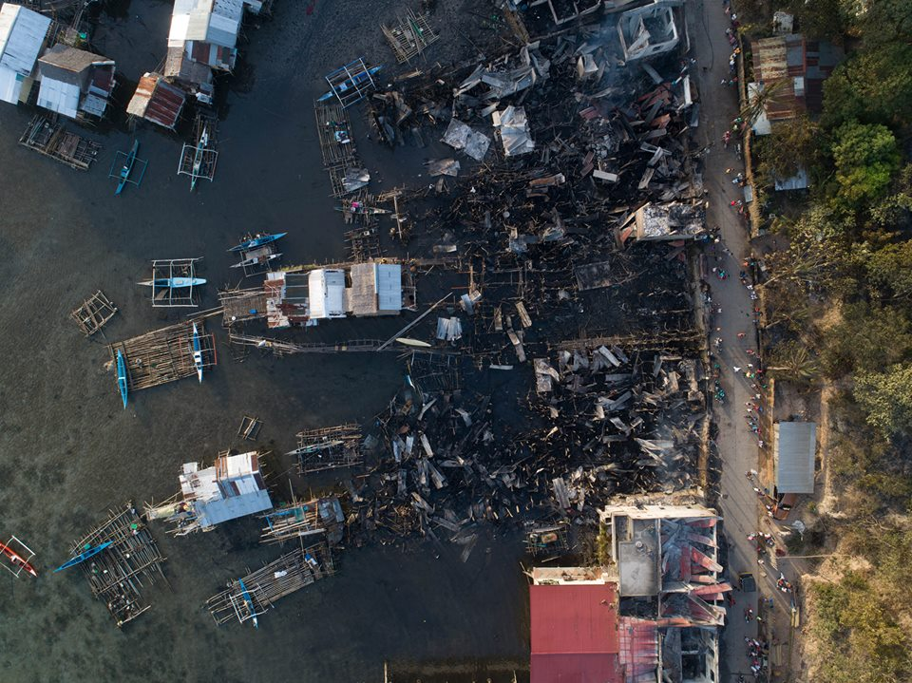
Aerial photos of the structures that were struck by the Fire Incident in
Sitio Bohol, Brgy. Jardin, Culion, Palawan

