DSWD DROMIC Terminal Report on the
Landslide Incident in Naga City, Cebu
as of 23 November 2018, 6PM

SITUATION OVERVIEW

At around 6:00 AM on 20 September 2018, a massive landslide affected an estimated 80.12-hectare area in Sitio Sindulan, Brgy. Tinaan in Naga City, Cebu. Disaster managers said the rains may have contributed in softening the ground soil causing the sloped land to collapse. However, some residents have also pointed on the ongoing quarrying operations in the area.

Source: DSWD Field Office VII

SUMMARY

- Status of Affected Families / Persons
A total of 2,087 families or 8,655 persons were affected in 6 barangays in City of Naga, Cebu. (See Table 1)

Table 1: Status of Affected Families / Persons
REGION / PROVINCE / MUNICIPALITY |  | NUMBER OF AFFECTED |  |  | NUMBER OF EVACUATION CENTERS (ECs) |  | INSIDE ECs |  |  |  | OUTSIDE ECs |  |  |  | TOTAL SERVED
 |  |  |  |  |  |  |  |  |  |  |  |  |  |  | Families |  | Persons
 |  | Barangays | Families | Persons |  |  | Families |  | Persons |  | Families |  | Persons |  | Total Families |  | Total Persons
 |  |  |  |  | CUM | NOW | CUM | NOW | CUM | NOW | CUM | NOW | CUM | NOW | CUM | NOW | CUM | NOW
GRAND TOTAL |  | 6 | 2,087 | 8,655 | 11 | - | 1,755 | - | 7,303 | - | 332 | - | 1,352 | - | 2,087 | - | 8,655 | -
REGION VII |  | 6 | 2,087 | 8,655 | 11 | - | 1,755 | - | 7,303 | - | 332 | - | 1,352 | - | 2,087 | - | 8,655 | -
Cebu |  | 6 | 2,087 | 8,655 | 11 | - | 1,755 | - | 7,303 | - | 332 | - | 1,352 | - | 2,087 | - | 8,655 | -
 | City of Naga | 6 | 2,087 | 8,655 | 10 | - | 1,684 | - | 7,043 | - | 332 | - | 1,352 | - | 2,016 | - | 8,395 | -
 | San Fernando | - | - | - | 1 | - | 71 | - | 260 | - | - | - | - | - | 71 | - | 260 | -
Note: Figures reflected in the table above are subject to change as the re-validation and re-assessment are being conducted due to reported instances of double counting and “fake evacuees”.
Number of affected families and persons is based on the DSWD DAFAC encoding.
There was no affected barangay and families in San Fernando, Cebu. An evacuation center was only opened in the said municipality to accommodate IDPs from Brgy. Tinaan, Naga City.
Source: DSWD Field Office VII

- Damaged Houses
There were 6 partially damage houses and 77 totally damaged houses due to the landslide incident. (See Table 2)

Table 2: Damaged Houses
REGION / PROVINCE / MUNICIPALITY |  | NO. OF DAMAGED HOUSES
 |  | Total | Totally | Partially
GRAND TOTAL |  | 83 | 77 | 6
REGION VII |  | 83 | 77 | 6
Cebu |  | 83 | 77 | 6
 | City of Naga | 83 | 77 | 6
Source: DSWD Field Office VII

- Assistance Provided
To date, DSWD has already extended relief support and financial assistance worth ₱8,653,230.18, LGU provided ₱45,282,880.60, and Others ₱26,539,521.35 worth of relief assistance. (See Table 3)

Table 3. Cost of Assistance Provided to Affected Families / Persons
REGION / PROVINCE / MUNICIPALITY |  | TOTAL COST OF ASSISTANCE
 |  | DSWD | LGU | NGOs | OTHERS | GRAND TOTAL
GRAND TOTAL |  | 8,653,230.18 | 45,282,880.60 | - | 26,539,521.35 | 80,475,632.13
REGION VII |  | 8,653,230.18 | 45,282,880.60 | - | 26,539,521.35 | 80,475,632.13
Cebu |  | 8,653,230.18 | 45,282,880.60 | - | 26,539,521.35 | 80,475,632.13
 | City of Naga | 8,653,230.18 | 45,282,880.60 | - | 26,539,521.35 | 80,475,632.13
Source: DSWD Field Office VII
Situational Reports

DSWD-DRMB
DATE | SITUATIONS / ACTIONS UNDERTAKEN
13 October 2018 - Present | - The Disaster Response Operations Monitoring and Information Center (DROMIC) of the DSWD-DRMB continues to closely coordinate with concerned DSWD-Field Office VII for significant disaster response updates.

FO VII
DATE | SITUATIONS / ACTIONS UNDERTAKEN
7 February 2019 | - DSWD FO VII submitted Terminal Report  - The City government of Naga provided continuous support and relief assistance to affected families since the landslide incident until the last family left the camp in December, before the Christmas holidays.  - Before families were allowed to go back, they had attend to information and education seminars conducted by the City Government and the MGB. Naga City Mayor Kristine Vannesa Chiong said families were also issued warning cards that would identify what area of the red and green zones they are situated in.  - The local government of Naga did not only provided financial assistance to the displaced families, they also shouldered other expenses including the wake and burial of the landslide victims, food for the community kitchen, relief operations, among others.  - Donations from hundreds of people from the different parts of the country and various civic and religious organizations flocked the city and turned over cash and in-kind donations for the victims of the massive landslide. Truckload of relief goods from different government agencies and local government units in Cebu province and neighboring provinces in the Visayas likewise arrived in the Naga City Hall to deliver relief items.  - Meanwhile, in-kind donations received on September 21, 24 and 25 totaled to P5,035,727.70 as reported by the Naga City General Services Office (GSO), who took charge in managing donations in kind – from acceptance to distribution to the 11 evacuation camps. Goods received on other days are still being assessed for value (Source: https://www.philstar.com/the-freeman/cebu-news/bottom-article-list/2018/10/04/1857104/cash-and-kindnaga-city-gets-p15-million-aid).  - GSO also supervised close to 8,000 volunteers who checked in, in coordination with the regional Department of Social Welfare and Development personnel who provide technical assistance in manning the receiving desks.  Staff Augmentation  - On the day of the incident, at least 30 personnel were deployed to help assess and administer DAFAC at the 1st camps established - ECAC and Naalad Elementary School. Staff also assisted in the distribution FIs and NFIs to the initial 500 family evacuees.  - The Regional QRT was activated where 50 personnel were immediately deployed in 3 teams providing 24-hour duty assisting LGU in camp management and facilitation of donations and volunteers through centralized process and step by step guide.  - Establishment of a 24-hour Operation Center as information hub for various stakeholders, media and partners. A team leader was assigned to oversee each shift. Reduction of manpower and hours of duty was later implemented both in OpCen and in camps at 12 hours only (8am to 8pm) starting October 7 and October 14 respectively.  - Then DSWD OIC Secretary designated the Assistant Regional director as the focal person to oversee the disaster operations in the City of Naga.  - On December 17 and 18, separate debriefing activities/sessions were conducted to at least 140 staff augmented for the Naga landslide operations.  Donations Facilitation  - TA provided to LGU in the setting up of the Donation’s Desk and management of goods received from donors and other groups.  - A system on donation was established centralizing the process and minimizing direct donation to the different camps.  - A process flow was developed in order to guide donors on where and what to do when they donate making it easier and more convenient for them.  Volunteer Management  - DSWD assisted the LGU in setting up the volunteers’ desk. A staff was assigned daily, side by side with the LGU to document and guide volunteers.  - The LGU was taught on how to manage and assign volunteers according to their area of expertise.  - An orientation was provided by DSWD to volunteers prior to their deployment.  - A step by step guide was also prepared to guide volunteers in the process  Data Management  - Camp personnel replaced majority of the old DAFAC issued to IDPs by LGU in order to complete needed data.  - Put up for 5 days a 24-hour encoding station and system in order to establish the profile of IDPs. At least 15 computer sets were set up with DSWD encoders and LGU volunteers who handled DAFAC encoding.  - Completed the encoding of DAFAC of IDPs in camps and home based on Oct 1. Duplicates were generated and printed and sent to camps for revalidation and crosschecking.  - Masterlist of IDPs based on DAFAC encoding and revalidation was sent to LGU on Oct 12. However, there were still a lot of movements by the IDPs since.  - On Oct 26, City Government of Naga forwarded to DSWD the list of families who are recipients of the housing assistance. List was crosschecked with the DSWD IDP Masterlist based on DAFAC.  Camp Coordination Camp Management  - Upon the request of the LGU, due to lack of training and expertise, DSWD took the lead role in managing ECs/camps with four ECs initially opened.  - At least 90 City and Provincial personnel were oriented on CCCM protocols on September 28. Another 30 outsourced personnel by Cebu Province were oriented on CCCM Protocols on October 19.  - Effective October 1, 5 big camps (ECAC, Naga Central, Naga National HS, Naalad and Colon) are jointly managed by LGU, Province and DSWD. Continuous provision of TA was done thru 12-hour shift by DSWD.  - All camps established the CWFS where sessions were provided by trained DSWD staff or trained providers through DOH / CHO and DepEd  - Regular meetings and monitoring were continuously done by camp managers and coordinators from LGU, Province and DSWD.  - Guidance notes were issued on a regular basis to address operational concerns. At least 5 Guidance Notes were issued and disseminated (See Annex E for the Guidance Notes).  - Reporting templates and other forms, such as pass slips, waiver and discharged forms were developed to aid the camp personnel on needs of IDPs, reports and ensure compliance to minimum standards (See Annex F for the forms used).  Community Kitchen  - A list of required utensils and cooking equipments were provided by DSWD. A menu good for two weeks was also prepared by DSWD ND III while the National Nutrition Council thru Dir. Letlet Mission agreed to prepare the succeeding menus.  - Coordination with Camp Managers for the organization of the CK committees in each camp.  - On October 11, DSWD-7 nutritionist dietician, orients participants from the City Government of Naga and DepEd on the establishment of community kitchen in the evacuation camps. On October 30, DSWD FO7-SFP personnel conducted orientation to all CK committee members from all 11 camps. This is to finally operationalize CK.
23 November 2018 | - On 21 November 2018, DSWD delivered and distributed additional 1,010 family food packs to families inside evacuation centers in Naga City.  - On 17 November 2018, camps made their community kitchen operational with equipment and kitchenware provided by Apo Cement Corporation and ingredients from the City Government.

PHOTO DOCUMENTATION

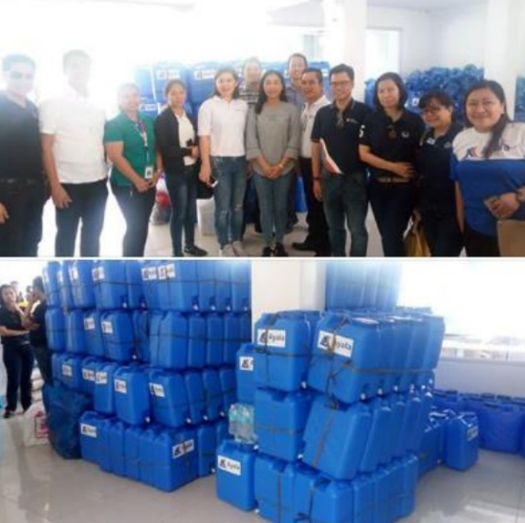

On 01 October 2018, another city government handed over cash assistance to Naga City. The City of Carcar headed by Mayor Nicepuro Apura turned over 1 Million Pesos to Mayor Vanessa Chiong as aid to the calamity victims. Together with Mayor Apura were Vice Mayor Barcenas and City Councilors.

Officers of the Ayala Business Club donated 500 jerry cans and assorted relief goods to landslide victims in the City of Naga.

Aside from the relief goods and jerry cans, the water provider Cebu Manila Water Development will provide 10 cubic meters of water or one water truck to the city's evacuation centers.

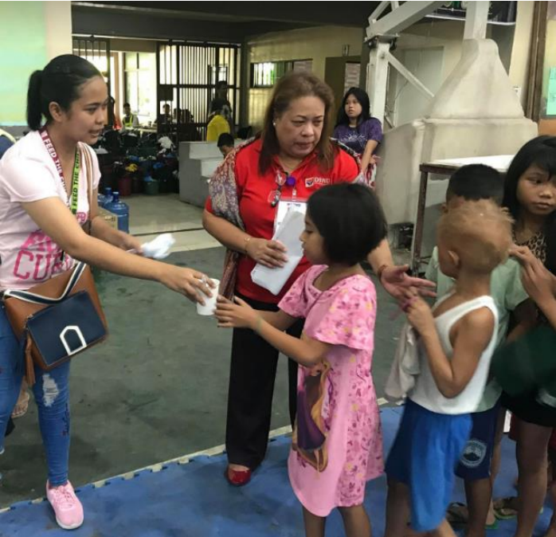
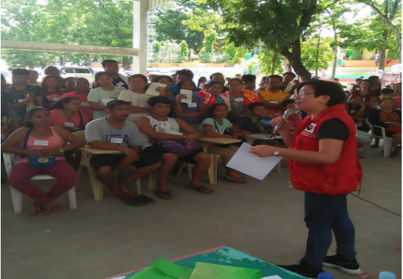
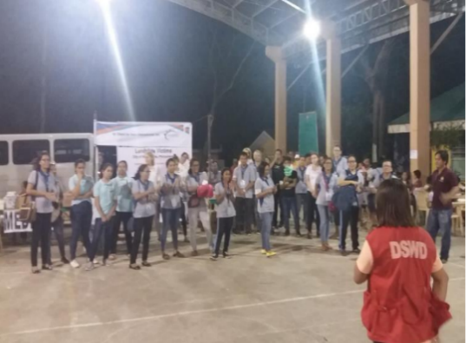

The Cebu Provincial government has also announced its donation of 2.7 hectares of the 24.7-hectare Balili property to City government of Naga, for the relocation site of the landslide victims and evacuees.

DSWD camp personnel continues to assist/facilitate volunteer groups for their relief distribution and/or activities planned for the evacuees day in and day out.

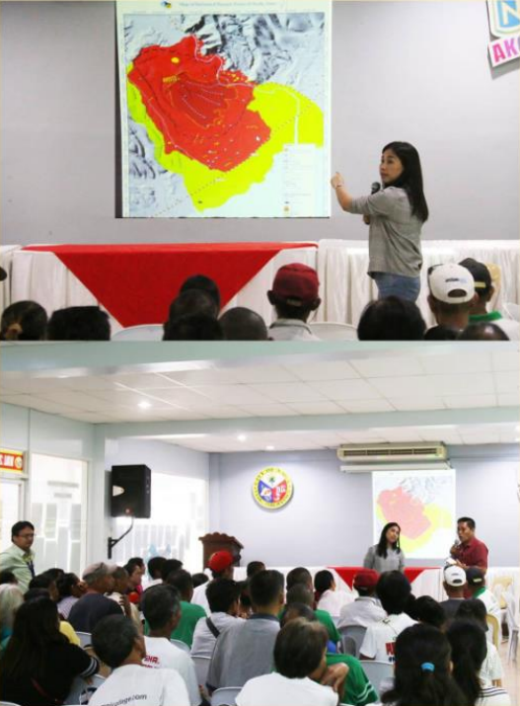
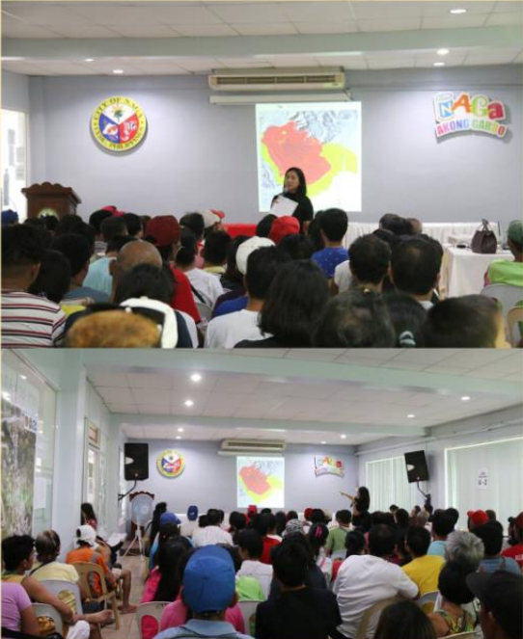

Information and Education Campaign and Community Dialogue
Purok Abaca I & II, Kawa I & II, and Tal-ot in Barangay Mainit and Purok Corssing in Barangay Naalad, November 1, 2018
Information and Education Campaign and Community Dialogue
Sitio Regla particulary Purok Gumamela in Barangay Cabungahan, November 5, 2018

Lessons Learned
- The need for a designated evacuation center/camp especially for longer-staying IDPs
- Available updated data/information and other statistics/demographics like population per barangay per purok/sitio, household data, etc.
- LGU to administer DAFAC to all using correct form
- Importance of available trained/skilled SWs at the LGU/Provincial level especially on CCCM
- Presence of a working disaster contingency plan and/or disaster response operation manual where roles and responsibilities are clearly indicated and process flow / mechanisms identified
- LGU must organize QRT and responders per cluster and to regularly update them
- LGU must be trained on Disaster Response Operations Monitoring and Information Center (DROMIC) reporting, management of Operations Center (OpCen), Donations and Volunteers
Source: DSWD Field Office VII

*****
The Disaster Response Operations Monitoring and Information Center (DROMIC) of the DSWD-DRMB continues to closely coordinate with concerned DSWD-Field Office VII for significant disaster response updates.

JAN ERWIN ANDREW I. ONTANILLAS
Releasing Officer

