DSWD DROMIC Preparedness for Response Report #1 on
Tropical Depression “CHEDENG”
as of 18 March 2019, 4PM

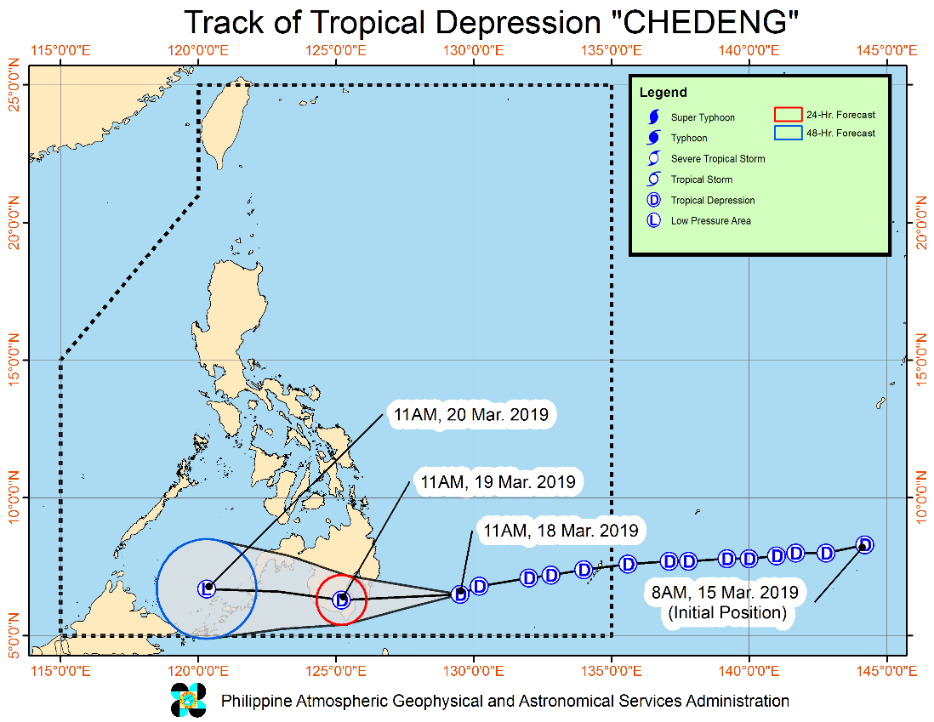
Situation Overview

Issued at 02:00 PM today, "CHEDENG" continues to move closer towards the eastern seaboard of Davao Region.
- Today (18 March), scattered to at times widespread moderate to heavy rains will prevail over Caraga and Davao Regions, especially over Surigao del Sur, eastern portion of Agusan del Sur, Davao Oriental, and Compostela Valley.
- Tomorrow (19 March), scattered to at times widespread moderate to heavy rains may be experienced over portions of Davao Region, SOCCSKSARGEN, Bangsamoro, and Zamboanga Peninsula.
- The disaster risk reduction and management offices concerned and residents of the aforementioned areas, especially those living in areas identified to be at high risk of flooding or landslide, are advised to undertake necessary preparations and continue monitoring for updates.
- Those with small seacrafts are advised not to venture out over the eastern seaboards of Visayas and Mindanao, as well as the seaboards of areas under Tropical Cyclone Warning Signals (TCWS).
- CHEDENG may make landfall over eastern coast of Davao Oriental tomorrow morning and is expected to weaken into a Low Pressure Area while crossing Mindanao.

At 1:00 PM today, the center of Tropical Depression "CHEDENG" was estimated based on all available data at 370 km East Southeast of Davao City (06.5 °N, 129.1 °E)

Forecast Position
- 24 Hours (Tomorrow morning) | 24 Hour(Tomorrow morning): 20 km North of General Santos City(6.3°N, 125.2°E)
- 48 Hours (Wednesday morning) | 48 Hour(Wednesday morning):110 km West Southwest of Zamboanga City(6.7°N, 120.3°E)

Source: DOST-PAGASA Severe Weather Bulletin

Status of Prepositioned Resources: Stockpile and Standby Funds

The DSWD Central Office (CO), Field Offices (FOs), and National Resource Operations Center (NROC) have stockpiles and standby funds amounting to ₱1,266,672,314.92 with breakdown as follows (see Table 1):

- Standby Funds
A total of ₱426,009,453.82 standby funds in the CO and FOs. Of the said amount, ₱379,175,082.35 is the available Quick Response Fund (QRF) in the CO.

- Stockpiles
A total of 291,020 Family Food Packs (FFPs) amounting to ₱105,580,374.18 and available Food and Non-food Items (FNIs) amounting to ₱735,082,486.92.

FIELD OFFICE | STANDBY FUNDS | STOCKPILE |  |  |  |  | TOTAL STANDBY FUNDS AND STOCKPILE
 |  | Family Food Packs |  | Food  (Raw Mats and Other Food Item) | Non-Food (Raw Mats and Other NFI) | Sub-Total  (Food and NFIs)
 |  | Quantity | Total Cost
TOTAL | 426,009,453.82 | 291,020 | 105,580,374.18 | 145,836,233.26 | 589,246,253.66 | 735,082,486.92 | 1,266,672,314.92
Central Office* | 379,175,082.35 | - | - | - | - |  | 379,175,082.35
NRLMB - NROC |  | 104,000 | 39,222,560.00 | 86,178,307.66 | 342,547,446.39 | 428,725,754.05 | 467,948,314.05
NRLMB - VDRC |  | 13,600 | 4,896,000.00 | 1,203,200.00 | 2,955,567.50 | 4,158,767.50 | 9,054,767.50
NCR | 3,292,543.50 | 600 | 215,850.72 | 1,621,758.59 | 928,770.00 | 2,550,528.59 | 6,058,922.81
CAR | 1,894,685.95 | 395 | 170,087.00 | 5,589,882.72 | 4,981,308.85 | 10,571,191.57 | 12,635,964.52
I | 3,000,752.75 | 2,404 | 865,440.00 | 2,405,567.60 | 42,614,105.66 | 45,019,673.26 | 48,885,866.01
II | 3,064,267.84 | 12,988 | 4,674,600.00 | 2,694,585.60 | 152,730.00 | 2,847,315.60 | 10,586,183.44
III | 4,354,000.00 | 14,432 | 5,531,648.00 | 355,719.70 | 259,588.00 | 615,307.70 | 10,500,955.70
CALABARZON | 3,000,000.00 | 3,534 | 1,266,406.44 | 4,756,639.32 | 2,575,749.59 | 7,332,388.91 | 11,598,795.35
MIMAROPA | 3,559,522.78 | 12,673 | 5,297,314.00 | 2,275,279.00 | 756,715.00 | 3,031,994.00 | 11,888,830.78
V | 1,536,000.00 | 22,168 | 8,489,476.76 | 3,715,716.80 | 41,878,359.22 | 45,594,076.02 | 55,619,552.78
VI | 3,000,000.00 | 9,774 | 3,518,640.00 | 11,273,321.50 | 7,274,957.70 | 18,548,279.20 | 25,066,919.20
VII | 3,000,000.00 | 13,086 | 1,585,333.20 | 7,049,271.80 | 17,621,916.27 | 24,671,188.07 | 29,256,521.27
VIII | 2,697,960.00 | 16,303 | 5,892,230.26 | 3,405,585.40 | 1,709,416.00 | 5,115,001.40 | 13,705,191.66
IX | 2,424,981.35 | 15,692 | 5,649,120.00 | 2,425,410.00 | 3,820,842.65 | 6,246,252.65 | 14,320,354.00
X | 3,000,000.00 | 20,128 | 7,246,080.00 | 5,448,048.00 | 99,387,755.00 | 104,835,803.00 | 115,081,883.00
XI | 3,000,000.00 | 6,049 | 2,186,108.60 | 323,200.00 | 10,306,504.16 | 10,629,704.16 | 15,844,562.76
XII | 3,009,657.30 | 11,400 | 4,571,400.00 | 2,812,836.67 | 3,083,366.67 | 5,896,203.34 | 13,477,260.64
CARAGA | 3,000,000.00 | 11,794 | 4,302,079.20 | 2,301,902.90 | 6,391,155.00 | 8,657,398.85 | 15,959,778.05
*Quick Response Fund (QRF) as of 15 March 2019

Situational Reports

DSWD-DRMB
DATE | SITUATIONS / ACTIONS UNDERTAKEN
18 March 2019 | - The Disaster Response Management Bureau (DRMB) is on BLUE Alert Status and is closely coordinating with the concerned DSWD-Field Offices for significant disaster preparedness for response updates.

DSWD-FO IX
DATE | SITUATIONS / ACTIONS UNDERTAKEN
- March 2019 | - DSWD-FO XI through its Disaster Response Management Division is continuously repacking goods to maintain the required 30,000 Family Food Packs (FFPs).  - DSWD-FO XI prepared and disseminated a memorandum on preparedness for response to officially inform the SWAD Team Leaders to monitor the situation in their respective area of responsibility.

DSWD-FO XI
DATE | SITUATIONS / ACTIONS UNDERTAKEN
- March 2019 | - DSWD-FO XI RPMO’s Quick Response Team (SWADTs, PATs, MATS, CATs) were alerted to be prepared for possible augmentation in the event of disaster occurrence.  - DRMD Personnel were advised for skeletal duty in the DSWD-FO XI Operation Center once requested.  - A total of 6,049 on-floor readily available Family Food Packs and continuous repacking is being conducted in the warehouse.  - A total of 10,000 FFPs from the CIU are readily available for distribution once needed.  - DSWD-FO XI requested 60k FFPs at NROC for stockpile and preposition relief goods.  - The Regional Resource Operation Section (RROS) were alerted to ensure the readiness of dispatching the food and non-food commodities whenever needed.  - Availability of Disaster Wing Van, vehicles and drivers in the event of a Relief Operation.  - DSWD-FO XI Disaster Response Management Division (DRMD) is monitoring the weather condition and is in close coordination with SWADOs, PSWDOs, CSWDO/MSWDOs and as well as the Office of Civil Defense (OCD) XI for monitoring and response mechanisms.

DSWD-FO CARAGA
DATE | SITUATIONS / ACTIONS UNDERTAKEN
- March 2019 | - DSWD-FO CARAGA thru the Disaster Response Management Division (DRMD) staff attended the Pre-Disaster Risk Assessment/Emergency Response Preparedness (PDRA/ERP) meeting on the risks in CARAGA Region as well as the preparedness measures of the RDRRMC Member Agencies. During the PDRA/ERP meeting, 280 barangays in 23 cities/municipalities in 3 provinces particularly in Agusan del Sur, Surigao del Sur ad Surigao del Norte were identified as landslide and flood prone areas.  - DSWD-FO CARAGA is now in BLUE Alert Status.  - The Response Cluster is ready for 24/7 duty for monitoring of the situation.  - The Disaster Response Management Division (DRMD) staff with the Provincial Quick Response Teams (QRTs) were advised to monitor and coordinate constantly with the LSWDOs and LDRRMOs for the provision of timely updates and information.

*****
The Disaster Response Operations Monitoring and Information Center (DROMIC) of the DSWD-DRMB is closely monitoring the effects of TD Chedeng and is coordinating with the concerned DSWD-Field Offices for any significant updates.

KIM AUSTIN A. ASPILLAGA
Releasing Officer

