DSWD DROMIC Preparedness for Response Report #2 on
Tropical Depression “CHEDENG”
as of 19 March 2019, 4AM

Situation Overview
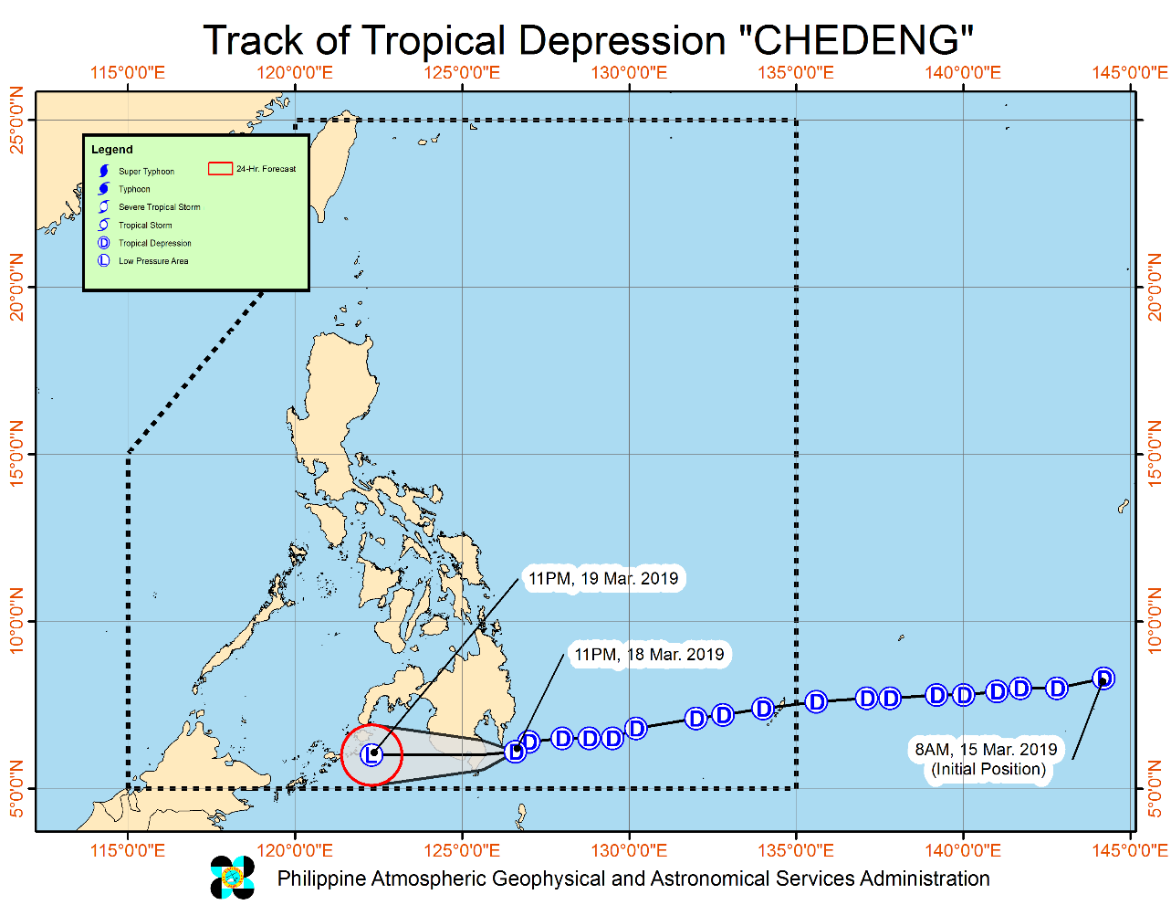

Issued at 11:00 PM yesterday, "Chedeng" has changed its course and is now moving towards Davao Occidental area.
- CHEDENG may make landfall over the eastern coast of Davao Occidental between 2:00 - 6:00 AM tomorrow. It is expected to weaken into a Low Pressure Area after landfall.
- Today (18 March), scattered to at times widespread moderate to heavy rains will prevail over Caraga and Davao Regions, especially over Surigao del Sur, Agusan del Sur, Davao Oriental, Davao del Norte and Compostela Valley.
- Tomorrow (19 March), scattered to at times widespread moderate to heavy rains may be experienced over most parts of Mindanao, especially over portions of Davao Region, SOCCSKSARGEN, Bangsamoro, and Zamboanga Peninsula.
- The disaster risk reduction and management offices concerned and residents of the aforementioned areas, especially those living in areas identified to be at high risk of flooding or landslide, are advised to undertake appropriate actions and continue monitoring for updates, including the Heavy Rainfall Warnings and Thunderstorm Advisories issued by PAGASA Regional Services Divisions.
- Those with small seacrafts are advised not to venture out over the eastern seaboards of Visayas and Mindanao, as well as the seaboards of areas under Tropical Cyclone Warning Signals (TCWS).

At 10:00 PM yesterday, the center of Tropical Depression "CHEDENG" was estimated based on Hinatuan radar and other available data at 180 km East of General Santos City (06.1 °N, 126.8 °E )
Forecast Position
- 24 Hours (Tomorrow morning) | 24 Hour(Tomorrow evening): 100 km Southeast of Zamboanga City(6.4°N, 122.8°E)

Source: DOST-PAGASA Severe Weather Bulletin

Status of Prepositioned Resources: Stockpile and Standby Funds

The DSWD Central Office (CO), Field Offices (FOs), and National Resource Operations Center (NROC) have stockpiles and standby funds amounting to ₱1,333,669,950.94 with breakdown as follows (see Table 1):

- Standby Funds
A total of ₱426,009,453.82 standby funds in the CO and FOs. Of the said amount, ₱379,175,082.35 is the available Quick Response Fund (QRF) in the CO.

- Stockpiles
A total of 305,830 Family Food Packs (FFPs) amounting to ₱110,926,870.78 and available Food and Non-food Items (FNIs) amounting to ₱796,733,626.34.

FIELD OFFICE | STANDBY FUNDS | STOCKPILE |  |  |  |  | TOTAL STANDBY FUNDS AND STOCKPILE
 |  | Family Food Packs |  | Food  (Raw Mats and Other Food Item) | Non-Food (Raw Mats and Other NFI) | Sub-Total  (Food and NFIs)
 |  | Quantity | Total Cost
TOTAL | 426,009,453.82 | 305,830 | 110,926,870.78 | 146,417,383.66 | 650,316,242.68 | 796,733,626.34 | 1,333,669,950.94
Central Office* | 379,175,082.35 | - | - | - | - |  | 379,175,082.35
NRLMB - NROC |  | 104,000 | 39,222,560.00 | 86,178,307.66 | 342,547,446.39 | 428,725,754.05 | 467,948,314.05
NRLMB - VDRC |  | 13,600 | 4,896,000.00 | 1,203,200.00 | 2,955,567.50 | 4,158,767.50 | 9,054,767.50
NCR | 3,292,543.50 | 600 | 215,850.72 | 1,621,758.59 | 928,770.00 | 2,550,528.59 | 6,058,922.81
CAR | 1,894,685.95 | 12,951 | 4,705,143.60 | 5,501,276.76 | 25,412,338.62 | 30,913,615.38 | 37,513,444.93
I | 3,000,752.75 | 4,658 | 1,676,880.00 | 2,405,567.60 | 42,614,105.66 | 45,019,673.26 | 49,697,306.01
II | 3,064,267.84 | 12,988 | 4,674,600.00 | 2,694,585.60 | 152,730.00 | 2,847,315.60 | 10,586,183.44
III | 4,354,000.00 | 14,432 | 5,531,648.00 | 355,719.70 | 259,588.00 | 615,307.70 | 10,500,955.70
CALABARZON | 3,000,000.00 | 3,534 | 1,266,406.44 | 5,209,219.00 | 6,643,361.00 | 11,852,580.00 | 16,118,986.44
MIMAROPA | 3,559,522.78 | 12,673 | 5,297,314.00 | 2,275,279.00 | 756,715.00 | 3,031,994.00 | 11,888,830.78
V | 1,536,000.00 | 22,168 | 8,489,476.76 | 3,715,716.80 | 41,878,359.22 | 45,594,076.02 | 55,619,552.78
VI | 3,000,000.00 | 9,774 | 3,518,640.00 | 11,273,321.50 | 7,274,957.70 | 18,548,279.20 | 25,066,919.20
VII | 3,000,000.00 | 13,086 | 1,585,333.20 | 7,049,271.80 | 17,621,916.27 | 24,671,188.07 | 29,256,521.27
VIII | 2,697,960.00 | 16,303 | 5,892,230.26 | 3,622,762.08 | 33,906,383.00 | 37,529,145.08 | 46,119,335.34
IX | 2,424,981.35 | 15,692 | 5,649,120.00 | 2,425,410.00 | 3,820,842.65 | 6,246,252.65 | 14,320,354.00
X | 3,000,000.00 | 20,128 | 7,246,080.00 | 5,448,048.00 | 99,387,755.00 | 104,835,803.00 | 115,081,883.00
XI | 3,000,000.00 | 6,049 | 2,186,108.60 | 323,200.00 | 14,680,885.00 | 15,004,085.00 | 20,190,193.60
XII | 3,009,657.30 | 11,400 | 4,571,400.00 | 2,812,836.67 | 3,083,366.67 | 5,896,203.34 | 13,477,260.64
CARAGA | 3,000,000.00 | 11,794 | 4,302,079.20 | 2,301,902.90 | 6,391,155.00 | 8,693,057.90 | 15,995,137.10
*Quick Response Fund (QRF) as of 15 March 2019

Situational Reports

DSWD-DRMB
DATE | SITUATIONS / ACTIONS UNDERTAKEN
18 March 2019 | - The Disaster Response Management Bureau (DRMB) is on BLUE Alert Status and is closely coordinating with the concerned DSWD-Field Offices for significant disaster preparedness for response updates.  - All QRT members and emergency equipment are on standby and ready for deployment.

DSWD-FO IX
DATE | SITUATIONS / ACTIONS UNDERTAKEN
- March 2019 | - DSWD-FO IX through its Disaster Response Management Division is continuously repacking goods to maintain the required 30,000 Family Food Packs (FFPs).  - DSWD-FO IX prepared and disseminated a memorandum on preparedness for response to officially inform the SWAD Team Leaders to monitor the situation in their respective area of responsibility.

DSWD-FO XI
DATE | SITUATIONS / ACTIONS UNDERTAKEN
19 March 2019 | - DSWD-FO XI RPMO’s Quick Response Team (SWADTs, PATs, MATS, CATs) were activated as “On-Call Duty”.  - Availability of Disaster Response and Management Division personnel for skeletal duty.  - A total of 6,049 on-floor readily available Family Food Packs and continuous repacking is being conducted in the warehouse.  - A total of 10,000 FFPs from the CIU are readily available for distribution once needed.  - Personnel manning the warehouse are alerted to ensure the readiness of dispatching food and non-food items and ensured that relief goods are ready and available at any given time.  - Availability of Disaster Wing Van, vehicles and drivers in the event of Relief Operation.  - DSWD-FO XI Disaster Response Management Division (DRMD) is monitoring the weather condition and is in close coordination with SWADOs, PSWDOs, CSWDO/MSWDOs and as well as the Office of Civil Defense (OCD) XI for monitoring and response mechanisms.  - Davao City declared the suspension of classes today, 19 March 2019, in all levels of public and private schools.

DSWD-FO XII
DATE | SITUATIONS / ACTIONS UNDERTAKEN
- March 2019 | - DSWD-FO XII activated BLUE Alert Status.  - All QRTs members are ready for activation if there is a need for deployment.  - Three (3) vehicles are ready for utilization in case of response activation.

DSWD-FO CARAGA
DATE | SITUATIONS / ACTIONS UNDERTAKEN
- March 2019 | - DSWD-FO CARAGA is in BLUE Alert Status.  - The Response Cluster is ready for 24/7 duty for monitoring of the situation.  - Skeletal forces are activated in the FO and in the provinces of Agusan del Sur and Surigao del Sur.  - The DRMD staff together with the Provincial Quick Response Teams (QRTs) are constantly monitoring and coordinating with the LSWDOs and LDRRMOs for the provision of timely updates and information.

*****
The Disaster Response Operations Monitoring and Information Center (DROMIC) of the DSWD-DRMB is closely monitoring the effects of TD “Chedeng” and is coordinating with the concerned DSWD-Field Offices for any significant updates.

JAN ERWIN ANDREW I. ONTANILLAS
Releasing Officer

