DSWD DROMIC Preparedness for Response Report #3 on
Tropical Depression “CHEDENG”
as of 19 March 2019, 4PM

Situation Overview
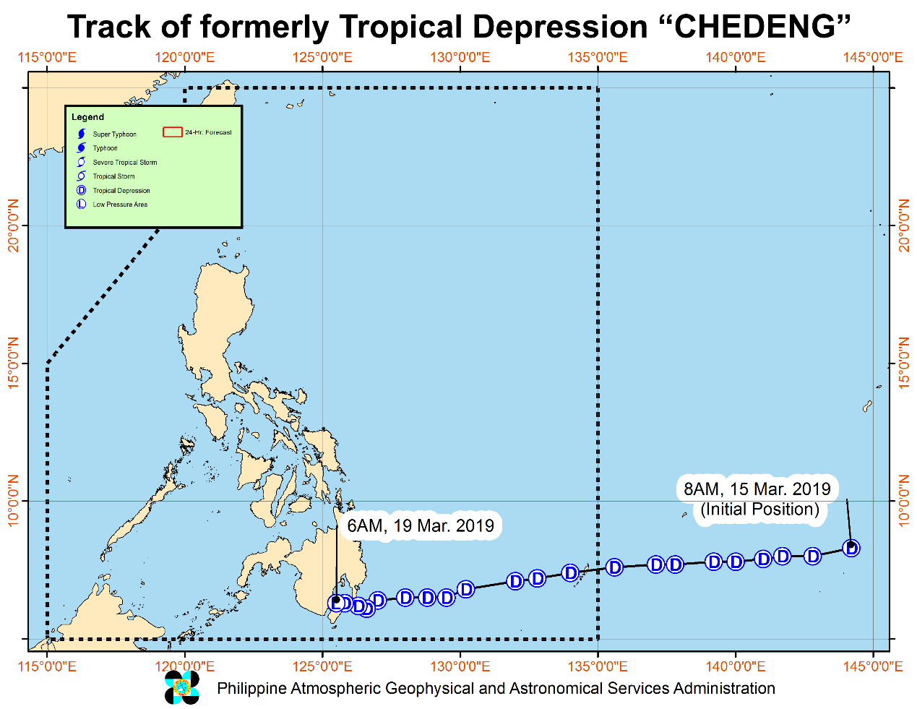

Issued at 8:00 AM today, Tropical Depression "Chedeng" has made landfall over Malita, Davao Occidental and has weakened into a low pressure area.
- At 5:30 AM today, "CHEDENG" has made landfall over Malita, Davao Occidental.
- All Tropical Cyclone Warning Signals have been lifted. However, scattered to at times widespread moderate to heavy rains will still be experienced over Surigao del Sur, Agusan del Sur, Davao Region, SOCCSKSARGEN, and portions of Northern Mindanao, Bangsamoro and Zamboanga Peninsula.
- The disaster risk reduction and management offices concerned and residents of the aforementioned areas, especially those living in areas identified to be at high risk of flooding or landslide, are advised to undertake appropriate actions and continue monitoring for updates, including the Weather Advisories and the Heavy Rainfall Warnings/ Thunderstorm Advisories issued by PAGASA Regional Services Divisions.
- Those with small seacrafts are advised not to venture out over the eastern seaboards of Visayas and Mindanao.

At 7:00 AM today, the Low Pressure area was estimated based on all available data at in the vicinity of Malungon, Sarangani (06.3 °N, 125.2 °E)

Source: DOST-PAGASA Severe Weather Bulletin

Status of Prepositioned Resources: Stockpile and Standby Funds

The DSWD Central Office (CO), Field Offices (FOs), and National Resource Operations Center (NROC) have stockpiles and standby funds amounting to ₱1,300,735,023.94 with breakdown as follows (see Table 1):

- Standby Funds
A total of ₱425,271,493.82 standby funds in the CO and FOs. Of the said amount, ₱379,175,082.35 is the available Quick Response Fund (QRF) in the CO.

- Stockpiles
A total of 305,830 Family Food Packs (FFPs) amounting to ₱110,926,870.78 and available Food and Non-food Items (FNIs) amounting to ₱764,536,659.34.

FIELD OFFICE | STANDBY FUNDS | STOCKPILE |  |  |  |  | TOTAL STANDBY FUNDS AND STOCKPILE
 |  | Family Food Packs |  | Food  (Raw Mats and Other Food Item) | Non-Food (Raw Mats and Other NFI) | Sub-Total  (Food and NFIs)
 |  | Quantity | Total Cost
TOTAL | 425,271,493.82 | 305,830 | 110,926,870.78 | 146,417,383.66 | 618,119,275.68 | 764,536,659.34 | 1,300,735,023.94
Central Office* | 379,175,082.35 | - | - | - | - |  | 379,175,082.35
NRLMB - NROC |  | 104,000 | 39,222,560.00 | 86,178,307.66 | 342,547,446.39 | 428,725,754.05 | 467,948,314.05
NRLMB - VDRC |  | 13,600 | 4,896,000.00 | 1,203,200.00 | 2,955,567.50 | 4,158,767.50 | 9,054,767.50
NCR | 3,292,543.50 | 600 | 215,850.72 | 1,621,758.59 | 928,770.00 | 2,550,528.59 | 6,058,922.81
CAR | 1,894,685.95 | 12,951 | 4,705,143.60 | 5,501,276.76 | 25,412,338.62 | 30,913,615.38 | 37,513,444.93
I | 3,000,752.75 | 4,658 | 1,676,880.00 | 2,405,567.60 | 42,614,105.66 | 45,019,673.26 | 49,697,306.01
II | 3,064,267.84 | 12,988 | 4,674,600.00 | 2,694,585.60 | 152,730.00 | 2,847,315.60 | 10,586,183.44
III | 4,354,000.00 | 14,432 | 5,531,648.00 | 355,719.70 | 259,588.00 | 615,307.70 | 10,500,955.70
CALABARZON | 3,000,000.00 | 3,534 | 1,266,406.44 | 5,209,219.00 | 6,643,361.00 | 11,852,580.00 | 16,118,986.44
MIMAROPA | 3,559,522.78 | 12,673 | 5,297,314.00 | 2,275,279.00 | 756,715.00 | 3,031,994.00 | 11,888,830.78
V | 1,536,000.00 | 22,168 | 8,489,476.76 | 3,715,716.80 | 41,878,359.22 | 45,594,076.02 | 55,619,552.78
VI | 3,000,000.00 | 9,774 | 3,518,640.00 | 11,273,321.50 | 7,274,957.70 | 18,548,279.20 | 25,066,919.20
VII | 3,000,000.00 | 13,086 | 1,585,333.20 | 7,049,271.80 | 17,621,916.27 | 24,671,188.07 | 29,256,521.27
VIII | 1,960,000.00 | 16,303 | 5,892,230.26 | 3,622,762.08 | 1,709,416.00 | 5,332,178.08 | 13,184,408.34
IX | 2,424,981.35 | 15,692 | 5,649,120.00 | 2,425,410.00 | 3,820,842.65 | 6,246,252.65 | 14,320,354.00
X | 3,000,000.00 | 20,128 | 7,246,080.00 | 5,448,048.00 | 99,387,755.00 | 104,835,803.00 | 115,081,883.00
XI | 3,000,000.00 | 6,049 | 2,186,108.60 | 323,200.00 | 14,680,885.00 | 15,004,085.00 | 20,190,193.60
XII | 3,009,657.30 | 11,400 | 4,571,400.00 | 2,812,836.67 | 3,083,366.67 | 5,896,203.34 | 13,477,260.64
CARAGA | 3,000,000.00 | 11,794 | 4,302,079.20 | 2,301,902.90 | 6,391,155.00 | 8,693,057.90 | 15,995,137.10
*Quick Response Fund (QRF) as of 19 March 2019

Situational Reports

DSWD-DRMB
DATE | SITUATIONS / ACTIONS UNDERTAKEN
19 March 2019 | - The Disaster Response Management Bureau (DRMB) is on BLUE Alert Status and is closely coordinating with the concerned DSWD-Field Offices for significant disaster preparedness for response updates.  - All QRT members are on stand-by and ready for deployment.  - Emergency communication equipment are on stand-by and ready for deployment.

DSWD-FO IX
DATE | SITUATIONS / ACTIONS UNDERTAKEN
- March 2019 | - DSWD-FO IX through its Disaster Response Management Division is continuously repacking goods to maintain the required 30,000 Family Food Packs (FFPs).  - DSWD-FO IX prepared and disseminated a memorandum on preparedness for response to officially inform the SWAD Team Leaders to monitor the situation in their respective area of responsibility.

DSWD-FO X
DATE | SITUATIONS / ACTIONS UNDERTAKEN
19 March 2019 | - DSWD-FO X is closely monitoring the weather condition in coordination with SWADTL and respective P/C/LDRRMC in all provinces.  - The department ensures enough relief goods/supplies for possible augmentation if need arises.  - Any untoward incidents monitored regarding the said weather condition will be reported immediately.

DSWD-FO XI
DATE | SITUATIONS / ACTIONS UNDERTAKEN
19 March 2019 | - A total of 6,049 on-floor readily available Family Food Packs and continuous repacking is being conducted in the warehouse.  - A total of 10,000 FFPs from the CIU are readily available for distribution once needed.  - DSWD-FO XI RPMO’s Quick Response Team (SWADTs, PATs, MATS, CATs) were activated as “On-Call Duty”.  - Availability of Disaster Response and Management Division personnel for skeletal duty.  - DSWD-FO XI Disaster Response Management Division (DRMD) is monitoring the weather condition and is in close coordination with SWADOs, PSWDOs, CSWDO/MSWDOs and as well as the Office of Civil Defense (OCD) XI for monitoring and response mechanisms.  - Personnel manning the warehouse were alerted to ensure the readiness of dispatching food and non-food items and ensured that relief goods are ready and available at any given time.  - Availability of Disaster Wing Van, vehicles and drivers in the event of Relief Operation.  - Davao City declared the suspension of classes today, 19 March 2019, in all levels of public and private schools.

DSWD-FO XII
DATE | SITUATIONS / ACTIONS UNDERTAKEN
- March 2019 | - DSWD-FO XII activated BLUE Alert Status.  - All QRTs members are ready for activation if there is a need for deployment.  - Three (3) vehicles are ready for utilization in case of response activation.

DSWD-FO CARAGA
DATE | SITUATIONS / ACTIONS UNDERTAKEN
- March 2019 | - DSWD-FO CARAGA is still in BLUE Alert Status.  - Skeletal forces are still activated in the FO and in the provinces of Agusan del Sur and Surigao del Sur.  - The DRMD staff together with the Provincial Quick Response Teams (QRTs) are constantly monitoring and coordinating with the LSWDOs and LDRRMOs for the provision of timely updates and information.

*****
The Disaster Response Operations Monitoring and Information Center (DROMIC) of the DSWD-DRMB is closely monitoring the effects of TD “Chedeng” and is coordinating with the concerned DSWD-Field Offices for any significant updates.

KIM AUSTIN A. ASPILLAGA
Releasing Officer

