DSWD DROMIC Report #3 on the Armed Conflict
in San Jose de Buan, Western Samar
as of 22 March 2019, 7PM

SUMMARY

On 08 March 2019 at about 8PM, an armed conflict transpired in Brgy. Hagbay, San Jose de Buan, Western Samar which resulted to displacement of families and individuals in the area.

Source: DSWD-FO VIII

- Status of Affected Families / Persons
A total of 252 families or 1,008 persons were affected by the armed conflict in San Jose de Buan, Western Samar (see Table 1).

Table 1. Number of Affected Families / Persons
REGION / PROVINCE / MUNICIPALITY |  | NUMBER OF AFFECTED
 |  | Barangays | Families | Persons
GRAND TOTAL |  | 3 | 252 | 1,008
Region VIII |  | 3 | 252 | 1,008
Western Samar |  | 3 | 252 | 1,008
 | San Jose de Buan | 3 | 252 | 1,008
Note: Ongoing assessment and validation.
Source: DSWD-FO VIII

- Status of Displaced Families/ Persons
  - There are 250 families or 1,000 persons who are currently staying at the Poblacion Covered Court and Poblacion Market Site (see Table 2).

Table 2. Number of Displaced Families / Persons Inside Evacuation Center
REGION / PROVINCE / MUNICIPALITY |  | NO. OF EVACUATION CENTER |  | INSIDE ECs
 |  |  |  | Families |  | Persons
 |  | CUM | NOW | CUM | NOW | CUM | NOW
GRAND TOTAL |  | 2 | 2 | 250 | 250 | 1,000 | 1,000
Region VIII |  | 2 | 2 | 250 | 250 | 1,000 | 1,000
Western Samar |  | 2 | 2 | 250 | 250 | 1,000 | 1,000
 | San Jose de Buan | 2 | 2 | 250 | 250 | 1,000 | 1,000
Note: Ongoing assessment and validation.
Source: DSWD-FO VIII

  - 2 families or 8 persons are temporarily staying with relatives (see Table 3).

Table 3. Number of Displaced Families / Persons Outside Evacuation Center
REGION / PROVINCE / MUNICIPALITY |  | OUTSIDE ECs
 |  | Families |  | Persons
 |  | CUM | NOW | CUM | NOW
GRAND TOTAL |  | 2 | 2 | 8 | 8
Region VIII |  | 2 | 2 | 8 | 8
Western Samar |  | 2 | 2 | 8 | 8
 | San Jose de Buan | 2 | 2 | 8 | 8
Note: Ongoing assessment and validation.
Source: DSWD-FO VIII

- Assistance Provided
A total of ₱125,313.00 worth of assistance was provided by DSWD to the affected families (see Table 4).

Table 4. Cost of Assistance Provided to Affected Families / Persons
REGION / PROVINCE / MUNICIPALITY |  | TOTAL COST OF ASSISTANCE
 |  | DSWD | LGU | NGOs | OTHERS | GRAND TOTAL
GRAND TOTAL |  | 125,313.00 | - | - | - | 125,313.00
Region VIII |  | 125,313.00 | - | - | - | 125,313.00
Western Samar |  | 125,313.00 | - | - | - | 125,313.00
 | San Jose de Buan | 125,313.00 | - | - | - | 125,313.00

Source: DSWD-FO VIII

SITUATIONAL REPORT

DSWD-DRMB
DATE | SITUATIONS / ACTIONS UNDERTAKEN
22 March 2019 | - The Disaster Response Operations Monitoring and Information Center (DROMIC) of the DSWD-DRMB continues to closely coordinate with DSWD-FO VIII for significant reports on the status of affected families, assistance, and relief efforts.

DSWD-FO VIII
DATE | SITUATIONS / ACTIONS UNDERTAKEN
21 March 2019 | - DSWD-FO VIII through its Disaster Response Management Division provided augmentation assistance to the displaced families consisting of family food packs and blankets.  - The Regional Resource Operation Section (RROS) dispatched food and non-food items to the affected families in San Jose de Buan.  - The Local Government of San Jose de Buan conducted relief operation to the affected families.  - DSWD-FO VIII through its Disaster Response Management Division is continuously coordinating with the concerned LGU for possible request of augmentation assistance.

*****
The Disaster Response Operations Monitoring and Information Center (DROMIC) of the DSWD-DRMB continues to closely coordinate with DSWD-FO VIII for significant disaster response updates and assistance provided.

MARC LEO L. BUTAC
Releasing Officer

PHOTO DOCUMENTATION

- Displaced families at the Poblacion Covered Court
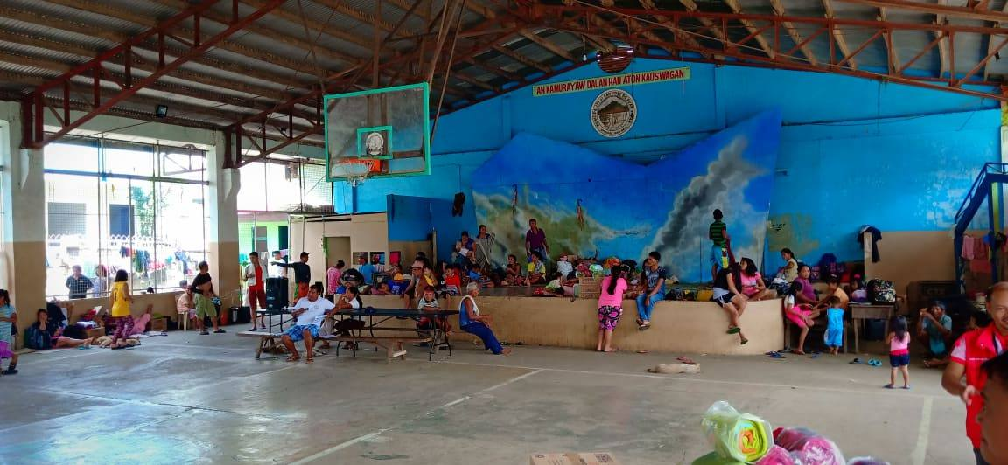
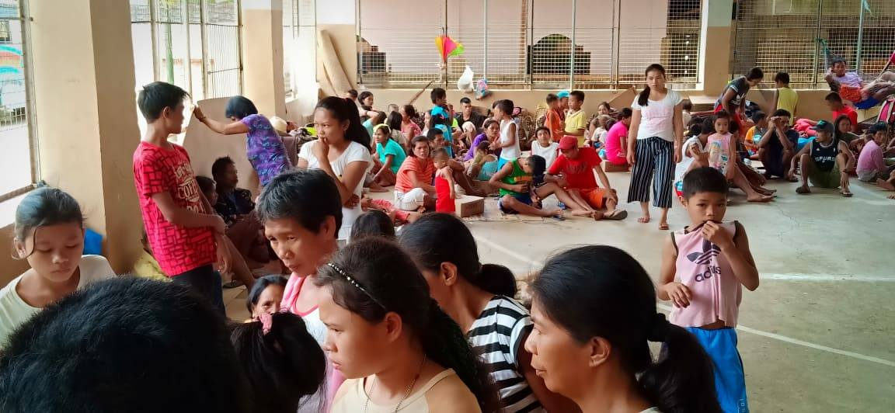
- Distribution of Family Food Packs (FFPs) and blanket last 21 March 2019
