DSWD DROMIC Terminal Report on the Fire Incident
in Sitio Pasil, Brgy. Poblacion, Talibon, Bohol
07 July 2020, 6PM

This is the final report on the fire incident that occurred at Sitio Pasil, Brgy. Poblacion, Talibon, Bohol on 17 February 2019.
Source: DSWD-FO VII

SUMMARY

- Status of Affected Families / Persons
A total of 14 families or 86 persons were affected by the fire incident in Sitio Pasil, Brgy. Poblacion, Talibon, Bohol (see Table 1).

Table 1. Number of Affected Families / Persons
REGION / PROVINCE / MUNICIPALITY |  | NUMBER OF AFFECTED
 |  | Barangays | Families | Persons
GRAND TOTAL |  | 1 | 14 | 86
REGION VII |  | 1 | 14 | 86
Bohol |  | 1 | 14 | 86
 | Talibon | 1 | 14 | 86
Source: DSWD-FO VII

- Status of Displaced Families / Persons Inside Evacuation Center
14 families or 86 persons took temporary shelter in the Municipal Gym (see Table 2).
Table 2. Number of Displaced Families / Persons Inside Evacuation Center
REGION / PROVINCE / MUNICIPALITY |  | NUMBER OF EVACUATION CENTERS (ECs) |  | INSIDE ECs
 |  |  |  | Families |  | Persons
 |  | CUM | NOW | CUM | NOW | CUM | NOW
GRAND TOTAL |  | 1 | - | 14 | - | 86 | -
REGION VII |  | 1 | - | 14 | - | 86 | -
Bohol |  | 1 | - | 14 | - | 86 | -
 | Talibon | 1 | - | 14 | - | 86 | -
Source: DSWD-FO VII

- Damaged Houses
A total of 12 houses were totally damaged by the fire (see Table 3).
Table 3. Number of Damaged Houses
REGION / PROVINCE / MUNICIPALITY |  | NO. OF DAMAGED HOUSES
 |  | Total | Totally | Partially
GRAND TOTAL |  | 12 | 12 | -
REGION VII |  | 12 | 12 | -
Bohol |  | 12 | 12 | -
 | Talibon | 12 | 12 | -
Source: DSWD-FO VII

- Assistance Provided
A total of ₱84,539.70 worth of assistance was provided by DSWD to the affected families (see Table 4).

Table 4. Cost of Assistance Provided to Affected Families / Persons
REGION / PROVINCE / MUNICIPALITY |  | TOTAL COST OF ASSISTANCE
 |  | DSWD | LGU | NGOs | OTHERS | GRAND TOTAL
GRAND TOTAL |  | 84,539.70 | - | - | - | 84,539.70
REGION VII |  | 84,539.70 | - | - | - | 84,539.70
Bohol |  | 84,539.70 | - | - | - | 84,539.70
 | Talibon | 84,539.70 | - | - | - | 84,539.70
Source: DSWD-FO VII

SITUATIONAL REPORT

DSWD-FO VII
DATE | SITUATIONS / ACTIONS UNDERTAKEN
01 July 2020 | - DSWD-FO VII submitted their terminal report.  - DSWD-FO VII provided family food packs, clothing kit, dignity kit, hygiene kit, mosquito net, fleece blanket, frying pan, cauldron, ladle, pail, water dipper and a malong for each affected family.

*****
The Disaster Response Operations Monitoring and Information Center (DROMIC) of the DSWD-DRMB continues to closely coordinate with DSWD-FO VII for any request of Technical Assistance and Resource Augmentation (TARA).

Prepared by:

MARIE JOYCE G. RAFANAN

MARC LEO L. BUTAC
Releasing Officer

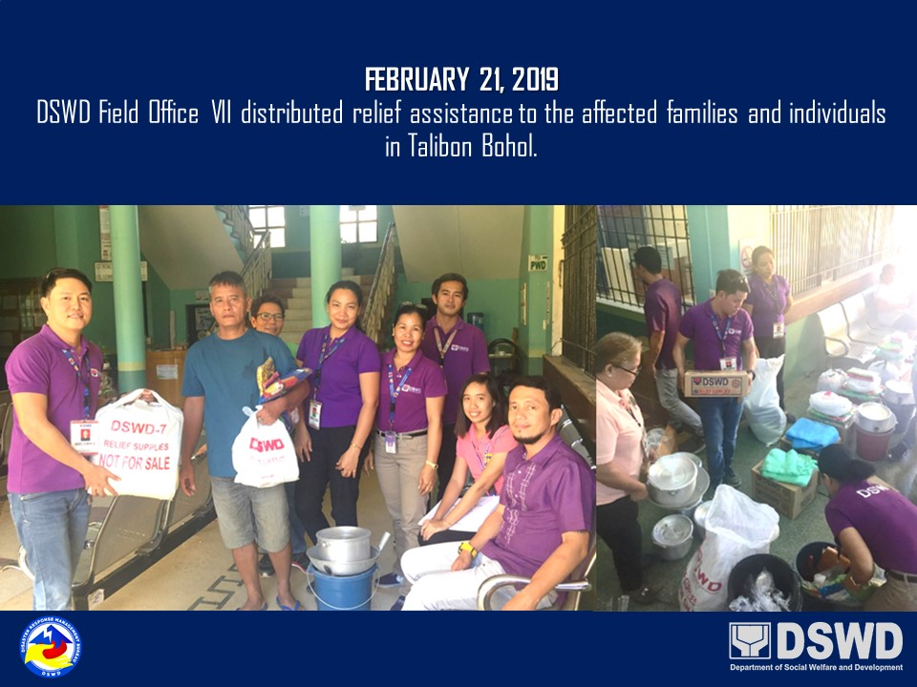
PHOTO DOCUMENTATION

