DSWD DROMIC Preparedness for Response Report #1
on the Earthquake Incident in Castillejos, Zambales
as of 22 April 2019, 6PM

Situation Overview

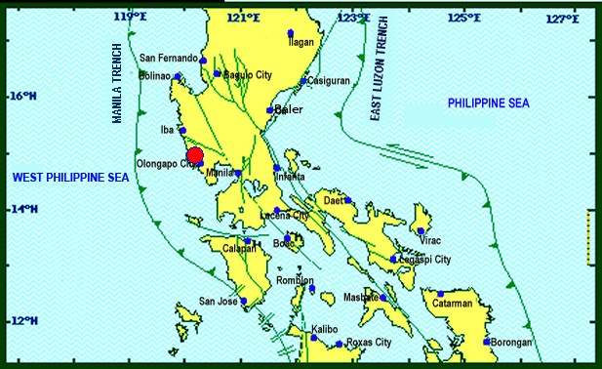

On April 22, 2019 at exactly 5:11 PM, a Magnitude 5.7 earthquake shook Castillejos, Zambales. The epicenter of the earthquake was located 14.95°N, 120.21°E - 002 km N of Castillejos, Zambales with a depth focus of 021 km and with a Tectonic origin.

Reported Intensities (05:11 PM): | Intensity V - San Felipe, Zambales; Quezon City
Expecting Damage: | YES
Expecting Aftershocks: | YES
Source: DOST-PHIVOLCS Earthquake Bulletin

Status of Prepositioned Resources: Stockpiles and Standby Funds

The DSWD Central Office (CO), Field Offices (FOs), and National Resource Operations Center (NROC) have stockpiles and standby funds amounting to ₱1,300,735,023.94 with breakdown as follows:

- Stockpiles
A total of 305,830 Family Food Packs (FFPs) (see Table 4) amounting to ₱110,926,870.78 and available Food and Non-food Items (FNIs) amounting to ₱764,536,659.34.
- Standby Funds
A total of ₱425,271,493.82 standby funds in the CO and FOs. Of the said amount, ₱379,175,082.35 is the available Quick Response Fund in the CO.

Standby Funds and Stockpile
FIELD OFFICE | STANDBY FUNDS | STOCKPILE |  |  |  |  | TOTAL STANDBY FUNDS AND STOCKPILE
 |  | Family Food Packs |  | Food  (Raw Mats and Other Food Item) | Non-Food (Raw Mats and Other NFI) | Sub-Total  (Food and NFIs)
 |  | Quantity | Total Cost
TOTAL | 425,271,493.82 | 305,830 | 110,926,870.78 | 146,417,383.66 | 618,119,275.68 | 764,536,659.34 | 1,300,735,023.94
Central Office* | 379,175,082.35 | - | - | - | - |  | 379,175,082.35
NRLMB - NROC |  | 104,000 | 39,222,560.00 | 86,178,307.66 | 342,547,446.39 | 428,725,754.05 | 467,948,314.05
NRLMB - VDRC |  | 13,600 | 4,896,000.00 | 1,203,200.00 | 2,955,567.50 | 4,158,767.50 | 9,054,767.50
NCR | 3,292,543.50 | 600 | 215,850.72 | 1,621,758.59 | 928,770.00 | 2,550,528.59 | 6,058,922.81
CAR | 1,894,685.95 | 12,951 | 4,705,143.60 | 5,501,276.76 | 25,412,338.62 | 30,913,615.38 | 37,513,444.93
I | 3,000,752.75 | 4,658 | 1,676,880.00 | 2,405,567.60 | 42,614,105.66 | 45,019,673.26 | 49,697,306.01
II | 3,064,267.84 | 12,988 | 4,674,600.00 | 2,694,585.60 | 152,730.00 | 2,847,315.60 | 10,586,183.44
III | 4,354,000.00 | 14,432 | 5,531,648.00 | 355,719.70 | 259,588.00 | 615,307.70 | 10,500,955.70
CALABARZON | 3,000,000.00 | 3,534 | 1,266,406.44 | 5,209,219.00 | 6,643,361.00 | 11,852,580.00 | 16,118,986.44
MIMAROPA | 3,559,522.78 | 12,673 | 5,297,314.00 | 2,275,279.00 | 756,715.00 | 3,031,994.00 | 11,888,830.78
V | 1,536,000.00 | 22,168 | 8,489,476.76 | 3,715,716.80 | 41,878,359.22 | 45,594,076.02 | 55,619,552.78
VI | 3,000,000.00 | 9,774 | 3,518,640.00 | 11,273,321.50 | 7,274,957.70 | 18,548,279.20 | 25,066,919.20
VII | 3,000,000.00 | 13,086 | 1,585,333.20 | 7,049,271.80 | 17,621,916.27 | 24,671,188.07 | 29,256,521.27
VIII | 1,960,000.00 | 16,303 | 5,892,230.26 | 3,622,762.08 | 1,709,416.00 | 5,332,178.08 | 13,184,408.34
IX | 2,424,981.35 | 15,692 | 5,649,120.00 | 2,425,410.00 | 3,820,842.65 | 6,246,252.65 | 14,320,354.00
X | 3,000,000.00 | 20,128 | 7,246,080.00 | 5,448,048.00 | 99,387,755.00 | 104,835,803.00 | 115,081,883.00
XI | 3,000,000.00 | 6,049 | 2,186,108.60 | 323,200.00 | 14,680,885.00 | 15,004,085.00 | 20,190,193.60
XII | 3,009,657.30 | 11,400 | 4,571,400.00 | 2,812,836.67 | 3,083,366.67 | 5,896,203.34 | 13,477,260.64
CARAGA | 3,000,000.00 | 11,794 | 4,302,079.20 | 2,301,902.90 | 6,391,155.00 | 8,693,057.90 | 15,995,137.10
* Quick Response Fund (QRF) as of 19 March 2019
Sources: DSWD-Central Office, DSWD-Field Offices, and NROC

Situational Reports

DSWD-DRMB
DATE | ACTION(S) TAKEN
22 April 2018 | - The Disaster Response Operations Monitoring and Information Center (DROMIC) of the DSWD-DRMB continues to closely coordinate with DSWD-FO III for significant reports on the status of affected families, assistance, and relief efforts.  - DSWD-RETT is on Standby and ready for deployment, with Emergency Communications Equipment  - DSWD-CO QRT members is on standby and ready for deployment.

***
The Disaster Response Operations Monitoring and Information Center (DROMIC) of the DSWD-DRMB is closely coordinating with DSWD-FO III for any significant disaster response updates.

by:

JAN ERWIN ANDREW I. ONTANILLAS
Releasing Officer

