DSWD DROMIC Preparedness for Response Report #1
on the Earthquake Incident in San Julian (Eastern Samar)
as of 23 April 2019, 4PM

Situation Overview

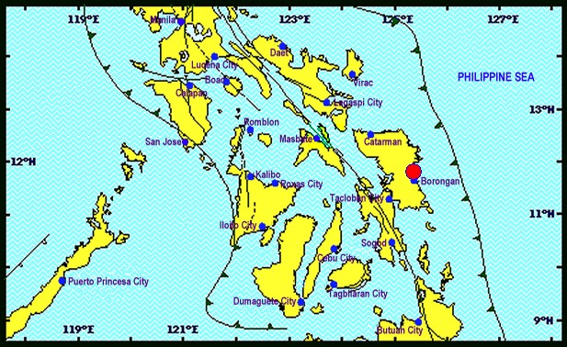

On April 23, 2019 at exactly 1:37 PM, a Magnitude 6.5 earthquake shook Castillejos, Zambales. The epicenter of the earthquake was located 11.79°N, 125.38°E - 009 km N 66° W of San Julian (Eastern Samar) with a depth focus of 063 km and with a Tectonic origin.

Reported Intensities (02:28 PM): | Intensity VI - San Julian, Eastern Samar;  Intensity V - Tacloban City; Catbalogan City, Samar; Gen. Mc Arthur, Salcedo and  Guiuan Eastern Samar; Naval, Biliran; Catarman, Northern Samar; Palo and Pastrana, Leyte;  Intensity IV - Abuyog, Hilongos, Javier, Capoocan, Julieta, Baybay, Barogo, Jaro, MacArthur,  Matalum, Villaba, Leyte; San Francisco, Southern Leyte; Bislig City, Surigao Del Sur; Iloilo City;  Naga City; Sorsogon City; Panganiban, Catanduanes;  Intensity III - Binalbagan, Negros Occidental; Cabalian, Southern Leyte; Dimasalang, Masbate;  Butuan City; Cabadbaran City;  Intensity II - Bago City; Bacolod City;  Instrumental Intensities:  Intensity VI - Catbalogan, Samar;  Intensity IV - Masbate City, Masbate;  Intensity III - Legazpi City; Iriga City, Camarines Sur; Ormoc City; Argao City, Cebu; Bogo City,  Cebu; Surigao City;  Intensity II - Passi City, Iloilo; Malinao, Aklan; Jamindan, Capiz; Roxas City; Talibon, Bohol; San  Francisco, Cebu; Gingoog City; Mulanay, Quezon; Bago City, Negros Occidental; Daet,  Camarines Norte  Intensity I - Tapaz, Capiz; Sipocot, Camarines Sur; Lapu-lapu City; La Carlota City;
Expecting Damage: | YES
Expecting Aftershocks: | YES
Source: DOST-PHIVOLCS Earthquake Bulletin

Status of Prepositioned Resources: Stockpiles and Standby Funds

The DSWD Central Office (CO), Field Offices (FOs), and National Resource Operations Center (NROC) have stockpiles and standby funds amounting to ₱2,233,678,895.43 with breakdown as follows:

- Stockpiles
A total of 328,814 Family Food Packs (FFPs) amounting to ₱130,495,937.34 and available Food and Non-food Items (FNIs) amounting to ₱765,214,172.68.
- Standby Funds
A total of ₱1,337,968,785.41 standby funds in the CO and FOs. Of the said amount, ₱1,292,745,590.16 is the available Quick Response Fund in the CO.

Standby Funds and Stockpile
FIELD OFFICE | STANDBY FUNDS | STOCKPILES |  |  |  |  | Total STANDBY FUNDS & STOCKPILE
 |  | Family Food Packs |  | Other Food Items | Non Food Items | SUB-TOTAL (Food and NFIs)
 |  | Quantity | Total Cost | Total Cost | Total Cost
TOTAL | 1,337,968,785.41 | 328,814 | 130,495,937.34 | 172,994,296.78 | 592,219,875.90 | 765,214,172.68 | 2,233,678,895.43
Central Office | 1,292,745,590.16 |  |  |  |  |  | 1,292,745,590.16
NRLMB - NROC | 0.00 | 110,817 | 49,277,147.90 | 85,666,485.55 | 346,507,018.64 | 432,173,504.19 | 481,450,652.09
NRLMB - VDRC | 0.00 | 9,000 | 3,240,000.00 | 23,541,007.73 | 8,783,294.00 | 32,324,301.73 | 35,564,301.73
I | 3,000,752.75 | 4,514 | 1,702,409.96 | 2,725,567.60 | 41,240,224.78 | 43,965,792.38 | 48,668,955.09
II | 2,477,816.92 | 12,046 | 3,904,435.44 | 3,657,302.00 | 349,519.59 | 4,006,821.59 | 10,389,073.95
III | 2,484,557.00 | 26,177 | 10,118,127.62 | 355,719.70 | 259,588.00 | 615,307.70 | 13,217,992.32
CALABARZON | 3,000,000.00 | 3,083 | 1,126,109.36 | 4,756,639.32 | 2,299,264.59 | 7,055,903.91 | 11,182,013.27
MIMAROPA | 2,754,714.78 | 18,771 | 7,846,278.00 | 3,654,739.72 | 859,605.00 | 4,514,344.72 | 15,115,337.50
V | 3,000,000.00 | 21,509 | 8,240,941.50 | 3,715,716.80 | 40,993,868.97 | 44,709,585.77 | 55,950,527.27
VI | 1,400,400.00 | 5,935 | 2,141,536.32 | 10,541,995.50 | 6,453,779.20 | 16,995,774.70 | 20,537,711.02
VII | 3,000,000.00 | 10,581 | 3,809,160.00 | 6,812,433.58 | 16,905,989.77 | 23,718,423.35 | 30,527,583.35
VIII | 3,001,960.00 | 29,523 | 10,670,202.66 | 1,331,639.16 | 1,210,683.00 | 2,542,322.16 | 16,214,484.82
IX | 2,780,581.35 | 17,851 | 6,426,360.00 | 2,425,410.00 | 3,793,242.65 | 6,218,652.65 | 15,425,594.00
X | 3,000,000.00 | 19,912 | 7,304,085.94 | 5,893,823.00 | 98,529,822.16 | 104,423,645.16 | 114,727,731.10
XI | 3,028,750.00 | 7,264 | 2,625,209.60 | 4,960,400.00 | 10,855,443.49 | 15,815,843.49 | 21,469,803.09
XII | 3,000,433.00 | 3,254 | 1,304,854.00 | 2,103,532.67 | 912,957.26 | 3,016,489.93 | 7,321,776.93
CARAGA | 3,000,000.00 | 11,585 | 4,224,707.70 | 2,301,902.90 | 6,355,495.95 | 8,657,398.85 | 15,882,106.55
NCR | 3,292,543.50 | 1,720 | 647,080.24 | 1,621,524.15 | 928,770.00 | 2,550,294.15 | 6,489,917.89
CAR | 3,000,685.95 | 15,272 | 5,887,291.10 | 6,928,457.40 | 4,981,308.85 | 11,909,766.25 | 20,797,743.30
* Quick Response Fund (QRF) as of 17 April 2019
Sources: DSWD-Central Office, DSWD-Field Offices, and NROC

Situational Reports

DSWD-DRMB
DATE | ACTION(S) TAKEN
23 April 2018 | - The Disaster Response Operations Monitoring and Information Center (DROMIC) of the DSWD-DRMB continues to closely coordinate with DSWD-FO VIII for significant reports on the status of affected families, assistance, and relief efforts.  - DSWD-RETT is on Standby and ready for deployment, with Emergency Communications Equipment  - DSWD-CO QRT members is on standby and ready for deployment.

DSWD-FO V
DATE | ACTION(S) TAKEN
23 April 2018 | - Coordinated with POOs responsible effects of the earthquake  - Conducted the SOP on Earthquake Situation.  - Alerted and advised to be prepared for augmentation support needed from the field and/or 24/7 duty at the DRMD Operation Center.  - PAT and MAT members in the 6 provinces are on standby and were instructed to coordinate with P/MDRRMOs for status reports and updates  - Continuous monitoring of the situation

DSWD-FO VI
DATE | ACTION(S) TAKEN
23 April 2018 | - Suspension of work at Iloilo City Hall following the magnitude 6.5 earthquake. Employees evacuated the building after the tremor.  - The earthquake was felt in entire Western Visayas as per report of QRTs stationed in the following provinces:  - Aklan  - Antique  - Capiz  - Guimaras  - Iloilo  - Negros Occidental  - Government Offices including DSWD evacuated their respective offices as preventive measure after the shake.  - DROMIC FO VI is in close coordination to warning agencies as to possible aftershocks and tsunami alert.  - No reported casualties and damages as of reporting time.  - Quick Response Team are on call and ready for activation during emergency situation.

***
The Disaster Response Operations Monitoring and Information Center (DROMIC) of the DSWD-DRMB continues to closely coordinate with the concerned DSWD Field Offices for updating of regional situation and preparedness for response.

by:

JAN ERWIN ANDREW I. ONTANILLAS
Releasing Officer

PHOTO DOCUMENTATION

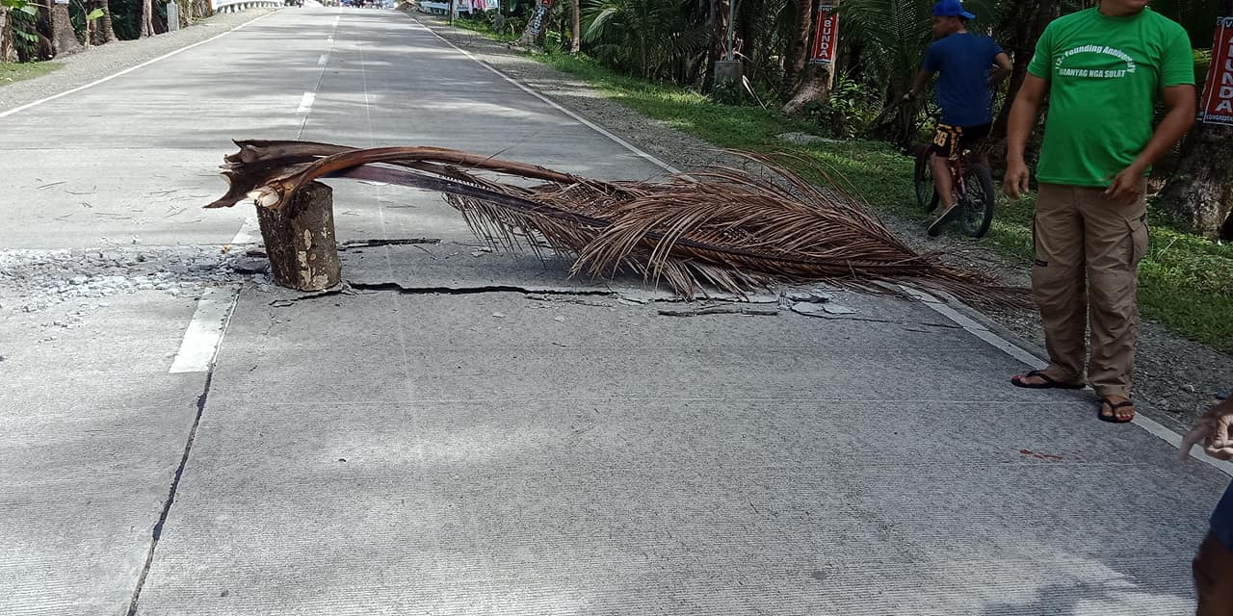
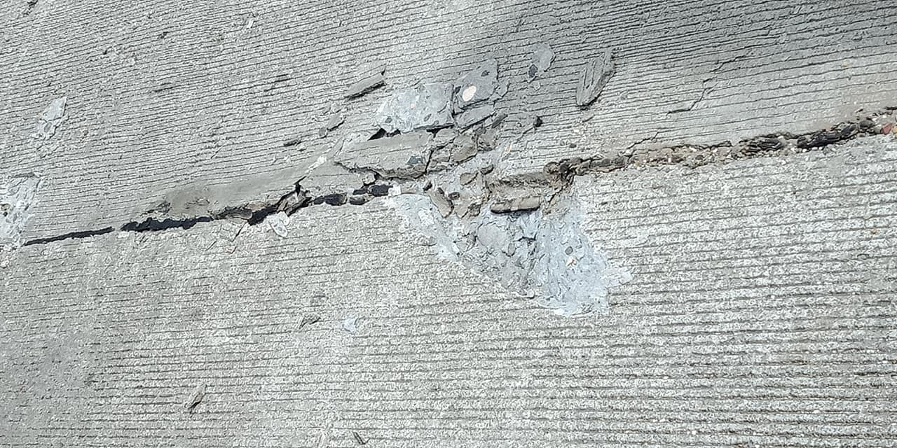
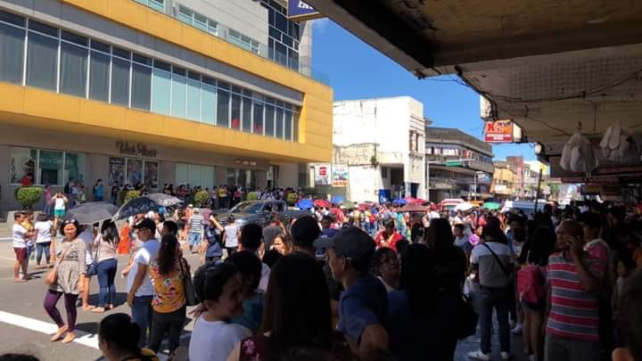
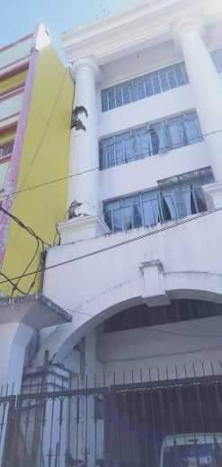
Source: Facebook.com/ilovetacloban

