DSWD DROMIC Report #1 on the Fire Incident
in Brgy. Nijaga, Calbayog City, Western Samar
as of 31 March 2019, 4PM

SUMMARY

On March 30, 2019 at around 11:51 AM, a fire incident occurred in Brgy. Nijaga, Calbayog City, Western Samar. It was around 12:01 PM when the fire was declared out. The cause of the fire is still under investigation.
Source: DSWD-FO VIII

- Status of Affected Families / Persons
A total of 200 families or 800 persons were affected in Brgy. Nijaga, Calbayog City, Western Samar (see Table 1).

Table 1. Number of Affected Families / Persons
REGION / PROVINCE / MUNICIPALITY |  | NUMBER OF AFFECTED
 |  | Barangays | Families | Persons
GRAND TOTAL |  | 1 | 200 | 800
REGION VIII |  | 1 | 200 | 800
Western Samar |  | 1 | 200 | 800
 | Calbayog City | 1 | 200 | 800
Note: Ongoing assessment and validation being conducted
Source: DSWD-FO VIII

- Status of Displaced Families / Persons
There are 200 families or 800 persons who are currently staying inside Nijaga Elementary School (see Table 2).

Table 2. Number of Displaced Families / Persons Inside Evacuation Center
REGION / PROVINCE / MUNICIPALITY | NUMBER OF EVACUATION CENTERS (ECs) |  | INSIDE ECs
 |  |  | Families |  | Persons
 | CUM | NOW | CUM | NOW | CUM | NOW
GRAND TOTAL | 1 | 1 | 200 | 200 | 800 | 800
REGION VIII | 1 | 1 | 200 | 200 | 800 | 800
Western Samar | 1 | 1 | 200 | 200 | 800 | 800
Calbayog City | 1 | 1 | 200 | 200 | 800 | 800
Note: Ongoing assessment and validation being conducted
Source: DSWD-FO VIII

- Damaged Houses
106 houses were totally damaged by the fire (see Table 3).

Table 3. Damaged Houses
REGION / PROVINCE / MUNICIPALITY |  | NO. OF DAMAGED HOUSES
 |  | Total | Totally | Partially
GRAND TOTAL |  | 106 | 106 | -
REGION VIII |  | 106 | 106 | -
Western Samar |  | 106 | 106 | -
 | Calbayog City | 106 | 106 | -
Note: Ongoing assessment and validation being conducted
Source: DSWD-FO VIII
SITUATIONAL REPORT

DSWD-DRMB
DATE | SITUATIONS / ACTIONS UNDERTAKEN
31 March 2019 | - The Disaster Response Operations Monitoring and Information Center (DROMIC) of the DSWD-DRMB continues to closely coordinate with DSWD-FO VIII for significant reports on the status of affected families, assistance, and relief efforts.

DSWD-FO VIII
DATE | SITUATIONS / ACTIONS UNDERTAKEN
31 March 2019 | - The DSWD-FO VIII through the Disaster Response Management Division will provide augmentation assistance for the displaced families consisting of 300 Family Food Packs, 300 pcs. of blankets and some used clothing tomorrow morning.  - DRMD-PDO assigned in Western Samar together with the SWADT Leader is in coordination with CSWDO to monitor the situation of the affected families and to prepare for the relief distribution tomorrow.  - The DROMIC Focal Person gathered data and coordinated with DRMD-PDO and CSWDO of Calbayog City.  - The Regional Resource Operation Section (RROS) is preparing the FNFIs for delivery to Calbayog City.

*****
The Disaster Response Operations Monitoring and Information Center (DROMIC) of the DSWD-DRMB is closely coordinating with DSWD-FO VIII for any significant disaster response updates.

JOANNA CAMILLE R. JACINTO
Releasing Officer

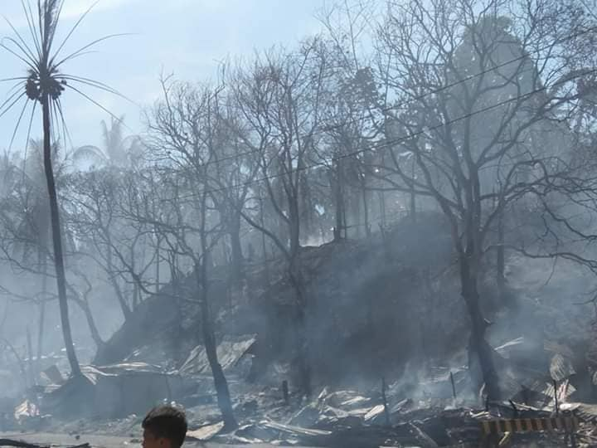
PHOTO DOCUMENTATION
