DSWD DROMIC Report #4 on the Armed Conflict
in San Jose de Buan, Western Samar
as of 26 March 2019, 4PM

SUMMARY

On 08 March 2019 at about 8PM, an armed conflict transpired in Brgy. Hagbay, San Jose de Buan, Western Samar which resulted to displacement of families and individuals in the area.

Source: DSWD-FO VIII

- Status of Affected Families / Persons
A total of 247 families or 988 persons were affected by the armed conflict in San Jose de Buan, Western Samar (see Table 1).

Table 1. Number of Affected Families / Persons
REGION / PROVINCE / MUNICIPALITY |  | NUMBER OF AFFECTED
 |  | Barangays | Families | Persons
GRAND TOTAL |  | 3 | 247 | 988
REGION VIII |  | 3 | 247 | 988
Western Samar |  | 3 | 247 | 988
 | San Jose de Buan | 3 | 247 | 988
Note: The decrease in the number of affected families and persons is due to the validation conducted.
Source: DSWD-FO VIII

- Status of Displaced Families/ Persons
  - There are 242 families or 968 persons who are currently staying at the Poblacion Covered Court and Poblacion Market Site (see Table 2).

Table 2. Number of Displaced Families / Persons Inside Evacuation Center
REGION / PROVINCE / MUNICIPALITY |  | NUMBER OF EVACUATION CENTERS (ECs) |  | INSIDE ECs
 |  |  |  | Families |  | Persons
 |  | CUM | NOW | CUM | NOW | CUM | NOW
GRAND TOTAL |  | 2 | 2 | 245 | 242 | 980 | 968
REGION VIII |  | 2 | 2 | 245 | 242 | 980 | 968
Western Samar |  | 2 | 2 | 245 | 242 | 980 | 968
 | San Jose de Buan | 2 | 2 | 245 | 242 | 980 | 968
Note: Ongoing assessment and validation.
Source: DSWD-FO VIII

  - 2 families or 8 persons are temporarily staying with relatives (see Table 3).

Table 3. Number of Displaced Families / Persons Outside Evacuation Center
REGION / PROVINCE / MUNICIPALITY |  | OUTSIDE ECs
 |  | Families |  | Persons
 |  | CUM | NOW | CUM | NOW
GRAND TOTAL |  | 2 | 2 | 8 | 8
Region VIII |  | 2 | 2 | 8 | 8
Western Samar |  | 2 | 2 | 8 | 8
 | San Jose de Buan | 2 | 2 | 8 | 8
Note: Ongoing assessment and validation.
Source: DSWD-FO VIII
- Assistance Provided
A total of ₱125,313.00 worth of assistance was provided by DSWD to the affected families (see Table 4).

Table 4. Cost of Assistance Provided to Affected Families / Persons
REGION / PROVINCE / MUNICIPALITY |  | TOTAL COST OF ASSISTANCE
 |  | DSWD | LGU | NGOs | OTHERS | GRAND TOTAL
GRAND TOTAL |  | 125,313.00 | - | - | - | 125,313.00
Region VIII |  | 125,313.00 | - | - | - | 125,313.00
Western Samar |  | 125,313.00 | - | - | - | 125,313.00
 | San Jose de Buan | 125,313.00 | - | - | - | 125,313.00
Note: Ongoing assessment and validation.
Source: DSWD-FO VIII

SITUATIONAL REPORT

DSWD-DRMB
DATE | SITUATIONS / ACTIONS UNDERTAKEN
26 March 2019 | - The Disaster Response Operations Monitoring and Information Center (DROMIC) of the DSWD-DRMB continues to closely coordinate with DSWD-FO VIII for significant reports on the status of affected families, assistance, and relief efforts.

DSWD-FO VIII
DATE | SITUATIONS / ACTIONS UNDERTAKEN
26 March 2019 | - The DSWD Field Office VIII through the Disaster Response Management Division will transport additional augmentation assistance for the displaced families consisting 255 Family Food Packs and 150 pcs. of blankets early tomorrow.  - DROMIC Focal Person is continuously coordinating updates of this incident with the SWADT and MDRRMC.  - Regional Resource Operation Section (RROS) is preparing the F/NFI’s for delivery to San Jose de Buan.

*****
The Disaster Response Operations Monitoring and Information Center (DROMIC) of the DSWD-DRMB continues to closely coordinate with DSWD-FO VIII for significant disaster response updates and assistance provided.

KIM AUSTIN A. ASPILLAGA
Releasing Officer

PHOTO DOCUMENTATION

- Displaced families at the Poblacion Covered Court
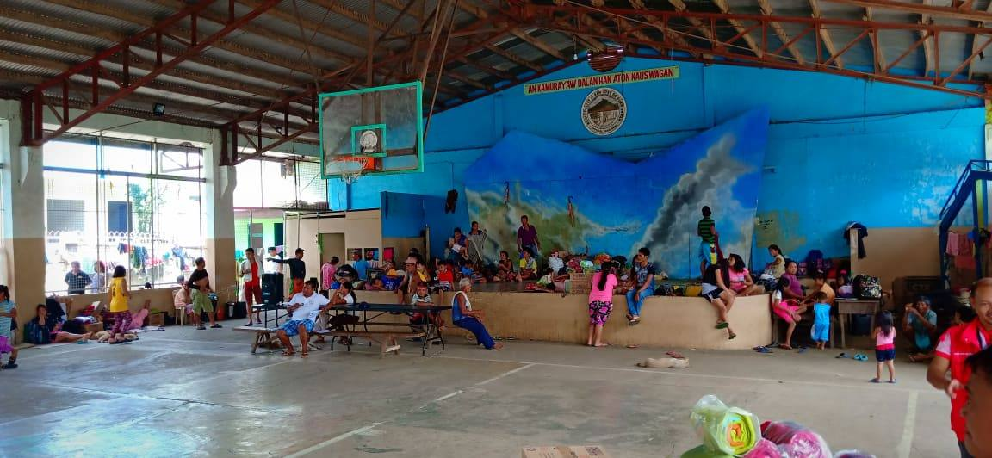
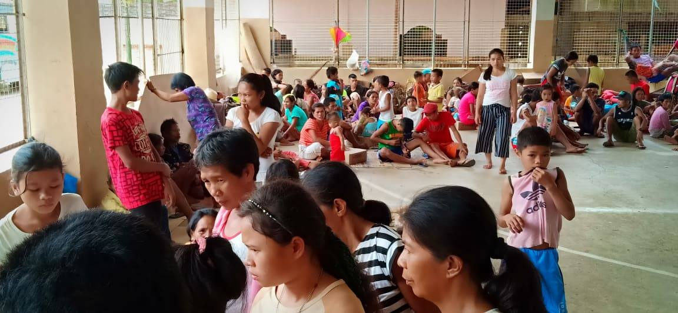
- Distribution of Family Food Packs (FFPs) and blanket last 21 March 2019
